|  |  |  |  |
| --- | --- | --- | --- |
|  | United Nations | ECE/TRANS/2025/20 | |
| _unlogo | **Economic and Social Council** | | Distr.: General  3 December 2024  Original: English |

**Economic Commission for Europe**

Inland Transport Committee

**Eighty-seventh session**

Geneva, 11-14 February 2025  
Item 7 (a) of the provisional agenda

**Strategic questions of a horizontal and   
cross-sectoral policy or regulatory nature:**

**Status of accession to and implementation of the**

**international United Nations inland transport**

**conventions and agreements (statements by delegates)**

Regional accession dynamics and the critical role of enhancing the monitoring of implementation of key legal instruments under the purview of the Inland Transport Committee

Note by the secretariat

I. Background and mandate

1. Under the purview of the Inland Transport Committee (ITC) of the Economic Commission for Europe (ECE) lie sixty United Nations legally binding instruments (Conventions, Agreements and their Protocols), forty-nine of which are currently in force.

2. At the time of preparation of this note, 155 United Nations Member States are contracting parties to at least one of these instruments. In recent years, there have been occasions where the number of accessions from outside the ECE region exceeded those from within the ECE region. Section II of this document presents the regional dynamics of accessions.

II. Regional Accession Dynamics by Regional Commission and related Considerations

A. Accession Dynamics by Regional Commission

3. When allocating countries to their regional commissions, it is important to note that many countries are members of more than one regional commission. If a country is a member of more than one regional commission, they are listed under the Regional Commission they are a member of.

1. Economic Commission for Europe region

4. Of the 1,843 accessions by Contracting Parties to the Conventions, 1,409 (76 per cent) are by fifty-six ECE member States. Of these, 380 are from the seventeen programme countries of ECE that are supported by the Regular Programme of Technical Cooperation (RPTC) of ECE. Luxembourg (44), Netherlands (44) and Serbia (42) lead the way with the most convention accessions of any member State.

2. Economic Commission for Latin America and the Caribbean region

5. Economic Commission for Latin America and the Caribbean (ECLAC) member States account for eighty-one accessions. Of the thirty-three member States of ECLAC, only twenty-two have acceded to at least one of the transport conventions under the purview of ITC. The remaining eleven member States that have not signed any convention are Belize, Bolivia, Colombia, Dominica, Grenada, Nicaragua, Panama, Saint Kitts and Nevis, Saint Lucia, Saint Vincent and the Grenadines, and Suriname. Cuba (fifteen accessions) and Trinidad and Tobago (seven) are the best performers in the ECLAC region in terms of total accessions.

3. Economic Commission for Africa region

6. To date, the Economic Commission for Africa (ECA) countries have made 165 accessions to ECE transport conventions. Thirty-six countries have acceded to at least one convention, leaving eighteen (33 per cent) that have not participated in any. The rate of accession from the ECA region has accelerated considerably in the years since the adoption of the ITC Strategy until 2030. Most recently in 2022, there was a significant uptick in accessions, with six by Uganda and two by Benin. Tunisia, with eighteen accessions, Morocco, with fifteen, and Uganda, with eleven, lead in terms of the number of accessions.

4. Economic and Social Commission for Western Asia region

7. As of November 2024, sixteen of the twenty-one member States of the Economic and Social Commission for Western Asia (ESCWA) have collectively made 103 accessions to twenty-five ECE transport conventions. Djibouti, Libya, Mauritania, Somalia, and Yemen have not yet acceded to any convention. Countries in the region with the most accessions are Tunisia (18), Morocco (15), Algeria, Egypt, and Jordan (nine each).

5. Economic and Social Commission for Asia and Pacific region

8. Among the fifty regional member States of the Economic and Social Commission for Asia and Pacific (ESCAP),[[1]](#footnote-2) thirty-nine member States have made 320 accessions to forty-three distinct inland transport conventions. This means, however, that eleven (or 22 per cent) of its members are not covered by a single transport convention. The countries leading on accessions are the Russian Federation (33), Türkiye (29), Georgia and Kazakhstan (18 each), all of whom are also ECE member States. Notably, Türkiye has been particularly active, with several accessions in May 2023 across several agreements related to road signs, signals, and markings.

B. Accession dynamics and related capacity development challenges and opportunities

9. The figure below shows, in the past five years, there have been two occasions where the number of accessions from outside the ECE region exceeded those from ECE member States.

**Accession of ECE and non-ECE Contracting Parties (1960–2024)**

**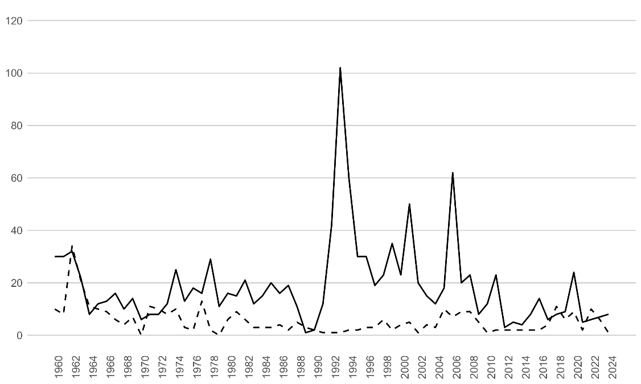**

*Legend:* Solid line: ECE member States – Dashed line: non-ECE member States.

*Source*: ECE.

10. As of November 2024, the seventeen programme countries of ECE collectively account for a **total of 380 accessions** to legal instruments. The ninety-nine non-ECE United Nations Member States accounted for a **total of 434 accessions** to legal instruments under the purview of ITC.

1. ESCAP has 53 member States; however for the purposes of the analysis, France, the Netherlands, and the United Kingdom of Great Britain and Northern Ireland are excluded. [↑](#footnote-ref-2)