UN/SCETDG/65/INF.62
Committee of Experts on the Transport of Dangerous Goods
and on the Globally Harmonized System of Classification
and Labelling of Chemicals
Sub-Committee of Experts on the Transport of Dangerous Goods 28 November 2024
Sixty-fifth session
Geneva, 25 November-3 December 2024
Item 4 (a) of the provisional agenda
Electric storage systems:
testing of lithium batteries

Lithium battery test and definition of “rupture” in section 38.3 of the Manual of Tests and Criteria
Submitted by the Rechargeable Battery Association (PRBA) and the Advanced Rechargeable & Lithium Batteries Association (RECHARGE)
I. Introduction
1. Following the sixty-fifth session discussion, an informal document is proposed to improve the definition of “rupture” in the Manuel of Tests and Criteria section 38.3.2.3.
2. The change in the main text is removed, as it was perceived by some experts as changing the scope of the definition. It is considered that the precision in the note only, is a sufficient clarification.
3. The text of the note is maintained, as a mean to help clarifying the definition word “exposure” used in the definition.
4. For a battery not fully enclosed by its casing, when a cover bulges or flexes from expansion, the already exposed internal cell components will be more exposed visually and it is unclear if this additional exposure would be interpreted as a rupture.
5. The note clarifies where the professional should focus their attention to determine whether there is a rupture or not after the test. It also clarifies that the mere fact of having cells exposed prior to the test is not a concern per se. The determination of the failure should be made on the base of the assessment of a change after test. The important question is: is it more exposed material fate the test, compared to the initial situation?
6. To help clarify the definition of rupture and provide for consistent interpretations across various battery types, PRBA proposes a change to the definition of rupture in 38.3.2.3.
II. Proposal
7. The Sub-Committee is invited to amend the definition of rupture in paragraph 38.3.2.3 of the Manual of Tests and Criteria as follows (new text is underlined, deleted text in strikethrough):
“Rupture means the mechanical failure of a cell container or battery case induced by an internal or external cause, resulting in exposure or spillage but not ejection of solid materials.
NOTE: In the case of a battery that is not fully enclosed by its casing and the cells are exposed by design prior to the tests, “exposure” means an increased visibility of components that are exposed beyond that of the original design of the battery.”

Annex
Reference definitions of rupture from various battery industry standards
UN ECE R100: Rupture means opening(s) through the casing of any functional cell assembly created or enlarged by an event, large enough for a 12mm diameter test finger (IPXXB) to penetrate and make contact with live parts.
ISO 1649-1: loss of mechanical integrity of an enclosure resulting in openings not fulfilling protection degree IPXXB according to ISO 20653
IEC 62281: A rupture is considered to have occurred if a cell container or battery case has mechanically failed, resulting in expulsion of gas or spillage of liquids but not forcible ejection of solid materials.
IEC 62133: mechanical failure of a cell container or battery case induced by an internal or external cause, resulting in exposure or spillage but not ejection of materials. It should be noted that IEC 62133 appears to provide an exception for rupture “exposure” in 7.2.2 Case stress at high ambient temperature (battery). The exception would appear to exempt battery designs not fully enclosed by its casings:
“7.2.2.a) Requirement: Internal components of batteries shall not be exposed during use at high temperature. This requirement only applies to batteries with a moulded case.”
ANSI C18.3: a mechanical failure of a cell container or battery case, resulting in an expulsion of gas or spillage of liquids but not ejection of solid materials.

Example photos

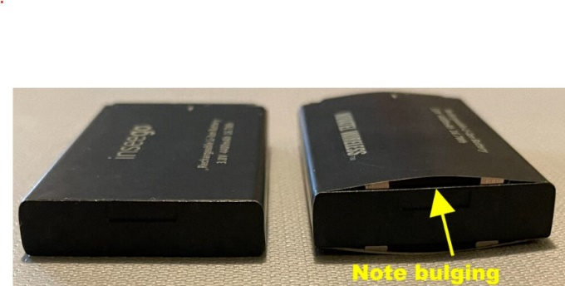  Figure 1  Battery with bulging resulting in internal cells exposed meets definition of rupture. | 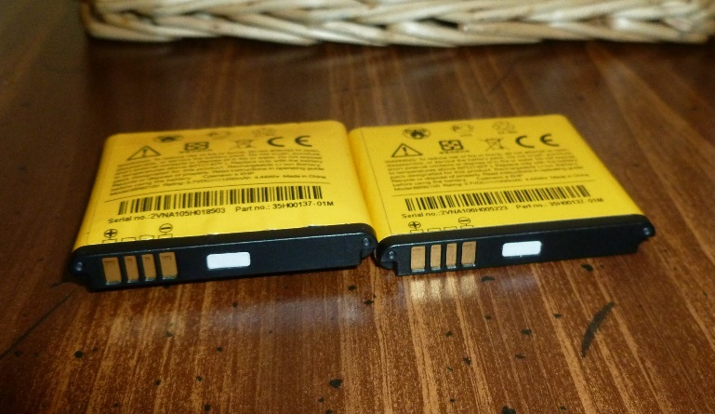  Figure 2  Battery with bulging (no cells exposed) would not meet definition of rupture
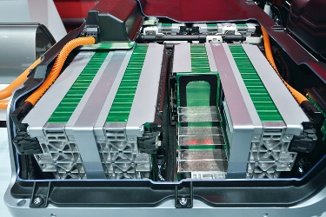  Figure 3  Example Battery Module with cells exposed by design | 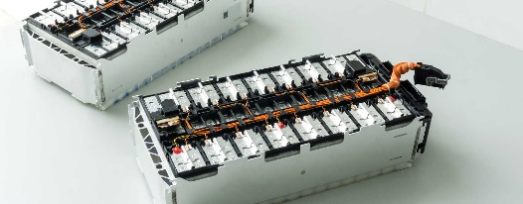  Figure 4  2nd Example Battery Module with cells exposed by design

Figure 5
3rd Example Battery Module with cells exposed by design

Note by the secretariat: The author of the document gave the authorization to use the materials contained in the section for the purpose of the discussion at the sixty-fifth session of the Sub-Committee of Experts on the Transport of Dangerous Goods. For reproduction permission and all other issues, please contact: MBoolish@wiley.law.

