Proposal for amendment of ECE/TRANS/WP.29/GRSG/2024/35

**and to combine GRSG-128-14**

(Reversing motion)

Submitted by the expert from Republic of Korea

The text reproduced below was prepared by the experts from Republic of Korea to amend the supplement 5 to the Original Version of UN Regulation No. 158 and this proposal corrects the contents of the working document (ECE/TRANS/WP.29/GRSG/2024/4) and combines the informal document(GRSG-128-14) that have already been submitted. The modifications to the existing text of Regulation 158 are displayed in bold for new or strikethrough for deleted characters.

I. Proposal

*Annex 9. Test methods for close-proximity rear-view field of vision*

*Paragraph 1.3.3.4.,* amend to read:

"1.3.3.4. Rear hatch**es** ~~and~~**,** trunk lids~~.~~ **and tailgates.**

If the vehicle is equipped with rear hatches**,** ~~or~~ trunk lids **or tailgates**, they are closed and latched in their normal vehicle operating condition."

*Annex 10., paragraph 1.1.,* amend to read:

"1.1. Test conditions.

The test object shall be as per paragraph 7.1. of ISO 17386:2010. During testing, the wind speed shall not exceed 1 m/s. The temperature shall be 20±5℃ and the humidity shall be 60±25 percent. There shall be no rain or snow. The test shall be performed on a flat, dry asphalt or concrete surface. The test shall not be affected by the reflection of sound waves or electromagnetic waves from any walls, auxiliary testing equipment or any other objects in the environment. **If the vehicle is equipped with rear hatches, trunk lids or tailgates, they are closed and latched in the normal conditions of vehicle operation.**”

*Annex 10, paragraph 1.2.,* amend to read:

“1.2. Test preparation One test object shall be used. The distance from the rear edge to the test object and the position of the test object are selected by the manufacturer to ensure the detection of the test object. The test object shall be located in the detectable grids within the rear horizontal area in 1.3.1. of this annex. The test vehicle in the initial state shall be with the detection system in the activated state, which is declared ~~[~~by the manufacturer ~~OR in the owner’s manual]~~ and shall be in the parking condition. Here, the parking condition means that the P (park) position is selected in the case of vehicles equipped with automatic transmissions, whereas it means the neutral gear being selected and the parking brake being engaged in the case of vehicles equipped with manual transmissions.”

II. Justification

*<Regarding the working document ECE/TRANS/WP.29/GRSG/2024/35>*

1. The vehicle conditions of the test methods for rear-view field of vision are clearly specified in the annex 9 in this Regulation, but not in the case of detection systems in annex 10. This is a problem of inconsistency between the rear-view field of vision and the detection systems that may also cause ambiguity in conducting the test for detection systems.

2. In addition, the test conditions should specify that not only rear hatches or trunk lids but also the tail gates of cargo trucks and van-type vehicles should be closed or latched in the normal conditions of vehicle operation during the test. For additional information on this matter, please refer to the following figures.

Figure 1   
**Example of the Tail Gate of Cargo Trucks**

Figure 2   
**Example of the Tail Gate for Van Type Vehicles**

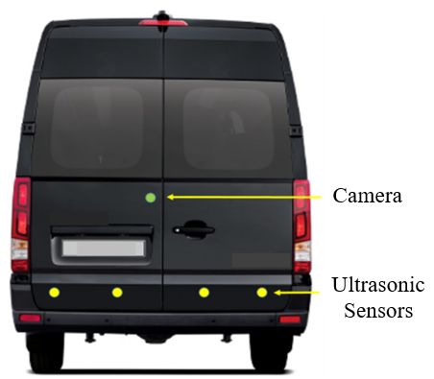

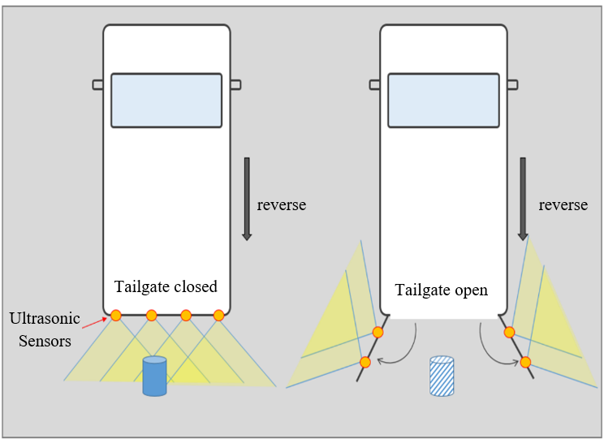

*<Regarding the informal document GRSG-128-14>*

3. The text remained in brackets in the original version of Regulation No. 158 is no longer the subject of discussion. With the proposed modification clarification is given as the vehicle owner is not concerned with test preparation and it shall not be implemented in the owner’s manual. The manufacturer shall deliver the required information at the time of approval to run the test appropriately.