Proposal for amendments to the 03 and 04 series of amendments to UN Regulation No. 79

*Note:* Modifications to the existing text of the Regulation indicated in **red bold** for new characters and ~~red strikethrough~~ for deleted characters.

I. Proposal

*Delete paragraph 1.2.3*:

“1.2. This Regulation does not apply to:

1.2.1. Steering equipment with a purely pneumatic transmission;

1.2.2. Autonomous Steering Systems as defined in paragraph 2.3.3.;

~~1.2.3. Steering systems exhibiting the functionality defined as ACSF of Category B2 or E until specific provisions are introduced in this Regulation.~~”

*Amend paragraph 4.4.3.,* to read:

“4.4.3. a letter “X” preceding the approval number in the case when either:

(a) ACSF of Category B1 or C have been exempted from the technical requirements of this UN Regulation according to paragraph 5.6.2. and/or 5.6.4.

(b) The steering system exhibits functionality defined as ACSF of Category **B2,** D **or E**.”

*Paragraph 5.6.5., amend* to read:

“5.6.5. Vehicles equipped with systems exhibiting the functionality defined as ACSF of Category **B2,** D **or E** shall not be approved according to this UN Regulation, unless the vehicle is equipped with a DCAS which:

1. incorporates the function(s), and
2. allows the activation of the function(s) only during operation and as part of DCAS, and
3. complies with the technical requirements and transitional provisions of UN Regulation No. 171. y”

*Amend footnote y* to read:

“y Contracting Parties who do not apply UN Regulation No. 171 are not obliged to accept approvals to UN Regulation No. 79 for vehicles with systems which exhibit the functionality defined as ACSF of Category **B2,** D **or E,** or for vehicles which do not comply in full with the technical requirements for ACSF in this UN Regulation.”

*Annex 1,*

*Amend paragraph 6.5,* to read*:*

“6.5. Vehicle is equipped with a steering system which exhibits functionality defined as an ACSF of Category **B2,** D **or E**: yes/no”

*Annex 2,* amend to read:

“Arrangements of approval marks

Model A

(See paragraph 4.4. of this Regulation)



**79 R – [03/04]2439**

a = 8 mm min

The above approval mark affixed to a vehicle shows that the vehicle type concerned has, with regard to steering equipment, been approved in the Netherlands (E 4) pursuant to UN Regulation No. 79 under approval No. [03/04]2439. The approval number indicates that the approval was granted in accordance with the requirements of UN Regulation No. 79 incorporating the [03/04] series of amendments.



**79 R - X[03/04]2439**

a = 8 mm min

The above approval mark affixed to a vehicle shows that the vehicle type concerned has, with regard to steering equipment, been approved in the Netherlands (E 4) pursuant to UN Regulation No. 79 under approval No. [03/04]2439. The letter “X” preceding the approval number indicates that the vehicle is equipped with ACSF which has been exempted from the requirements of this UN Regulation, and/or that the vehicle is equipped with a steering system which exhibits functionality defined as an ACSF of Category **B2,** D **or E**. The approval number indicates that the approval was granted in accordance with the requirements of UN Regulation No. 79 incorporating the [03/04] series of amendments.”

Model B

(See paragraph 4.5. of this Regulation)

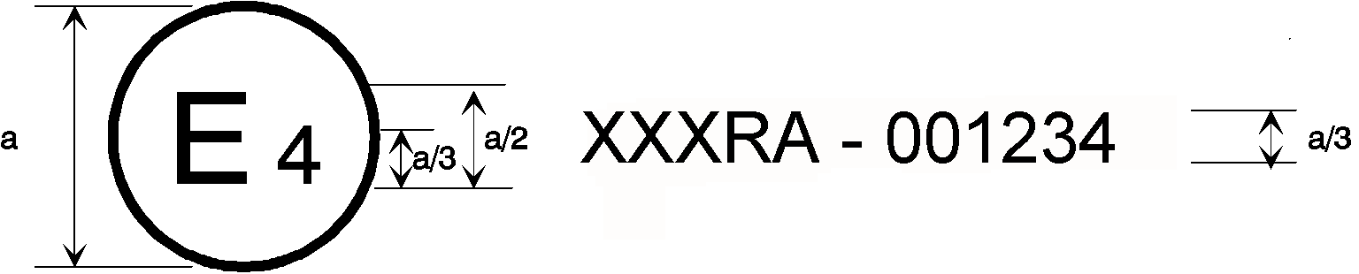

|  |  |
| --- | --- |
| **79** | **[03/04]2439** |
| **31** | **021628** |

a = 8 mm min

The above approval mark affixed to a vehicle shows that the vehicle type concerned has been approved in the Netherlands (E 4) pursuant to Regulations Nos. 79 and 31.[1]3 The approval numbers indicate that, at the dates when the respective approvals were given, UN Regulation No. 79 incorporating the [03/04] series of amendments and UN Regulation No. 31 included the 02 series of amendments.



|  |  |
| --- | --- |
| **79** | **X[03/04]2439** |
| **31** | **021628** |

a = 8 mm min

The above approval mark affixed to a vehicle shows that the vehicle type concerned has been approved in the Netherlands (E 4) pursuant to Regulations Nos. 79 and 31.[2]4 The letter “X” preceding the approval number pursuant to Regulation No. 79 indicates that the vehicle is equipped with ACSF which have been exempted from the requirements of this UN Regulation, or that the vehicle is equipped with a steering system which exhibits functionality defined as an ACSF of Category **B2,** D **or E**. The approval numbers indicate that, at the dates when the respective approvals were given, UN Regulation No. 79 incorporating the [03/04] series of amendments and UN Regulation No. 31 included the 02 series of amendments.”

II. Justification

1. The amendment should not place any additional requirements on vehicles already approved to UN Regulation No. 79, since the Regulation previously did not apply to vehicles with such features. It is therefore proposed as a supplement.

2. *Paragraphs 1.2.3. and 5.6.5*.: Approval of steering systems exhibiting Automatically Commanded Steering Function of category B2, D or E functionality was excluded from UN Regulation No. 79 until ‘specific provisions are introduced’ into the Regulation. ACSF-D was removed from these paragraphs following the introduction of UN Regulation No. 171, as that regulation covers this functionality. Specific provisions for functions meeting the definitions of ACSF-B2 and E now also exist in UN Regulation No. 171, and so it is now appropriate to remove these references too. The footnote allows Contracting Parties who do not apply UN Regulation No. 171 to maintain the previous restrictions imposed by UN Regulation No. 79.

3. *Paragraph 4.4.3. and Annex 2:* The additional marking provision is updated to also cover ACSF-B2 and E.

4. Because the amendments introduced here are aligned with the amendment of UN Regulation No. 171 to cover these functions, this proposal should be agreed at the same session of GRVA as that amendment.

1. 3 The second number is given merely as an example.
2. 4 The second number is given merely as an example.