**Proposal for a new supplement to the 03 series**

**of amendments to UN Regulation No. 51**

The text reproduced below was prepared by the experts from OICA in order to address the original intent of the Task Force on Quiet Road Transport Vehicles (TF QRTV) to the 03 series of amendments to UN Regulation No. 51. This text is based on the adoption of GRBP/2024/22 and will replace GRBP-80-21. The modifications to the current text of the UN Regulation are marked in bold for new or strikethrough for deleted characters.

**I. Proposal**

*Annex7, Paragraph 2.3.,* amend to read:

"2.3. Control range

The ASEP requirements apply to every gear ratio κ that leads to test results within the control range as defined below.

Vehicle speed vAA_ASEP: vAA ≥ 20 km/h

**vAA > 0 km/h for vehicles according to paragraph 1.1. of this Annex**

…"

*Annex 7, paragraph 3.2.1.,* amend to read:

"3.2.1. Calculation of the slope of the regression line for each gear ratio κ

…

**For vehicles according to paragraph 1.1 of this annex, a constant value of   
Slopek = 5 dB/1,000 min-1 shall be considered for further calculation.** "

**II. Justification**

1. This document GRBP-80-21-Rev.1 is only valid in combination with GRBP/2024/22.
2. With this amendment OICA proposes to expand the speed range of ASEP for BEVs down to speeds > 0 km/h.

At the same time, OICA withdraws GRBP-80-21, which addresses the same topic in UN Regulation No. 138, which is originally not designed for noise emission.

1. Explanation of the graph 1:
2. The proposed limit (dotted black line) is related to accelerated conditions of ASEP, which are the worst conditions for urban noise emission.
3. The yellow stairs are the limits proposed in GRBP-80-06 by EC for rolling condition (corrected from 2 m of UN-R 138 to 7.5m distance of UN-R 51), which are the best conditions for urban noise emission.
4. Regarding paragraph 6.2.8. of UN-R 138 any other driving condition, like acceleration, shall not deviate in a significant matter. GRB-68-03 quantifies a significant matter with a value of greater than 6 dB. To compare the EC proposal (yellow steps) with the OICA proposal (dotted black line), a margin of 6 dB has to be added to the yellow steps.
5. This brings us to the result that there is nearly no difference in low speeds < 10 km/h and for the higher speeds OICA’s ASEP proposal is even more restrictive.
6. The crossing point at 0 km/h matches the maximum noise limits for stand-still condition in UN Regulation 138/02 (corrected from 2.0 m to 7.5 m due to the different methods in UN-R 138 and UN-R 51). Since we have not a suitable measurement method for EVs in stand still condition, we cannot include it.
7. The blue and grey dots in the graph 1 represent different driving conditions of different vehicles. The blue dots show pass-by test runs of EVs only equipped with an AVAS, while the grey dots show pass-by-tests of EVs equipped with AVAS and ESES. The limit curve is so designed that vehicles equipped with an AVAS only fulfil the noise emission requirements.

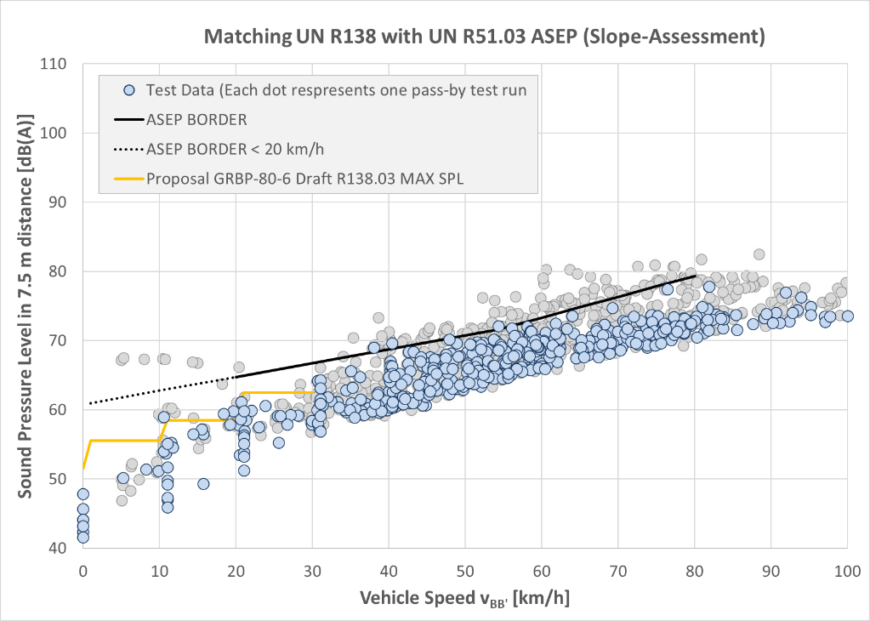

Graph 1: Noise emission limits for EVs

1. This supplement in combination with GRBP/2024/22 adds noise limits for EVs to the ASEP method in a speed range from > 0 km/h to 80 km/h. Consequently, a double regulation of noise emission using parallelly the methods of UN Regulation No. 138 for minimum safety shall be eliminated.
2. The Slope has been fixed to the maximum value, in order to archieve the maximum environmental benefit of EVs at low speeds.