|  |  |  |  |
| --- | --- | --- | --- |
|  | United Nations | ECE/TRANS/WP.29/GRSG/2024/35 | |
| _unlogo | **Economic and Social Council** | | Distr.: General  22 July 2024  Original: English |

**Economic Commission for Europe**

Inland Transport Committee

**World Forum for Harmonization of Vehicle Regulations**

**Working Party on General Safety Provisions**

**128th session**

Geneva, 7–11 October 2024

Item 4(b) of the Provisional Agenda  
**Awareness of the Proximity of Vulnerable Road Users:**

**UN Regulation No. 158 (Reversing Motion)**

Proposal for Supplement 3 to the Original Version of UN Regulation No. 158 (Reversing Motion)

Submitted by the expert from the Republic of Korea[[1]](#footnote-2)\*

The text reproduced below was submitted by the representative from the Republic of Korea to amend UN Regulation No. 158. The proposal aims to clarify the test conditions of rear-view camera and detection system. This document is based on the informal document GRSG-127-13 which was presented at the 127th GRSG session in April 2024. The modifications to the current text of UN Regulation No. 158 are displayed in bold for new or strikethrough for deleted characters.

1. **Proposal**

*Annex 9. Test methods for close-proximity rear-view field of vision*

*Paragraph 1.3.3.4.,* amend to read:

"1.3.3.4. Rear hatch ~~and~~**,** trunk lids~~.~~ **and tail gates.**

If the vehicle is equipped with rear hatches**,** ~~or~~ trunk lids~~,~~ **or tail gates,** they are closed and latched in their normal vehicle operating condition."

*Annex 10., paragraph 1.1.,* amend to read:

"1.1. Test conditions.

The test object shall be as per paragraph 7.1. of ISO 17386:2010. During testing, the wind speed shall not exceed 1 m/s. The temperature shall be 20±5℃ and the humidity shall be 60±25 percent. There shall be no rain or snow. The test shall be performed on a flat, dry asphalt or concrete surface. The test shall not be affected by the reflection of sound waves or electromagnetic waves from any walls, auxiliary testing equipment or any other objects in the environment. **If the vehicle is equipped with rear hatches, trunk lids or tail gates, they are closed and latched in the normal conditions of vehicle operation.**”

**II. Justification**

1. The vehicle conditions of the test methods for rear-view field of vision are clearly specified in the annex 9 in this Regulation, but not in the case of detection systems in annex 10. This is a problem of inconsistency between the rear-view field of vision and the detection systems that may also cause ambiguity in conducting the test for detection systems.

2. In addition, the test conditions should specify that not only rear hatches or trunk lids but also the tail gates of cargo trucks and van-type vehicles should be closed or latched in the normal conditions of vehicle operation during the test. For additional information on this matter, please refer to the following figures.

Figure 1   
**Example of the Tail Gate of Cargo Trucks**

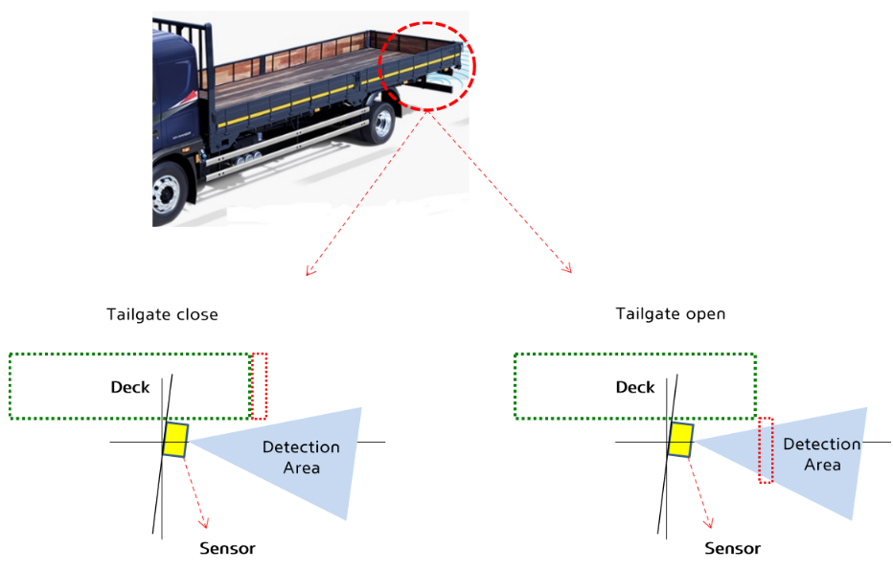

Tailgate closed

Tailgate open

Sensor

Sensor

Detection area

Detection area

**Deck**

**Deck**

Figure 2   
**Example of the Tail Gate for Van Type Vehicles**

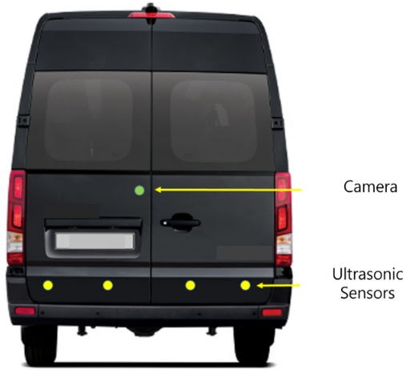

Ultrasonic

Sensors

Camera

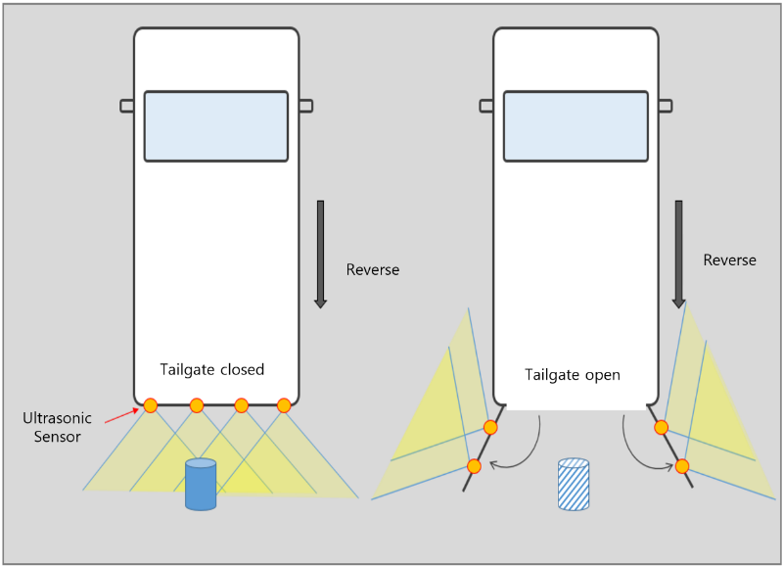

Tailgate open

reverse

reverse

Tailgate closed

Ultrasonic

Sensors

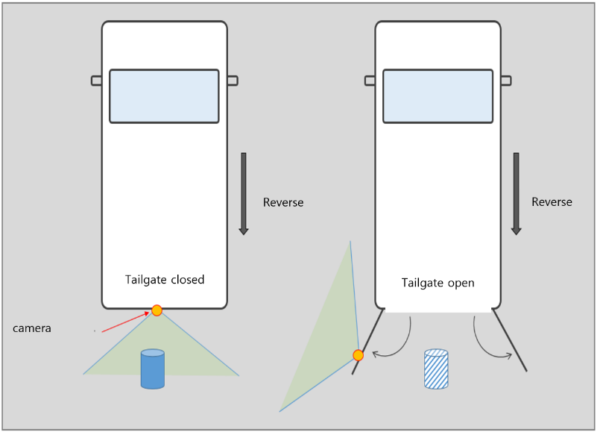

Tailgate open

Tailgate closed

camera

reverse

reverse

1. \* In accordance with the programme of work of the Inland Transport Committee for 2024 as outlined in proposed programme budget for 2024 (A/78/6 (Sect. 20), table 20.5), the World Forum will develop, harmonize and update UN Regulations in order to enhance the performance of vehicles. The present document is submitted in conformity with that mandate. [↑](#footnote-ref-2)