ECE/TRANS/180/Add.13/Amend.1/Corr.1
24 July 2024

Global registry
Created on 18 November 2004, pursuant to Article 6 of the Agreement concerning the establishing of global technical regulations for wheeled vehicles, equipment and parts which can be fitted and/or be used on wheeled vehicles (ECE/TRANS/132 and Corr.1) done at Geneva on 25 June 1998
Addendum 13: UN Global technical regulation No. 13
Hydrogen and Fuel Cell Vehicles
Amendment 1 - Corrigendum 1
Established in the Global Registry on 26 June 2024
_______________
UNITED NATIONS

Section H, paragraph 2 title, amend to read:
"2. National Requirements Complementary to UN GTR Requirements"
Section I, paragraph 190, amend to read:
"190. … the requirements presented as optional requirements in this document (LHSS Section G of the preamble) could be adopted as requirements with appropriate modifications. "
Section O, Table 10, amend to read:
"Table 10
Optional Tolerances for Test Parameters
Paragraph | Test Parameter | Value | Optional Tolerance | Unit
…
Distance
6.2.3.2. (a) (i) | Horizontal drop height | 1.8 m | ±0.02 | m
6.2.3.2.(b) (c) | Vertical drop height | calculated drop height | ±0.02 | m
6.2.3.2. (d) | 45° angle centre of gravity height | 1.8 m | ±0.02 | m
…
"
Table 1 in paragraph 3.52., amend to read:

" Table 1
Compressed Hydrogen Density (g/l)
Temperature  (°C) | Pressure (MPa)
 | 1 | 10 | 20 | 30 | 35 | 40 | 50 | 60 | 65 | 70 | 75 | 80 | 87.5
-40 | 1.0 | 9.7 | 18.1 | 25.4 | 28.6 | 31.7 | 37.2 | 42.1 | 44.3 | 46.1 | 48.4 | 50.3 | 53.0
-30 | 1.0 | 9.4 | 17.5 | 24.5 | 27.7 | 30.6 | 36.0 | 40.8 | 43.0 | 45.1 | 47.1 | 49.0 | 51.7
-20 | 1.0 | 9.0 | 16.8 | 23.7 | 26.8 | 29.7 | 35.0 | 39.7 | 41.9 | 43.9 | 45.9 | 47.8 | 50.4
-10 | 0.9 | 8.7 | 16.2 | 22.9 | 25.9 | 28.7 | 33.9 | 38.6 | 40.7 | 42.8 | 44.7 | 46.6 | 49.2
0 | 0.9 | 8.4 | 15.7 | 22.2 | 25.1 | 27.9 | 33.0 | 37.6 | 39.7 | 41.7 | 43.6 | 45.5 | 48.1
10 | 0.9 | 8.1 | 15.2 | 21.5 | 24.4 | 27.1 | 32.1 | 36.6 | 38.7 | 40.7 | 42.6 | 44.4 | 47.0
15 | 0.8 | 7.9 | 14.9 | 21.2 | 24.0 | 26.7 | 31.7 | 36.1 | 38.2 | 40.2 | 42.1 | 43.9 | 46.5
20 | 0.8 | 7.8 | 14.7 | 20.8 | 23.7 | 26.3 | 31.2 | 35.7 | 37.7 | 39.7 | 41.6 | 43.4 | 46.0
30 | 0.8 | 7.6 | 14.3 | 20.3 | 23.0 | 25.6 | 30.4 | 34.8 | 36.8 | 38.8 | 40.6 | 42.4 | 45.0
40 | 0.8 | 7.3 | 13.9 | 19.7 | 22.4 | 24.9 | 29.7 | 34.0 | 36.0 | 37.9 | 39.7 | 41.5 | 44.0
50 | 0.7 | 7.1 | 13.5 | 19.2 | 21.8 | 24.3 | 28.9 | 33.2 | 35.2 | 37.1 | 38.9 | 40.6 | 43.1
60 | 0.7 | 6.9 | 13.1 | 18.7 | 21.2 | 23.7 | 28.3 | 32.4 | 34.4 | 36.3 | 38.1 | 39.8 | 42.3
70 | 0.7 | 6.7 | 12.7 | 18.2 | 20.7 | 23.1 | 27.6 | 31.7 | 33.6 | 35.5 | 37.3 | 39.0 | 41.4
80 | 0.7 | 6.5 | 12.4 | 17.7 | 20.2 | 22.6 | 27.0 | 31.0 | 32.9 | 34.7 | 36.5 | 38.2 | 40.6
85 | 0.7 | 6.4 | 12.2 | 17.5 | 20.0 | 22.3 | 26.7 | 30.7 | 32.6 | 34.4 | 36.1 | 37.8 | 40.2
"
Paragraph 6.2.3.2., amend to read:
"6.2.3.2. Drop (impact) test (unpressurized)
…
(d) From a 45° angle from the vertical orientation with the shut-off valve interface location downward with its centre of gravity at 1.8 m above the ground. However, if the bottom is closer to the ground than 0.6 m, the drop angle shall be changed to maintain a minimum height of 0.6 m and a centre of gravity at 1.8 m above the ground. In case of non-axisymmetric container, the line passing the shut-off valve interface location end and its centre of gravity shall be 45° angled from vertical orientation and the shut-off valve interface location shall become the lowest.
…"
Figure 3 in paragraph 6.2.3.2., amend to read (correct the place of words in the drawing):
"Figure 3
Drop Orientations
1.8 m
≥ 488 J
≤ 1.8 m
45°
≥ 0.6 m
No. 1
No.
2
No.
3
No.
4
centre of gravity
"
Paragraph 6.2.5.4.5.3., amend to read:
"6.2.5.4.5.3. The 60-second rolling averages of individual temperature readings in the localized fire zone (i.e. TB_{LOC}, TMF_{LOC}, TMR_{LOC} and TU_{LOC}) and the engulfing fire zone (i.e. TBR, TBC, TBL, TMRF, TMCF, TMLF, TMRR, TMCR, TMLR, TUR, TUC and TUL) shall be …"
Figure 3 (Example of a hydrogen fuel cell bus), three labels of "High Voltge Lines", amend to read:
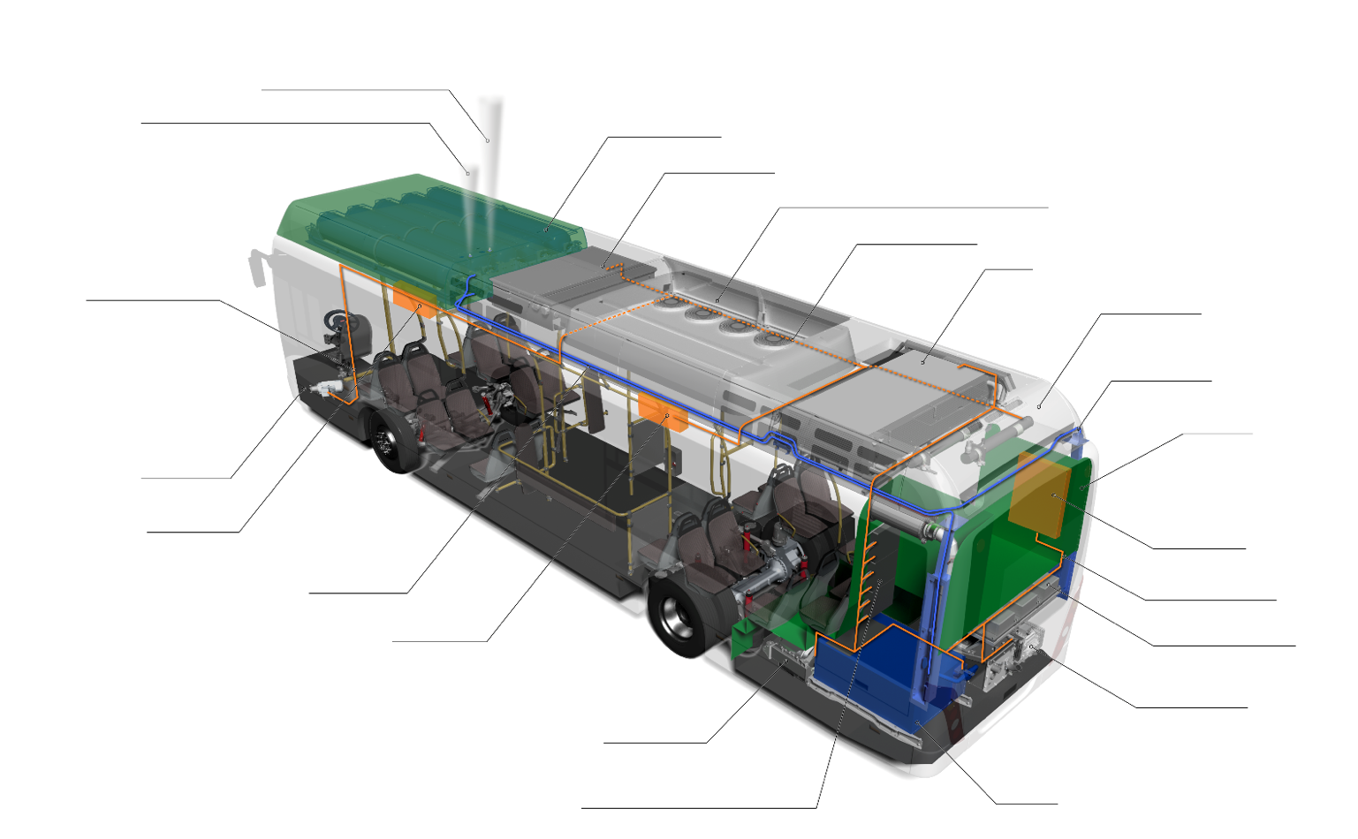
High Voltage Lines
Low-pressure blow-off Line (maintenance)
Hydrogen Tanks
Traction Battery
Climate control / Traction Battery Cooler
High Voltage Lines
Cooler
Brake Resistor
Hydrogen Line
Bulkhead
Junction Box
High Voltage Lines
Converters / Inverters
Air Compressor
Fuel Cell
Servo Pump
Junction Box
Junction Box
Hydrogen Line
Traction Motor
Converters secondary Consumers
High-pressure blow-off Line

"
Table 1 (Results of Japanese Study), amend to read (such that 5,500 is actually deleted and not just crossed out):
Vehicle Type | Max svc. Life | Max lifetime miles travelled | Lifetime No. of fills  ("pressure test cycles") | Ref: UN GTR13 Phase 2 Proposal
HD Commercial | 15 yrs  20 yrs  25 yrs | --  3,500,000 km  4,000,000 km | --  8,450  9,750 | 11,000  11,000  11,000
LD Commercial | 15 yrs  20 yrs  25 yrs | --  2,100,000 km  2,400,000 km | --  6,560  7,440 | 7,500 or 11,000  11,000  11,000
"
Paragraph 78.(a)(iv), amend to read:
"78. …
(a) …
(iv) … While it is difficult to get a single data-based fuelling interval value for hydrogen fuelled HDVs, an assumption of 400 km (250 mi.) can be a sufficiently conservative values; "
Figure 10, amend to read (such that x-axis label is consistent with the paragraph above it):

Ventilation Rate (1/Hour)
Vehicle Size (m³)
46 mL/h/L CHSS Permeation/Leakage
Less Than 25% LFL
Less than 0.18 air exchanges per hour
House with "Tight" Attached Garage
Tractor Only
With Trailor
"
Figure 29 (Top View Showing Extension of the Engulfing Fire Zone Toward the Nearest TPRD on a Cylinder), amend to read:
Extension for Engulfing
TPRD
Localized
"Case 1
Nearest TPRD Located on the Axis of the Cylinder

Localized
Extension for Engulfing
TPRD
Case 2
Nearest TPRD Located Off -axis on the Cylinder Wall
"
Paragraph 3.28., amend to read:
"3.28. "Hydrogen-fuelled vehicle" indicates any motor vehicle that uses compressed gaseous or liquefied hydrogen… Hydrogen fuel for the vehicles is specified in ISO 14687:2019 and SAE J2719_202003."
Figure 2 (Verification Test for Expected On-Road Performance (Pneumatic/hydraulic)), amend to read:
"Figure 2
Verification Test for Expected On-Road Performance (Pneumatic)"

Figure 12 in paragraph 88, amend to read (corrected labels, no changes to values):
"
"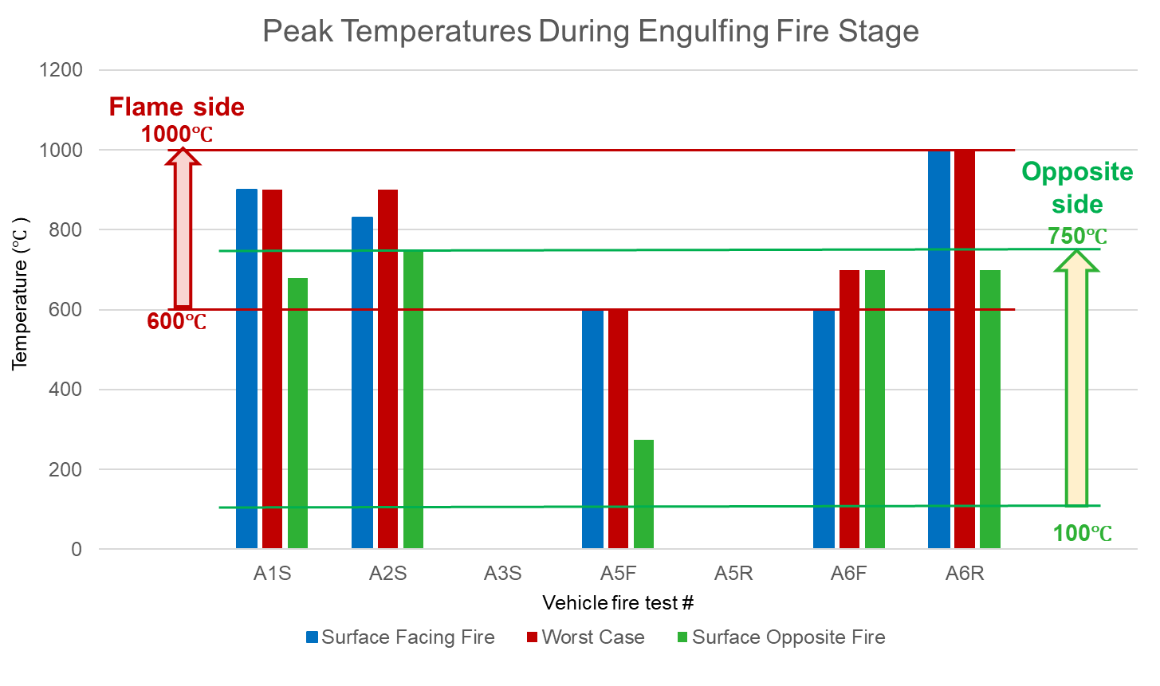
Temperature (°C)
Surface Opposite Fire
Vehicle Fire test
Worst Case
Surface Facing Fire
Opposite side
Flame side
Peak Temperatures During Engulfing Fire Stage

