UN/SCEGHS/46/INF.18
Committee of Experts on the Transport of Dangerous Goods
and on the Globally Harmonized System of Classification
and Labelling of Chemicals
Sub-Committee of Experts on the Globally Harmonized
System of Classification and Labelling of Chemicals 1 July 2024
Forty-sixth session
Geneva, 3-5 July 2024
Item 2 (j) of the provisional agenda
Work on the Globally Harmonized System of Classification
and Labelling of Chemicals: Other matters
Proposed amendment to 4.1.3.6
Transmitted by the United Nations Institute for Training and Research (UNITAR)
Introduction
1. Paragraph 4.1.3.6 currently reads (bold added for emphasis):
“4.1.3.6 Classification of mixtures with ingredients without any useable information
In the event that no useable information on acute and/or chronic aquatic toxicity is available for one or more relevant ingredients, it is concluded that the mixture cannot be attributed (a) definitive hazard category(ies). In this situation the mixture should be classified based on the known ingredients only, with the additional statement that: “× % of the mixture consists of ingredient(s) of unknown hazards to the aquatic environment”. The competent authority can decide to specify that the additional statement is communicated on the label or on the SDS or both, or to leave the choice of where to place the statement to the manufacturer/supplier.”.
2. This document contains a proposal to modify the first sentence in that paragraph by replacing “acute and/or chronic aquatic toxicity” by “Short-term (acute) and/or Long-term (chronic) aquatic hazard(s)”.
Justification
3. For classification of acute hazard, data on acute toxicity are necessary and sufficient. However, for classifying chronic hazard there are two methods:
(a) either chronic toxicity data can be used and are sufficient, or
(b) acute toxicity data together with information on degradability and/or bioaccumulation, which is sufficient.
4. The current requirement in 4.1.3.6 is not in line with the criteria in table 4.1.1 (b)(iii) according to which classification of chronic hazard is also possible without adequate chronic toxicity data:
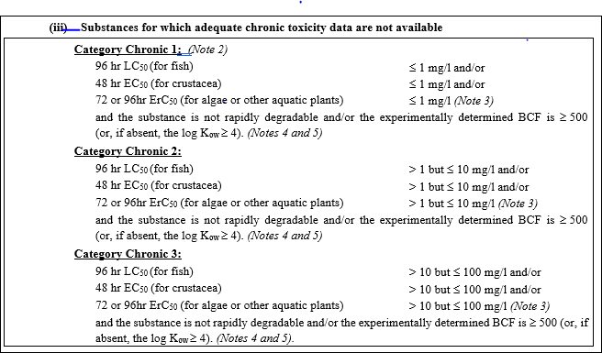
5. Thus, valid acute toxicity data together with information according to notes 4 and 5 concerning degradation and bioaccumulation is usable information and are sufficient “…to attribute a definitive hazard category to a relevant ingredient…” also with respect to chronic hazards in the absence of adequate chronic toxicity data.
6. Also, with respect to Category Chronic 4 a decision on classification or no classification is possible on the basis of information about acute toxicity, degradation and bioconcentration (table 4.1.1 (c)).
7. This procedure is also described in 4.1.2.7: “…Chronic toxicity data are not available for many substances, however, and in those cases it is necessary to use the available data on acute toxicity to estimate this property. The intrinsic properties of a lack of rapid degradability and/or a potential to bioconcentrate in combination with acute toxicity may be used to assign a substance to a long-term (chronic) hazard category….”
8. Furthermore, decision logics 4.1.3 (a) and (b) also use information about acute toxicity, degradation and bioaccumulation in order to classify definitively chronic hazards.
9. It is also worth noting that other regulatory texts, e.g.: the European Union’s Classification, Labelling and Packaging Regulation (CLP Regulation) uses the wording “hazard..” instead of “…toxicity” in the first sentence of 4.1.3.6.
Proposal
10. The Sub-Committee is invited to consider the following amendment to the first sentence in 4.1.3.6.
4.1.3.6 Amend the first sentence in 4.1.3.6 as follows (modifications are shown in track-changes mode):
“In the event that no useable information on short-term (acute) and/or long term (chronic) aquatic hazard is available for one or more relevant ingredients, it is concluded that the mixture cannot be attributed to a definitive hazard category.”

