|  |  |  |  |
| --- | --- | --- | --- |
|  | United Nations | ECE/TRANS/WP.29/GRSG/2024/38 | |
| _unlogo | **Economic and Social Council** | | Distr.: General  22 July 2024  Original: English |

**Economic Commission for Europe**

Inland Transport Committee

**World Forum for Harmonization of Vehicle Regulations**

**Working Party on General Safety Provisions**

**128th session**

Geneva, 7-11 October 2024

Item 7 of the Provisional Agenda

**UN Regulation No. 73 (Lateral Protection Devices)**

Proposal for the 02 Series of Amendments to UN Regulation No. 73 (Lateral Protection Devices)

Submitted by the expert from Japan[[1]](#footnote-2)\*

The text was reproduced below was prepared by the experts from Japan to amend UN Regulation No. 73 for adding some safety requirements. The modifications to the existing text of the UN Regulation are marked in bold for new or strikethrough for deleted characters.

**I. Proposal**

*Paragraphs 1.1.1. to 1.1.3., footnote 1,* amend to read:

"1 As defined in the Consolidated Resolution on the Construction of Vehicles (R.E.3.), document ECE/TRANS/WP.29/78/Rev.7. - <https://unece.org/transport/vehicle-regulations/wp29/resolutions>"

*Paragraphs 1.2. to 1.2.1.,* shall be deleted.

*Paragraph 5.1.2., amend to read:*

"5.1.2. **An approval number shall be assigned to each type approved in accordance with Schedule 4 of the Agreement (E/ECE/TRANS/505/Rev.3).** "

*Paragraph 5.1.4.1., footnote 2,* amend to read:

"2 The distinguishing numbers of the Contracting Parties to the 1958 Agreement are reproduced in Annex 3 to the Consolidated Resolution on the Construction of Vehicles (R.E.3), document ECE/TRANS/WP.29/78/Rev.7. - <https://unece.org/transport/vehicle-regulations/wp29/resolutions>"

*Paragraph 5.2.2*.,amend to read:

"5.2.2. **An approval number shall be assigned to each type approved in accordance with Schedule 4 of the Agreement (E/ECE/TRANS/505/Rev.3).** "

*Paragraph 5.3.2.,* amend to read:

"5.3.2. **An approval number shall be assigned to each type approved in accordance with Schedule 4 of the Agreement (E/ECE/TRANS/505/Rev.3).** "

*Insert new paragraphs 11.5. to 11.10.*, to read:

"**11.5. As from the official date of entry into force of the 02 series of amendments, no Contracting Party applying this Regulation shall refuse to grant or refuse to accept type-approvals under this Regulation as amended by the 02 series of amendments.**

**11.6. As from 1 September [2031], Contracting Parties applying this Regulation shall not be obliged to accept type-approvals to the preceding series of amendments, first issued after 1 September [2031].**

**11.7. Until 1 September [2034], Contracting Parties applying this Regulation shall accept type-approvals to the preceding series of amendments, first issued before 1 September [2031].**

**11.8. As from 1 September [2034], Contracting Parties applying this Regulation shall not be obliged to accept type-approvals issued to the preceding series of amendments to this Regulation.**

**11.9. Notwithstanding paragraph 11.8. above, Contracting Parties applying this Regulation shall, with respect to vehicles, components or separate technical units not affected by the modifications introduced by the 01 series of amendments, shall continue to accept type approvals issued in accordance with the 01 series of amendments to this Regulation.**

**11.10. Notwithstanding the transitional provisions above, Contracting Parties whose application of this Regulation comes into force after the date of entry into force of the most recent series of amendments are not obliged to accept approvals which were granted in accordance with any of the preceding series of amendments to this Regulation.**"

*Paragraph 12.8.,* amend to read:

"12.8. The lower edge of LPD shall at no point be more than ~~550mm~~ **450 mm** above the ground."

*Paragraphs 12.9. to 12.9.2.*, amend to read:

"12.9. The upper edge of LPD shall not be more than 350 mm below that part of the structure of the vehicle, cut or contacted by a vertical plane tangential to the outer surface of the tyres, excluding any bulging close to the ground **(see Figure 1 below)**, except in the following cases:

**Figure 1**

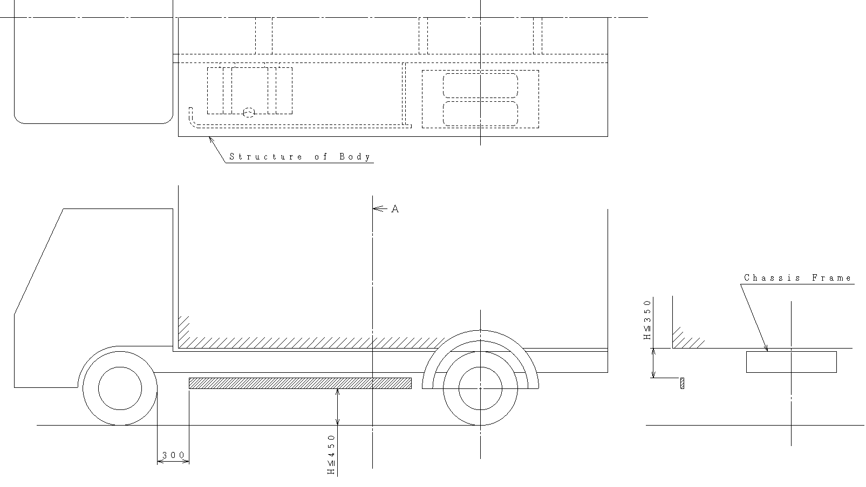

Chassis frame

Structure of the body

12.9.1. Where the plane in paragraph 12.9. does not cut the structure of the vehicle **or cuts the structure of the vehicle at a level more than 1.3 m above the ground, then the upper edge shall not be less than,** ~~then the upper edge shall be level with the surface of the load-carrying platform, or~~950 mm above the ground **(see Figure 2 below)**;

**Figure 2**

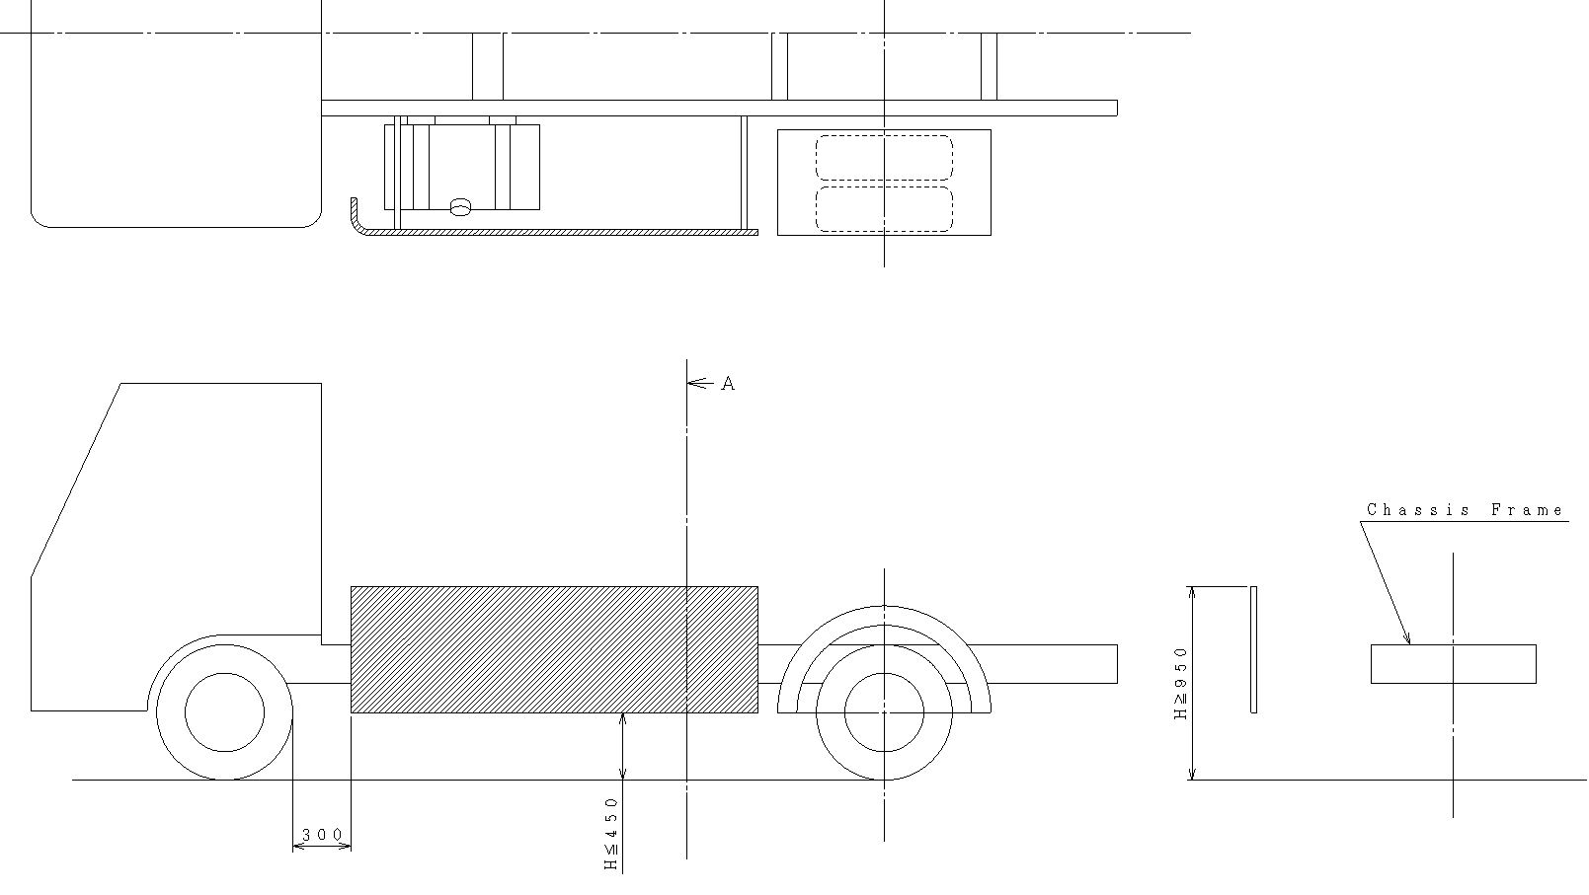

Chassis frame

12.9.2. ~~Where the plane in paragraph 12.9. cuts the structure of the vehicle at a level more than 1.3 m above the ground, then the upper edge of the device shall not be less than 950 mm above the ground;~~

**The upper edge of LPD is [650] mm above the ground, be level with the surface of the chassis frame, whichever is less, and the structure is designed to prevent cyclists from falling under the vehicle fly over the LPD (see Figure 2 below).**

**The fall prevention shall be demonstrated by the structure not allowing the [450] mm sphere to fall to the ground from the area enclosed by the LPD, chassis frame, and fender.**

**Other methods may be adopted to comply with this requirement if a manufacturer so requests. The sufficiency of the fall prevention method shall be established to the satisfaction of the Technical Service.**

**Figure 3**

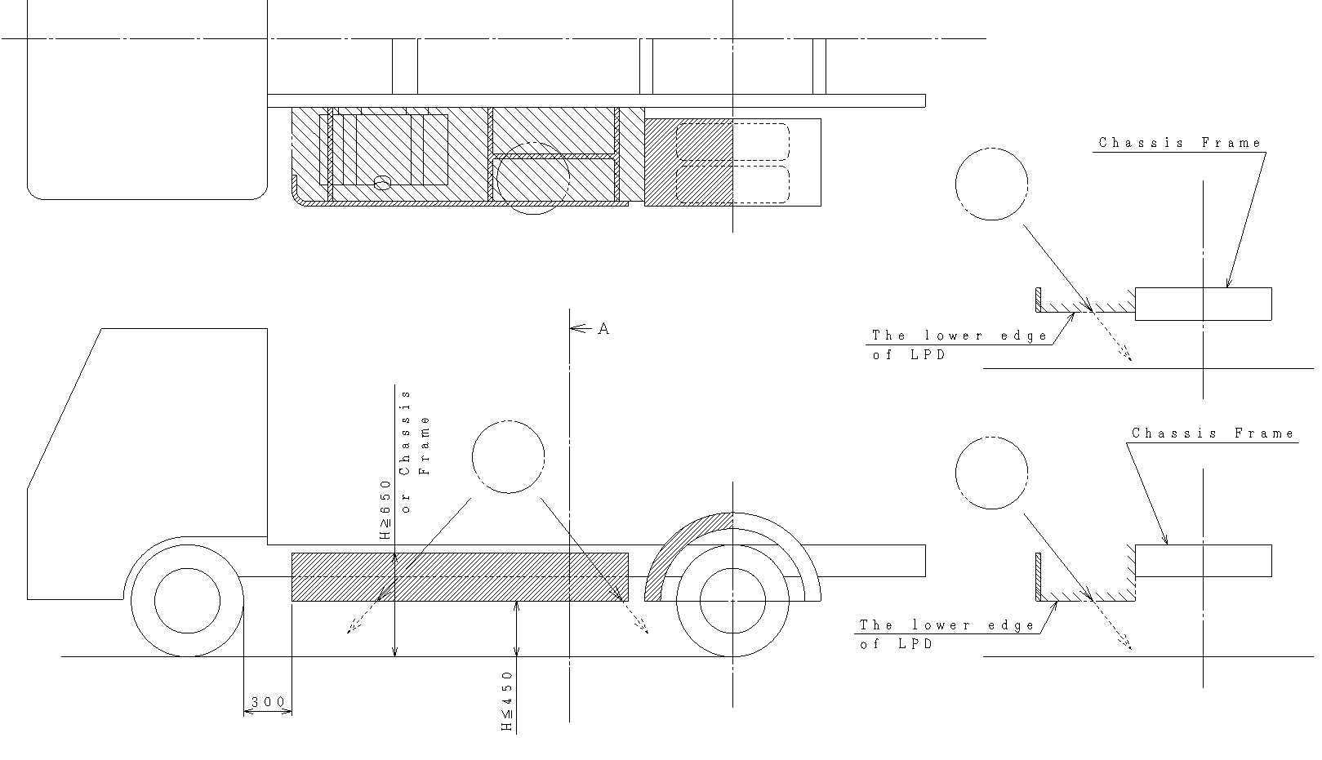"

of chassis frame

The lower edge of LPD

The lower edge of LPD

Chassis frame

Chassis frame

*Paragraph 12.9.3.*, shall be deleted

*Paragraph 12.9.4., renumber as paragraph 12.9.3.*

*Insert new paragraph 13.1.6.,* to read:

"**13.1.6. On a vehicle fitted with Blind Spot Information System, making it impracticable to comply with all the requirements of paragraph 12., LPD may be arranged with additional gaps where these are necessary to comply with the requirements for them.**"

*Paragraph 15.6.,* amend to read:

"15.6. The lower edge of LPD shall at no point be more than ~~550mm~~ **450 mm** above the ground."

*Paragraphs 15.7. to 15.7.2.,* amend to read:

"15.7. The upper edge of LPD shall not be more than 350 mm below that part of the structure of the vehicle, cut or contacted by a vertical plane tangential to the outer surface of the tyres, excluding any bulging close to the ground **(see Figure 1)**, except in the following cases:

15.7.1. Where the plane in paragraph 15.7. does not cut the structure of the vehicle **or cuts the structure of the vehicle at a level more than 1.3 m above the ground, then the upper edge shall not be less than,** ~~then the upper edge shall be level with the surface of the load-carrying platform, or~~950 mm above the ground **(see Figure 2)**;

15.7.2. ~~Where the plane in paragraph 15.7. cuts the structure of the vehicle at a level more than 1.3 m above the ground, then the upper edge of the device shall not be less than 950 mm above the ground;~~

**The upper edge of LPD is [650] mm above the ground, be level with the surface of the chassis frame, whichever is less, and the structure is designed to prevent cyclists from falling under the vehicle fly over the LPD (see Figure 3).**

**The fall prevention shall be demonstrated by the structure not allowing the [450] mm sphere to fall to the ground from the area enclosed by the LPD, chassis frame, and fender.**

**Other methods may be adopted to comply with this requirement if a manufacturer so requests. The sufficiency of the fall prevention method shall be established to the satisfaction of the Technical Service."**

*Paragraph 15.7.3.*, shall be deleted

*Paragraph 15.7.4.,* renumber as *paragraph 15.7.3.*

*Paragraph 15.7.3.(new),* amend to read:

"15.7.3. On a vehicle fitted with a crane for loading, unloading or other operations, having a permanently fitted ~~operator~~ **operator's** workstation or operating platform from which the crane may be controlled, the upper edge of the LPD may be determined in accordance with paragraphs ~~12.9.1.~~ **15.7.1.** and ~~12.9.2.~~ **15.7.2.**, the workstation or operating platform being considered as if it was the load carrying platform."

*Insert new paragraph 16.1.6.,* to read:

"**16.1.6. On a vehicle fitted with Blind Spot Information System, making it impracticable to comply with all the requirements of paragraph 12., LPD may be arranged with additional gaps where these are necessary to comply with the requirements for them.**"

*Annex 2,* amend to read *(01→ 02):*

"**Annex 2**

**Arrangements of Approval Marks**

**Model A**

(see paragraphs 5.1.4. and 5.3.4. of this Regulation)

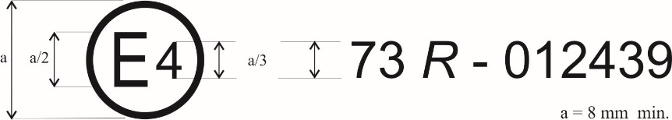

73 *R* - 022439

The above approval mark affixed to a vehicle or to an LPD shows that the vehicle type concerned has, with regard to its lateral protection, been approved in the Netherlands (E 4) pursuant to Regulation No. 73 under approval number ~~012439~~ **022439** as a complete vehicle. The first two digits of the approval number indicate that the approval was granted in accordance with the requirements of Regulation No. 73 as amended by the ~~01~~ **02** series of amendments.

**Model B**

(see paragraph 5.2.4. of this Regulation)



73 *R* - 022439

The above approval mark affixed to an LPD shows that the LPD type concerned has, with regard to its lateral protection, been approved in the Netherlands (E 4) pursuant to Regulation No. 73 under approval number ~~012439~~ **022439**. The first two digits of the approval number indicate that the approval was granted in accordance with the requirements of Regulation No. 73 as amended by the ~~01~~ **02** series of amendments.

**Model C**

(see paragraphs 5.1.5. and 5.3.5. of this Regulation)

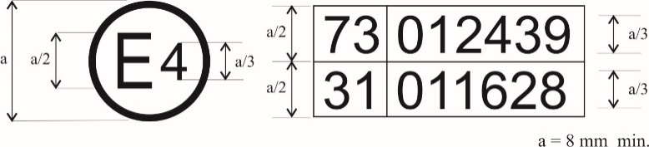

022439

021628

021628

The above approval mark affixed to a vehicle shows that the vehicle type concerned has been approved in the Netherlands (E 4) pursuant to Regulations Nos. 73 and 31[[2]](#footnote-3). The first two digits of the approval numbers indicate that, at the dates when the respective approvals were granted, Regulation No. 73 included the ~~01~~ **02** series of amendments and the approval was granted for a completed vehicle, and Regulation No. 31 included the ~~01~~ **02** series of amendments."

II. Justification

A. Deletion of Former Paragraphs 1.2. to 1.2.1.

1. LPD must be installed on tractors where the components are located within the overall width of the vehicle due to the design or installation of the side of the vehicle, as specified of tractors for semi-trailers.

B. Amendments of Paragraphs 12.8. and 15.6.

2. An investigation and analysis of bicycle accidents in Japan has shown that when the height of LPD at the lower end is 550 mm or less from the ground, the cyclist falls to the side of the vehicle (safety standard: the height of the lower end of LPD is 450 mm or less from the ground), and the cyclist falls directly under the vehicle, which is pulled by the wheels, increasing injury.

C. Amendments of Paragraphs 12.9.1., 12.9.2., 15.7.1. and 15.7.2.

3. Proposals for clarification of top side protection.

D. Deletion of Former Paragraphs 12.9.3. and 15.7.3.

4. Prevents cyclists from crossing the LPD and entering the underbody of the vehicle.

5. A vehicle with a removable container or a body system may be driven on public roads without the container or body.

E. Insert New Paragraphs 13.1.6. and 16.1.6.

6. Additional requirements for LPD installation on vehicles equipped with blind spot information systems are specified.

F. Amendment of Former Paragraph 15.7.4.

7. Correction of references and typos.

G. Amendment of Annex 2

8. Aligned with the 02 series of amendments.

1. \* In accordance with the programme of work of the Inland Transport Committee for 2024 as outlined in proposed programme budget for 2024 (A/78/6 (Sect. 20), table 20.5), the World Forum will develop, harmonize and update UN Regulations in order to enhance the performance of vehicles. The present document is submitted in conformity with that mandate. [↑](#footnote-ref-2)
2. This latter number is given as an example only. [↑](#footnote-ref-3)