 | United Nations | INF.2
Economic Commission for Europe  ADN Administrative Committee  Thirty-second session  Geneva, 30 August 2024  Item 3 (b) of the provisional agenda  Matters relating to the implementation of ADN:  special authorizations, derogations and equivalents |  |  | 26 July 2024  Original: English
Request for a recommendation on the use of hydrogen fuel cells for the propulsion of the vessel “Antonie”
Transmitted by the Government of the Netherlands
Annexes to document ECE/ADN/2024/3

Annex I
Project description.
Basic description “Antonie”:
MS Antonie is an inland waterways dry cargo container vessel.
Main dimensions: Length: 135 m
Breadth: 11.45 m
Draught: 3.65 m
Tonnage: 4071 ton

1. The Antonie has been built for as specific route transporting salt from Delfzijl to Rotterdam Botlek. The vast majority of time the ship will sail the same route. Normal roundtrip will take approximately 5 days. Antonie has a 10 year contract with Nobian for this transport.
2. The ship is designed with one cargo hold and will be loaded and unloaded in a pre-defined sequence, this is designed to ensure bending moments do not get to high.
3. Ship will be executed as a double propelled vessel and fitted with two bow thrusters.
4. Ship is built as a complete double hull vessel according Class, ES-TRIN and ADN regulations. A exemption from CCNR was applied for and has been received. Regarding ADN regulations all prescriptions have been followed except for the flashpoint of the fuel.
5. The vessel will be fitted with Hydrogen electrical propulsion.
6. All Hydrogen equipment is situated on the foreship, all crew areas are situated on the aft ship, this to ensure sufficient safety distance.
7. Power/energy needed for the complete vessel (propulsion and hotel load) is generated by a Hydrogen Fuel Cell (300 kWh). Energy from the Fuel cell is stored in a battery pack, which feeds the complete ship.
8. Hydrogen is stored in three containers (MEGC’s), which are placed in the open air but which are surrounded by steel walls. See underneath the Main ship system overview.
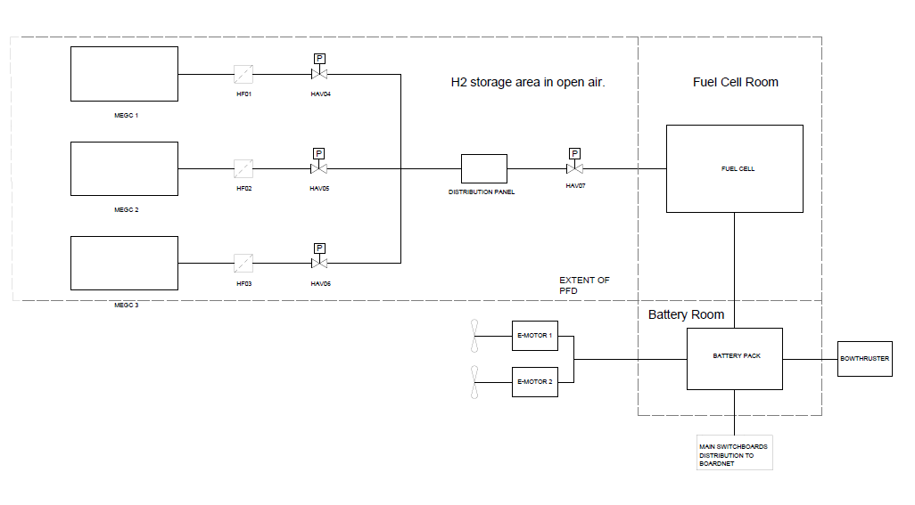
9. From the MEGC’s the hydrogen is distributed through a distribution panel to the Fuel Cell.

On the aft ship a backup, diesel driven, generator is fitted. In case of emergency, failure or additional power request, this generator can supply the necessary power and safety.
The Fuel cell is delivered by Koedood, the MEGC’s are delivered by H2TEC and the distribution panel is delivered by ECS. Mounting and connecting of all part is executed by CCM3 at the Yard in Werkendam.
The following safety measures regarding the Hydrogen installation are applied on the Antonie:
Fuel Cell room:
- Fuel cell placed in a steel room, which has been fitted with A60 insulation where necessary (between Fuel cell room and MEGC area, FC room and electrical room and between fuel cell room and forepeak). This to prevent fire or heat damaging the Fuel cell.
10. On the aft ship a backup, diesel driven, generator is fitted. In case of emergency, failure or additional power request, this generator can supply the necessary power and safety.
11. The Fuel cell is delivered by Koedood, the MEGC’s are delivered by H2TEC and the distribution panel is delivered by ECS. Mounting and connecting of all part is executed by CCM3 at the Yard in Werkendam.
12. The following safety measures regarding the Hydrogen installation are applied on the Antonie:
Fuel Cell room:
- Fuel cell placed in a steel room, which has been fitted with A60 insulation where necessary (between Fuel cell room and MEGC area, FC room and electrical room and between fuel cell room and forepeak). This to prevent fire or heat damaging the Fuel cell.
- Fuel cell room is fitted with redundant ventilation system, to ensure at least 30 air changes per hour. Under normal circumstances ventilation system is set at 15 air changes per hour.
- In case of leakage in the fuel cell room the ventilation is increased to 30 air changes. In case of fire in the Fuel Cell area (Non Hydrogen fire), ventilation is stopped (by the captain), ventilation ducts are closed and fire fighting system is activated.
- Hydrogen detection is fitted in the fuel cell room. This to ensure rapid detection is there is hydrogen leaking in the Fuel cell room. When hydrogen is detected the ventilation system will automatically ramp up.
- Heat and smoke detectors are fitted in the fuel cell room.
- Novec firefighting installation is fitted.
- Portable fire extinguisher mounted in fuel cell room.
- Water fire hose fitted in fuel cell room.
- Emergency shutdown with button. When emergency shutdown is activated, Hydrogen supply to Fuel cell is shut down (at MEGC’s) and ventilation is ramped up to 30 air changes per hour.
- Distance from openings and entrance of Fuel cell room to the cargo is > 7 m.
Battery room:
- Batteries stored in steel room, fitted with A60 insulation.
- Room fitted with heat and smoke detectors.
- Room fitted with sprinkler installation, for cooling purposes.
- Ventilation system is fitted in the battery room, in case of thermal runaway room can be ventilated.
- Emergency shutdown with button outside of battery room.
- Distance from openings en entrance of Battery room to the cargo hold is more than 6 m.
MEGC area:
- Open top to ensure natural ventilation.
- Surrounded by steel walls to protect MEGC’s from impact.
- Steel walls provide A0 protection.
- Wall between MEGC area and Fuel cell room A60 insulated.
- Deck between MEGC area and battery room A60 insulated.
- MEGC area fitted with sprinkler installation to cool surrounding surfaces.
- MEGC area fitted with flooding pipe, so the area can be fully filled with water.
- Earthing to ship.
- Twist locks to secure the MEGC’s to the ship.
- More than 1 m space between MEGC’s and the side of the ship.
- Smoke and heat detectors.
- Hydrogen detectors.
- Infrared detectors.
- Acoustic detectors to detect leakages in an early stage.
Transport of ADN goods.
13. Although the Antonie will be mainly sailing salt from Delfzijl to Rotterdam Botlek it is also fitted to be able to sail ADN goods. The Antonie is therefore built and outfitted according applicable ADN regulations.
14. During the HAZID the experts decided that there should be no interaction between ADN goods and the Hydrogen installation. From Hazid worksheet:
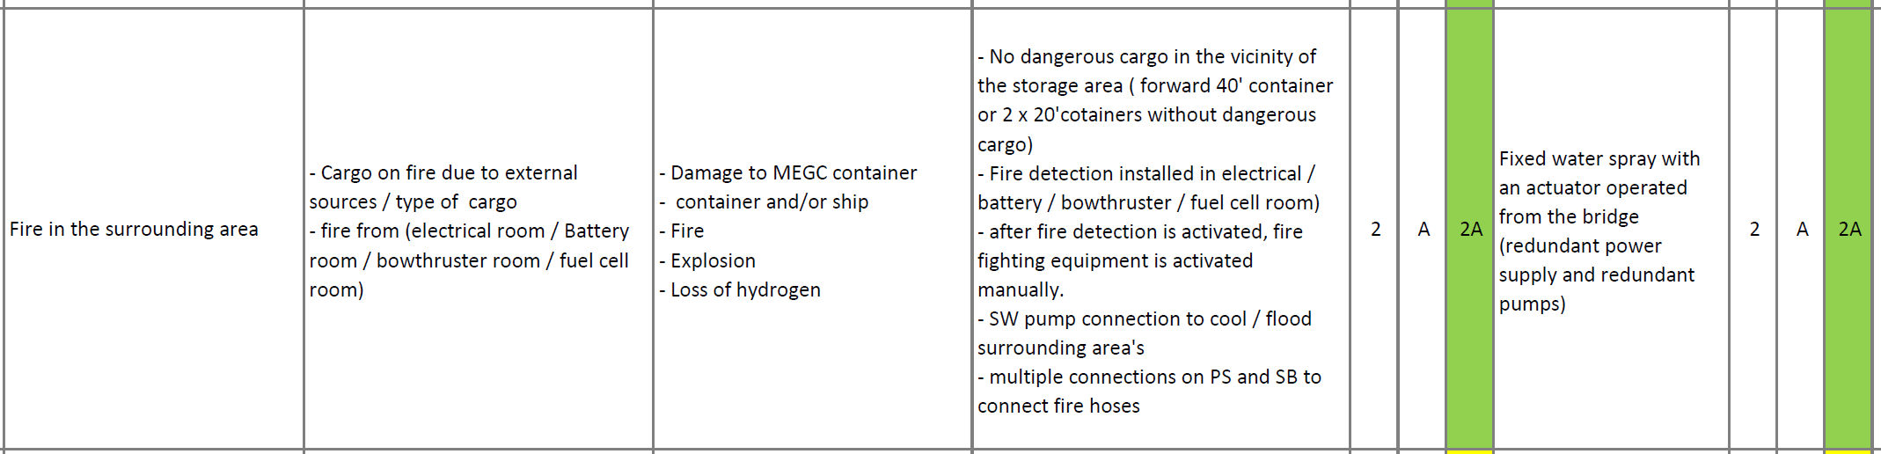
15. In principle there are two ways those to can interact, ADN goods can influence the Hydrogen installation and Hydrogen installation can influence the ADN goods. The established danger is fire of ADN goods or fire of Hydrogen installation.
16. To prevent fire to cause dangerous situations studies were made by HYEX and RINA. They calculated various possible scenarios which can be found in the reports they made (calculations regarding plumes and Heat radiation).
17. As a result of these studies the area in which no ADN containers can be placed was changed from two TEU to four TEU (approximately from 12 to 24 m).
18. Measures taken to prevent interaction between ADN goods and Hydrogen installation in case of fire:
- Steel wall between cargo hold and MEGC area to provide A0 protection.
- MEGC area fitted with sprinkler installation to cool surrounding surfaces, including the bulkhead mentioned in item 1.
- MEGC area fitted with flooding pipe, so the area can be fully filled with water, herewith also cooling steel bulkhead between cargo hold and MEGC area.
- Smoke and heat detectors in MEGC area so fire can be detected early.
- Infrared detectors to detect fires at an early stage.
- Acoustic detectors to detect leakages in an early stage.
- As a result of the Heat radiation calculation it was decided that no ADN goods are allowed in the first 24 m of the cargo area (see General Arrangement).
- Gangway of cargo area fitted with fire hose connections. With which a fire in the cargo hold can be extinguished, but also the bulkhead between cargo hold and MEGC area can be cooled.
Swapping of the containers.
19. On the Antonie the MEGC’s are not bunkered on board of the vessel. When the hydrogen containers are empty they will be swapped for full containers. Antonie has in total six MEGC’s, off which three are on board and three are on shore, while sailing the three on shore containers are filled at a land based station. For full procedure of swapping containers see the swapping procedure which has already been approved.
20. Basic safety regarding cargo is that it is not allowed to hoist the MEGC’s over the cargo area, also it is not allowed to hoist MEGC’s over each other. This to ensure that there is no interaction between ADN goods and the hydrogen containers.
21. Before hoisting all hydrogen systems are shut down.
Training personnel.
22. Personnel on the Antonie will be given two training courses:
(a) ADN basic training;
(b) Crew training zero-emission technology;
23. The ADN basic training, is a standard training, that will cover the following topics:
- ADN legislation for the transport of hazardous substances
- Construction and equipping
- Measuring techniques and sampling
- Knowledge of products
- Loading, unloading and transport
- Documents
- Hazards and precautionary measures
- Practical exercises
- Treating loading spaces and adjoining areas
- Treating loading tanks and adjoining areas
- Exposure to danger and precautionary measures
- Stability
23. The crew training “zero emission technology” is a tailor made training, especially for MS Antonie. This training has been surveyed and approved by Lloyd’s.
24. Zero emission technology training will cover the following topics:
- Familiarity with physical and chemical properties of fuels aboard ships subject to the ESTRIN and IGF Code.
- Operate the controls of fuel related to propulsion plant and engineering systems and services
- and safety devices on ships subject to the ESTRIN and IGF Code.
- Plan and monitor safe bunkering, stowage and securing of the fuel on board ships subject to the ESTRIN and IGF Code.
- Take precautions to prevent pollution of the environment from the release of fuels found on ships subject to the ESTRIN and IGF Code.
- Monitor and control compliance with legislative requirements.
- Take precautions to prevent hazards.
- Apply occupational health and safety precautions and measures on board a ship subject to the ESTRIN and IGF Code.

Annex II
Antonie drawing
