UN/SCETDG/64/INF.60
Committee of Experts on the Transport of Dangerous Goods
and on the Globally Harmonized System of Classification
and Labelling of Chemicals
Sub-Committee of Experts on the Transport of Dangerous Goods 26 June 2024
Sixty-fourth session
Geneva, 24 June-3 July 2024
Item 6 (c) of the provisional agenda
Miscellaneous proposals for amendments to the Model Regulations
on the Transport of Dangerous Goods:
Portable tanks

Informal working group on portable tanks with shells made of fibre-reinforced plastics (FRP) intended for the transport of non-refrigerated liquefied gases

Terms of reference

Transmitted by the expert from the Russian Federation

Introduction
1. The Informal working group (IWG) is requested to develop requirements for the construction, testing, approval, inspection, and use of portable tanks with shells made of fibre-reinforced plastics (FRP) intended for the transportation of substances of class 2 (non-refrigerated liquefied gases)” based on:
- requests to industry;
- request to transport companies;
- request to scientific and research institutions.
2. The IWG should take into account:
(a) The definition of list of class 2 substances allowed for the transportation by FRP portable tanks.
(b) The evaluation of a performance equivalence with commonly used metal tanks intended for the transportation of substances of class 2 related to:
- stress and fatigue resistance for MAWP corresponding to T50 portable tank instruction;
- thermal compatibility of liner and FRP structural shell;
- gas permeability;
- aging;
- fire resistance; and
- impact resistance.
(c) Different materials for fibers and resins including new technologies.
(d) Different manufacturing techniques and performance evaluation methods.
(e) Existing regulations at international (RID, ADR) regional or national level.
(f) Specific periodic inspection needs including after repair.
3. The IWG should keep in mind the justification and illustration given in the annex to this informal document.

Annex

Justification and illustrations

1. Intergovernmental Panel on Climate Change, 2023*
1. The market for pressure vessels used to store zero-emission fuels such as compressed and renewable natural gas (CNG/RNG) is growing as industries seek to reduce CO₂ emissions and global warming. With the hottest temperatures recorded in 2023, global warming has already reached 1.1°C and emissions continue to rise. A 43% reduction is needed by 2030 to limit warming to 1.5°C.
2. RNG are seen as a key part of the energy mix needed to decarbonize transportation and hit zero-emission targets. The most mature and predominant storage systems for both of these fuels include Type 3 and 4 pressure vessels comprising carbon fiber/epoxy wrapped over an aluminum and plastic liner, respectively, using filament winding
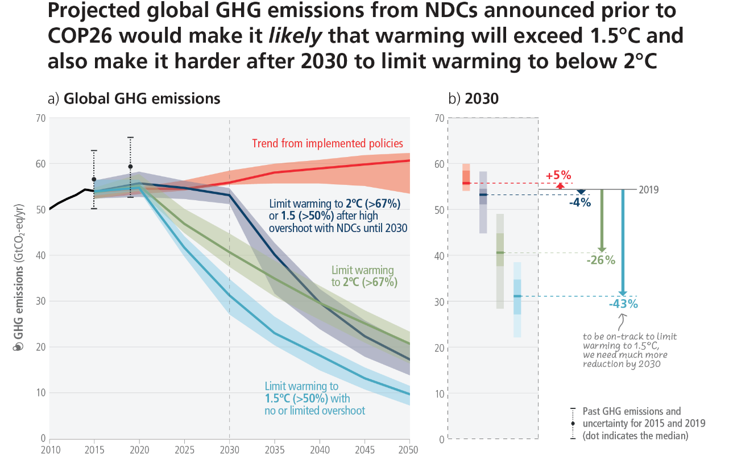

2. Composite pressure vessel commercial standards
3. Gas cylinders. Refillable composite reinforced tubes of water capacity between 450 L and 3000 L — design, construction and testing. Standard ISO FDIS 11515. Geneva, Switzerland: ISO; 2022.
4. Transportable gas cylinders. Fully wrapped composite cylinders, BS EN 12245. Brussels, Belgium: European Standards; 2022.
5. BPVC section X-fiber-reinforced plastic pressure vessels, BPVC-X. New York, NY, USA: ASME; 2021.
6. Gas cylinders. Design, construction and testing of refillable composite gas cylinders and tubes — Part 3: fully wrapped fibre reinforced composite gas cylinders and tubes up to 450 l with non-load-sharing metallic or non-metallic liners or without liners. Standard ISO 11119-3. Geneva, Switzerland: ISO; 2020.
7. Gas cylinders. Refillable permanently mounted composite tubes for transportation. Standard ISO/TS 17519. Geneva, Switzerland: ISO; 2019.
8. Standard: Space Systems. Composite overwrapped pressure vessels, ANSI/AIAA S- 081B, Reston, VA, USA: American Institute of Aeronautics and Astronautics; 2018.
9. Gas cylinders. Refillable composite gas cylinders and tubes — design, construction and testing — Part 3: fully wrapped fibre reinforced composite gas cylinders and tubes up to 450L with non-load-sharing metallic or non-metallic liners. Standard ISO 11119-3. Geneva, Switzerland: ISO; 2013.
10. Pressure vessels, AS 1210. Sydney, Australia: Standards Australia; 2021.
11. Filament-wound FRP pressure vessels. Materials, design, manufacturing and testing, BS EN 13923. Brussels, Belgium: European Standards; 2005.
12. Space systems - Pressure vessels and pressurized structures. Design and operation. Standard ISO 14623. Geneva, Switzerland: ISO; 2003.
13. Gas cylinders of composite construction. Specification and test methods — Part 3: fully wrapped fibre reinforced composite gas cylinders with non-load-sharing metallic or non-metallic liners. Standard ISO 11119-3. Geneva, Switzerland: ISO; 2002.

3. Examples of cutting-edge solutions

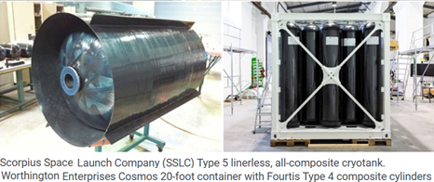
https://www.compositesworld.com/articles/composites-end-markets-pressure-vessels-(2024)
Automated fiber placement manufacturing of the 5.5 m diameter cryotank**
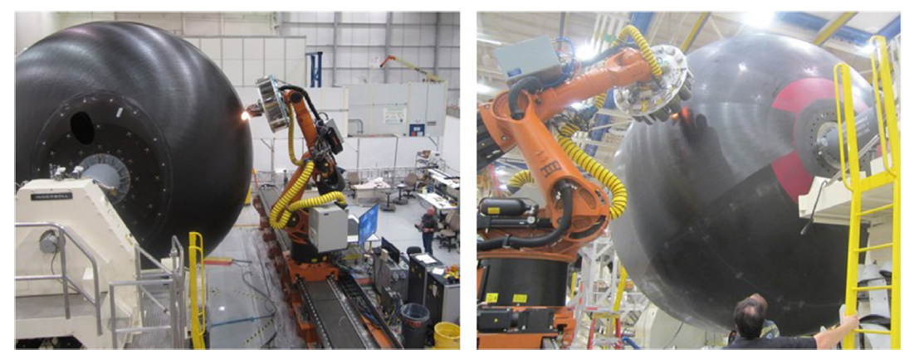 | 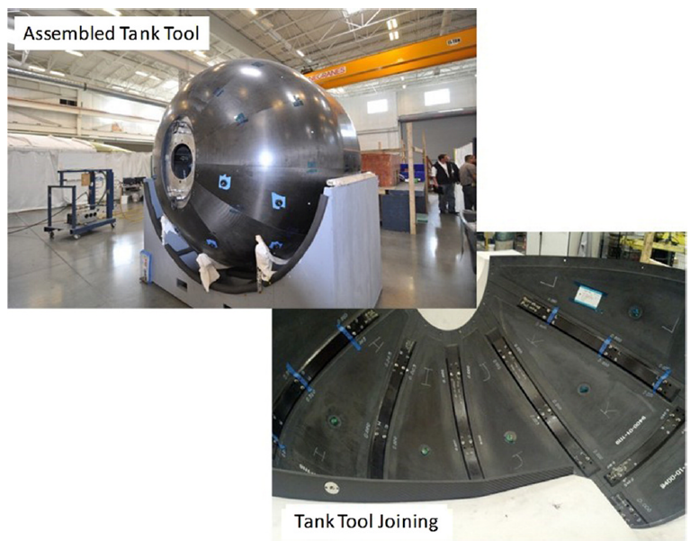

* IPCC, 2023: Climate Change 2023: Synthesis Report. Contribution of Working Groups I, II and III to the Sixth Assessment Report of the Intergovernmental Panel on Climate Change [Core Writing Team, H. Lee and J. Romero (eds.)]. IPCC, Geneva, Switzerland, pp. 35-115, doi:10.59327/IPCC/AR6-9789291691647.
** McCarville DA, Guzman JC, Dillon AK, Jackson JR, Birkland JO. Design, manufacture and test of cryotank components. In: Comprehensive composite materials II. second ed. Amsterdam, Netherlands: Elsevier; 2018. p. 153–79.

