UN/SCETDG/64/INF.54
Committee of Experts on the Transport of Dangerous Goods
and on the Globally Harmonized System of Classification
and Labelling of Chemicals
Sub-Committee of Experts on the Transport of Dangerous Goods 21 June 2024
Sixty-fourth session
Geneva, 24 June-3 July 2024
Item 2 (h) of the provisional agenda
Explosives and related matters:
Miscellaneous

Screening rules for estimating the SADT of 50 kg packages: Derivation under the Thomas model

Transmitted by the European Chemical Industry Council (Cefic)

I. Introduction
- In the December 2023 session, Cefic presented an informal document that introduced simple screening rules to determine if the estimated SADT for a substance is greater than 75 °C for a standard 50 kg package based on DSC measurements (informal document INF.42, sixty-third session). For the sixty-fourth session Cefic has already submitted a formal proposal for this concept following helpful comments from national and non-governmental organizations (document ST/SG/AC10/C3/2024/16).
- Derived from fundamental principles of thermal safety assuming zero-order kinetics for the decomposition reaction, these rules propose that the estimated SADT in a standard 50 kg package can be considered to be above 75 °C if:
  - the DSC-onset is equal to or higher than 175 °C (for liquids) or 200 °C (for solids), or
  - the isothermal heat flow at 75 °C is equal to or less than 100 mW kg⁻¹ (for liquids) or 50 mW kg⁻¹ (for solids).
- Comparison of these screening rules with measured data from over 300 compounds revealed no false negatives (i.e., a compound that would have incorrectly not been identified as a possible self-reactive although it met the conditions of the screening rules) and very few false positives (i.e., a compound incorrectly identified as a possible self-reactive). This comparison shows that these simple rules, together with the provisions in Appendix 6 of the Manuel of Tests and Criteria (MTC), would allow an efficient screening for compounds requiring further testing as potential self-reactive substances without compromising safe transport.
- These screening rules were derived assuming the Semenov model for heat flow, where the main resistance to heat flow is at the boundary of the package with the surroundings, and these calculations were presented for interested readers in both of the papers cited above.
- Strictly speaking, the Semenov model is generally only used to assess heat flow in liquids, although experience has shown that it can also be extended to solids in relatively small packages where a nearly uniform temperature profile can be assumed (see 28.1.1 of the MTC). To challenge this assumption, the screening rules for solids were also derived using the Thomas model for heat flow, where the resistance to heat flow is both from the package boundary and within the substance. This more rigorous consideration is presented here in support of our formal proposal.
- Gratifyingly, the results from these calculations are in excellent agreement with those from the simpler Semenov model and further support the proposed screening rules.

II. Derivation of the proposed screening rules (solids, Thomas Model)
- As outlined in the formal proposal document (ST/SG/AC10/C3/2024/16), derivation of the proposed screening starts with the ratio between the thermal relaxation time (τ_{relax}) and the adiabatic induction time (τ_{chem}). Unlike with the simpler Semenov model, this ration under the Thomas model is not assumed to be the inverse of Euler’s number, but rather is given by a more complicated equation considering thermal resistance in the bulk sold and the package geometry (e.g. an isometric cylinder, see DIN EN 15188).
$$\frac{τ_{relax}}{τ_{chem}}=\frac{0.8047}{0.2830+ \frac{0.7292}{Biot}}$$ |  | τ_{relax} | = | Thermal relaxation time (s)
 |  | τ_{chem} | = | Adiabatic induction time (s)
 |  | Biot | = | Biot number

- This equation contains a Biot number, which itself depends on the heat flow characteristics and the characteristic length of the package. The radius of an isometric cylinder (i.e., a barrel with equivalent height and diameter) can be taken as a conservative estimation of the characteristic length (i.e., the distance that heat must travel to escape the package). Assuming a bulk density of 600 kg m⁻³ for a typical solid, the radius of an isometric cylindrical 50 kg package is ca. 0.24 m. Further assuming a thermal conductivity of 0.15 W m⁻¹ K⁻¹ and an external heat transfer coefficient of 5 W m⁻² K⁻¹ as typical values then leads to a Biot number of ca. 7.9 for the 50 kg isometric cylindrical package.
$$Biot=\frac{αr}{λ}$$ |  | Biot | = | Biot number
 |  | $$λ$$ | = | Thermal conductivity (W m⁻¹ K⁻¹)
 |  | $$α$$ | = | External heat transfer coefficient (W m⁻² K⁻¹)
 |  | $$r$$ | = | Characteristic length of the package (m)

- Conservatively assuming zero-order kinetics for the decomposition reaction, the adiabatic induction time (τ_{chem}) can be calculated from the following equation, which is the same equation used previously under the Semenov model:
$$τ_{chem}=\frac{c_{p}∙R∙T^{2}}{E_{a}∙\dot{q_{T}}}$$ |  | τ_{chem} | = | Adiabatic induction time (s)
 |  | c_{p} | =̇ | Heat capacity (J kg⁻¹ K⁻¹)
 |  | R | = | Universal gas constant (8.314 J mol⁻¹ K⁻¹)
 |  | T | = | Temperature (K)
 |  | E_{a} | = | Activation energy (J mol⁻¹)
 |  | q̇_{T} | = | Specific heat release rate at temperature T (W kg⁻¹)

- Under the Thomas model, the equation for τ_{relax} changes to reflect the geometry of the package as well as heat flow parameters for the solid.
$$τ_{relax}=\frac{{r^{2}ρc}_{p}}{λ}$$ |  | τ_{relax} | = | Thermal relaxation time (s)
 |  | $$r$$ | = | Characteristic length of the package (m)
 |  | c_{p} | = | Heat capacity (J kg⁻¹ K⁻¹)
 |  | $$λ$$ | = | Thermal conductivity (W m⁻¹ K⁻¹)
 |  | $$ρ$$ | = | Bulk density (kg m⁻³)

- Finally, combining the three equations from paragraphs ‎7, ‎9, and ‎10 allows for a derivation of the critical heat flow that can lead to a thermal explosion.
$${\dot{q}}_{T}=\frac{R∙T^{2}}{E}∙\frac{λ}{r^{2}ρ}∙\frac{0.8047}{0.2830+\frac{0.7292}{Biot}}$$ |  | q̇_{T} | =̇ | Specific heat release rate at temperature T (W kg⁻¹)
 |  | E | = | Activation energy (J mol⁻¹)
 |  | R | = | Universal gas constant (8.314 J mol⁻¹ K⁻¹)
 |  | T | = | Temperature (K)
 |  | Biot | = | Biot number
 |  | $$λ$$ | = | Thermal conductivity (W m⁻¹ K⁻¹)
 |  | $$ρ$$ | = | Bulk density (kg m⁻³)
 |  | $$r$$ | = | Characteristic length of the package (m)

- Using the assumed values in paragraph ‎8, the equation in paragraph ‎11 then gives the following critical heat flows for solids for representative activation energies in a 50 kg isometric cylindrical package with an SADT of 75 °C (Table 1).
Table 1: Critical heat flow for solids with an SADT of 75 °C for a standard 50 kg package (Thomas model)
Activation Energy (kJ mol⁻¹) | 50 | 100 | 150 | 200
${\dot{q}}_{SADT}$ (mW kg⁻¹) | 193 | 96 | 64 | 48
Minimum heat flow highlighted in red

- Using the same procedure described before (see paragraphs 8-10 in Annex 1 of ST/SG/AC.10/C.3/2024/16), these calculated critical heat flows then lead to the following expected DSC-onset temperatures (Table 2):
Table 2: Predicted DSC-onset for solids with an SADT of 75 °C for a standard 50 kg package (Thomas model)
Activation Energy (kJ mol⁻¹) | 50 | 100 | 150 | 200
T_{DSC} (°C) | 203 | 139 | 118 | 108
Maximum DSC-onset highlighted in red

- Gratifyingly, the critical heat flows and DSC-onset temperatures predicted for solids under the Thomas approach are in very good agreement with those from the Semenov model (Table 3). Under this more rigorous treatment the critical onset is just above 200 °C, while the critical heat flow is slightly below 50 mW kg⁻¹. Exactly the opposite was observed with the simpler Semenov mode, where these values were slightly below 200 °C or slightly above 50 mW kg⁻¹ respectively. Within experimental error for modern devices these values are essentially the same, especially considering that the SADT is generally rounded off to the nearest multiple of five in the H-series tests. In view of the rather conservative assumptions grounding these theoretical calculations the screening rules can be viewed as safe criteria for screening potentially self-reactive substances.
Table 3: Comparison of the results for solids from the Thomas and Semenov models
 | Activation Energy (kJ mol⁻¹) | 50 | 100 | 150 | 200
${\dot{q}}_{SADT}$ (mW kg⁻¹) | Thomas model | 193 | 96 | 64 | 48
 | Semenov model | 222 | 111 | 74 | 56
T_{DSC} (°C) | Thomas model | 203 | 139 | 118 | 108
 | Semenov model | 198 | 136 | 117 | 107
Minimum heat flow and maximum DSC-onset highlighted in red

III. Sensitivity analysis for solids (Thomas model)
- The proposed DSC rule for solids derived under the Thomas model was subjected to a sensitivity analyse.
- Taking the assumed values for heat losses for the various variables in the equations (λ = 0.15 W m⁻⁻¹ K⁻¹, α = 5 W m⁻² K⁻¹, bulk density = 600 kg m⁻³, activation energy 100 kJ mol⁻¹) and the DSC-detection limit (20 W kg⁻¹), a DSC-onset temperature of ca. 140 °C can be calculated as a starting reference point for this analysis (black dash line). Systematically varying one of these variables while holding the others constant then leads to the following sensitivity plot for the screening rules for solids under the Thomas model (Figure 1).

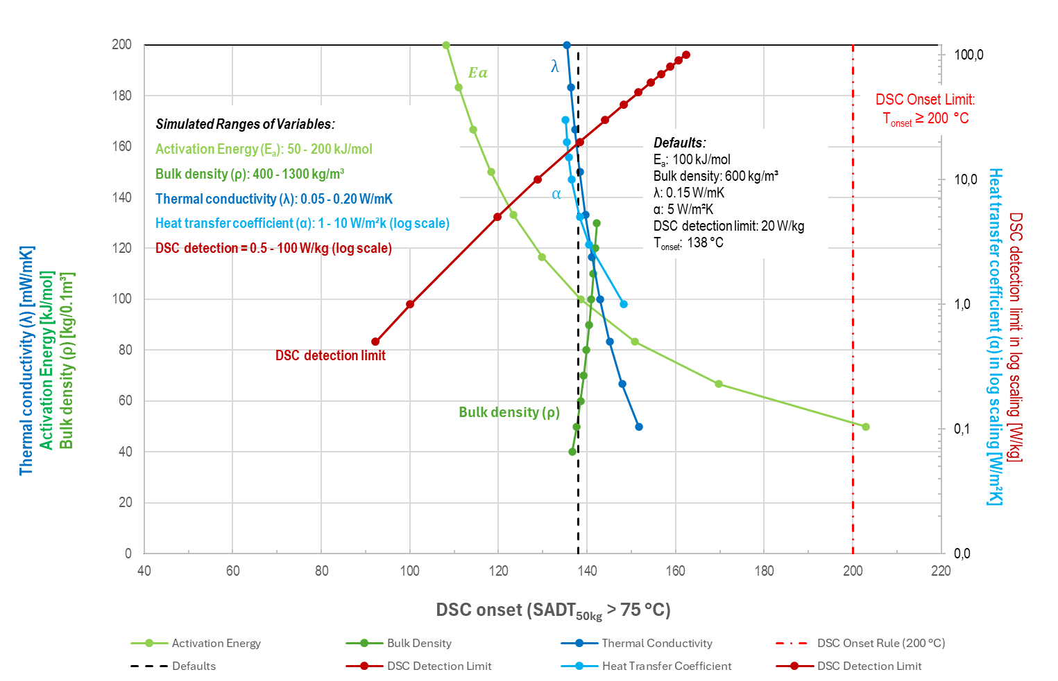
Figure 1: Sensitivity plot for the screening rules for solids
(Thomas model)

- Similar to the results from the Semenov sensitivity plot (see ST/SG/AC.10/C.3/2024/16), the sensitivity test revealed that the screening rules for solids as calculated under this more rigorous approach are sufficiently conservative versus variation in DSC-detection limit, and that the 200 °C limit would only be breached at exceptionally poor levels of detection (>> 100 W kg⁻¹). Interestingly, the derived DSC_{onset} is rather insensitive to the substance specific parameters (bulk density, thermal conductance and heat transfer), showing that these values are not decisive for the DSC_{onset} rule.
18. Keeping in mind that a survey of empirical data from over 300 samples revealed no example with an SADT less than 75 °C (as measured by any of the recommended methods in Test Series H) and a DSC-onset of greater than 150 °C (see ST/SG/AC.1/C.3/2024/16), these sensitivity analyses support the use of the proposed DSC-screening rules for excluding solid substances from classification as self-reactive according to the guidelines for classification described in Section 28 and Appendix 6 of the MTC.

