UN/SCETDG/64/INF.46
Committee of Experts on the Transport of Dangerous Goods
and on the Globally Harmonized System of Classification
and Labelling of Chemicals
Sub-Committee of Experts on the Transport of Dangerous Goods 21 June 2024
Sixty-fourth session
Geneva, 24 June-3 July 2024
Item 6 (d) of the provisional agenda
Miscellaneous proposals for amendments to the Model Regulations
on the Transport of Dangerous Goods:
Other miscellaneous proposals

Prohibited packagings for substances which may become liquid during transport – Additional proposals for document ST/SG/AC.10/C.3/2024/43

Transmitted by the experts from Germany and the Republic of Korea

I. Introduction
1. Packagings prohibited for use with substances that may become liquid during transport are specified in both provision 4.1.3.4 of the Model Regulations and the packing instructions. However, inconsistencies have been identified between the two provisions and the Republic of Korea submitted working document ST/SG/AC.10/C.3/2024/43 proposing an amendment to 4.1.3.4.
2. After the submission of the working document, Germany and the Republic of Korea identified further inconsistencies between provision 4.1.3.4 and packing instructions P002, P410, and LP02, leading to the submission of this document. Germany and the Republic of Korea hope to gather expert opinions during this session and are willing to supplement and submit the document as a working document for the next session of the Sub-Committee.
3. This document contains proposals to amend provision 4.1.3.4 to harmonize it with packing instructions P002, P410, IBC04, IBC05, IBC06, IBC07, IBC08 and LP02 to prevent confusion regarding the use of packagings for substances that may become liquid during transport and to ensure consistent application across multimodal transport regulations.

II. Explanation
4. Packagings prohibited for use with substances that may become liquid during transport are listed in provision 4.1.3.4 of the Model Regulations. However, some packagings not listed in 4.1.3.4 are mentioned in the footnotes of packing instructions P002 and P410.
5. Additionally, some footnotes of packing instruction P002 reference provision 4.1.3.4, but the prohibited packagings are not listed in the provision. This can cause confusion.
6. The following inconsistencies between provision 4.1.3.4 and P002 have been identified:
(a) According to the footnote (d) of packing instruction P002, single packagings 1A2, 1B2, 1N2, 1H2, 3A2, 3B2, and 3H2 cannot be used for substances of packing group I that may become liquid during transport and reference provision 4.1.3.4. However, these packagings are not listed in the provision, making it unclear whether their use is prohibited for substances of packing group I. Moreover, it is not clear, whether these packaging types approved for liquid transport are prohibited even if an according design type is approved for the transport of liquids.
(b) According to the footnote (e) of packing instruction P002, single packagings 4A, 4B, 4N, and 4H2, and composite packagings 6PH2 cannot be used for substances that may become liquid during transport, and provision 4.1.3.4 is referenced. However, these packagings are not listed in provision 4.1.3.4, making it unclear whether their use is prohibited.
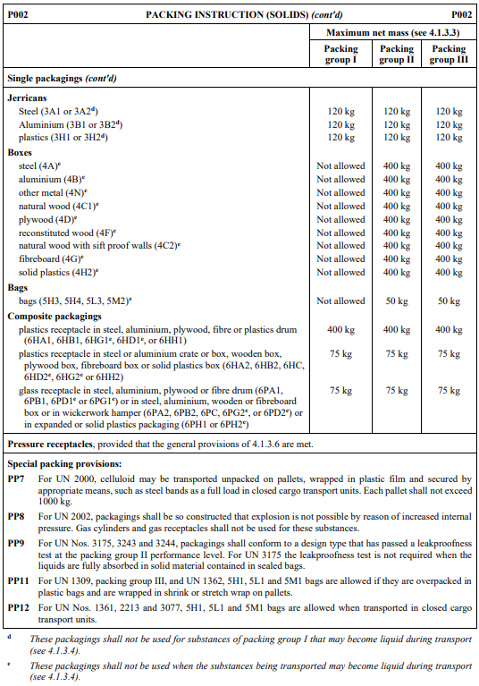
(c) According to provision 4.1.3.4, packagings 6HC, 6PC, and 6PH1 are prohibited for use with substances that may become liquid during transport. However, unlike other packagings, footnote (e) is not indicated for 6HC, 6PC, and 6PH1 of packing instruction P002, leading to potential misinterpretation that their use is permitted.

7. Additional necessary amendments have been identified in packing instructions P410, IBC04, IBC05, IBC06, IBC07, IBC08, and LP02, as follows:
(a) Packing instruction P410 lacks footnote (c) for all composite packagings, which may cause misinterpretation that their use is permitted for substances that may become liquid during transport.
(b) According to provision 4.1.3.4, any type of IBC cannot be used for substances of packing group I that may become liquid during transport. However, packing instructions IBC04 and IBC05, which can be allocated to substances of packing group I, do not include footnote (e) or additional requirements indicating this prohibition. Moreover, the regulation in 4.1.3.4 generally prohibits the use of IBCs for substances of packing group I, which includes IBCs approved for the transport of liquids (code 31) in IBC04, IBC05, IBC06, IBC07 and IBC08.
(c) Provision 4.1.3.4 prohibits the use of large packaging 51H (outer packagings) for substances that may become liquid during transport, but this prohibition is not reflected in the additional requirements or footnote (e) of packing instruction LP02. In addition, footnote (a) of LP02 refers to “packagings” whereas “inner packagings” are meant (see footnote (b) in P002 and footnote (b) in P410 for comparison).
8. Since the above-mentioned packing instructions specify compliance with the general provisions of 4.1.3, they should follow provision 4.1.3.4 even without specific mention in the footnotes or additional requirements of the packing instructions. However, the inconsistent reflection of prohibited packagings between 4.1.3.4 and the footnotes or additional requirements of P002, P410, IBC06, IBC07, and IBC08 can cause confusion. Therefore, amendments are needed to ensure consistency and correct application.
9. Comparing other transport regulations such as ADR, RID, and IMDG Code, provisions 4.1.3.4 of ADR and RID clearly list 4A, 4B, 4N, and 4H2 (not listing 6PH2) as prohibited for substances that may become liquid. In contrast, the Model Regulations and the IMDG Code do not list 4A, 4B, 4N, 4H2, and 6PH2 in provision 4.1.3.4.

III. Proposals
10. To prevent misinterpretation by transport stakeholders in applying the regulations, it is proposed to amend provision 4.1.3.4 to include all single packagings marked in footnote (d) or (e) of packing instruction P002. The amendment is as follows (new text in bold underline, deleted text in strikethrough):
“4.1.3.4 The following packagings shall not be used when the substances being transported are liable to become liquid during transport:
Single Ppackagings
For substances of packing group I, if approved for transport of solids only:
Drums: 1A2, 1B2, 1N2 and 1H2
Jerricans: 3A2, 3B2 and 3H2,
For substances of packing group I, II and III:
Drums: 1D and 1G
Boxes: 4A, 4B, 4N, 4C1, 4C2, 4D, 4F, 4G, and 4H1 and 4H2
Bags: 5L1, 5L2, 5L3, 5H1, 5H2, 5H3, 5H4, 5M1 and 5M2
Composite packagings: 6HC, 6HD2, 6HG1, 6HG2, 6HD1, 6PC, 6PD1,6PD2, 6PG1, 6PG2, and 6PH1 and 6PH2
…”
11. To allow (new text in bold underline):
“IBCs
For substances of packing group I: All types of IBCs, except they are approved for the transport of liquids and packing group I;”
12. To address the inconsistencies described in paragraphs 4 to 8 above, the following amendments to packing instructions P002, P410, IBC04, IBC05, and LP02 are proposed by inserting the existing additional requirements of packing instructions IBC06, IBC07 and IBC08:
(a) Delete the footnotes (d) and (e) of packing instruction P002 and add an additional requirement: "Where the solid may become liquid during transport, see 4.1.3.4."
(b) Delete the footnote (c) of packing instruction P410 and add an additional requirement: "Where the solid may become liquid during transport, see 4.1.3.4."
(c) Add an additional requirement into packing instructions IBC04 and IBC05: "Where the solid may become liquid during transport, see 4.1.3.4."
(d) Add an additional requirement into packing instruction LP02: "Where the solid may become liquid during transport, see 4.1.3.4."
(e) Add “inner” in the footnote (a) of LP02 before “packagings”.

