UN/SCETDG/64/INF.34
Committee of Experts on the Transport of Dangerous Goods
and on the Globally Harmonized System of Classification
and Labelling of Chemicals
Sub-Committee of Experts on the Transport of Dangerous Goods 18 June 2024
Sixty-fourth session
Geneva, 24 June-3 July 2024
Item 5 (c) of the provisional agenda
Transport of Gases:
Miscellaneous

Comments on updated ISO standards in Class 2 and document ST/SG/AC.10/C.3/2024/11

Transmitted by the expert from Germany

I. Introduction
1. ISO has submitted document ST/SG/AC.10/C.3/2024/11 and proposes updates for different standards. In this document Germany shares comments on proposals 1, 2, 3, 4, and 5 in document ST/SG/AC.10/C.3/2024/11.

II. Comments on proposal 1 in ST/SG/AC.10/C.3/2024/11
2. We share the opinion that acoustic emission testing (AT) is the most promising non-destructive examination (NDE) technique for the retesting of composite cylinders. In fact, we are of the opinion that the hydraulic proof testing has a very limited value when performed on composite cylinders and tubes when performed without any additional non-destructive testing (NDT) method. Therefore, a powerful NDT method should be developed and introduced into regulations. But we have some severe doubts that proposal 1 is an appropriate proposal for solving this.
3. ISO 23876:2022 as mentioned in proposal 1 shows two different approaches:
- 1st (ISO 23876:2022; 7.2.4.2 Method A) means a hydraulic testing up to test pressure PH.
- 2nd (ISO 23876:2022; 7.2.4.3 Method B) means a pneumatic pressurisation to a peak pressure level much less than the test pressure. (“If the previous maximum developed pressure experienced by the cylinder is not known, the AT test pressure is equal to either 76 % of the cylinder test pressure or 5 per cent above the cylinder’s maximum allowable developed pressure at 65 °C, whichever is greater.”)
4. While method A means that the mandatory hydraulic proof testing is performed and AT makes only additional information available, method B offers ample freedom of retesting with respect to the requested pressure level, traceability, reproducibility of generated data, as well as concerning level of obligation and accuracy of acceptance criteria that cannot be accepted on the basis of the provided rational.
5. Germany and some other countries have voted against this standard at ISO due to following reasons:
- This standard has a significant deficit concerning level of obligation of acceptance criteria for composite cylinders and tubes (COPVs). For a standardized and retraceable inspection, detailed acceptance or rejection criteria must be provided. In the standard, only non-binding examples are provided (see chapter 7.2.5 and (informative) Annex B).
- This standard has a significant deficit concerning reproduceable measurability of relevant values. For a standardized and retraceable inspection, reproduceable and measurable values must be provided. There is no mandatory calibration method provided for the sensors and AT equipment (chapter 7.2.2).
- It is indicated that mechanical impact was studied in the HyPactor project (which is the only source for data introduced in this standard). The consideration of other damage mechanisms, e.g. abrasion, localized heat, etc., is not included.
- The required testing and confirmation for using AT does not provide support for the scope of this standard. The failure mechanisms of type 5 cylinders are significantly different from the COPVs of the types 2 to 4, and as an internal visual inspection cannot inspect for the potential of leakage vulnerability in type 5 cylinders, failure via leakage in type 5 cylinders must be considered for the periodic inspection of COPVs.
6. To our experience the AT process as described in the standard ISO 23876:2022 is neither appropriate to replace the hydraulic pressure test of 6.2.1.6.1 (d) on its current safety level nor to solve the problem of labour safety during gaseous tests. Further work on non-destructive testing (NDT) technique is needed before it is ready for substituting the currently mandatory tests in the UN Model Regulations. There is a rapid development of this technique promising a much better safety level than proposed. Especially the reproducibility as well as the accuracy of NDT must be demonstrated on a much higher level, for a greater scope of cylinder types and for other and different failure mechanism.
7. Replacing the pressure test by a non-destructive examination technique based on an insufficiently detailed description of the process and acceptance criteria may cause safety issues in transport. The experience for the process described in ISO 23876:2022 is only limited to type 4 cylinders. Nevertheless, the scope covers nearly all types of composite cylinders and tubes (from type 2 to type 5). In addition, the demonstrated experience covers just a very limited number of possible defects and damages. Therefore, the resulting risks in appliance of this standards is not acceptable. Because the pressure test is one of the key tests for safety during testing and transportation, the substitutional measures requested in ISO 23876:2022 are not adequate. Proposal 1 of the document ST/SG/AC.10/C.3/2024/11 should not be accepted.

III. Comments on proposal 2 in ST/SG/AC.10/C.3/2024/11
8. The following paragraphs are included in ISO 11623:2023, chapter 9 “Pressure test”:
“In the case when a pneumatic pressure test is carried out, appropriate measures should be taken to ensure safe operation and to contain any energy that can be released.
WARNING — Appropriate measures shall be taken to ensure safe operation and to contain any energy that can be released. Pneumatic proof pressure tests require more precautions than hydraulic volumetric expansion tests, regardless of the size of the cylinder or tube. Errors in carrying out this test can lead to a rupture under gas pressure. Therefore, these tests shall be carried out only after ensuring that the safety measures adopted satisfy the safety requirements.
Special care shall be taken using air as the medium for the pneumatic pressure test due to the oxidizing potential of high-pressure air. At 300 bar¹⁾, the partial pressure of oxygen is approximately 60 bar.
Any cylinder failing to conform to the requirements of this test shall be rejected.
The pressure test may be replaced by a suitable non-destructive examination (NDE) technique (e.g. ISO 23876, ISO/TS 19016) with agreement between the manufacturer and the competent authority.
When a cylinder is used in an assembly in a protective frame, a pneumatic proof pressure test of the entire assembly may be conducted, where allowed by the competent authority of the country of use.”
9. According to 6.2.1.6.1 note 1 of the UN Model Regulations the hydraulic pressure test may be replaced by a test using gas only with the agreement of the competent authority. In addition, the replacement of the hydraulic by a pneumatic test according to note 1 keeps the request for demonstrating the pressure proof test. This is not reflected in the standard.
10. According to 6.2.1.6.1 (d) of the UN Model Regulations a hydraulic pressure test has to be done. A replacement is only allowed for seamless steel cylinders as defined in 6.2.1.6.1 note 2 of the UN Model Regulations. A general replacement of the pressure proof test of composite cylinders by a suitable non-destructive examination (NDE) technique with agreement between the manufacturer and the competent authority does not comply with the UN Model Regulations.
11. No requirements are defined to assess the suitability of non-destructive examination (NDE) techniques. Further essential requirements for a non-destructive examination (NDE) technique are needed in the UN Model Regulations to assess consistently the suitability of different technique in all countries.
12. According to chapter 7 of this standard an external visual inspection must be performed. Therefore, each cylinder shall be cleaned and have all loose foreign matter removed from its external surface by a suitable method (e.g. washing, light brushing, controlled water jet cleaning, plastic bead blasting). Consequently, there is no rational that the currently mandatory dismounting was neither unnecessary nor can be substituted by other tests. Even with respect to the check of the framework a dismounting is necessary. Additionally, a poorly tested assembly or a pneumatic proof pressure test of the entire assembly would be an unnecessary additional risk to be avoided. Considering that this new version is applicable for tubes with a water capacity of more than 450 l up to 3000 l, a pneumatic pressure test for tubes means a much higher potential consequence compared to a pneumatic pressure test for cylinders, which require already addition safety measures. Replacing the pressure test by a non-suitable non-destructive examination technique may cause safety issues in transport.
13. As the pressure test is one of the key tests and safety is impacted during testing and transportation accepting proposal 2 of the document ST/SG/AC.10/C.3/2024/11 is not appropriate. In case of referencing this revised standard, it must exclude several parts of the standard.

IV. Comments on proposal 3 in document ST/SG/AC.10/C.3/2024/11
14. In the standard ISO 4706:2023 the main changes are documented as follows:
- references have been updated;
- X-ray is required on three-piece designs;
- X-ray frequency has been changed from 50 to 250;
- criteria for X-ray retesting requirements have been added.
15. A comparison of the standards in the versions 2023 and 2008 shows additional changes, which are not minor.
16. In chapter 6 “Design” the requirement “A minimum pressure of 30 bar shall be used in the design of LPG cylinders.” is missing.
17. In chapter 7 “Calculation of minimum wall thickness (sidewall and ends)” the calculation of the guaranteed minimum sidewall thickness of the cylindrical shell is changed.

ISO 4706:2008:
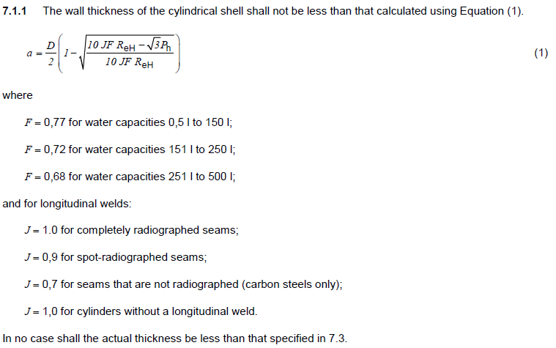

ISO 4706:2023:
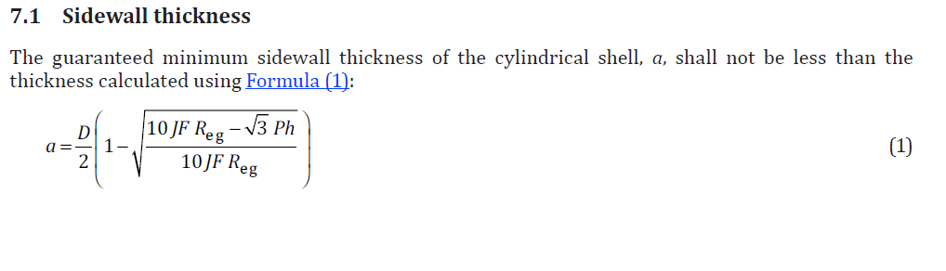
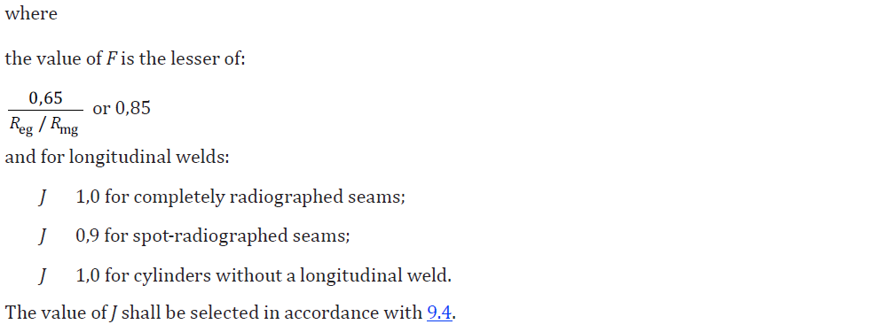
18. This change allows a reduction of the guaranteed minimum wall thickness for cylinders with a water capacity of 251 l to 500 l down to 80 % of the value according to ISO 4706:2008. The definition “J = 0,7 for seams that are not radiographed (carbon steels only)” is missing.
19. A reduction of the guaranteed minimum wall thickness is a major change which should be justified in detail before accepting proposal 3 of the document ST/SG/AC.10/C.3/2024/11.

V. Comments on proposal 4 in document ST/SG/AC.10/C.3/2024/11
20. The amendment to standard ISO 11119-2:2020 was implemented to align the criteria for cycling to 2/3 test pressure in 8.5.8.5.2 with the cycle testing requirements for cylinders, greater than 50 l water capacity, in 8.5.8.4.2. Chapter 8.5.8.5 addresses tubes over 150 l water capacity.
The standard ISO 11119-2:2020 paragraph 8.5.8.4.2 reads:
“The cylinders shall withstand 3000 pressurization cycles to 2/3 of the test pressure, ph, without failure by burst or leakage. The test shall continue for a further 9 000 cycles, or until the cylinder fails by leakage, whichever is the sooner. In either case, the cylinder shall be deemed to have passed the test. However, if failure during this second part of the test is by burst, then the cylinder shall have failed the test. […]”
and paragraph 8.5.8.5.2 reads:
“The tubes shall withstand 3000 pressurisation cycles at maximum developed pressure pmax without failure by burst or leakage. The test shall continue for additional cycles representing its specified lifetime, or until the tube fails by leakage, whichever is the sooner. In either case the tube shall be deemed to have passed the test. However, if failure during this second part of the test is by burst, then the tube shall have failed the test. […]”.
The amendment 1 to standard ISO 11119-2:2020 reads:
“8.5.8.5.2, first paragraph
Replace the paragraph with the following:
The cylinders shall withstand 3 000 pressurization cycles to 2/3 of the test pressure, ph, without failure by burst or leakage. The test shall continue for a further 9 000 cycles, or until the cylinder fails by leakage, whichever is sooner. In either case, the cylinder shall be deemed to have passed the test. However, if failure during this second part of the test is by burst, then the cylinder shall have failed the test.”
21. For safety during transport, cylinders and tubes shall be designed and tested to be loaded with a maximum developed pressure. Therefore, the minimum loading after a non-recognised impact damage e.g., initiated during mounting etc. must be at least the maximum developed pressure.
22. In opposite to this in this amendment the lower level of safety for cylinders has been transferred from cylinders to tubes. No reasons were presented to justify lowering the level of safety for tubes. An alignment of both paragraphs should be done by transferring the level of safety from tubes (testing to pmax) to cylinders and not vice versa.
23. The amendment to standard ISO 11119-2:2020 addresses tubes over 150 l water capacity. Consequently, the criteria in paragraph 8.5.8.5.2 should be defined for tubes as in standard ISO 11119-2:2020 and not for cylinders as ISO 11119-2:2020/Amd.1:2023.
24. The amendment could cause confusions and lowers the level of safety for tubes. We recommend asking ISO for correction before adoption of proposal 4 of the document ST/SG/AC.10/C.3/2024/11.

VI. Comments on proposal 5 in document ST/SG/AC.10/C.3/2024/11
25. Proposal 5 is very similar to proposal 4. So, the same argumentation leads to the conclusion: Chapter 8.5.9.5 addresses tubes over 150 l water capacity. Consequently, the criteria in paragraph 8.5.9.5.2 should be defined for tubes as in ISO 11119-3:2020 and not for cylinders as ISO 11119-3:2020/Amd.1:2023.
26. The amendment could cause confusions and lowers the level of safety for tubes. We recommend asking ISO for correction before adoption of proposal 5 of the document ST/SG/AC.10/C.3/2024/11.

