|  |  |  |  |
| --- | --- | --- | --- |
|  | United Nations | ECE/TRANS/WP.15/AC.2/2024/62 | |
| _unlogo | **Economic and Social Council** | | Distr.: General  12 June 2024  Original: English |

**Economic Commission for Europe**

Inland Transport Committee

**Working Party on the Transport of Dangerous Goods**

**Joint Meeting of Experts on the Regulations annexed to the   
European Agreement concerning the International Carriage   
of Dangerous Goods by Inland Waterways (ADN)  
(ADN Safety Committee)**

**Forty-fourth session**

Geneva, 26-30 August 2024

Item 4 (b) of the provisional agenda

**Proposals for amendments to the Regulations annexed to ADN:**

**other proposals**

Proposal for changing the explosion group for UN No. 2370 1-HEXENE in Table C

Submitted by the European Barge Union and the European Skippers Organization (EBU/ESO)[[1]](#footnote-2)\*, [[2]](#footnote-3)\*\*

|  |
| --- |
| *Summary* |
| **Related documents:** Informal documentINF.22of the forty-third session  ECE/TRANS/WP.15/AC.2/88(Paragraph 64) |
|  |

Introduction

1. A safe gap of 1-Hexene is not listed in the official database (Chemsafe) of the Physikalisch-Technische Bundesanstalt (PTB) and Bundesanstalt für Materialforschung (BAM). Therefore, PTB has been requested to determine the Maximum Experimental Safe Gap (MESG) of 1-Hexene.

Proposal

2. Based on the test results (as shown in the Annex), the MESG is equal to 0.88 mm and EBU/ESO proposes for UN No. 2370 1-HEXENE in Table C of Chapter 3.2 of ADN, to amend column (16) to read “II B (II B1)”.

Annex

[English/German only]

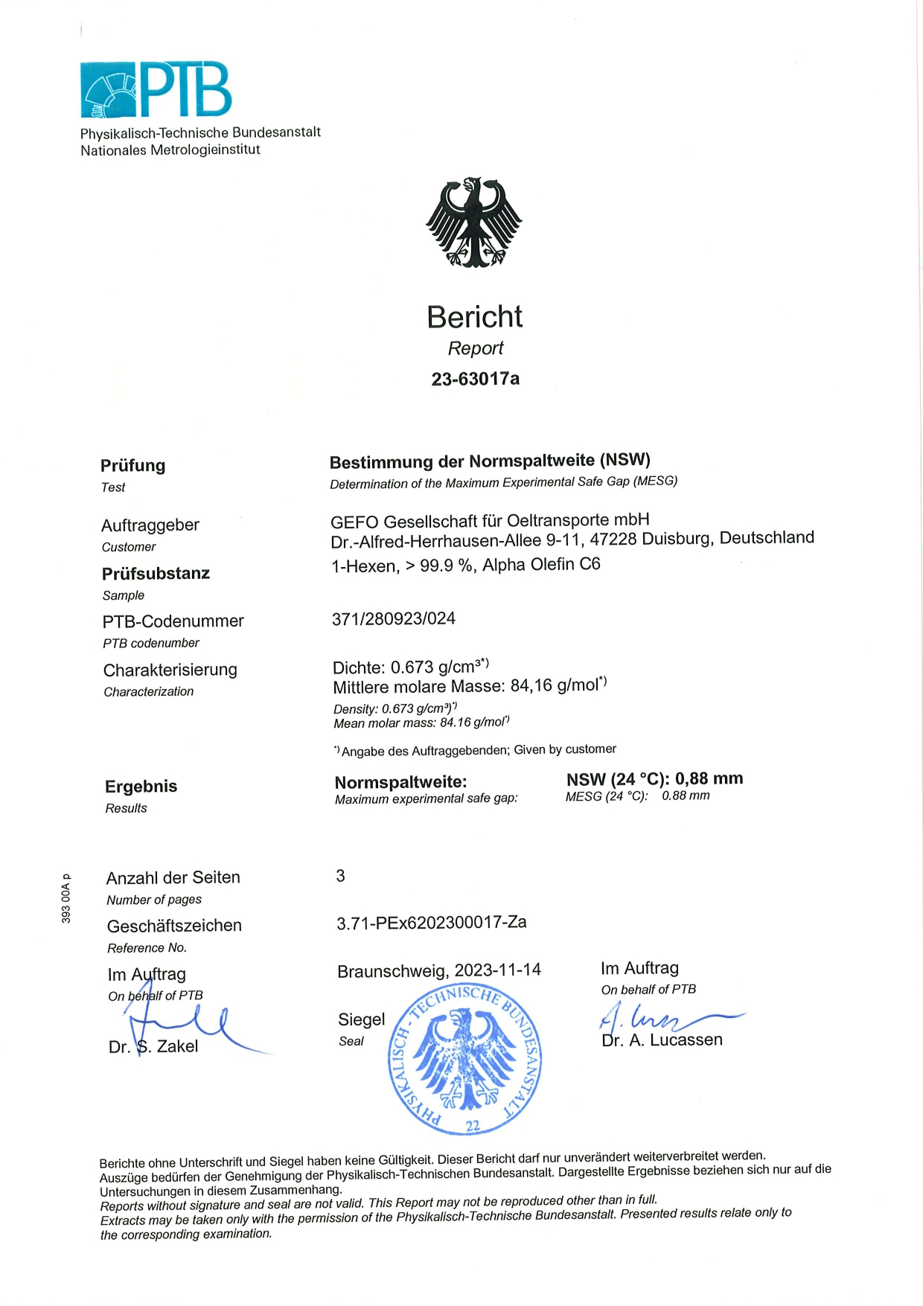

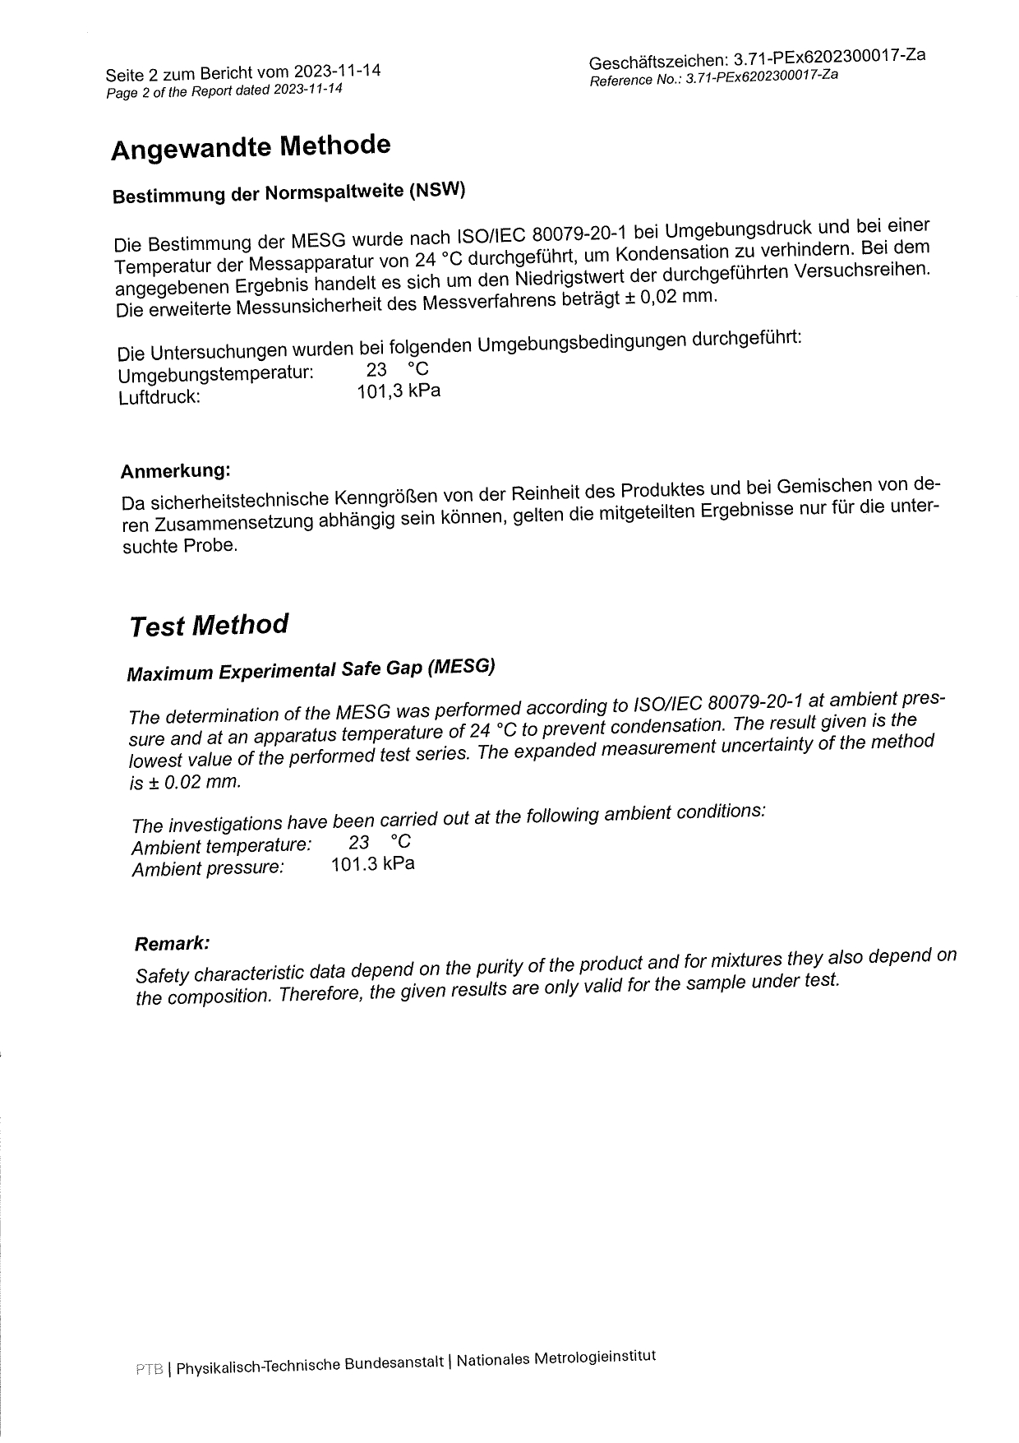

1. \* Distributed in German by the Central Commission for the Navigation of the Rhine under the symbol CCNR-ZKR/ADN/WP.15/AC.2/2024/62 [↑](#footnote-ref-2)
2. \*\* A/78/6 (Sect. 20), table 20.5 [↑](#footnote-ref-3)