|  |  |  |  |
| --- | --- | --- | --- |
|  | United Nations | ECE/TRANS/WP.15/AC.2/2024/59 | |
| _unlogo | **Economic and Social Council** | | Distr.: General  11 June 2024  Original: English |

**Economic Commission for Europe**

Inland Transport Committee

**Working Party on the Transport of Dangerous Goods**

**Joint Meeting of Experts on the Regulations annexed to the   
European Agreement concerning the International Carriage   
of Dangerous Goods by Inland Waterways (ADN)  
(ADN Safety Committee)**

**Forty-fourth session**

Geneva, 26-30 August 2024

Item 4 (b) of the provisional agenda

**Proposals for amendments to the Regulations annexed to ADN:**

**other proposals**

Proposal for amendments to 1.4.3.3 and 1.4.3.7.1 of ADN - Safety obligations of the main participants

Transmitted by European Barge Union and European Skippers Organisation (EBU/ESO) [[1]](#footnote-2)\*, [[2]](#footnote-3)\*\*

|  |
| --- |
| *Summary* |
| **Related documents:** Informal document INF.23 of the thirty-first session  ECE/TRANS/WP.15/AC.2/64(Paragraph 60)  Informal document INF.20 of the forty-first session  ECE/TRANS/WP.15/AC.2/84 (Paragraph 49)  Informal document INF.20 of the forty-second session  ECE/TRANS/WP.15/AC.2/86 (Paragraphs 67 to 70)  Informal document INF.25 of the forty-third session  ECE/TRANS/WP.15/AC.2/88 (Paragraph 64) |

Introduction

1. EBU/ESO would like to raise awareness and re-open discussions for a problem that was already addressed at the thirty-first session of the ADN Safety Committee in August 2017 (see informal document INF.23 of the thirty-first session), January 2023 (see informal document INF.20 of the forty-first session), August 2023 (see informal document INF.20 of the forty-second session) and January 2024 (see informal document INF.25 of the forty-third session).

2. The crewmembers are still confronted with the fact that loading arms/hoses are not (fully/efficiently) emptied and/or not being released from pressure before and/or after loading/discharging, which always leads to loss of containment; in several cases to environmental spills and/or exposure to the crewmembers. This is of great concerns of the barging industry and aim to improve safety regarding this integral part of the transport, physically connecting/disconnecting with fillers and unloaders.

3. During both the forty-first and forty-second session of the ADN Safety Committee EBU/ESO presented incident statistics, derived from the Platform Zero Incidents database, on the issue as described under paragraph 2 above. A description of the Platform Zero Incidents and an explanation of the number of registered incidents and near misses can be found in informal document INF.20 of the forty-second session of the ADN Safety Committee.

4. EBU/ESO would like to provide the ADN Safety Committee with this document an update on the incident statistics (see update incident statistics 2015 to 2024 in paragraph 6 below). In total more than 170 incidents are reported in the Platform Zero Incidents since 2015.

5. EBU/ESO is positive about how the industry is dealing with this issue in the Dutch context, where also the competent authority is involved. The problem has been recognized and a joint effort is underway to identify best practices to reduce the risk of exposure to crewmembers and the environment. Nevertheless, EBU/ESO still believes that an amendment in the ADN legislation is necessary to further protect crewmembers and the environment from exposure to dangerous goods.

6. More detailed information on the incidents from 2015 - 2023 and 2024 year to date are given in the Annexes I and II of this document.

Requests for amendments

7. Complying with the main general safety measures as set out in ADN 1.4.1.1:

"The participants in the carriage of dangerous goods shall take appropriate measures according to the nature and the extent of foreseeable dangers, to avoid damage or injury and, if necessary, to minimize their effects. They shall, in all events, comply with the requirements of ADN in their respective fields."

8. EBU/ESO requests the ADN Safety Committee to consider to add an obligation to 1.4.3.3 of ADN:

"1.4.3.3 ***Filler***

In the context of 1.4.1, the filler has the following obligations in particular:

…

*Obligations concerning the* ***filling of cargo tanks****:"*

Proposal 1

Add in 1.4.3.3:

"(l) Ascertain that the ship/shore connection(s) provided by him are sufficiently (adequately) drained of liquid and, if applicable, any overpressure is (has been) released. These measures are to be taken to ensure a safe connection/disconnection, before (prior to) connection/disconnection;"

Hence: letter (l) was already reserved for something in ADN 2023.

9. EBU/ESO also requests the ADN Safety Committee to consider adding an obligation to 1.4.3.7.1 of ADN:

"1.4.3.7 **Unloader**

1.4.3.7.1In the context of 1.4.1, the unloader shall in particular:

…

*Additional obligations concerning the* ***unloading of cargo tanks****;"*

**Proposal 2**

Add in 1.4.3.7.1:

"(n) Ascertain that the ship/shore connection(s) provided by him are sufficiently (adequately) drained of liquid and, if applicable, any overpressure is (has been) released. These measures are to be taken to ensure a safe connection/disconnection, before (prior to) connection/disconnection;"

10. Finally, EBU/ESO requests the ADN Safety Committee to address these obligations in the ADN Safety Checklist 8.6.3, as where the corresponding box shall be ticked off by the filler/unloader only.

**Proposal 3**

Add in 8.6.3:

Under part 6 "Vessel/shore connections" a new question could be added with the following text:

"Is it ensured that, before connecting/disconnecting, the shoreside loading arms and/or hoses are sufficiently (adequately) drained of liquid and any overpressure is being (has been) released?"

Sustainable Development Goals (SDG)

11. The SDG’s applicable to *workers health and wellbeing* (SDG 3) and *decent work* (SDG 8) are linked to this proposal. Spills to the environment need to be avoided, linked to *clean water* (SDG 6) and *life below water* (SDG 14).

Annex I

[English only]

Statistics Platform Zero Incidents 2015 to 2024

First Aid = First Aid injury, MTC = Medical Treatment Case, LWC = Lost Workday Case

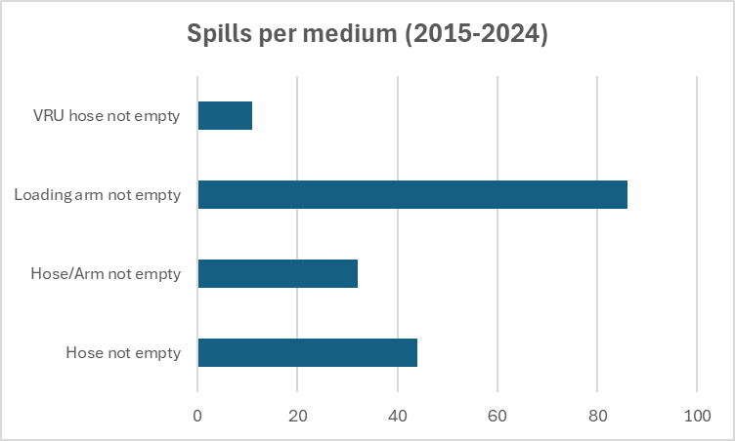

Annex II

[English only]

Explanatory text on incident statistics from informal document INF.20 of the forty-second session

1. The Platform Zero Incidents (PZI) started its activities in 2015. PZI strives to reduce the number of incidents by learning from near misses and incidents reported by its members. Between 2015 and 2023, more than 90 per cent of the inland tanker shipping sector has joined the initiative.

2. The incident statistics presented are derived from the PZI database.

Explanation Personal Injury: First aid = First Aid Cases | MTC = Medical Treatment Cases | LWC = Lost Work Cases

3. It should be emphasized that this concerns the incidents reported to PZI and therefore not the actual number of incidents in the period 2015-2023, this number is higher for the following reasons:

* At the start of PZI, approximately 30 per cent of the industry joined. Over time, this has increased to over 90 per cent of the industry. The number of reported incidents has therefore increased over the period.
* Willingness to report ships to operators due to different reasons, amongst others, risk normalisation. The issue described is a known and recognized problem in the industry. Over time it has become part of the process. As a result, there may be risk normalization, so that these types of incidents are no longer identified as incidents on both the shore and the ship side. Consequently, the incidents are not reported.
* Operators' willingness to report to the Platform Zero Incidents. There are differences between the various PZI members in terms of willingness to report.

4. The actual number of incidents is therefore probably several factors higher.

1. \* Distributed in German by the Central Commission for the Navigation of the Rhine under the symbol CCNR-ZKR/ADN/WP.15/AC.2/2024/59. [↑](#footnote-ref-2)
2. \*\* A/78/6 (Sect. 20), table 20.5 [↑](#footnote-ref-3)