Proposal for the 05 series of amendments to Regulation No. 100 (Electric power trained vehicles) [1]*

Submitted by the expert from Contracting Parties participated into SIG Thermal Propagation

The text reproduced below was prepared by the expert from [Australia], France, Germany, Japan, [Republic of Korea], the Netherlands, [the United Kingdom] and the European Commission, aiming for enabling the identification of vehicles approved using certain provision for thermal propagation as well as for proper treatment of intellectual properties of the manufacturers. The proposal is based on the outcome from special interest group on thermal propagation participated by the above Contracting Parties as well as the interested Technical Services, OICA, CLEPA and other entities not a member of these industry organizations. The modifications to the current text of the UN Regulation (including ECE/TRANS/WP.29/2024/41) are marked in bold for new or strikethrough for deleted characters.

I. Proposal

*Insert new paragraph 2.54.,* to read:

"**2.54. "*Common space*" means an area on which two or more information functions (e.g. symbol) may be displayed but not simultaneously.**"

*Insert new paragraphs 3.4. to 3.5.,* to read:

"**3.4. In cases where information is shown to be covered by intellectual property rights or to constitute specific know-how of the manufacturer or of their suppliers, the manufacturer or their suppliers shall make available sufficient information to enable the checks referred to in this Regulation to be made properly. Such information shall be treated on a confidential basis.**

**3.5. Documentation shall be made available in two parts:**

**(a) The formal documentation package for the approval, containing the material specified in Annex 1, Appendix 1 or Appendix 2 which shall be supplied to the Approval Authority or its Technical Service at the time of submission of the type approval application. This documentation package shall be used by the Approval Authority or its Technical Service as the basic reference for the approval process. The Approval Authority or its Technical Service shall ensure that this documentation package remains available for at least 10 years counted from the time when production of the vehicle/REESS type is definitively discontinued.**

**(b) Additional material relevant to the requirements of this Regulation may be retained by the manufacturer, but shall be made open for inspection at the time of type approval. The manufacturer shall ensure that any material made open for inspection at the time of type approval remains available for at least a period of 10 years counted from the time when production of the vehicle/REESS type is definitively discontinued.**"

*Paragraph 5.2.1.1.,* amendto read:

"5.2.1.1. For a REESS which has been type approved in accordance with Part II of ~~this series of Amendments to~~ this Regulation, it shall be installed in accordance with the instructions provided by the manufacturer of the REESS, and in conformity with the description provided in Annex 1, Appendix 2 to this Regulation. **In case that the component based test is performed for the verification of thermal propagation and thermal propagation occurred during the test, the additional test specified in paragraph 6.15.3.3.(a) shall be performed on the vehicle in accordance with Annex 9K, paragraph.7.** "

*Insert new paragraphs 5.2.1.1.1. to 5.2.1.1.1.3.,* to read:

"**[5.2.1.1.1. Requirements for the installation of type approved REESS**

**5.2.1.1.1.1. Structural compatibility**

**The type approved REESS to be installed shall be compatible with the design of a vehicle, inter alia it shall be adequately protected by parts of the frame or bodywork against contact with possible obstacles on the ground. Such protection shall not be required if the type approved REESS beneath the vehicle is further above the ground than the part of the frame or bodywork in front of it.**

**The cables and all other parts of the type approved REESS to be installed shall be accommodated on the vehicle at sites protected to the fullest possible extent. Twisting and bending movements, and vibrations of the vehicle's structure or drive unit, shall not subject the type approved REESS to be installed to friction, compression or any other abnormal stress.**

**The connections of the type approved REESS to be installed (e.g. the cooling system) shall be so designed and constructed as to remain leak-proof under the various conditions of use of the vehicle, despite twisting and bending movements and despite vibrations of the vehicle's structure or drive unit.**

**If the charging port is situated on the side of the vehicle, the lid of the charging port shall not, when closed, project beyond the adjacent surfaces of the bodywork.**

**5.2.1.1.1.2. Electrical installation**

**Electric cables and wires of the type approved REESS to be installed shall be attached to the vehicle's structure or walls or partitions near which they lead. The points at which they pass through walls or partitions shall be satisfactorily protected to prevent cutting of the insulation.**

**The electrical installation shall be so designed, constructed and fitted that its components are able to resist the corrosion phenomena to which they are exposed.**

**5.2.1.1.1.3. Communication between the on-board diagnostic system of a vehicle and the type approved REESS to be installed.**

**The installation of type approved REESS shall ensure communication between the on-board diagnostic system of a vehicle and the type approved REESS, which should be error-free and at the frequency required by the design of type approved REESS.]**"

*Paragraph 6.12.1.,* amendto read:

"6.12.1. Under vehicle operation including the operation with a failure, the vehicle occupants shall not be exposed to any hazardous environment **inside the passenger compartment** caused by emissions from REESS."

*Paragraph 6.12.1.,* amendto read:

"[6.12.3. For REESS other than open-type traction battery, the requirement of paragraph 6.12.1. is deemed to be satisfied, if all applicable requirements of the following tests are met: paragraph 6.2. (vibration), paragraph 6.3. (thermal shock and cycling), paragraph 6.6. (external short circuit protection), paragraph 6.7. (overcharge protection), paragraph 6.8. (over-discharge protection), paragraph 6.9. (over-temperature protection)**,** ~~and~~ paragraph 6.10. (overcurrent protection) **and paragraph 6.15. (thermal propagation)**.]"

*Paragraphs 6.15. to 6.15.2.4.3.,* amendto read and remove footnote:

"6.15. Thermal propagation.

For a REESS containing flammable electrolyte [**and/or alkaline metal anode**], the vehicle occupants shall not be exposed to any hazardous environment caused by thermal propagation which is triggered by an internal short circuit leading to a single cell thermal runaway. To ensure this, the requirements of paragraphs 6.15.1. and 6.15.2. shall be satisfied **in accordance with the verification procedure described in paragraph 6.15.3.**~~[2]~~

[6.15.1. The REESS or vehicle system shall provide a signal to activate the ~~advance~~ **warning specified in paragraph 5.2.3.** **in the event of a thermal propagation which is triggered by an internal short circuit leading to a single cell thermal runaway in order** ~~indication in the vehicle~~ to allow egress**. This requirement is deemed to be met if** **one of the below conditions is satisfied:**

**(a)** **the presence of a hazardous situation as defined by pass/fail criteria in paragraph 6.15.3.4. does not occur within 5 minutes following the warning signal; or**

**(b) the single cell thermal runaway does not lead to thermal propagation in the REESS; or**

**(c) the single cell thermal runaway cannot be triggered according to paragraph 6.15.3.4.2.**

**In case of the conditions (b) or (c), the warning indication specified in paragraph 5.2.3. is not required.]** ~~or 5 minutes prior to the presence of a hazardous situation inside the passenger compartment caused by thermal propagation which is triggered by an internal short circuit leading to a single cell thermal runaway such as fire, explosion or smoke. This requirement is deemed to be satisfied if the thermal propagation does not lead to a hazardous situation for the vehicle occupants. REESS or vehicle manufacturer shall make available, at the request of the Technical Service with its necessity, the following documentation explaining safety performance of the system level or sub-system level of the vehicle:~~

**6.15.1.1. REESS or vehicle manufacturer shall make available the following documentation:**

~~6.15.1.1.~~ **(a)** The parameters (for example, temperature, voltage or electrical current) which trigger the warning indication.

~~6.15.1.2.~~ **(b)** Description of the warning system.

6.15.2. The REESS or vehicle system shall have functions or characteristics in the cell**, REESS or vehicle** ~~or REESS~~ intended to protect vehicle occupants (as described in paragraph 6.15.) in conditions caused by thermal propagation which is triggered by an internal short circuit leading to a single cell thermal runaway. ~~REESS or vehicle manufacturers shall make available, at the request of the Technical Service with its necessity, the following documentation explaining safety performance of the system level or sub-system level of the vehicle:~~

~~6.15.2.1. A risk reduction analysis using appropriate industry standard methodology (for example, IEC 61508, MIL-STD 882E, ISO 26262, AIAG DFMEA, fault analysis as in SAE J2929, or similar), which documents the risk to vehicle occupants caused by thermal propagation which is triggered by an internal short circuit leading to a single cell thermal runaway and documents the reduction of risk resulting from implementation of the identified risk mitigation functions or characteristics.~~

~~6.15.2.2. A system diagram of all relevant physical systems and components. Relevant systems and components are those which contribute to protection of vehicle occupants from hazardous effects caused by thermal propagation triggered by a single cell thermal runaway.~~

~~6.15.2.3. A diagram showing the functional operation of the relevant systems and components, identifying all risk mitigation functions or characteristics.~~

~~6.15.2.4. For each identified risk mitigation function or characteristic:~~

~~6.15.2.4.1. A description of its operation strategy;~~

~~6.15.2.4.2. Identification of the physical system or component which implements the function;~~

~~6.15.2.4.3. One or more of the following engineering documents relevant to the manufacturers design which demonstrates the effectiveness of the risk mitigation function:~~

~~(a) Tests performed including procedure used and conditions and resulting data;~~

~~(b) Analysis or validated simulation methodology and resulting data.~~ "

*Insert new paragraphs 6.12.3. to 6.12.4.4,* to read:

"**6.15.3. The verification process of thermal propagation safety compliance**

**Recognizing that there are different REESS and vehicle designs on the market, and to ensure the technical neutrality of this requirement, the verification of thermal propagation safety compliance process follows a multi-step approach described in paragraphs 6.15.3.1. to 6.15.3.4.**

**Conformance with thermal propagation safety is either demonstrated by physical testing (as described in Annex 9K) or when it is deemed that physical testing is not possible without compromising the REESS safety design, e.g. because REESS design precludes disassembly, by a systematic risk management analysis method (paragraph 6.15.4.). The Type Approval Authority and the Technical Service shall determine, with the help of documentation provided by the manufacturer, whether the physical testing is possible without compromising the safety functionality and design of the vehicle/REESS.**

**If the REESS is designed to be charged only by an energy source on the vehicle [and its capacity in Ah does not exceed the total electric energy of 2 kWh taking into account the working voltage of the REESS], only the risk management analysis according to paragraph 6.15.4. needs to be performed.**

**[Figure 3  
Decision flow of verification process**

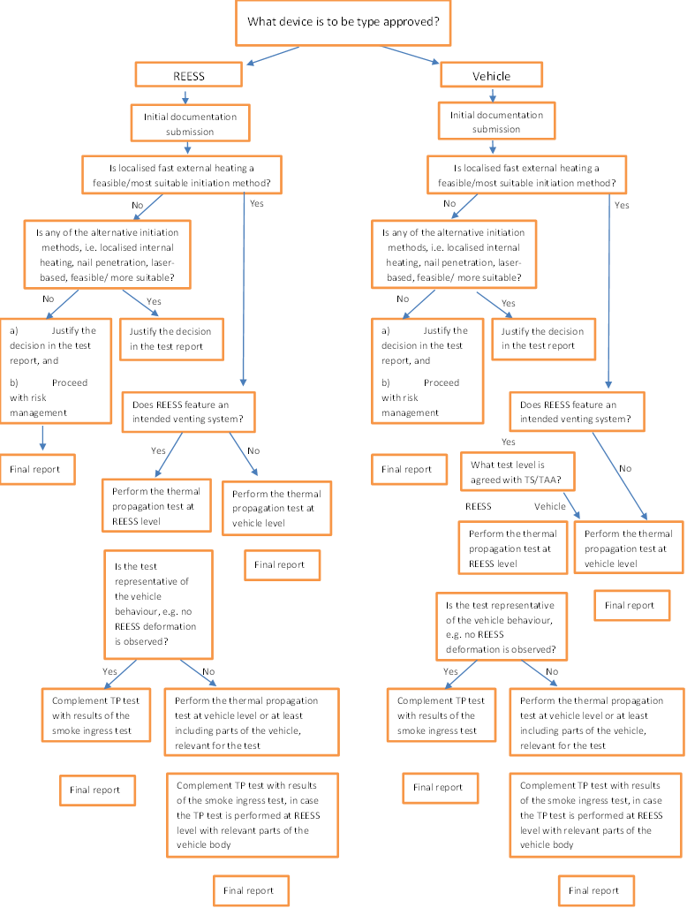**]**

**6.15.3.1. Step 1: Initial documentation submission**

**The manufacturer shall provide technical documentation containing the followings:**

**(a) A system diagram of all relevant physical systems and components;**

**(b) A diagram showing the functional operation of the relevant systems and components, identifying all risk mitigation functions or characteristics;**

**(c) For each identified risk mitigation function of characteristic implemented, the physical system or component which implements the function shall be identified and the operating strategy described;**

**(d) [the maximum operating temperature or storage temperature, whichever is higher];**

**(e) The recommendations on the feasibility for conducting the physical testing;**

**(f) If applicable, the recommendations on [a more] suitable trigger method including [appropriate parameters for the details of the trigger method,] the preparation and instrumentation of the Tested-Device; and**

**(g) If applicable, the recommendation on pre-instrumentation of the triggering and measuring devices including sufficient details of such pre-instrumentation.**

**Relevant systems and components are those which contribute to protection of vehicle occupants from hazardous situation caused by thermal propagation triggered by a single cell thermal runaway.**

**6.15.3.2. Step 2: Selection of trigger method**

**Localized fast external heating is the default trigger method for physical testing of thermal propagation safety performance. Alternative methods, e.g. localized internal heater, nail penetration or laser-based trigger, may be used if one of those methods is recommended by manufacturer and recognized as [a more] suitable for the REESS design by the Technical Service to cause the single cell thermal runaway satisfying the criteria given in Annex 9K, paragraph 5. The decision of the Technical Service shall be duly documented and justified in the test report.**

**Test method descriptions for the respective trigger methods are found in Annex 9K – Appendices 1 to 4.**

**6.15.3.3. Step 3: Selection of test level**

**Either vehicle based test or component based test shall be performed.**

**In case the component based test is performed, thermal propagation test shall be complemented by:**

**(a) Additional test(s) to demonstrate the protection of vehicle occupants against smoke as described in Annex 9K, paragraph 7. In case of smoke resulting from thermal propagation coming out of the intended venting system during the component-based test, protection of vehicle occupants against smoke shall be demonstrated by the smoke ingress test according to the Annex 9K, paragraph 7. In case the REESS casing does not feature any intended venting system and smoke occurs during the test, the vehicle based test shall be performed ; and**

**(b) Evidence to demonstrate that the component based test is representative of a vehicle-level behaviour. Phenomena such as deformation of the casing of the REESS during the thermal propagation test shall be considered as evidence demonstrating that component-based test is not representative of a vehicle-level behaviour. In this case, the thermal propagation test shall be performed at the vehicle level or shall at least include the parts of the vehicle relevant for the test.**

**6.15.3.4. Pass/fail criteria for physical thermal propagation test**

**During the 5 minutes after the warning indication, there shall be no evidence of the following [hazardous situations caused by thermal propagation:**

**(a) Fire**

**(b) Explosion**

**(c) Smoke inside the passenger compartment**

**The warning indication may occur either when the triggered cell enters thermal runaway or when the REESS has reliably identified a thermal propagation event, provided that the safety objectives listed above are satisfied.**

**For vehicle based test, the evidence of hazardous condition, i.e. fire, explosion and smoke inside the passenger compartment, shall be verified by visual inspection without disassembling any part of the Tested-Device [or vehicle].**

**For component-based test, the evidence of hazardous condition, i.e. fire and explosion, shall be verified by visual inspection without disassembling any part of the Tested-Device.**

**6.15.3.4.1. In case that no thermal propagation is observed during 2 h after thermal runaway was triggered in the initiation cell, the requirements of paragraph 6.15.3.4. are deemed to be satisfied.**

**6.15.3.4.2. In case that no thermal runaway can be triggered during the test with the chosen triggering method, and this is confirmed by repeating the same test procedure (i.e. the same trigger method and the same test level) or by conducting a cell level test, the requirements of paragraph 6.15.3.4. are deemed to be satisfied.**

**6.15.4. Risk management analysis method**

**The manufacturer shall perform and document a risk assessment and risk reduction analysis for considering occupant protection in normal in-use operational modes (e.g. active driving possible, [parking] and external charging modes). The risk analysis shall be holistic and follow a systematic work process including both hardware and software aspects, (see for example ISO 6469-1:2019/AMD 2022 and ISO 26262 or equivalent standards for additional guidance). The work product shall explain the safety performance of the vehicle systems in conditions caused by thermal propagation which is triggered by an internal short circuit leading to a single cell thermal runaway.**

**The manufacturer shall make a summary of important information considering occupant protection in the case of a single cell thermal runaway and thermal propagation from the risk assessment and the risk reduction activities to the Type Approval Authority and Technical Service in charge of that approval. The report structure shall comprise a four-part structure with the elements described in paragraphs 6.15.4.1., 6.15.4.2., 6.15.4.3. and 6.15.4.4. below.**

**6.15.4.1. System analysis**

**The system analysis includes:**

**(a) A system diagram of all relevant physical systems and components;**

**(b) Description of systems/components relevant to single-cell thermal runaway and thermal propagation due to internal short circuit and their interoperability. Relevant systems and components are those which contribute to protection of vehicle occupants from hazardous effects caused by thermal propagation triggered by a single cell thermal runaway include but are not limited to REESS, sensors, thermal management system, battery management system, etc.;**

**(c) Description of warning indication and operating logic; and**

**(d) Functional analyses identifying the conditions leading to single cell thermal runaway, i.e. internal short circuit of the cell, and allocating them to the corresponding components or functional units or subsystems;**

**6.15.4.2. Risk identification and mitigation**

**A risk identification and mitigation analysis using appropriate industry standard methodology (for guidance, see for example, IEC 61508, MIL-STD 882E, ISO 26262, AIAG & VDA FMEA Handbook, fault analysis as in SAE J2929, or similar), which documents the hazards to vehicle occupants caused by thermal propagation triggered by an internal short circuit leading to a single cell thermal runaway and documents the reduction of risk resulting from implementation of the identified risk mitigation functions or characteristics. The severity of the thermal event and the risk of propagation to adjacent cells in the battery pack shall be determined.**

**The risk identification and mitigation analysis shall include:**

**(a) Risk mitigation by design;**

**(b) Risk mitigation by manufacturing control; and**

**(c) Risk mitigation by other means;**

**The risk analysis shall also include information about and justify any assumptions made on system performance characteristics and properties, model behaviour or relative relevance and likelihood of specified risk scenarios.**

**The risk assessment is limited to occupant protection for the relevant operational design domain of the REESS and the vehicle.**

**6.15.4.3. Risk mitigation effectiveness – validation & verification**

**The effectiveness of each of the risk reduction measure shall be analysed and evaluated. Effectiveness may be analysed by testing, analysis, simulation, models, reference to scientific papers, field data and/or other appropriate methods, either singly or in combination. Effectiveness assessments shall fulfil the requirements of paragraphs 6.15.4.3.1. and 6.15.4.3.2., as appropriate.**

**6.15.4.3.1. Test and verification methods**

**Test and verification methods used for unit testing, implementation testing and validation shall be documented, clearly identifying which safety functionalities are addressed with the respective methods. Recognized industry standard tests, for example ISO, IEC, SAE or equivalent, should be used when available and appropriate for the testing purposes. In the absence of appropriate industry standard methods and tests, the manufacturer shall design test methods and verification techniques that are feasible to verify component and/or system performance as required to verify and validate the effectiveness of the risk mitigation strategy. Any such methods used shall be explicitly documented, including an explanation of what property, capability or attribute that is tested and the suitability of the method to generate the data required, as well as the rationale for why the method is appropriate.**

**6.15.4.3.2. Data sources and quality requirements**

**The data set shall evaluate performance of the components and functional units that have been identified in the allocation process. The relevance and appropriateness of the data shall be described and justified. Major uncertainty factors shall be identified and quantified as far as possible.**

**Data can comprise of technical specifications and verifying test reports from suppliers and/or manufacturers, mathematical simulations from theoretical or empirical system models, scientific reports and publications, as well as field data.**

**All relevant results available shall be gathered to create a full consistent reports. The sources of externally derived data shall be identified.**

**A completeness check shall be conducted so as to ensure that all relevant information and data needed for the interpretation are available and complete.**

**A sensitivity check shall be conducted to evaluate the reliability of the final results and the conclusions by determining how they are affected by uncertainties in the data, allocation methods or assumptions made about the REESS.**

**6.15.4.4. Conclusions**

**[(a)] The concluding part of the report shall comprise a brief summary of the major results of the risk management analysis and a statement that the requirements in paragraphs 6.15.1. and 6.15.2. are satisfied, including: The methods used are scientifically and technically valid for the scope of the risk management analysis;**

**[(b) The data used are appropriate and reasonable in relation to the intention of the risk reduction analysis;**

**(c) The interpretations are relevant and reflect the assumptions made and the limitations identified for the study;**

**This part may be in the form of an internal or external critical review report, if the manufacturer has such a process in place.** ]"

*Insert new paragraphs 12.10. to 12.17.,* to read:

"**12.10. As from the official date of entry into force of the 05 series of amendments, no Contracting Party applying this Regulation shall refuse to grant or refuse to accept type approvals under this Regulation as amended by the 05 series of amendments.**

**12.11. As from [1 September 2028], Contracting Parties applying this Regulation shall not be obliged to accept type approvals to any of the preceding series of amendments that were first issued on or after [1 September 2028].**

**12.12. Until [1 September 2030], Contracting Parties applying this Regulation shall accept type approvals to the 03 (subject to paragraph 12.9.) or 04 series of amendments, first issued before [1 September 2028].**

**12.13. As from [1 September 2030], Contracting Parties applying this Regulation shall not be obliged to accept type approvals issued to any of the preceding series of amendments to this Regulation.**

**12.14. [Notwithstanding paragraph 12.13., Contracting Parties applying this Regulation shall continue to accept type approvals issued according to the 03 (subject to paragraph 12.9.) or 04 series of amendments to this Regulation, applying the provisions in paragraph 6.15.1. (a) of the 03 or 04 series of amendments to this Regulation, first issued before [1 September 2028]. ]**

**12.15. Notwithstanding paragraph 12.13., Contracting Parties applying this Regulation shall continue to accept type approvals issued according to the 03 (subject to paragraph 12.9.) or 04 series of amendments to this Regulation, for the vehicles/vehicle systems which are not affected by the changes introduced by the 05 series of amendments, provided the transitional provisions in these respective previous series of amendments foresee this possibility.**

**12.16. Contracting Parties applying this Regulation may grant type approvals according to any of the preceding series of amendments to this Regulation.**

**12.17. Contracting Parties applying this Regulation shall continue to grant extensions of existing approvals to any of the preceding series of amendments to this Regulation.**"

*Delete (former) paragraph 12.10.*

*Renumber (former) paragraph 12.11. as new paragraph 12.18.*

*Annex 1* ***–*** *Part 1*, amend to read:

"Communication

**…**

**18. Remarks:** "

*Annex 1* ***–*** *Part 2,* amend to read:

"Communication

**…**

6. Installation restrictions applicable to the REESS as described in paragraphs 6.4**.,** ~~and~~ 6.5**., 6.10. and 6.15.**:

**…**

**18. Remarks:** "

**…**"

*Annex 2,* amend to read:

"Annex 2

Arrangements of the approval marks

# Model A

# (See paragraph 4.4. of this Regulation)

# Figure 1

 a = 8 mm min.



**100 R - 05~~04~~2492**

The approval mark in Figure 1 affixed to a vehicle shows that the road vehicle type concerned has been approved in the Netherlands (E 4), pursuant to Regulation No. 100, and under the approval number ~~04~~**05**2492. The first two digits of the approval number indicate that the approval was granted in accordance with the requirements of Regulation No. 100 as amended by ~~04~~**05** series of amendments.

# Figure 2



**100 RES - 05~~04~~2492**



a = 8 mm min.

The approval mark in Figure 2 affixed to a REESS shows that the REESS type ("ES") concerned has been approved in the Netherlands (E 4), pursuant to Regulation No. 100, and under the approval number ~~04~~**05**2492. The first two digits of the approval number indicate that the approval was granted in accordance with the requirements of Regulation No. 100 as amended by ~~04~~**05** series of amendments.

# Model B

(See paragraph 4.5. of this Regulation)





|  |  |
| --- | --- |
| **100** | **05~~04~~ 2492** |
| **42** | **00 1628** |

a = 8 mm min.

The above approval mark affixed to a vehicle shows that the road vehicle concerned has been approved in the Netherlands (E4) pursuant to Regulations Nos. 100 and 42[3]. The approval number indicates that, at the dates when the respective approvals were granted, Regulation No. 100 was amended by the ~~04~~**05** series of amendments and Regulation No. 42 was still in its original form. "

*Insert new Annex 9K and Annex 9K Appendices 1 to4,* to read:

"Annex 9K

Thermal propagation test

**1. Purpose**

**The purpose of the thermal propagation test is to ensure the occupant safety in a vehicle when a forced thermal runway of a cell in the REESS is triggered/initiated. The phenomena of forced thermal runaway simulate a severe thermal event caused by an internal short circuit.**

**2. Installations**

**This test shall be conducted wither with a complete vehicle or using the complete REESS or REESS subsystem(s) at the discretion of the manufacturer in agreement with Technical Service. If the manufacturer chooses to test with REESS subsystem(s), the manufacturer shall demonstrate that the test result can reasonably represent the performance of the complete REESS with respect to its safety performance under the same conditions.**

**For test using REESS or REESS subsystem, the parts of the vehicle relevant for the test, e.g. to reproduce the equivalent phenomena such as deformation of the casing of the REESS during the thermal propagation test, shall be installed to the Tested-Device.**

**3. General test conditions**

**The following conditions shall apply to the test**

**3.1. Environmental conditions**

**(a) The test shall be conducted either indoors or outdoors. In case of outdoor testing there shall be no precipitation for the duration of the test.**

**(b) Immediately prior to the test commencing, wind speed shall be measured at a location which is no more than 5 m from the Tested-Device and the average wind speed over 10 min shall be less than 28 km/h. It shall be ensured that the results are not affected by gusts of wind. Gusts shall not exceed 36 km/h when measured over a period of 20 s. Test set up shall consider the impact of features such as shielding screens or walls which may create excessive funnelling effects during test execution.**

**(c) The test shall be carried out at a relative humidity of 10% to 90%.**

**3.2. Tested-Device**

**(a) Required modifications shall be kept to a minimum compared to the original un-modified Tested-Device. Any modifications of REESS components, such as mechanical and thermal barriers, cooling plates/channels, electrical connections, and cell to cell spacing shall be documented and rationalized as to why such changes do not result in significant change to performance. The original sealing capability of the REESS shall be confirmed not to be compromised through instrumentation and any venting shall be through pre-existing seals. [If the Tested-Device is pre-instrumented, the manufacturer is responsible to verify the sealing capability, otherwise the Technical Service shall ensure this.] All components and features that are required for the functioning of the Tested-Device and safety related features e.g. cell connecting busbars, tab welding, connection and functionality of relevant management system, isolation resistance, etc., shall be maintained and un-compromised;**

**(b) For vehicle level test, all windows, roof and doors are closed.**

**(c) At the beginning of the test, the state of charge (SOC) shall be adjusted according to the procedure defined in Annex 9- Appendix 1 to this Regulation;**

**(d) At the beginning of and, as long as possible, during the test, all necessary functions of the Tested-Device shall be operational. The Tested-Device shall be representative of the REESS when installed in a vehicle that is system power** **“on” and set in "parked" mode [(i.e. the shift selector in a position that does not allow propulsion)]. The defined thermal management/safety strategy and the battery management system used within the REESS shall be fully operational. The coolant flow could be null or active depending on the management system of the Tested-Device. The native thermal management strategy (if installed), and other relevant management systems of the Tested-Device, which are necessary for the test, shall be operational for as long as possible during the test.**

**(e) Immediately before turning on the initiation device, the temperature of the cells in the Tested-Device, shall be maintained between 18 °C and maximum operating temperature defined by the manufacturer.**

**3.3. Initiation cell**

**In the field, a single cell thermal runaway may occur in any cell location within the REESS. For the test, the initiation cell selection shall consider the number of adjacent cells, cell packaging, and the distance between cells in proximity to the potential initiation cell as well as the practicality of initiation.**

**The intent is to allow for the selection of any cell in the pack. However, it is understood that there are differing limitations in the ability to access certain cells in any given Tested-Device and that certain cells may pose a higher risk of propagation stemming from a single cell failure. The criteria below will ensure that Tested-Device functionality and safety systems are not compromised by installation of test equipment. It also provides the basis for selecting a cell that is potentially at a higher risk of causing propagation.**

**Paragraph 3.3.1. below is essential to ensure that the whole system is being tested and any installed safety systems within the Tested-Device are not compromised.**

**Paragraph 3.3.2. below is subjective to the specific product as well as the test level and the initiation method selected in accordance with paragraph 6.15.3. Representative case shall be determined by the Type Approval Authority and/or Technical Service with the help of documentation provided by the manufacturer be.**

**3.3.1. Installation of test equipment shall not compromise the functionality of the REESS relevant to the safety performance. The installation shall minimize modification to thermal insulators and structure and shall not:**

**(a) Disable or affect the functionality of the battery management systems;**

**(b) Change pack gas flow direction and permeability, both internal and exit paths.]**

**3.3.2. A cell shall be selected that represents severe conditions for generating a potentially hazardous condition in case of a thermal runaway:**

**(a) A high level of heat transfer to at least one adjacent cell (e.g. thinnest spacers/gaps/barriers or vent direction towards an adjacent cell);**

**(b) Subject to (a), few heat sinks and non-productive thermal pathways (e.g. edge cell with few adjacent cells and/or with large adjacent air space);**

**(c) Other criteria known be the manufacturer to reflect a condition/location which may have greater potential to lead to a hazardous condition.**

**4. Recorded data and measurements**

**4.1. The following information shall be recorded during the test and during the observation period. All data measurement systems shall be referenced to the same starting time.**

**(a) Identification of the test method, including the trigger method, and a description of the test set-up;**

**(b) Test conditions (e.g. environmental conditions, SOC, and other pre-conditioning parameters);**

**(c) Temperature of the initiation cell, [ensuring that the trigger device or test instrumentation does not influence the measurement];**

**(d) Voltage of the initiation cell during the thermal runaway triggering procedure;**

**(e) Temperature of one adjacent cell;**

**(f) Video and audio recording, including indication of a time stamp of observable events during the test (e,g, initiation cell thermal runaway/venting, thermal propagation to adjacent cell(s), smoke, fire/flame, explosion, etc);**

**(g) Condition of the Tested-Device at the end of the test, supported by video or photographs (before and after test);**

**(h) If the test is performed on vehicle level, the time stamp of warning indications or alarms to occupants. If the test is performed on REESS or REESS subsystem, the time stamp of the signal to trigger the warning indications;**

**(i) The Technical Services may perform additional optional measurements and record the data, e.g. infrared temperature video, if deemed necessary.**

**5 Detection criteria of thermal runaway**

**Thermal runaway can be detected by the following conditions:**

**(i) The measured voltage of the initiation cell drops, and the drop value exceeds 25% of the initial voltage [for at least 1 second];**

**(ii) The measured temperature of the initiation cell exceeds the maximum temperature safety limit defined by the manufacturer;**

**(iii) dT/dt ≥ 1 °C/s of the measured temperature of the initiation cell for at least 3 consecutive seconds.**

**(a) Both (i) and (iii) are detected; or**

**(b) Both (ii) and (iii) are detected.**

**6. Trigger methods to initiate thermal runaway**

**The trigger method shall not affect the adjacent cell(s), e.g. in case localized fast external heating, localized internal heating or laser-based trigger methods are used, the temperature of the adjacent cell(s) shall not exceed [maximum operating or storage temperature (whatever is higher)], defined by the manufacturer before the thermal runaway of the initiation cell is detected. Appropriate methods may be used to isolate the adjacent cell(s), provided that the REESS original functionality is not impeded.**

**7. [Additional smoke ingress test on vehicle]**

**7.1. Environmental conditions :**

**(a) The test shall be conducted either indoors or outdoors. In case of outdoor testing there shall be no precipitation for the duration of the test.**

**(b) Immediately prior to the test commencing, wind speed shall be measured at a location which is no more than 5 m from the Tested-Device and the average wind speed over 10 min shall be less than 28 km/h. It shall be ensured that the results are not affected by gusts of wind. Gusts shall not exceed 36 km/h when measured over a period of 20 s. Test set up shall consider the impact of features such as shielding screens or walls which may create excessive funnelling effects during test execution.**

**(c) The test shall be carried out at a relative humidity of 10% to 90%.**

**(d) The temperature shall be in the range of the operational temperatures of the smoke machine specifications.**

**7.2. Smoke machine:**

**The smoke machine shall be able to generate visible smoke at a flow rate representative of the exhaust of the battery venting exit** **for the duration of the test.**

**7.3. Vehicle configuration:**

**7.3.1. The vehicle shall represent the series production without previous modifications** **or repairs that may affect the test results.**

**7.3.2. [All windows, roof and doors, as well as air ventilation and if there are air inlets that can be automatically closed upon** **detection of thermal event, are closed.]**

**[7.3.3. Passenger compartment shall be maintained at an under-pressure of at least 2 mbar for the duration of the test.]**

**7.4. Smoke ingress verification procedure:**

**The smoke ingress inside the passenger compartment is checked using sufficient numbers of different video camera locations.**

**[The smoke machine exhaust exit shall be positioned at the proxy of battery venting exit pointing the direction of the exhaust from the battery venting.]**

**7.5. Test steps:**

**(a) The start time begins with the start of the smoke production by the smoke machine.**

**In case of the smoke machine needs to warm up before expulsing smoke, first visible smoke from the machine shall be taken as the starting point.**

**(b) [Use the smoke machine during at least 5 minutes. The amount and duration of smoke release shall be motivated by the manufacturer and in agreement with the technical service.]**

**(c) Write the time of the first smoke entrance visible on camera if it is the case.**

**[7.6. Pass/fail criteria for smoke ingress test:**

**During the 5 minutes after the start moment of the test, determined as described in paragraph 7.5, there shall be no evidence of smoke inside the passenger compartment as verified by visual inspection [without disassembling any part of the Tested-Device [or vehicle].**

Annex 9K – Appendix 1

Thermal runaway initiation method with localized fast external heater

**1. Preparation of Tested-Device**

**1.1. The feedthrough installation of the chosen heating element and measuring sensors should only modify the REESS by permitting electrical and thermocouple connections. These connections shall provide greater seal integrity than the other connectors in the REESS.**

**1.2. The chosen heating element shall be set to avoid direct contact to any surface of the components in the Tested-Device except for the initiation cell. Intimate thermal contact between the heating element and the initiation cell surface is important for the successful application of this method. Thermal contact between the heating element and initiation cell may be improved through various methods (e.g. avoiding air gaps, addition of a heat transfer paste and applying pressure, which should be maintained throughout the test).**

**1.3. A sample of potential heater application methods are shown in Figure 1 and the applied method is dependent on the REESS or REESS subsystem design. Maintain a contact pressure for the heating element on the initiation cell during the test to ensure contact and optimal heat transfer, see Figure 1.**

**Figure 1  
Methods to apply pressure on the heating element to maintain heating element contact to initiation cell throughout the test for different cell types.**

**(a) REESS with large spacing between cells**

Key

Heating element

Heat transfer paste

Ceramic paper/foam

Wire or high-temperature tape

Initiation cell

**(b) center cell fixed spacing (e.g. prismatic cells**

Initiation cell

Initiation cell

Key

Heating element

Heat transfer paste

Ceramic paper/foam

Adjacent cell

**(c) center cell compressed modules (e.g. pouch cells)**

External applied pressure

Initiation cell

Key

Heating element

Heat transfer paste

Ceramic paper/foam

Adjacent cell

**1.5. For implementation in vehicle based tests, the vehicle response shall not be influenced by the insertion of this trigger method into the REESS.**

**[1.6. A temperature sensor shall be placed on the surface of the heating element and affixed with high-temperature resistant and electrically insulating tape for power regulation of the heater.**

**Figure 2**

**Placement of temperature sensor on the heater element (example)**

]

**[1.7. A temperature sensor for measuring the temperature of the initiation cell shall be placed 1 ± 0.2 cm above the heater for vertically-oriented cells and 1 ± 0.2 cm away from the heater for horizontally–oriented cells.**

**Figure 3**

**Placement of temperature sensor on the initiation cell (example)**

]

**2. Heater element selection guide**

**2.1. The trigger method applies a high-powered heat pulse, locally, to the external surface of the initiation cell. The successful implementation of the method requires the application of sufficient power to the chosen heating element but it shall also not apply so much power that there is a premature heating element failure nor a side wall failure of the initiation cell prior to thermal runaway.**

**2.2. The heating device shall be a resistive heating element, or other suitable heating device/technology capable of delivering the target parameters. Target parameters for the heating element are listed in Table 1.**

**Table 1  
Heater device selection guide: Target parameters**

|  |  |  |
| --- | --- | --- |
| ***Parameter*** | ***Value*** | ***Rationale*** |
| **Heater device material** | **[A suitable resistive heating material**, **e.g. nickel-chrome, with an isolating barrier]** | **Achieve high temperatures and prevent element failures.**  **Isolating materials may include alumina, ceramic, or fiberglass.** |
| **Thickness** | **<5 mm** | **Minimize effect of heater on REESS. Some REESS designs may require a thinner heating element.** |
| **Area** | **As small as possible, but no larger than 20 % of the surface area of the targeted face of the initiation cell** | **Concentrate heat to the smallest feasible area on the cell surface.**  **Largest cell surface should be used, if possible** |
| **Heating rate** | **≥15 °C/s** | **Similar to heating rates observed within thermal runaway conditions.a** |
| **Maximum temperature** | **200 °C larger than [the maximum operating temperature or storage temperature, whichever is higher]** | **Heater shall maintain integrity and take into account temperature deviations from heater element to thermocouple.b** |
| **Control method** | **Thermostatic closed loop** | **Avoids undesirable test results, such as heating element burnout, elevated heating element temperature, battery cell sidewall ruptures due to high element temperature.c** |
| **aThe heating rate is measured directly by an external ~~a~~ thermocouple placed on top of the heating element installed in the pack (Figure 2).**  **b This temperature may need adjustment for other chemistries and potentially other cell types to avoid cell sidewall ruptures.**  **c Using a low voltage power source for the heating element will require higher currents (thicker wires), while a higher voltage source will require more resistant isolating material and higher levels of user safety while implementing the test.** | | |

**3. Test procedure for vehicle based test**

**The general conditions in Annex 9K, paragraph 3. shall be satisfied when the method is implemented with the vehicle .**

**(a) Instrument the REESS and the vehicle as outlined above and place the vehicle in the active driving possible mode. Make sure that the cooling and communication system operate as intended.**

**(b) Start recording the data that are needed to determine if thermal runaway and/or thermal propagation are taking place. Verify that there are no fault codes or failures relevant for the outcome of the test present in the system.**

**(c) Begin sending power to the heating element.**

**(d) Switch off the heater after a total energy input to the heater reaches 20% of initiation cell energy.**

**(e) If (d) is satisfied, but no thermal runaway has occurred in the initiation cell during the observation period of 1 hour after the opening of the heater relay, the REESS type is considered to comply with this requirement.**

**(f) The test ends when one of the conditions specified below is met:**

**(i) The initiation is stopped in accordance with the subparagraph (d) above followed by an observation period of 1 hour; or**

**(ii) At least 5 minutes elapse after the activation of the warning indication, if thermal propagation is observed.**

**4.Test procedure for component based test**

**The general conditions in Annex 9K, paragraph 3. shall be satisfied when the method is implemented on the REESS or REESS subsystem.**

**(a) Instrument the REESS or REESS subsystem** **as outlined above and prepare the REESS or REESS subsystem** **such that it represents the situation when it is installed in the vehicle, with the system in the active driving possible mode. Make sure that the thermal management and communication system operate as intended.**

**(b) Start record the data that are needed to determine if thermal runaway and/or thermal propagation are taking place. Verify that there are no fault codes or failures relevant for the outcome of the test present in the system.**

**(c) Begin sending power to the heating element.**

**(d) Switch off the heater immediately when thermal runaway is confirmed or after a total energy input to the heater reaches 20 % of initiation cell electric energy.**

**[(e) The test ends when one of the conditions specified below is met;**

**(i) The initiation is stopped in accordance with the subparagraph d) above followed by an observation period of 1 hour, or**

**(ii) at least 5 minutes elapse after the activation of the warning indication, if thermal propagation is observed.**

Annex 9K – Appendix 2

Thermal runaway initiation method with internal heater

[**This test method is similar with the external heating method except it relies on an internal, localized short circuit inside the cell created by a local heater. The concept of this trigger method is to cause an internal short circuit through the creation of a hole in the separator of the initiation cell. The hole comes from the local melting of the separator induced by the local heater.**

**The trigger method applies a high-powered heat pulse, locally, to the jellyroll surface of one initiation cell within the REESS via an internal heater with minimal increase in temperature of the adjacent battery cell(s) prior to thermal runaway within the initiation cell. The temperature of adjacent cell(s), prior to thermal runaway in the initiation cell, shall remain below the maximum temperature safety limit, defined by the manufacturer.]**

**1. Trigger method description**

**The heating device should be a resistive heating element, or other suitable heating device/technology capable of delivering the target parameters. Target parameters for the heating element are listed in Table 1.**

**Parameters to use with this test methodology for typical lithium-ion battery cells for electric vehicles are shown in Table 2 as a guideline. The power of the heater is dependent on cell chemistry, energy density and volume of the initiation cell. The maximum time allowed for the first thermal runaway event shall be agreed between the manufacturer and the Technical Service (see soak time in Table 2).**

**Figure 1  
Example of an internal heater flat spiral of tungsten**

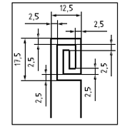 **(mm)**

**NOTE: The wire diameter is usually 0.1 mm to 0.3 mm**

**Table 1  
Heating element selection guide – Target Parameters**

| ***Parameter*** | ***Value*** | ***Reasoning*** |
| --- | --- | --- |
| **Heating element material** | **A suitable resistive heating material with an insulating barrier, e.g. copper or tungsten** | **Achieve high temperatures and prevent element failures. Isolating material may include polyimide or other heat-resisting material.** |
| **Thickness [mm]** | ≤**0.5** | **Due to the heater need to be placed inside of cell, thickness of heater should be controlled in a reasonable value.** |
| **Area[mm2]** | **50*50~15*15** | **Concentrate heat to the smallest feasible area on the cell surface.** |
| **Power of heater[W]** | **150~700** | **Provide enough heat to enable initiation of cell thermal runaway.** |

**Table 2  
Typical heater parameters for implementation of internal heater methodology**

| ***Parameter Category*** | ***VED<450Wh/L***  ***(eg.: LFP Cell)*** | ***VED≥450Wh/L***  ***(eg.: NCM Cell)*** | ***Remarks*** |
| --- | --- | --- | --- |
| **Power of heater[W]** | **400~700** | **150~700** | **These values are based on: Cell chemistry/energy density/ volume of the initiation cell.** |
| **Soak time phase and power off condition** | **Heating until thermal runaway is achieved or until heater is burnout** | | **Heating until thermal runaway is achieved within 5 min.** |

**Heater Characteristic (For example):**

**The dimension of heater is 30mm*30mm, and heating power is 250W. When the internal heater is used to trigger the initiation cell to thermal runaway, the temperature of heater surface will rapidly increase beyond 300 °C with an rate of ~80 °C/s, and the maximum temperature will reach ~700 °C (as shown in Figure 2). For normal design, the separator will rapidly melt down at the temperatures filed, and lead to cell thermal runaway by an internal short circuit.**

**Figure 2  
Thermal behaviour of internal heater**

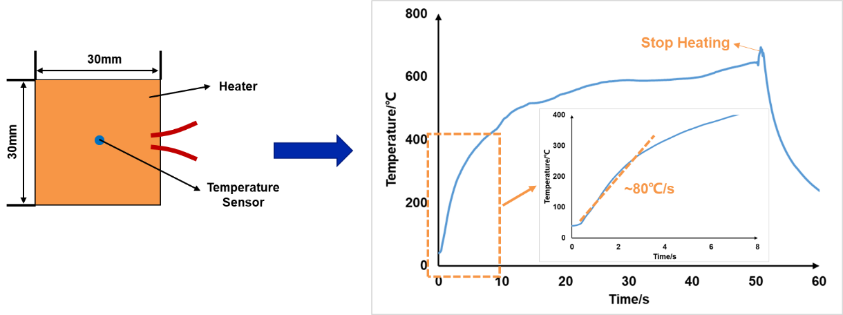

**[2. Test application and necessary modifications - Subsystem level testing**

**The use of this test method relies on quickly and effectively heating up a single cell into thermal runaway within a REESS and REESS subsystem. To ensure the test is conducted efficiently, a preliminary test on a single cell or a small number of cells should be performed using a modified cooling strategy (if desired). This subsystem level test permits the refinement of test parameters (heating rate, target temperature, soak time) for the specific cell used in the chosen REESS design, which vary (from those shown in Table 1 and Table 2) upon change of cell chemistry and cell size/construction. Modifications required for subsystem level testing should mimic those found in the REESS to obtain an accurate test result relative to that obtained at a REESS test level.]**

**3. Initiation Cell/Cell Block Preparation**

**The internal heater is assembled in the cell during the production of cell. Here is the example of manufacturing process for this special cell.**

**3.1. Step 1:**

**Locate the heater on the surface of the jellyroll. For one-jellyroll-cell, the heater is suggested to be located on the surface of jellyroll. For n-jellyrolls-cell (n≥2), the heater is suggested to be located on the surface of jellyroll and is surround by two jellyrolls, as shown in Figure 3.**

**Figure 3  
Example of location of internal heater in a cell with more than one jellyroll.**

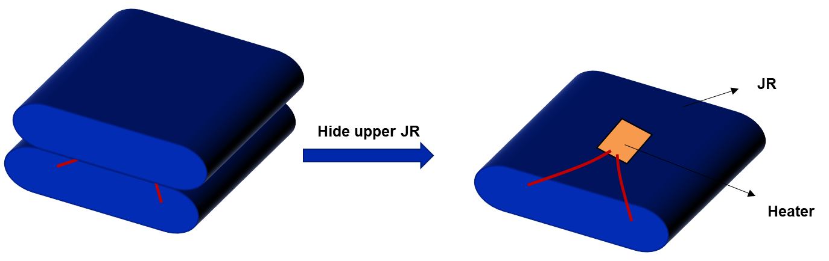

**3.2. Step 2:**

**A hole is drilled into the top cover of cell to allow the electrical feedthrough of the heater from the inside to the outside of the cell.**

**3.3. Step 3:**

**All wires used in the REESS or REESS subsystem shall be electrically isolated. Furthermore, it should be ensured that no electrolyte or gases can leak out through the space between the wire strand and the wire insulator.**

**The selection of sealing resin is critical as the strength of seal shall be greater than any installed vent of the cell.**

**Next, assemble the cell according to the standard manufacturing process (Figure 4). After it is completely dry, carry out a helium test to check the sealing before filling the cell with electrolyte.**

**When the helium test is successful, the cell is ready to be filled and formed. After the helium test, verification of the characteristic parameters (voltage, ACR, dimension, *etc*) should be performed and the tolerance range should be provided.**

**According to requirement of experiment, the prepared cell can be assembled inside the battery module or REESS or REESS subsystem. The CCS component need to be drilled a hole to make sure the electrical feedthrough of the heater can come out of cell block (Figure 5).**

**Figure 4  
Example of cell assembly**

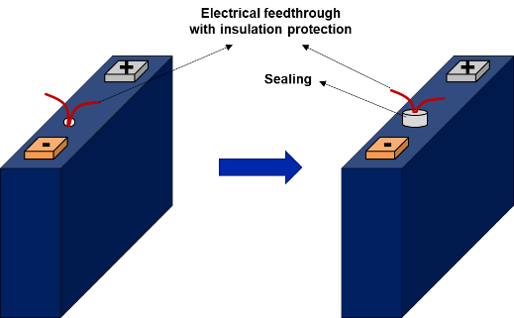

**Figure 5  
Example of module assembly**

**3.4. Step 4:**

**Connect wires of the heater to the outside of the REESS or REESS subsystem though the sealing pad between pack top cover and pack casing and seal the position with sealant. [(Figure 6).] The wires can also come out of the pack though a hole in the REESS casing, which is then sealed with heat-resistant resin.**

**[Figure 6  
Example of battery pack assembly**

]

**[4. Test procedure for vehicle based test**

**The general conditions in Annex 9K, paragraph 3. shall be satisfied when the method is implemented with the vehicle.**

**(a) Instrument the REESS and the vehicle as outlined above and place the vehicle in the active driving possible mode. Make sure that the cooling and communication system operate as intended.**

**(b) Start recording the data that are needed to determine if thermal runaway and/or thermal propagation are taking place. Verify that there are no fault codes or failures relevant for the outcome of the test present in the system.**

**(c) Begin sending power to the heating element.**

**(d) The test ends when one of the conditions specified below is met:**

**(i) The initiation is stopped due to the burn out of the heater; or**

**(ii) At least 5 minutes elapse after the activation of the warning indication, if thermal propagation is observed.**

**[5.Test procedure for component based test**

**The general conditions in Annex 9K, paragraph 3. shall be satisfied when the method is implemented on the REESS or REESS subsystem.**

**(a) Instrument the REESS or REESS subsystem as outlined above and prepare the REESS or REESS subsystem such that it represents the situation when it is installed in the vehicle, with the system in the active driving possible mode. Make sure that the thermal management and communication system operate as intended.**

**(b) Start recording the data that are needed to determine if thermal runaway and/or thermal propagation are taking place. Verify that there are no fault codes or failures relevant for the outcome of the test present in the system.**

**(c) Begin sending power to the heating element.**

**(e) The test ends when one of the conditions specified below is met:**

**(i) The initiation is stopped due to the burn out of the heater; or**

**(ii) at least 5 minutes elapse after the activation of the warning indication, if thermal propagation is observed.**

Annex 9K – Appendix 3

Thermal runaway initiation method with nail penetration

**1. Preparation of Tested-Device**

**If the REESS is enclosed in a housing, a penetrating hole on the housing may be needed to enable the nail to be inserted into a target position of an initiation cell. The device such as gas tight sleeve for the nail that prevents venting gas from leaking out from the nailhole should be applied, if necessary.**

**The nail penetrating position and direction are selected from the position and direction of the nail where causing a thermal runaway in an initiation cell is possible (e.g. in vertical direction to electrode layer.**

**2. Nail selection guide**

**The nail type can be chosen from the parameters** **given in Table 1.**

Table 1  
**Nail selection guide: Target parameters**

|  |  |  |
| --- | --- | --- |
| ***Parameter*** | ***Value*** | ***Rationale*** |
| ***(i) Material*** | ***Steel*** | ***To be electrically conductive and sufficiently hard to penetrate a cell outer case*** |
| ***(ii) Diameter [mm]*** | ***3 to 8*** | ***To be smaller to simulate the internal short circuit*** |
| ***(iii) Angle of tip [°]*** | ***20 to 60*** | ***To select angle to occur cause thermal runaway*** |
| ***(ⅳ) Penetrating speed [mm/s]*** | ***0.1 to 1*** | ***If the speed is low, the nail traveling is easily controlled, especially to stop.*** |

**3. Test procedure for vehicle based test**

**The general conditions in Annex 9K, paragraph 3. shall be satisfied when the method is implemented with the vehicle.**

**(a) Instrument the REESS as outlined above and connect all thermal management and high voltage lines and reinstall REESS into vehicle.**

**(b) Start recording the data that are needed to determine if thermal runaway and/or thermal propagation are taking place. Verify that there are no fault codes or failures relevant for the outcome of the test present in the system.**

**(c) Select the nail shape and diameter and set the appropriate penetrating speed according to the guidance in paragraph 2.(iv).**

**(d) Tune on the power to the nail operating device.**

**(e) Stop the nail and let it remain inside the initiation cell when the thermal runaway is confirmed or the nail has penetrated both the front and back side of the cell.**

**[(k) The test ends when one of the conditions specified below is met:**

**(i) The initiation is stopped in accordance with the subparagraph (e) above; or**

**(ii) 5 minutes after the activation of the warning indication****, if thermal propagation is observed.]**

**[(g) If thermal runaway could not be triggered even when the nail penetrated both the front and back side of the cell, the test is considered as void.]**

**4. Test procedure for component based test**

**The general conditions in Annex 9K, paragraph 3. shall be satisfied when the method is implemented on the REESS or REESS subsystem.**

**(a) Instrument the REESS or REESS subsystem as outlined above and prepare the REESS or REESS subsystem such that it represents the situation when it is installed in the vehicle, with the system in the active driving possible mode. Make sure that the thermal management and communication system operate as intended.**

**(b) Start recording the data that are needed to determine if thermal runaway and/or thermal propagation are taking place. Verify that there are no fault codes or failures relevant for the outcome of the test present in the system.**

**(c) Select the nail shape and diameter and set the appropriate penetrating speed according to the guidance in paragraph 2.(iv).**

**(d) Tune on the power to the nail operating device.**

**(e) Stop the nail and let it remain inside the initiation cell when thermal runaway is confirmed or the nail has penetrated both the front and back side of the cell.**

**[(k) The test ends when one of the conditions specified below is met:**

**(i) The initiation is stopped in accordance with the subparagraph (e) above;**

**(ii) 5 minutes after the activation of the warning indication, if thermal propagation is observed.]**

**[(g) If thermal runaway could not be triggered even when the nail penetrated both the front and back side of the cell, the test is considered as void.]**

Annex 9K – Appendix 4

Thermal runaway initiation method with laser-based trigger

**1. Preparation of Tested-Device**

**Before conducting the test, the laser beam path shall be secured so that the laser beam reaches a predetermined position on the initiation cell surface. Figure 1 shows examples of laser irradiation to on-board battery modules consisting of different types of battery cells.**

**Figure 1  
Examples of laser irradiation to on-board battery modules consisting of different types of battery cells**

| ***(a) Cylindrical cell module*** | ***(b) Square cell module*** | ***(c) Pouch cell module*** |
| --- | --- | --- |
|  |  |  |

**2. Laser selection guide**

**The laser type can be chosen from material process lasers such as used for cutting, welding or hardening, e.g. CO2 laser, YAG laser, semiconductor laser, disk laser, fiber laser, and so on.**

**An example of a laser irradiation system is shown in Figure 2.**

**Figure 2  
Example of a laser irradiation system**

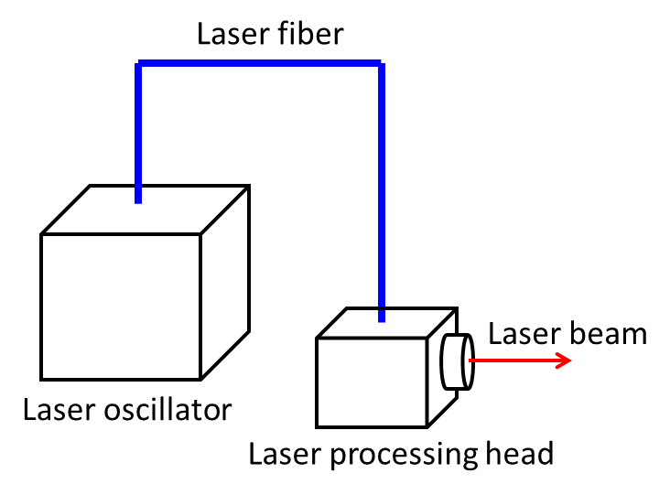

**3. Test procedure for vehicle based test**

**The general conditions in Annex 9K, paragraph 3. shall be satisfied when the method is implemented with the vehicle .**

**(a) Instrument the REESS as outlined above and connect all thermal management and high voltage lines and reinstall REESS into vehicle.**

**(b) Start recording the data that are needed to determine if thermal runaway and/or thermal propagation are taking place. Verify that there are no fault codes or failures relevant for the outcome of the test present in the system.**

**(c) Before starting the test, secure the laser beam path so that the laser beam reaches the initiation cell surface of the Tested-Device.**

**(d) Set and confirm the laser irradiation program.**

**(e) Irradiate the initiation cell with the laser at the determined point.**

**(f) Switch off the** **laser irradiation** **immediately when thermal runaway is confirmed.**

**(g) The test ends when one of the conditions specified below is met:**

**(i) 5 minutes after the activation of the warning indication, if thermal propagation is observed.**

**4. Test procedure for component based test**

**The general conditions in Annex 9K, paragraph 3. shall be satisfied when the method is implemented on the REESS or REESS subsystem.**

**(a) Instrument the REESS or REESS subsystem as outlined above and prepare the REESS or REESS subsystem such that it represents the situation when it is installed in the vehicle, with the system in the active driving possible mode. Make sure that the thermal management and communication system operate as intended.**

**(b) Start recording the data that are needed to determine if thermal runaway and/or thermal propagation are taking place. Verify that there are no fault codes or failures relevant for the outcome of the test present in the system.**

**(c) Before starting the test, secure the laser beam path so that the laser beam reaches the initiation cell surface of the Tested-Device.**

**(d) Set and confirm the laser irradiation program.**

**(e) Irradiate the initiation cell with the laser at the determined point.**

**(f) Switch off the laser irradiation immediately when thermal runaway is confirmed.**

**[(g) The test ends when one of the conditions specified below is met:**

**(i) 5 minutes after the activation of the warning indication, if thermal propagation is observed.** "

II. Justification

1. Thermal runaway is a known failure mode of the lithium ion but also of other contemporary traction battery cells, which are currently used in many REESS for electric vehicles. Thermal runaway reactions occur when the thermal stability limit of the cell chemistry is exceeded, and the cell releases its energy exothermically at an uncontrolled rate. The thermal runaway is typically accompanied by venting, fire and, in extreme cases, possibly even explosion. The vented gas and smoke contain flammable, toxic and corrosive substances, can become very hot and can ignite. Fire is very common during thermal runaway, given the emission of hot gases and smoke. Usually when a cell undergoes thermal runaway, it will transfer heat to adjacent cells via conductive, convective, and radiative heat transfer modes. By heat transfer, the thermal runaway in a single cell may propagate to the surrounding cells, causing thermal propagation that can involve the entire REESS. The smoke, fire and explosion threaten the safety of electric vehicle occupants. The hazard caused by thermal propagation must be restricted.

2. The internal short circuit in contemporary traction batteries has already been reported in field failures. Requirements are needed to ensure that an internal short failure occurring in an electric vehicle does not lead to significant risks for vehicle occupants.

3. The thermal propagation test procedure is currently not adopted as a requirement. Instead, the requirement exists whereby the manufacturer is required to submit engineering documentation to demonstrate the vehicle's ability to minimize the risk associated with single cell thermal runaway. This implies that the conformity assessment is based solely on the implementation and validation of the countermeasures by the manufacturer to minimize or prevent single cell thermal runaway and its propagation in the REESS.

4. Given a considerable divergence in the application of the existing documentation requirement by different technical services under the type approval system, the impracticality of such a requirement in particular in the context of the verification of compliance, and with a view to improve regulatory certainty for economic operators, a test procedure needs to be provided to demonstrate that potential risks to vehicle occupants associated with thermal propagation are appropriately minimized.

5. The purpose of the thermal propagation test is to ensure the occupant safety in a vehicle if thermal runaway occurs in the battery system.

6. Four different methods were selected as the test methods to initiate the thermal runaway of a single cell in terms of practicability and repeatability. Localized fast external heating is the default trigger method for physical testing of thermal propagation safety performance. Alternative methods, e.g. localized internal heater, or nail penetration, or laser-based trigger, may be used if one of those methods is recommended by manufacturer and recognized as the most suitable for the REESS design by the Type Approval Authority and Technical Services to cause the single cell thermal runaway.

7. This test shall be conducted either with the vehicle or the complete REESS or with REESS subsystem(s) . In case the component-based test is performed at the REESS level, and in order to approve it for the installation in a vehicle, thermal propagation test shall be complemented by additional tests. If the manufacturer chooses to test with related subsystem(s), the manufacturer shall demonstrate that the test result can represent the performance of the complete REESS with respect to its safety performance under the same conditions.

1. * In accordance with the programme of work of the Inland Transport Committee for 2023 as outlined in proposed programme budget for 2023 (A/77/6 (Sect. 20), table 20.6), the World Forum will develop, harmonize and update UN Regulations in order to enhance the performance of vehicles. The present document is submitted in conformity with that mandate.
2. ~~The manufacturer will be accountable for the verity and integrity of documentation submitted, and assume full responsibility for the safety of occupants against adverse effects arising from thermal propagation caused by internal short circuit.~~ 
3. The latter number is given only as an example.