|  |  |  |  |
| --- | --- | --- | --- |
|  | United Nations | ST/SG/AC.10/C.3/2024/23 | |
| _unlogo | **Secretariat** | | Distr.: General  15 April 2024  Original: English |

**Committee of Experts on the Transport of Dangerous Goods  
and on the Globally Harmonized System of Classification  
and Labelling of Chemicals**

**Sub-Committee of Experts on the Transport of Dangerous Goods**

**Sixty-fourth session**

Geneva, 24 June-3 July 2024

Item 3 of the provisional agenda

**Listing, classification and packing**

Wearable airbag system

Submitted by the expert from Italy[[1]](#footnote-2)\*

I. Introduction

1. At last December session of the Sub-Committee, informal document INF.34 outlined the need to standardize the criteria for classification and, consequently, the transport provisions applicable to wearable airbag devices

2. The diffusion of these articles is growing, and it has been learned, from discussions with other experts, that there are many industrial sectors in which they are used as personal protective equipment, thus affecting not only motorcycling but all areas in which there is a need for increased protection of the human body.

3. The Sub-Committee agreed on the need to include such lifesaving systems within the existing provisions of the *Model Regulations*, inviting all experts to send their comments to the expert from Italy, who offered to prepare an official proposal.

II. Item description and classification

4. Wearable airbags are composed of several elements belonging to different hazard classes, and in general have a structure of this type:

(a) Small lithium battery (3.65 V – 9.5 Wh), powering the ACU which activates the pyrotechnic canister upon detection of a crash situation;

(b) One or two canisters containing non-dangerous and non-inflammable pressurized gas (argon or helium), for the airbag inflation;

(c) Pyrotechnic substances of Division 1.4 S (between 300 mg and 600 mg for each canister) necessary to activate the gas diffusion.

5. A more complete description is available in the annex to this document, where some pictures of the assembled system and its components are shown.

6. Currently, in the lack of clearer indications, either UN 3268 (SAFETY DEVICES, electrically initiated) or UN 2990 (LIFE-SAVING APPLIANCES, SELF-INFLATING) are to be used, to which the transport provisions collected in this table apply.

|  |  |  |  |  |  |  |  |  |  |
| --- | --- | --- | --- | --- | --- | --- | --- | --- | --- |
| UN  No. | Name and description | Class or division | Subsidiary hazard | UN packing group | Special provisions | Limited and excepted quantities | | Packaging and IBC’S | |
| Packing instruction | Special packing provisions |
| (1) | (2) | (3) | (4) | (5) | (6) | (7a) | (7b) | (8) | (9) |
| - | 3.1.2 | 2.0 | 2.0 | 2.0.1.3 | 3.3 | 3.4 | 3.5 | 4.1.4 | 4.1.4 |
| 2990 | LIFE-SAVING APPLIANCES, SELF-INFLATING | 9 |  |  | 296 | 0 | E0 | P905 |  |
| 3268 | SAFETY DEVICES, electrically initiated | 9 |  |  | 280  289 | 0 | E0 | P902  LP902 |  |

7. In both cases, the presence of Division 1.4S substances is permitted, provided that a 6(c) series test has been carried out. In addition, transport under full exemption is permitted in both cases, although under different conditions.

Special provision 296, assigned to UN 2990, allows carriage under full exemption when shipped in a strong outer packaging with a maximum mass of 40 kg. It may also contain articles of different classes, including lithium batteries (class 9); canisters containing power devices (pyrotechnic contents) of Division 1.4 S, with a limit of 3.2 g; compressed or liquefied gases (class 2.2), with a limit of 120 ml.

Special provision 289, assigned to UN 3268, allows transport with full exemption if it is installed as a safety device in a vehicle or if it is shipped as a complete component (doors, seats, steering columns).

III. Proposal

8. Since the two entries UN 2990 and UN 3268 already provide a specific exemption, by special provisions 296 and 289 respectively, a partial amendment of these provisions would allow these new items to be considered as well.

9. These following proposals must be considered as alternatives.

Option 1

10. Insert a new paragraph at the end of special provision 296 as follows (new text is underlined):

“… Life-saving appliances packed in strong rigid outer packagings with a total maximum gross mass of 40 kg, containing no dangerous goods other than Division 2.2 compressed or liquefied gases with no subsidiary risk in receptacles with a capacity not exceeding 120 ml, installed solely for the purpose of the activation of the appliance, are not subject to these Regulations.

Wearable airbag system packed in outer strong packagings, with a total maximum gross weight of 25 kg, containing no dangerous goods other than:

- Division 2.2 compressed or liquefied gases with no subsidiary risk in receptacles with a capacity not exceeding 120 ml, installed solely for the purpose of the activation of the appliance; and

- Pyrotechnic substances classified 1.4 S, not exceeding the quantities of 600 mg for each canister, with a maximum of 2 canister for each article; are not subject to these Regulations.”

Option 2

11. Insert a new paragraph at the end of special provision 289 as follows (new text is underlined):

“Safety devices electrically initiated and safety devices, pyrotechnic installed in vehicles, vessels or aircraft or in completed components such as steering columns, door, panels, seats, etc. are not subject to these Regulations.

Wearable Airbag System packed in outer strong packagings, with a total maximum gross weight of 25 kg, containing no dangerous goods other than:

- Division 2.2 compressed or liquefied gases with no subsidiary risk in receptacles with a capacity not exceeding 120 ml, installed solely for the purpose of the activation of the appliance; and

- Pyrotechnic substances classified 1.4 S, not exceeding the quantities of 600 mg for each canister, with a maximum of 2 canister for each article;

are not subject to these Regulations.”

IV. Justification

12. To avoid non harmonised application of transport requirements with potential safety implication, the current proposal aims at establishing a shared and homogeneous international classification for these objects.

13. It is also foreseeable that, in the next few years, the use of such devices will be further extended to sectors such as speed skating, hockey, acrobatic gymnastics, climbing, luge, alternative mobility (such as skateboard or scooter) and city mobility (such as to passengers on trains, subways or buses who are totally unprotected in case of an accident). In light of the above, it is highly likely that the product at stake is destined to become a widely consumed commodity due to the fact that it will reduce the extent of injuries or fatalities in such accidents.

V. Sustainable Development Goals (SDGs)

14. The proposal works both in the context to improve road safety (SDG 3) and to promote a safer sustainable mobility (SDG 11).

15. In the context of the United Nations SDG priorities[[2]](#footnote-3) the proposal introduces positive elements in the following’s topics:

**SDG 3 - Ensure healthy lives and promote well-being for all at all ages**

Improving road safety

Supporting healthy and sustainable mobility

**SDG 11- Make cities and human settlements inclusive, safe, resilient and sustainable**

Harnessing new technologies for smart cities

Fostering sustainable mobility in cities.

Annex

Wearable airbag[[3]](#footnote-4)

|  |  |
| --- | --- |
|  |  |
|  |  |

Wearable Airbag assembly

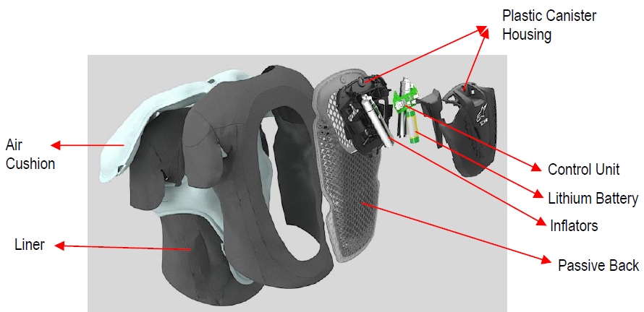

Liner

Air Cushion

Lithium Battery

Control Unit

Inflators

Passive Bacck

Plastic Canister

Housing

Inflator drawings

|  |  |
| --- | --- |
| ***Inflator*** | Immagine che contiene linea, schermata  Descrizione generata automaticamente  INITIATOR |
| ***Chamber and Diffuser*** | Immagine che contiene testo, diagramma, linea, schermata  Descrizione generata automaticamente  PLUG  LASER WELDINGS  CHAMBER  STORED GAS MIX  TOPHAT DIFFUSER  BURST DISK |
| ***Initiator Description*** | IMI secondary load  IMI primary load  CHAMBER  LASER WELDING  IMI  RESISTANCE WELDING  SHUNT RING  DOME  CRIMPING |

1. \* A/78/6 (Sect. 20), table 20.5. [↑](#footnote-ref-2)
2. <https://unece.org/sdg-priorities> , <https://sdgs.un.org/goals>. [↑](#footnote-ref-3)
3. The author of the document gave the authorization to use the materials contained in this annex for the purpose of the discussion at the sixty-fourth session of the Sub-Committee of Experts on the Transport of Dangerous Goods. For reproduction permission and all other issues, please contact [talk-to-us@alpinestars.com](mailto:talk-to-us@alpinestars.com). [↑](#footnote-ref-4)