|  |  |  |  |
| --- | --- | --- | --- |
|  | United Nations | ECE/TRANS/WP.29/2024/86 | |
| _unlogo | **Economic and Social Council** | | Distr.: General  2 April 2024  Original: English |

**Economic Commission for Europe**

Inland Transport Committee

**World Forum for Harmonization of Vehicle Regulations**

**193rd session**

Geneva, 25–28 June 2024

Items 4.15.1 and 14.4.1 of the provisional agenda

**1958 Agreement:**

**Proposal for amendments to Mutual Resolutions  
Consideration and vote by AC.3 of draft UN GTRs and/or   
draft amendments to established UN GTRs, if any:  
Proposal for amendments to the Mutual Resolutions   
of the 1958 and the 1998 Agreement, if any**

Proposal for Amendment 4 to Mutual Resolution No. 1

Submitted by the Working Party on Passive Safety[[1]](#footnote-2)\*

The text reproduced below was adopted by the Working Party on Passive Safety (GRSP) at its seventy-fourth session (ECE/TRANS/WP.29/GRSP/74, para. 32). It is based on ECE/TRANS/WP.29/GRSP/2023/33 as amended by Annex VIII to the report. It is submitted to the World Forum for Harmonization of Vehicle Regulations (WP.29) and to the Executive Committee of the 1998 Agreement (AC.3) for consideration at their June 2024 sessions.

*Contents*, amend to read:

"Contents

*Page*

Preamble

I. Statement of technical rationale and justification

II. Mutual Resolution (M.R.1) of the 1958 and 1998 Agreements concerning the description   
and performance of test tools and devices necessary for the assessment of compliance of   
wheeled vehicles, equipment and parts according to the technical prescriptions specified in Regulations and global technical regulations

1. Scope

2. General provisions

3. Specific provisions

Appendix

Addendum 1 - (Reserved for Bio Rear Impact Dummy (BioRID) specifications)

Addendum 2 - Specifications for the Construction, Preparation and Certification of the   
World Side Impact 50th percentile adult male anthropomorphic test device   
(WorldSID 50th male)

Addendum 3 - Specifications for the Construction, Preparation and Certification of the   
flexible Pedestrian Legform Impactor (FlexPLI)

Addendum 4 – (Reserved for Q Dummies)

Addendum 5 – Specifications for the Qualification of Human Body Models for pedestrian Head Impact Time determination as a Deployable Pedestrian Protection Systems prerequisite

**I. Statement of technical rationale and justification**

…

**II Mutual Resolution (M.R.1) of the 1958 and 1998 Agreements concerning the description and performance of test tools and devices necessary for the assessment of compliance of wheeled vehicles, equipment and parts according to the technical prescriptions specified in Regulations and global technical regulations**

[…]

*Paragraphs 3. and 3.1., Specific provisions,* amend to read:

3. Specific provisions

3.1. The table below details the individual addenda to this Mutual Resolution in which details of the design, construction, maintenance and preparation of the test devices or equipment can be found.

| *ECE/TRANS/WP.29/1101* | *Generic name of the Test Tool* | *Regulation(s) requiring the test Tool Device* | *Global technical regulation(s) requiring the Test Tool or Device* | *Date of adoption of the Addendum* |
| --- | --- | --- | --- | --- |
| Amend 3  - Addendum 1 to M.R.1 | (Reserved)  BioRID Dummy | No 17 | No 7 | … |
| Amend.1  - Addendum 2 to M.R.1 | WorldSID 50th male Dummy | No. 135 | No. 14 | 12 Nov. 2014 |
| Amend.2  - Addendum 3 to M.R.1 | FlexPLI | No. 127 | No. 9 |  |
| Amend.  - Addendum 4 to M.R.1 | (Reserved)  Q Dummy | … | … | **…** |
| Amend.4  - Addendum 5 to M.R.1 | DPPS HBMs | No. 127 | No. 9 | ( ) |

"

*Appendix,* amendto read:

"Addendum 1 – (Reserved for Bio Rear Impact Dummy (BioRID) specifications)

Addendum 2 – Specifications for the Construction, Preparation and Certification of the World Side Impact 50th percentile adult male anthropomorphic test device (WorldSID 50th male)

Addendum 3 – Specifications for the Construction, Preparation and Certification of the flexible Pedestrian Legform Impactor (FlexPLI)

Addendum 4 – (Reserved for Q Dummies)

Addendum 5 – Specifications for the Qualification of Human Body Models for pedestrian Head Impact Time determination as a Deployable Pedestrian Protection Systems prerequisite

"Appendix

Addendum 5 - Specifications for the Qualification of Human Body Models for pedestrian Head Impact Time determination as a Deployable Pedestrian Protection Systems prerequisite

Contents

*Page*

1. General Provisions

2. Qualification Procedure and Reference Results

3. Documentation of Results

Annexes

A. Reference Systems

B. Background: Validation of Reference Human Body Models

C. Generic Vehicle Models

Appendix C1 File list for Generic Vehicle Models available on ECE Website

Appendix C2 Auxiliary Files for Generic Vehicle Models available on ECE Website

1. General Provisions

This Addendum provides the specifications for the Human Body Models (HBMs) related to the Head Impact Time (HIT) Determination Procedure defined in GTR No.9 Annex 2. The HBM qualification procedure and all related tools, as requested in Annex 1 of GTR No.9 are specified in this Addendum.

Figure 1.1  
**Flowchart showing the interaction between UN GTR No.9 Annex 2 and this M.R.1 Addendum.**

HBM Qualification Simulation

Documentation (section 3)

Pass requirements

Test without DPPS activation

No

Yes

HIT\_d determination sim. with deployed DPPS (40km/h)

HIT\_d ˃ TRT

No

Yes

HIT\_s determination sim. with undeployed DPPS (40km/h)

HIT\_s/WAD graph for dynamic test

Qualifies for static test

M.R.1 Addendum 5

GTR No.9 Annex 2

Static test requested

No\*

Yes

\* For example: airbag

GV Model

HBM

Vehicle model

HIT\_d/WAD graph

1.1 Limitations

The qualification procedure described in this text is simplified and therefore limited to the purpose of pedestrian Head Impact Time (HIT) and Wrap Around Distance (WAD) calculation and is not suited to qualify for injury assessment in this or any other crashworthiness regulation. Only measures relevant for these outputs are included in the qualification procedure and have been determined within sensitivity studies and round robin simulations.

1.2. Definitions

Throughout this Addendum the following definitions are used:

1.2.1. A "Human Body Model" (HBM) is understood as a virtual geometric and mechanical representation of the human body, which takes the human anatomy into consideration. The procedure described in this Annex refers to HBMs used for the simulation of pedestrian impacts. Pedestrian models which are required for GTR No.9 Annex 2 shall be selected from the following statures, a six-year-old (6YO), 5th percentile female (AF05), 50th percentile male (AM50) and 95th percentile male (AM95).

1.2.2. "Generic Vehicle (GV) Models" are generic replications of car fronts representing three vehicle categories: Family Cars (FCR), Roadsters (RDS), Sports Utility Vehicles (SUV). (The shape of the generic Multi-Purpose-Vehicle (MPVs) was found to lay in between the generic FCR and generic SUV and is therefore covered already.) The vehicle models provide representative shapes for the selected vehicle categories as well as median structural response upon pedestrian impact in terms of force- deflection characteristics and are modelled to be robust and transferable to all considered explicit Finite Element (FE) codes.

1.2.3. "HBM Qualification Simulation" : A computer simulation (GV Model vs. HBM) providing evidence that the specific HBM simulation is comparable with reference simulations and shows consistent results – in particular referring to HIT and WAD. The reference simulations are based on models which have been validated by comparing their simulation response with post-mortem-human-subject (PMHS) tests. Another purpose is to make sure that models give comparable results with varying hardware or software environments when applied for a specific purpose.

1.2.4. "HIT-Determination simulation": A computer simulation for determination of HIT as a function of WAD in the DPPS vehicle model for deriving the test conditions for the assessment of deployable systems as specified in GTR No.9 Annex 2.

2. Qualification Procedure and Reference Results

2.1. Human Body Models Pre-processing

2.1.1. Shoes

The HBM may be fitted with a pair of shoes, featuring a sole thickness (at the heels) of 20 to 30 mm.

2.1.2. Positioning

The car manufacturer has the freedom to choose a positioning tool. Positioning can be achieved through pre-simulation (pulling/pushing the limbs of the HBM to the desired position) or by re- meshing/morphing. The target posture of the AM 50 model is specified in [Table 2-1](#_bookmark1). All other model sizes have to meet the required initial posture defined in Table 2-2. The angles shall be measured using the reference axis as defined in Annex A. The reference measures for the other sizes of models are listed in [Table 2-2](#_bookmark2).

The right side in viewing/walking direction of the HBM is defined as the struck side. The z-direction is defined as the vertical axis, positive in inferior direction. The local HBM x-axis is the frontal axis, facing anterior. (Both shoe soles shall ideally contact the ground – if the height of Acetabulum (ACz) (see table 2-1) cannot be achieved with ground contact, a z-offset of the HBM is permitted).

None of the limbs, i.e. arms/legs shall be artificially connected, tied or constrained to each other (e.g. wrists tied). The HBM shall be exposed to a vertical acceleration field constituting the gravitational loading for HBM qualification and HIT determination simulation.

Table 2-1  
**Initial Posture AM 50.**

| *Abbrev.* | *Measure* | *Reference Value*  *AM50* | *Tolerance (±)* |
| --- | --- | --- | --- |
| Px | Heel to heel distance Longitudinal | 310 mm | 5.0% |
| Py | Heel to heel distance lateral | 185 mm | 15.0% |
| ACz | Height of AC relative to the ground level | 949 mm | 2.0% |
| K | Right Upper Leg Angle (around Y w.r.t. horizontal) | 89° | 5° |
| L | Left Upper Leg Angle (around Y w.r.t. the horizontal) | 106° | 5° |
| G | Right Knee flexion Angle (Y) | 164° | 5° |
| H | Left Knee flexion Angle (Y) | 175° | 5° |
| Ty | Right Upper Arm Angle (Y w.r.t. horizontal) | 98° | 5° |
| Uy | Left Upper Arm Angle (Y w.r.t. horizontal) | 70° | 5° |
| Tx | Right Upper Arm Angle (X w.r.t. horizontal) | 100° | 10° |
| Ux | Left Upper Arm Angle (X w.r.t. horizontal) | 100° | 10° |
| V | Right Elbow flexion Angle | 140° | 5° |
| W | Left Elbow flexion Angle Left | 160° | 10° |
| HCx | x-Position of HC relative to AC | 44 mm | 15 mm |
| HCz | Height of HC relative to the ground level | 1686 mm | 1.5% |
| M | Body mass | 76.7kg | -5%/ +10% |

Figure 2-1 **Measurements to describe the initial posture of the HBM. For all abbreviations and reference point description (HC, AC etc.) see ~~Appendix~~ Annex A.**

K

Uy

W

ACz

HCx

G

H

L

Ty

HCz

Right Left

V

z

x

Ux

Tx

z

y

## 

## Table 2-2 **Reference Posture of other pedestrian sizes****.**

| *Abbrev.* | *Unit* | *Reference* | *Reference* | *Reference* | *Tolerance* |
| --- | --- | --- | --- | --- | --- |
| 6YO | AF05 | AM95 | (*±)* |
| Px | mm | 199 | 243 | 340 | 5.0% |
| Py | mm | 152 | 164 | 265 | 15.0% |
| ACz | mm | 613 | 831 | 1043 | 2.0% |
| K | ° | 89° | 89° | 89° | 5° |
| L | ° | 106° | 106° | 106° | 5° |
| G | ° | 164° | 164° | 164° | 5° |
| H | ° | 175° | 175° | 175° | 5° |
| Ty | ° | 98° | 98° | 98° | 5° |
| Uy | ° | 70° | 70° | 70° | 5° |
| Tx | ° | 100° | 100° | 100° | 10° |
| Ux | ° | 100° | 100° | 100° | 10° |
| V | ° | 140° | 140° | 140° | 5° |
| W | ° | 160° | 160° | 160° | 10° |
| HCx | mm | 6.5 | 27 | 16 | 15 mm |
| HCz | mm | 1100 | 1468 | 1836 | 1.5% |
| M | kg | 22.8 | 46.9 | 102.6 | -5%/ +10% |

2.1.3. Output Parameters

The HBM must be equipped with "sensors" and other output definitions, which allow tracking the trajectories of selected body parts.

Node histories must be output at the HC and AC. Outputs shall be in the global coordinate system, with the x-direction parallel to the vehicle longitudinal axis in driving direction and the z- direction parallel to the vehicle height axis facing upwards. The sensor shall be constrained to the structure, which was used for the definition of the geometric centre (at least 10 nodes of the cortical bone for HBMs with skeleton and all related bodies for HBMs without skeleton).

2.2. Impact Simulations

According to Tables 2-3, 2-4 and 2-5, the HBM must be impacted by the GV Models defined in 1.2.2. at three different impact velocities (30 km/h, 40 km/h and 50 km/h). The simulation time must be higher than the expected Head Impact Time.

The static and dynamic coefficient of friction between the car and the HBM shall be set to 0.3.

The Head Centre of Gravity (CoG) of the HBM must be positioned in line with the vehicle centreline (y=0 in the global coordinate system).

2.3. Output Requirements

It shall be confirmed that the following outputs have been generated from each simulation:

Time history curves of:

1. x and z coordinate of HC and AC in the global coordinate system;
2. x displacement of vehicle COG in the global coordinate system;
3. Resultant acceleration of HC;
4. Contact forces (between vehicle and HBM without upper extremities, vehicle and HBM head and total contact force);
5. Total hourglass and internal energies of the total setup;
6. Mass increase,

all plotted every 0.1ms.

Furthermore, animations of the simulations shall be generated with an output interval of 1ms.

2.4. Quality Checks

The following Quality Checks shall be performed:

1. Contact force (between HBM and vehicle) is zero at simulation start.
2. Total energy remains constant within a 15 per cent tolerance.
3. Hourglass energy ≤ 10 per cent of the total energy.
4. Artificial mass increase is less than 3 per cent.

2.5. Calculation of Head Impact Time

Time of first contact is defined as the first time at which the contact force is no longer 0.

The Head Impact Time (HIT) is defined as the elapsed time subsequent to the time of first contact of the HBM (neglecting forearms and hands) with the vehicle outer surface and the time of first contact of its head with the vehicle outer surface.

If this method is for any reason not applicable, an appropriate alternative method shall be applied and documented.

2.6. Reference Results for Qualification Simulations

From the qualification simulations with the GV Models, HIT values and the location of HC at the time of head impact shall be compared with the references in Tables 2-3, 2-4 and 2-5.

These tables have been created using simulations with validated HBMs as Addendum 5 of Mutual Resolution No. 1 (M.R.1) of the 1958 and the 1998 Agreements ECE/TRANS/WP.29/1101.

The trajectories are measured relative to the GV Model, which means that the x-displacement of the GV Model has to be subtracted from the measured x coordinate HCx in the global coordinate system. For HCz the global z-coordinates are used.

The AM95 does not need to be specifically qualified. AM95 models which can be used are all derived from AM50 models and therefore the AM95 only has to meet the positioning requirements and no specific qualification simulations need to be performed.

Table 2-3 **Reference Results AM50**

| *GV Model Shape* | *Velocity (km/h)* | *HIT (ms)* | | *HCx (mm)* | | *HCz (mm)* | |
| --- | --- | --- | --- | --- | --- | --- | --- |
|  |  | Min | Max | Min | Max | Min | Max |
| FCR | 30 | 152 | 197 | -1438 | -1005 | 1019 | 1117 |
|  | 40 | 127 | 150 | -1489 | -1105 | 1006 | 1158 |
|  | 50 | 107 | 121 | -1504 | -1179 | 1024 | 1169 |
| RDS | 30 | 163 | 199 | -1574 | -1104 | 931 | 1125 |
|  | 40 | 133 | 156 | -1659 | -1191 | 931 | 1178 |
|  | 50 | 112 | 127 | -1665 | -1283 | 981 | 1183 |
| SUV | 30 | 127 | 144 | -1000 | -624 | 1092 | 1193 |
|  | 40 | 101 | 116 | -1032 | -737 | 1103 | 1187 |
|  | 50 | 86 | 99 | -1110 | -799 | 1109 | 1191 |

Table 2-4 **Reference Results 6YO**

| *GV Model Shape* | *Velocity (km/h)* | *HIT (ms)* | | *HCx (mm)* | | *HCz (mm)* | |
| --- | --- | --- | --- | --- | --- | --- | --- |
|  |  | Min | Max | Min | Max | Min | Max |
| FCR | 30 | 60 | 78 | -388 | -325 | 912 | 936 |
|  | 40 | 49 | 60 | -428 | -358 | 907 | 949 |
|  | 50 | 43 | 49 | -459 | -387 | 891 | 968 |
| RDS | 30 | 66 | 80 | -480 | -362 | 857 | 913 |
|  | 40 | 53 | 61 | -496 | -409 | 851 | 924 |
|  | 50 | 45 | 52 | -525 | -449 | 848 | 930 |
| SUV | 30 | 35 | 50 | -154 | -101 | 1011 | 1032 |
|  | 40 | 28 | 38 | -183 | -139 | 1024 | 1050 |
|  | 50 | 19 | 34 | -227 | -156 | 1027 | 1090 |

Table 2-5  
**Reference Results AF05**

| *GV Model Shape* | *Velocity (km/h)* | *HIT (ms)* | | *HCx (mm)* | | *HCz (mm)* | |
| --- | --- | --- | --- | --- | --- | --- | --- |
|  |  | Min | Max | Min | Max | Min | Max |
| SUV | 30 | 90 | 102 | -622 | -447 | 1042 | 1133 |
|  | 40 | 69 | 82 | -679 | -496 | 1046 | 1126 |
|  | 50 | 59 | 70 | -736 | -527 | 1048 | 1127 |

3. Documentation of results

3.1. General

The following information shall be documented:

1. Date of report
2. Name of car manufacturer
3. Type and release version of software (FE-software package name, revision and version)
4. Name and version of HBM
5. Version of GV Models applied

Images showing the front view and side view of the pedestrian, at t0 and at the time of head impact shall be added to the report.

3.2 Quality Checks

For all simulations Table 3-1 shall be filled in

Table 3-1 **Quality Checks**

| *Verification evaluation criteria* | *Allowed* | *Observed* | *Pass?* |
| --- | --- | --- | --- |
|  |  |  |  |
| Coefficient of friction between GV Model and HBM | 0.3 |  | Y/N |
| Head centre of gravity is positioned at vehicle centreline | Y=0 mm |  | Y/N |
| Contact force between HBM and vehicle at simulation start | 0 |  | Y/N |
| Change in total energy throughout simulation | ≤15% |  | Y/N |
| Amount of hourglass energy relative to total energy | ≤10% |  | Y/N |
| Artificial mass increase relative to total mass of the setup | ≤3% |  | Y/N |

3.3. Initial Posture of Pedestrian Model

To qualify one HBM stature the following Table 3-2 has to be filled in using the references from Table 2-1 and 2-2.

Table 3-2  
**Initial Posture Check**

| *Abbrev.* | *Unit* | *Measured Value (for Stature …)* | *Deviation to Reference* | *Tolerance* | *Pass?* |
| --- | --- | --- | --- | --- | --- |
| Px | mm |  |  | 5.0% | Y/N |
| Py | mm |  |  | 15.0% |  |
| ACz | mm |  |  | 2.0% |  |
| K | ° |  |  | 5° |  |
| L | ° |  |  | 5° |  |
| G | ° |  |  | 5° |  |
| H | ° |  |  | 5° |  |
| Ty | ° |  |  | 5° |  |
| Uy | ° |  |  | 5° |  |
| Tx | ° |  |  | 10° |  |
| Ux | ° |  |  | 10° |  |
| V | ° |  |  | 5° |  |
| W | ° |  |  | 10° |  |
| HCx | mm |  |  | 15 mm |  |
| HCz | mm |  |  | 1.5% |  |
| Body mass | kg |  |  | -5% +10% |  |

3.4. Results of Qualification Simulations

To qualify one HBM stature the following Table 3-3 has to be filled in including all GV Model shapes and collisions speeds, where reference values are provided in the corresponding Tables 2-3, 2-4 or 2-5. To pass the requirements the values of the respective HBM have to be within the min/max values of Tables 2-3, 2-4 and 2-5.

Table 3-3 **Results of Qualification Simulation**

| *GV Model Shape* | *Velocity (km/h)* | *HIT (ms)* | | *HCx (mm)* | | *HCz (mm)* | |
| --- | --- | --- | --- | --- | --- | --- | --- |
|  |  | Measured | Pass? | Measured | Pass? | Measured | Pass? |
| FCR | 30 |  |  |  |  |  |  |
|  | 40 |  |  |  |  |  |  |
|  | 50 |  |  |  |  |  |  |
| RDS | 30 |  |  |  |  |  |  |
|  | 40 |  |  |  |  |  |  |
|  | 50 |  |  |  |  |  |  |
| SUV | 30 |  |  |  |  |  |  |
|  | 40 |  |  |  |  |  |  |
|  | 50 |  |  |  |  |  |  |

For each simulation, the following diagrams shall be documented:

1. ACx and HCx as a function of time
2. ACz and HCz as a function of time
3. HCz as a function of HCx and ACz as a function of ACx
4. Total Contact Force between HBM and GV Model as a function of time
5. Total, kinetic, internal and hourglass energy as a function of time

Annex A - Reference Systems

1. Global Coordinate System

The global coordinate system is defined as shown in [Figure A.](#_bookmark9)1:

1. X direction is the driving direction of the vehicle (longitudinal axis) and X=0 at the foremost point of the vehicle at t=0.
2. Y direction is the vehicle lateral axis with Y=0 at the vehicle centreline.
3. Z direction is parallel to the vehicle height axis facing upwards, Z=0 at the ground level.

Figure A.1  
**Global Coordinate System**

**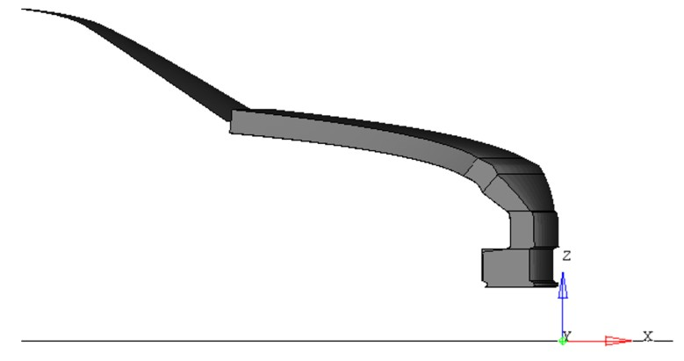**

Note: All GV Models available as Addendum 5 of Mutual Resolution No. 1 (M.R.1) of the 1958 and the 1998 Agreements ECE/TRANS/WP.29/1101 are already positioned correctly – no transformation of the vehicle is required.

2. Human Body Models Reference Axis

The HBM reference coordinate system is defined as follows: The x-axis of the local HBM is defined in the sagittal plane, oriented in the anterior direction. The y-axis is the one defined in the coronal plane, pointing to the right of the HBM and the z-direction is defined as the cross product of the aforementioned axis, this being the vertical axis oriented in the inferior direction.

The local axes describing the initial posture with the corresponding landmarks are shown in [Figure](#_bookmark10) A.2 (small capital r stands for right and l for left side of the body)

3. Human Body Models with skeleton

## Figure A.2 **Local HBM axes for angle definitions**

HC

SCl SCr

HMl

HMr

USl

AC

x

z

Fr

Fl

Mr

Ml

USr

**right left**

1. Centre of gravity of the head (hereafter called HC) is defined as the mass centre of all parts of skull, scalp, face, brain and intracranial space. It shall be connected to all nodes of inner cranium for the dynamic output.
2. AC is defined as the geometric centre of the right and left acetabulum centres. The geometric centre of all nodes within the concave surface of each acetabulum has to be determined as averaged coordinate of all nodes on the pelvic bone surface within the boundaries defined as sharp edge where the bone changes its curvature shown in Figure A.3. This has to be done at the left and the right Acetabulum. The midpoint of the left and right acetabulum centred is AC and shall be connected to all nodes of the right and left acetabulum.

## Figure A.3 **Definition of Acetabulum Centre (all nodes up to sharp edge where the bone changes curvature)**

|  |  |
| --- | --- |
|  |  |

1. The Upper Leg Angle is defined as the angle about Y between the femur reference axis and the horizontal.
2. The femur reference axis is defined as the connection between the centre of the nodes of the acetabulum and the midpoint (F) between Epicondylus femoralis medialis (FEM) and Epicondylus femoralis lateralis (FEL). If FEM and FEL are not clearly identifiable from the bony structure, the approach shown in [Figure A.3](#_bookmark11) can be used. For this approach the femur model has to be positioned such that the lateral and medial epicondyle are overlaying as much as possible, as seen in the left image in Figure A.4. Then a cylinder is created from the contour of femoral condyle. The points of intersection of the axis of a longitudinal cylinder along the femoral condyle and the outer surface of the bone shall be used as FEM and FEL. This point has to be determined on the left (Fl) and the right femur (Fr) of the HBM.

Figure A.4 **Construction of FEL and FEM**

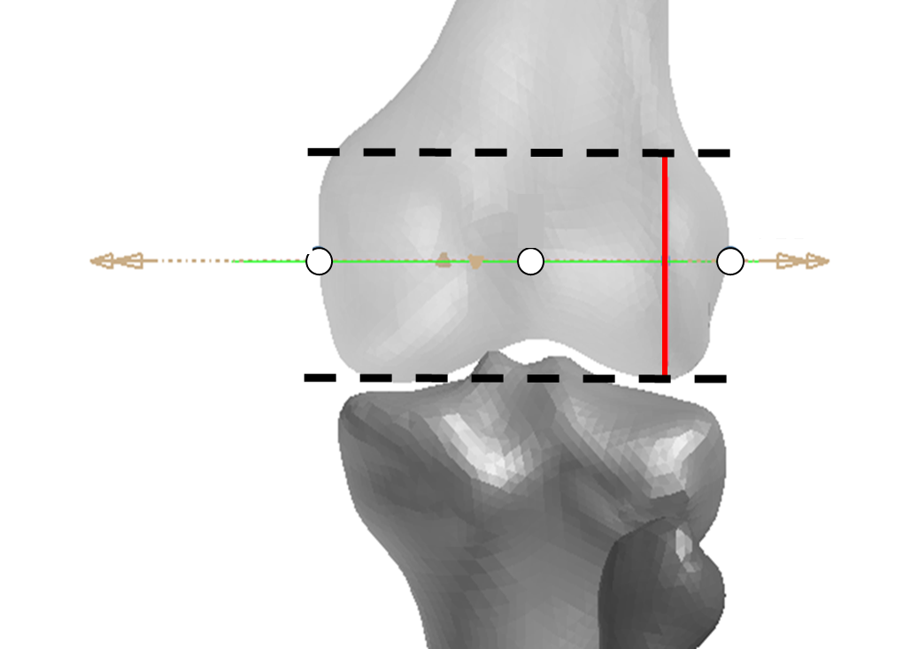

FEL

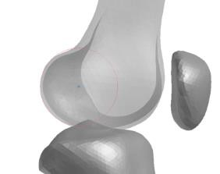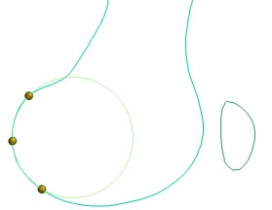

FEM

F

1. The Knee Flexion Angle is defined between the femur reference axis and the connection between the midpoint of the femoral epicondyles and the inter-malleolar point (M) located midway between the tip of the medial malleolus (MM) on the tibia bone and tip of the lateral malleolus (LM) on the fibula as shown in Figure A.5. These points have to be defined on the left (Ml) and right side (Mr) of the HBM.

## Figure A.5 **The right inter-malleolar point (M) located midway between MM and LM**

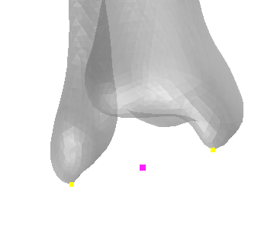

LM

MM

M

Tibia

Fibula

1. The Upper Arm Angle is defined as angle around the Y axis between the horizontal plane and the humerus reference axis. The humerus reference axis is defined as the connection between the shoulder reference point (SC) and the Humerus reference point (HM). SC is determined as the midpoint of the most laterodorsal point of the Angulus Acromialis (AA) and the most ventral point of processus coracoideus on the scapula (PC), both on the scapula. HM is defined as the midpoint of the most caudal-lateral point on lateral epicondyle (EL) and the most caudal-medial point on medial epicondyle (EM). These points have to be defined on the left (SCl, HMl) and right side (SCr, HMr) of the HBM (Figure A.6).
2. The Elbow Flexion Angle is defined as angle between the humerus reference axis and the connection between HM and the most caudal-medial point on the ulnar styloid (US). This axis has to be defined on the left (HMl, USl) and right side (HMr, USr) of the HBM.

## Figure A.6 **Anatomic Landmarks of upper extremities**

|  |  |
| --- | --- |
| Scapula  Humerus  Clavicle  AA  PC  SC | EL  EM  HM  Humerus |
| US  Ulna  Radius | |

1. The Heel-to-Heel distance is defined as the distance between the centre of all nodes of the right and the left calcaneus. If this cannot be determined, the distance between the most posterior node of the left heel to the most posterior node of the right heel of the shoe sole has to be used.

4. Human Body Models without skeleton

Wherever the landmarks described in the previous section cannot be identified in an HBM, points according to the definition in Table 2-10 shall be used.

Table 2-10  
**Reference nodes used for determination of the initial posture for HBMs where anatomic landmarks cannot be defined**

| *HBM with full skeleton* | *HBM without skeleton* |
| --- | --- |
|  |  |
| HC | Centre of gravity of the body/bodies representing the full head |
| Scl/SCr | Geometric centre of shoulder joint connecting the thorax with the body representing the upper arm |
| HMl/HMr | Geometric centre of elbow joint connecting the body representing the upper arm with the body representing the lower arm |
| USl/USr | Geometric centre of wrist joint connecting the body representing the hand with the body representing the lower arm (on the posterior side / side of the pinkie) |
| AC | Geometric centre of hip joint connecting the body representing the pelvis with the body representing the upper leg |
| Fr/Fl | Geometric centre of knee joint connecting the body representing the upper leg with the body representing the lower leg |
| Mr / Ml | Geometric centre of ankle joint connecting the body representing the foot with the body representing the lower leg bones |

Annex B – Background: Validation of Reference Human Body Models

1.1 The reference HBMs have been validated in a harmonised way. This information is background and explains the validation. The validations do not have to be repeated by the users for the qualification of the HBMs.

1.2. This section contains a description of the validation of the reference AM50 HBMs that were used for the definition of the qualification corridors, as depicted in paragraph 2.6 (Reference Results for Qualification Simulations) of this Addendum.

1.3. The validation procedure, in contrast to the qualification simulations, describes the process towards determination of the degree to which the reference models represent the pedestrian kinematics during real world crashes.

1.4. For their individual validations, the different HBMs had to undergo a harmonized procedure. This procedure consisted of simulations of the HBM against a model representing a generic vehicle frontend (SAE buck[[2]](#footnote-3),[[3]](#footnote-4)) used in PMHS experiments[[4]](#footnote-5). The SAE buck simulation model2 has been validated by comparing its responses to previously published impactor tests with a hardware version of the SAE buck1, as shown in Figure B.1.

Figure B.1  
**Impactor responses of SAE bucks used for HBM validation**

|  |  |
| --- | --- |
|  |  |

1.5. The HBM responses were compared to scaled corridors derived from three tests with PMHS. The procedure used for the validation of those models that were used for the qualification corridors is limited to the purpose of pedestrian Head Impact Time (HIT) and Wrap Around Distance (WAD) calculation. It is not suited to qualify for injury assessment in UN-GTR No.9 or any other crashworthiness regulation. If HBMs are intended for extended usage, more enhanced validations are needed.

1.6. To validate the very same model, which is used for the qualification simulations, the HBM posture was not aligned with the PMHS tests3, but corresponded to Table 2-1 of Annex 2 instead. The main difference between the two postures from the PMHS tests3 and Annex 2 Table 2-1 is the arm posture (the PMHS leg position and the proposed HBM position both target the SAE J2782[[5]](#footnote-6) measures and are therefore comparable). Previous studies have shown that the arm posture effects HIT by roughly ±3 ms[[6]](#footnote-7) which is smaller than the range of results observed in the PMHS study3.

1.7. The HBMs were positioned vertically relative to the SAE buck such that the centre of gravity of the acetabulum (AC) (as defined in Fig. A.3 in Annex 2) is positioned at a height of 932 mm. (Based on the offset between H-Point and pelvis reference point used for tracking defined in SAE J27824, the provided location of the pelvis reference point from the PMHS experiments3 was offset by 73 mm to convert it to the AC location. The minimum value of the pelvis reference point from the corridor was taken to ensure that the centre of gravity of the head (HC) requirements on the initial posture from Table 2-1 of this Addendum are not contradictory.) For the lateral position, AC was aligned with the vehicle centreline.

1.8. No ground floor was modelled. Gravity was applied and the HBM was positioned as close as possible to the vehicle model. The SAE buck model driving towards the HBM with an initial velocity of 40 km/h. The same contact settings as defined in paragraph 2.2 of this Addendum were used (i.e. the static and dynamic coefficient of friction between the car and the HBM is set to 0.3.).

1.9. All outputs as described in 2.3. were generated and analysed. From the simulations, the HIT was calculated according to paragraph 2.5. of this Addendum. All reference HBMs fulfilled the criteria defined in Table B.1 based on the scaled corridors from the PMHS tests3 (transformed to the coordinate system defined in Figure A.1) while also fulfilling all quality checks defined in paragraph 2.4 of this Addendum. For the calculation of ΔHCx, HCx was offset with its value at the time of first contact with the vehicle to be in line with the PMHS tests3. For the HIT, the mean value from the PMHS tests3 was taken and a tolerance of +5 / -10 per cent was added (consistent to the tolerance defined for trajectories in SAEJ27824).

Table B.1  
**Validation of AM50 HBMs**

|  | *HIT (ms)* | | *ΔHCx (mm)* | | *HCz (mm)* | |
| --- | --- | --- | --- | --- | --- | --- |
|  | Min | Max | Min | Max | Min | Max |
| Reference from PMHS Tests | 117 | 159 | -1653 | -1402 | 1020 | 1271 |
| GHBMC M50-PS v5.3.4 LS-DYNA MPP R10.2 | 136.6 | | -1492 | | 1160 | |
| GHBMC M50-PS v1.5 Radioss 2019.2.5 | 139.4 | | -1614 | | 1181 | |
| GHBMC M50-PS v5.33 R1.09 VPS 2019.0.4 | 130.3 | | -1500 | | 1186 | |
| GHBMC M50-P v5.3.4 LS-DYNA MPP R10.2 | 140.7 | | -1503 | | 1182 | |
| JAMA pedestrian\_AM50 ver6.2.1. LS-Dyna MPP R10.0 | 141.9 | | -1586 | | 1191 | |
| THUMS v4.02 TB024 (05/22) LS-Dyna MPP R9.3 | 141.6 | | -1622 | | 1223 | |
| THUMS v4.02 (licensed) LS-Dyna MPP R12 | 140.5 | | -1609 | | 1224 | |
| THUMS v4.02 VWG006.2 Aud165VH VPS 2020.54 | 135.6 | | -1574 | | 1219 | |

1.10. For the other statures, no reference PMHS tests were available. The following reference HBMs have been used for developing the corridors in Table 2-4 and Table 2-5 of this Addendum.

Table B.2  
**Reference models used for 6yo and AF05**

| *AF05* | *6yo* |
| --- | --- |
|  |  |
| GHBMC F05-PS v5.3.4 LS-DYNA MPP R10.2 | GHBMC 6YO-PS v2.8.1 LS-DYNA MPP R10.2 |
| GHBMC F05-PS v1.6 Radioss 2019.2.5 | GHBMC 6YO-PS v2.4-scale Radioss 2019.2.5 |
| GHBMC F05-PS V1.6 R1.09 VPS 2019.0.4 | GHBMC C6YO-PS v2.43 R1.11 VPS 2019.0.4 |
| GHBMC F05-P v5.3.4 LS-DYNA MPP R10.2 | JAMA pedestrian\_6YO ver6.2.1. LS-Dyna MPP R10.0 |
| JAMA pedestrian\_AF05 ver6.2.1. LS-Dyna MPP R10.0 | THUMS v4.02 TB024 (05/22) LS-Dyna MPP R9.3 |
| THUMS v4.02 TB024 (05/22) LS-Dyna MPP R9.3 | THUMS v4 (licensed with mass adjustment) LS-Dyna R12 |
| THUMS v4.00 VWG003 Aud080VF VPS 2020.54 | PIPER v00.08 PIPEpA100V6 VPS 2020.54 |
| THUMS v4 (licensed) LS-Dyna MPP R12 | PIPER v1.0.2 LS-Dyna MPP R12 |

Annex C – Generic Vehicle Models

1. General provisions

1.1. This Annex provides the specifications for the GV Models to be used for the qualification of pedestrian models for HIT determination. In this Annex, the models and their usage are specified.

1.2. The GV Models as such are available on the UNECE website. In this Amendment, the general usage is explained, and their structure and properties documented.

2. User Manual

2.1. Type of GV Models:

2.1.1. The GV Models are available in the three different Finite Element codes for DPPS simulations:

* LS-Dyna (Ansys)
* RADIOSS (Altair)
* VPS (ESI)

A consistent approach for all codes was pursued. Download the package in the FE code, which is intended to be used. All GV Model files are listed in Appendix C1.

2.1.2. The GV Models are available in three different shapes (shown in Figure C.1), whereby all three are required for the procedure to qualify the HBMs:

* Family Car (FCR)
* Roadster (RDS)
* Sport Utility Vehicle (SUV)

Figure C.1

**Shapes of GV Models**

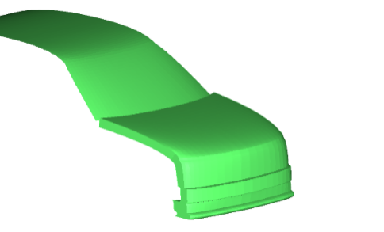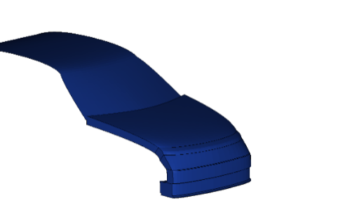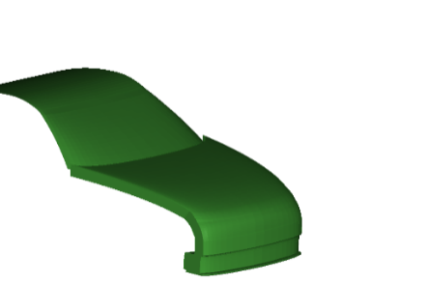

SUV

Familycar

Roadster

2.1.3. The GV Models are available in two different unit systems and shall be used in the unit system used throughout the procedure:

* Millimetre, kilogram, milliseconds (mm\_kg\_ms)
* Millimetre, tons, seconds (mm\_to\_s)

2.2. Auxiliary files for the utilisation of the GV Models are available together with the models, which are listed in Appendix C2. These files are templates only and therefore have to be adjusted by the user.

3. General design

3.1. The GV Models are finite element simulation models, which were designed to represent three different shapes and stiffnesses representative for the European fleet at the time of development of the models. The geometry of the cross-section at the vehicle centreline of the three different vehicle shapes is shown below:

Figure C.2

**Components of the GV Models to represent generic structure**

3.2. Physical properties

3.2.1. The GV Model consists of the components shown in Figure C.3. The structural response is modelled through an outer shell surface, an interface layer, (for modelling the vehicles fascia), a generic foam (to model energy absorbing structures like rips), resting on the bottom layer (a rigid skeletal vehicle structure) and the compaction layer which works a hard stop.

Figure C.3

**Components of the GV Models to represent generic structure**

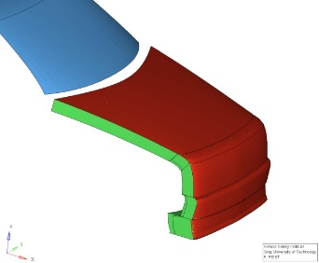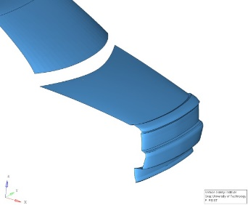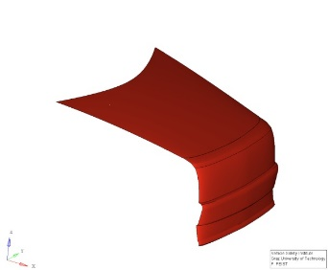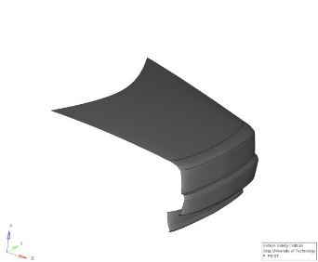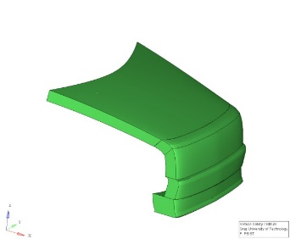

Interface Layer

Foam Layer

Compaction Layer

Foam Bottom Layer

Generic Vehicle

3.2.2. The GV Models have only one degree of freedom, which is the x-direction in the vehicle coordinate system. An initial velocity is applied to the GV Models at the start of the simulation. Further motion in x is not prescribed. The masses of the GV Models are shown in Table C.1. The vehicle’s moments of inertia remain unconsidered, though.

Table C.1  
**Mass of the GV Models**

| *GV Model Shapes* | *Total Mass (kg)* |
| --- | --- |
| SUV | 1775 |
| Familycar | 1690 |
| Roadster | 1462.5 |

4. Plausibility Check

4.1. Impactor simulations on the GV Models may be performed if the user has any doubt that the GV Models work properly with the solver version and control cards used as plausibility check. If issues (the deviations to the reference curves outside of the provided corridors shown in red) are identified, the user shall switch to another solver version, review the control settings and report the issue to GRSP through a Contracting Party.

4.2. To perform the comparison, the files specified in Table C2.1 for the respective FE code, vehicle shape and impactor location shall be used. Impacts shall be performed with the rigid cylindrical impactor (density= 7.89 E‐6 kg/mm³, diameter= 120 mm, height= 400 mm and wall thickness= 5 mm) at the vehicle centreline on the spoiler (ID=1), Bumper (ID=3), Bonnet Leading Edge (ID=5) and bonnet (ID=7), as shown in Figure C.4.

Figure C.4

**Impact locations for GV Model plausibility check**

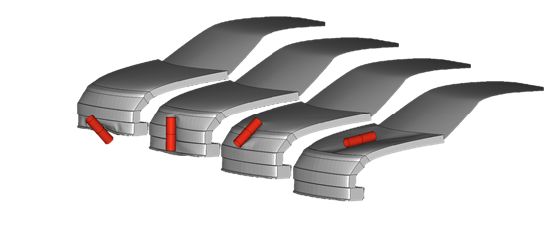

1

3

5

7

4.3. The outputs of the impactor node shall be utilised to compare the simulation results with the references shown in Table C.2. The impactor acceleration has to be multiplied with 5.95kg to receive the force and the resultant displacement is used as displacement. The black and grey lines shown in the figures show the responses of the GV Models in the three different FE codes and should be used as reference.

4.4. The GV Models have been developed and tested with the following solver versions:

• RADIOSS 2019

• LS-Dyna R9, R12

• VPS 2019, 2020, 2021, 2022

Other solver versions can be used, but users shall check the behaviour of the GV Models by performing the impactor simulations as plausibility check as described in this paragraph 4. The response of the models up to the maximum deflection shall be within the specified corridors utilizing the tabular values which are part of the auxiliary files shown in Table C2.1. If modifications of the models are required, they shall comply with the specified corridors and be documented and reported to GRSP through a Contracting Party.

The steep increase of the force observed for load case 7 at ~80mm deflection for FCR and SUV and ~60mm for the RDS is caused by the modelling of the artificial hard stop due to a contact between the interface and compaction layer. To ensure that the GV Models work robustly also in the most severe impact conditions (elbow impact on the bonnet), the rigid impactor simulations are performed with an initial kinetic Energy of 367 J up to a hard stop. The hard stop is defined based on simulations with the same rigid impactor in full FE vehicle simulations.

Table C.2 **Reference Curves for Impactor Simulations with GV Models. The red corridors shall be used to compare the response of the GV Models up to the maximum deflection. The black lines show the responses of the GV Models in the three different codes at the time of development.**

|  |  |  |  |
| --- | --- | --- | --- |
| *LC* | *FCR* | *RDS* | *SUV* |
|  | Corridor  LS-Dyna  Radioss  VPS | | |
| 1 |  |  |  |
| 3 |  |  |  |
| 5 |  |  |  |
| 7 |  |  |  |

Annex C - Appendix C1

File list of GV Models[[7]](#footnote-8)

Table C1.1 **File structure and names of the GV Models. The models are provided "as is". The users are responsible to check the behaviour of the models according to paragraph 4 of this Annex.**

| *FE Code* | *Unit System* | *Master files* | *File ID* |
| --- | --- | --- | --- |
| LS-Dyna | mm, kg, ms | GV\_FCR\_R3\_1\_mm\_kg\_ms.key | D-GV-1 |
|  |  | GV\_RDS\_R3\_1\_mm\_kg\_ms.key | D-GV-2 |
|  |  | GV\_SUV\_R3\_1\_mm\_kg\_ms.key | D-GV-3 |
|  | mm, to, s | GV\_FCR\_R3\_1\_mm\_to\_s.key | D-GV-4 |
|  |  | GV\_RDS\_R3\_1\_mm\_to\_s.key | D-GV-5 |
|  |  | GV\_SUV\_R3\_1\_mm\_to\_s.key | D-GV-6 |
| RADIOSS | mm, kg, ms | GV\_FCR\_R3\_1\_mm\_kg\_ms.0000.rad  GV\_FCR\_R3\_1\_mm\_kg\_ms.0001.rad | R-GV-1  R-GV-10 |
|  |  | GV\_RDS\_R3\_1\_mm\_kg\_ms.0000.rad  GV\_RDS\_R3\_1\_mm\_kg\_ms.0001.rad | R-GV-2  R-GV-20 |
|  |  | GV\_SUV\_R3\_1\_mm\_kg\_ms.0000.rad  GV\_SUB\_R3\_1\_mm\_kg\_ms.0001.rad | R-GV-3  R-GV-30 |
|  | mm, to, s | GV\_FCR\_R3\_1\_mm\_to\_s.0000.rad  GV\_FCR\_R3\_1\_mm\_to\_s.0001.rad | R-GV-4  R-GV-40 |
|  |  | GV\_RDS\_R3\_1\_mm\_to\_s.0000.rad  GV\_RDS\_R3\_1\_mm\_to\_s.0001.rad | R-GV-5  R-GV-50 |
|  |  | GV\_SUV\_R3\_1\_mm\_to\_s.0000.rad  GV\_SUV\_R3\_1\_mm\_to\_s.0001.rad | R-GV-6  R-GV-60 |
| VPS | mm, kg, ms | GV\_FCR\_R3\_1\_mm\_kg\_ms\_VPS.inc | V-GV-1 |
|  |  | GV\_RDS\_R3\_1\_mm\_kg\_ms\_VPS.inc | V-GV-2 |
|  |  | GV\_SUV\_R3\_1\_mm\_kg\_ms\_VPS.inc | V-GV-3 |
|  | mm, to, s | GV\_FCR\_R3\_1\_mm\_to\_s\_VPS.inc | V-GV-4 |
|  |  | GV\_RDS\_R3\_1\_mm\_to\_s\_VPS.inc | V-GV-5 |
|  |  | GV\_SUV\_R3\_1\_mm\_to\_s\_VPS.inc | V-GV-6 |

Annex C - Appendix C2

Auxiliary Files[[8]](#footnote-9)

Table C2.1: Auxiliary files to facilitate the use of the GV Models. All master files listed in this table have to be adjusted by the user to create the specific simulation setup to perform the impactor simulations specified in paragraph 4 of this Annex C. They are available in both unit systems. It also includes the reference curves and corresponding corridors shown in Table C.2 for each shape and loadcase.

| LS-Dyna | | |
| --- | --- | --- |
| Template for Impactor Simulations | \Auxiliary\_files\_Impactor\_Sim\00\_\_GV\_Main\_IMP\_Template.dyn | D-I-1 |
| referring to include files:   * Cylindrical impactor * Parameters for impact on FCR * Parameters for impact on RDS * Parameters for impact on SUV * Exemplary control file | \IMP\_FILES\11a\_IMP\_NodEle\_Cyl.inc  \IMP\_FILES\10\_\_IMP\_Parameters\_FCR.inc  \IMP\_FILES\10\_\_IMP\_Parameters\_RDS.inc  \IMP\_FILES\10\_\_IMP\_Parameters\_SUV.inc  \CONTROL\_EXAMPLE\00\_\_Controls\_example.inc | D-I-2  D-I-3  D-I-4  D-I-5  D-I-6 |
| RADIOSS | | |
| Template for Impactor Simulations | \Auxiliary\_files\_Impactor\_Sim\00\_\_GV\_Main\_IMP\_Template\_0001.rad  \Auxiliary\_files\_Impactor\_Sim\00\_\_GV\_Main\_IMP\_Template\_0000.rad | R-I-1 |
| referring to include files:   * Cylindrical impactor | \IMP\_FILES\IMPACTOR.inc | R-I-2 |
| * Parameters for impact on FCR   \ | \IMP\_FILES\IMP\_Parameters\_FCR\_01.inc  \IMP\_FILES\IMP\_Parameters\_FCR\_03.inc  \IMP\_FILES\IMP\_Parameters\_FCR\_05.inc  \IMP\_FILES\IMP\_Parameters\_FCR\_07.inc | R-I-3  R-I-4  R-I-5  R-I-6 |
| Parameters for impact on RDS | \IMP\_FILES\IMP\_Parameters\_RDS\_01.inc  \IMP\_FILES\IMP\_Parameters\_RDS\_03.inc  \IMP\_FILES\IMP\_Parameters\_RDS\_05.inc  \IMP\_FILES\IMP\_Parameters\_RDS\_07.inc | R-I-7  R-I-8  R-I-9  R-I-10 |
| * Parameters for impact on SUV | \IMP\_FILES\IMP\_Parameters\_SUV\_01.inc  \IMP\_FILES\IMP\_Parameters\_SUV\_03.inc  \IMP\_FILES\IMP\_Parameters\_SUV\_05.inc  \IMP\_FILES\IMP\_Parameters\_SUV\_07.inc | R-I-11  R-I-12  R-I-13  R-I-14 |
| VPS | | |
| Template for Impactor Simulations | \Auxiliary\_files\_Impactor\_Sim\fcr-impactor-template.pc  \Auxiliary\_files\_Impactor\_Sim\rds-impactor-template.pc  \Auxiliary\_files\_Impactor\_Sim\suv-impactor-template.pc | V-I-1  V-I-2  V-I-3 |
| referring to include files:   * Cylindrical impactor | \Auxiliary\_files\_Impactor\_Sim\impactor.inc | V-I-4 |
| COMMON | | |
| Tabular values of curves shown in Table 2 for   * FCR Loadcase 1 * FCR Loadcase 3 * FCR Loadcase 5 * FCR Loadcase 7 * RDS Loadcase 1 * RDS Loadcase 3 * RDS Loadcase 5 * RDS Loadcase 7 * SUV Loadcase 1 * SUV Loadcase 3 * SUV Loadcase 5 * SUV Loadcase 7 | COMMON\Reference\_Values\_FCR\_01.csv  COMMON\Reference\_Values\_FCR\_03.csv  COMMON\Reference\_Values\_FCR\_05.csv  COMMON\Reference\_Values\_FCR\_07.csv  COMMON\Reference\_Values\_RDS\_01.csv  COMMON\Reference\_Values\_RDS\_03.csv  COMMON\Reference\_Values\_RDS\_05.csv  COMMON\Reference\_Values\_RDS\_07.csv  COMMON\Reference\_Values\_SUV\_01.csv  COMMON\Reference\_Values\_SUV\_03.csv  COMMON\Reference\_Values\_SUV\_05.csv  COMMON\Reference\_Values\_SUV\_07.csv | C-A-1  C-A-2  C-A-3  C-A-4  C-A-5  C-A-6  C-A-7  C-A-8  C-A-9  C-A-10  C-A-11  C-A-12 |

1. \* In accordance with the programme of work of the Inland Transport Committee for 2024 as outlined in proposed programme budget for 2024 (A/78/6 (Sect. 20), table 20.5), the World Forum will develop, harmonize and update UN Regulations in order to enhance the performance of vehicles. The present document is submitted in conformity with that mandate. [↑](#footnote-ref-2)
2. Development and component validation of a generic vehicle front buck for pedestrian impact evaluation. 2014 IRCOBI Conference Proceedings: http://www.ircobi.org/wordpress/downloads/irc14/pdf\_files/82.pdf [↑](#footnote-ref-3)
3. [SAE](file:///C:\Users\gianotti\AppData\Local\Microsoft\Windows\INetCache\Content.Outlook\5OHL0NCI\SAE) Buck Simulation Models: https://doi.org/10.5281/zenodo.7870181 [↑](#footnote-ref-4)
4. Biofidelity Corridors for Whole‐Body Pedestrian Impact with a Generic Buck. 2015 IRCOBI Conference Proceedings: http://www.ircobi.org/wordpress/downloads/irc15/pdf\_files/49.pdf [↑](#footnote-ref-5)
5. Performance Specifications for a Midsize Male Pedestrian Research Dummy: https://doi.org/10.4271/J2782\_201911 [↑](#footnote-ref-6)
6. Development of a Procedure to Compare Kinematics of Human Body Models for Pedestrian Simulations. 2017 IRCOBI Conference Proceedings: http://www.ircobi.org/wordpress/downloads/irc17/pdf-files/64.pdf. [↑](#footnote-ref-7)
7. The specified files are available on the website of the Mutual Resolution No. 1 (M.R.1) of the 1958 and the 1998 Agreements: [https://unece.org/transport/standards/transport/vehicle-regulations-wp29/resolutions  
   *For review, the files are available in the meantime here: https://openvt.eu/EuroNCAP/tb024/-/tree/GV-models-for-DPPS/Generic\_vehicle\_Models]* [↑](#footnote-ref-8)
8. The specified auxiliary files are available on the website of the Mutual Resolution No. 1 (M.R.1) of the 1958 and the 1998 Agreements: https://unece.org/transport/standards/transport/vehicle-regulations-wp29/resolutions

   [https://unece.org/transport/standards/transport/vehicle-regulations-wp29/resolutions  
   *For review, the files are available in the meantime here: https://openvt.eu/EuroNCAP/tb024/-/tree/GV-models-for-DPPS/Generic\_vehicle\_Models]* [↑](#footnote-ref-9)