|  |  |  |  |
| --- | --- | --- | --- |
|  | United Nations | ECE/TRANS/WP.29/GRSP/2024/2 | |
| _unlogo | **Economic and Social Council** | | Distr.: General  15 March 2024  Original: English |

**Economic Commission for Europe**

Inland Transport Committee

**World Forum for Harmonization of Vehicle Regulations**

**Working Party on Passive Safety**

**Seventy-fifth session**

Geneva, 27–31 May 2024

Item 7 of the provisional agenda

**UN Regulation No. 16 (Safety-belts)**

Proposal for the [11] Series of Amendments of UN Regulation No. [16] (Safety-belts)

Submitted by the experts of the Ad Hoc Group on Safety-belts Reminder [[1]](#footnote-2)\*

[[2]](#footnote-3)The text reproduced below was prepared by the Safety-Belts Reminder (SBR) ad hoc group to address SBR-related issues in UN Regulation No. 16 raised by the expert of the Republic of Korea (GRSP 72-13). The modifications to the existing text of the UN Regulation are marked in bold for new or strikethrough for deleted characters.

**I. Proposal**

*Insert new paragraph 2.55.*, to read:

"[**2.55. *"Vehicle master control switch"* means the device by which the vehicle’s on-board electronics system is brought from being switched off, as in the case where a vehicle is parked without the driver being present, to a normal operation mode (i.e. the vehicle status is "ready to drive").]**"

*Paragraph 8.4.1.3*., amend to read:

"8.4.1.3. A safety-belt reminder is not compulsory on folding seats (i.e. normally folded **or stowed** and designed for occasional use, **fitted in the access passages of vehicles of category M2 or M3, or fitted to** **N1 or N2 for the safe ingress and egress of the driver via the front passenger door** ~~e.g. foldable crew seats in the buses and coaches~~) as well as seating positions fitted with an S-type belt (including Harness belt)."

*Paragraph 8.4.2.3.1.*, amend to read:

"8.4.2.3.1. The first level warning shall be at least a visual warning activated for 30 seconds or longer for seating positions covered by paragraph 8.4.1.1. and for 60 seconds or longer for seating positions covered by paragraph 8.4.1.2. when the safety-belt of any of the seats is not fastened and the ignition switch or master control switch is activated

**If the vehicle master control switch has been activated remotely, the first level warning shall be (re-)initiated once the driver has entered the vehicle or driver presence is detected.**"

*Insert new paragraph 8.4.5.3.*, to read:

"**8.4.5.3. In case of activation of the accident emergency call system, the second level warning may be muted.**"

*Insert new paragraph 15.8.*, to read:

"**15.8. As from the official date of entry into force of the 11 series of the amendments, no Contracting Party applying this Regulation shall refuse to grant or refuse to accept type approvals under this Regulation as amended by the 11 series of the amendments.**

**15.8.1. As from [1 September 2026], Contracting Parties applying this Regulation shall not be obliged to accept type approvals to the preceding series of amendments that were first issued on or after [1 September 2026].**

**15.8.2. Until [1 September 2027], Contracting Parties applying this Regulation shall accept type approvals to the preceding series of amendments that were first issued before [1 September 2026].**

**15.8.3. Notwithstanding paragraph [15.6.2.], Contracting Parties applying this Regulation shall continue to accept type approvals of safety-belts and restraint systems to the preceding series of amendments to the UN Regulation.**

**15.8.4. Notwithstanding paragraph [15.6.2.], Contracting Parties applying this Regulation shall continue to accept type approvals to the preceding series of amendments to this Regulation, for vehicles which are not affected by the changes introduced by the 11 series of amendments**."

*Annex 18, paragraph 1,* amend to read:

"1. The first level warning shall be tested according to the following conditions:

(a) Safety-belt is not fastened;

(b) Engine or propulsion system is stopped or idling, and the vehicle is not in forward or reverse motion;

~~(c) Transmission is in neutral position;~~

(~~d~~c) Ignition switch or **vehicle** master control switch is activated;

(~~e~~d) A load of 40 kg is placed on each seat cushion in the same row as the driver's seat, or the state in which occupants are on board the vehicle is simulated by an alternative method specified ….

(~~f~~e) The state of the safety-belt reminder is checked for all of the relevant seat(s), in conditions (a) to ~~(e)~~(d)."

*Annex 2*, amend to read:

"Annex 2

…

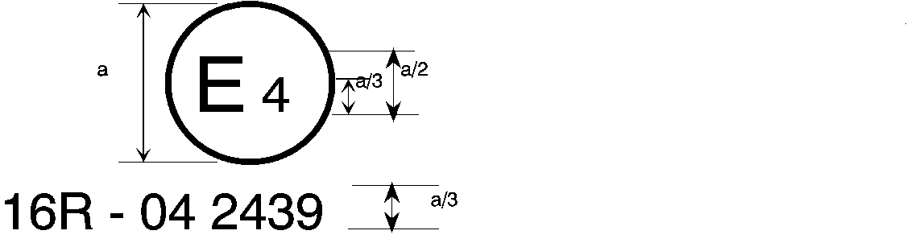

011 2439

The above … amended by the **11** series of amendments.

…

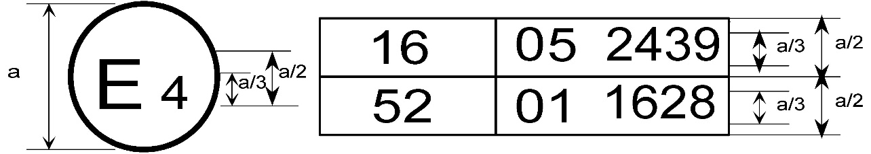

11 2439

The above … included the **11** series of amendments and Regulation No. 52 the 01 series of amendments.

…

2. Arrangements of the safety-belt approval marks (see paragraph 5.3.5. of this Regulation)



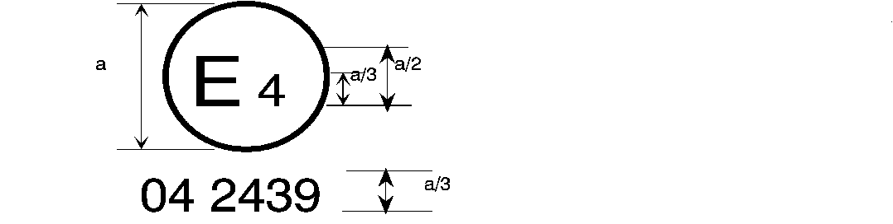

11 2439

a = 8 mm min.

The belt … the 06, 07**,** 08, 09, 10 or **11** series of amendments at the time of approval.

###### B → 4 m



**11** 2489

The belt … 06, 07**,** 08, 09 or **11** series of amendments at the time of approval.

…

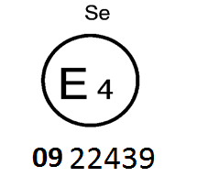

**11** 22439

The belt bearing … the 06, 07, 08, 09, 10 or **11** series of amendments at the time of approval.

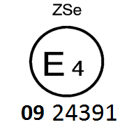

**11** 224391

The belt … the 06, 07**,** 08, 09, 10 or **11** series of amendments at the time of approval.



11 2439

a ≥ 8 mm

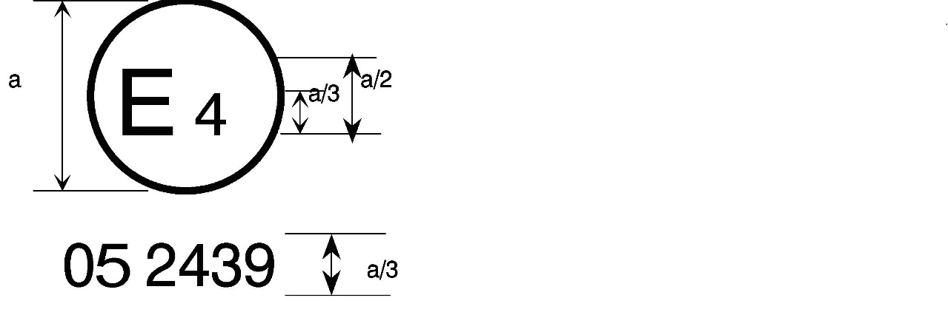

a = 8 mm min.



The belt … the 06, 07**,** 08, 09, 10 or **11** series of amendments at the time of approval. This belt shall not be fitted to vehicles of category M1.

Aer4m

**E4**

AIRBAG

**11**2439

The … 06, 07**,** 08, 09, 10 or **11** series of amendments at the time of the approval. This safety-belt has to be fitted to a vehicle equipped with an airbag in the given seating position."

**II. Justifications**

1. The amendment of paragraph 8.4.1.3. aims to clarify which folding seats are exempt from the SBR requirements. The wording "fitted in the access passages of vehicles of category M2 or M3" means to cover folding seats located in the entry and exit areas of buses and coaches, as well as folded or stowed seats for occasional usage in the aisle areas of such vehicles. The wording "fitted to N1 or N2 for the safe ingress and egress of the driver via the front passenger door" means to cover folding seats that can typically be found in delivery vans, and where this front passenger door is frequently used by the driver to safely exit the vehicle (on the vehicle side away from traffic).

2. The first level warning shall be activated whether the transmission is in neutral position or not. Hence Annex 18; 1. (c) is deleted.

3. For vehicles equipped without conventional devices to activate propulsion systems, "vehicle master control switch" definition is harmonized with other regulations, such as UN Regulation No. 159 and revised "master control switch" to "vehicle master control switch" in the text.

4. In the case of a remotely activated vehicle master control switch, the first cycle of the initial warning may already have ended before the driver enters the vehicle. The addition to paragraph 8.4.2.3.1. ensures that a driver will still receive the initial warning when entering the vehicle.

5. During an emergency call, it should be possible to have a clear voice communication inside the vehicle without additional audible warnings.

1. \* In accordance with the programme of work of the Inland Transport Committee for 2024 as outlined in proposed programme budget for 2024 (A/78/6 (Sect. 20), table 20.5), the World Forum will develop, harmonize and update UN Regulations in order to enhance the performance of vehicles. The present document is submitted in conformity with that mandate. [↑](#footnote-ref-2)
2. [↑](#footnote-ref-3)