|  |  |  |  |
| --- | --- | --- | --- |
|  | United Nations | ECE/TRANS/WP.29/2024/85 | |
| _unlogo | **Economic and Social Council** | | Distr.: General  16 April 2024  Original: English |

**Economic Commission for Europe**

Inland Transport Committee

**World Forum for Harmonization of Vehicle Regulations**

**193rd session**

Geneva, 25–28 June 2024

Items 14.3.1. of the provisional agenda

**1998 Agreement:  
Proposal for a corrigendum to a UN GTR, if any**

Proposal for Corrigendum 1 to UN Global Technical Regulation No. 13 (Hydrogen and Fuel Cell Vehicles)

Submitted by the Working Party on Passive Safety[[1]](#footnote-2)\*

The text reproduced below was adopted by the Working Party on Passive Safety (GRSP) at its seventy-fourth session (ECE/TRANS/WP.29/GRSP/74, paras. 6 and 7). It is based on ECE/TRANS/WP.29/GRSP/2023/26 as amended by annex III to the report. It is submitted to the World Forum for Harmonization of Vehicle Regulations (WP.29) and to the Executive Committee of the 1998 Agreement (AC.3) for consideration at their June 2024 sessions.

*Section H, paragraph 2 title,* amend to read:

"2. National Requirements Complementary to UN GTR Requirements"

*Section I, paragraph 190,* amend to read:

"190. … the requirements presented as optional requirements in this document (LHSS Section G of the preamble) could be adopted as requirements with appropriate modifications. "

*Section O, Table 10,* amend to read:

"Table 10

**Optional Tolerances for Test Parameters**

| *Paragraph* | *Test Parameter* | *Value* | *Optional Tolerance* | *Unit* |
| --- | --- | --- | --- | --- |
| *…* | | | | |
| *Distance* | | | | |
| 6.2.3.2. (a) (i) | Horizontal drop height | 1.8 m | ±0.02 | m |
| 6.2.3.2.**(b) (c)** | Vertical drop height | calculated drop height | ±0.02 | m |
| 6.2.3.2. **(d)** | 45° angle centre of gravity height | 1.8 m | ±0.02 | m |
| *…* |  |  |  |  |

"

*Table 1 in paragraph 3.52.,* amend to read:

" Table 1

**Compressed Hydrogen Density (g/l)**

|  |  |  |  |  |  |  |  |  |  |  |  |  |  |
| --- | --- | --- | --- | --- | --- | --- | --- | --- | --- | --- | --- | --- | --- |
| *Temperature*  *(°C)* | *Pressure (MPa)* | | | | | | | | | | | | |
| *1* | *10* | *20* | *30* | *35* | *40* | *50* | *60* | *65* | *70* | *75* | *80* | *87.5* |
| -40 | 1.0 | 9.7 | 18.1 | 25.4 | 28.6 | 31.7 | 37.2 | 42.1 | 44.3 | 46.1 | 48.4 | 50.3 | 53.0 |
| -30 | 1.0 | 9.4 | 17.5 | 24.5 | 27.7 | 30.6 | 36.0 | 40.8 | 43.0 | 45.1 | 47.1 | 49.0 | 51.7 |
| -20 | 1.0 | 9.0 | 16.8 | 23.7 | 26.8 | 29.7 | 35.0 | 39.7 | 41.9 | 43.9 | 45.9 | 47.8 | 50.4 |
| -10 | 0.9 | 8.7 | 16.2 | 22.9 | 25.9 | 28.7 | 33.9 | 38.6 | 40.7 | 42.8 | 44.7 | 46.6 | 49.2 |
| 0 | 0.9 | 8.4 | 15.7 | 22.2 | 25.1 | 27.9 | 33.0 | 37.6 | 39.7 | 41.7 | 43.6 | 45.5 | 48.1 |
| 10 | 0.9 | 8.1 | 15.2 | 21.5 | 24.4 | 27.1 | 32.1 | 36.6 | 38.7 | 40.7 | 42.6 | 44.4 | 47.0 |
| 15 | 0.8 | 7.9 | 14.9 | 21.2 | 24.0 | 26.7 | 31.7 | 36.1 | 38.2 | 40.2 | 42.1 | 43.9 | 46.5 |
| 20 | 0.8 | 7.8 | 14.7 | 20.8 | 23.7 | 26.3 | 31.2 | 35.7 | 37.7 | 39.7 | 41.6 | 43.4 | 46.0 |
| 30 | 0.8 | 7.6 | 14.3 | 20.3 | 23.0 | 25.6 | 30.4 | 34.8 | 36.8 | 38.8 | **40.6** | 42.4 | 45.0 |
| 40 | 0.8 | 7.3 | 13.9 | 19.7 | 22.4 | 24.9 | 29.7 | 34.0 | 36.0 | 37.9 | 39.7 | 41.5 | 44.0 |
| 50 | 0.7 | 7.1 | 13.5 | 19.2 | 21.8 | 24.3 | 28.9 | 33.2 | 35.2 | 37.1 | 38.9 | 40.6 | 43.1 |
| 60 | 0.7 | 6.9 | 13.1 | 18.7 | 21.2 | 23.7 | 28.3 | 32.4 | 34.4 | 36.3 | 38.1 | 39.8 | 42.3 |
| 70 | 0.7 | 6.7 | 12.7 | 18.2 | 20.7 | 23.1 | 27.6 | 31.7 | 33.6 | 35.5 | 37.3 | 39.0 | 41.4 |
| 80 | 0.7 | 6.5 | 12.4 | 17.7 | 20.2 | 22.6 | 27.0 | 31.0 | 32.9 | 34.7 | 36.5 | 38.2 | 40.6 |
| 85 | 0.7 | 6.4 | 12.2 | 17.5 | 20.0 | 22.3 | 26.7 | 30.7 | 32.6 | 34.4 | 36.1 | 37.8 | 40.2 |

"

*Paragraph 6.2.3.2.,* amend to read:

"6.2.3.2. Drop (impact) test (unpressurized)

…

(d) From a 45° angle from the vertical orientation with the shut-off valve interface location downward with its centre of gravity at 1.8 m above the ground. However, if the bottom is closer to the ground than 0.6 m, the drop angle shall be changed to maintain a minimum height of 0.6 m and a centre of gravity at 1.8 m above the ground. In case of non-axisymmetric container, the line passing the shut-off valve interface location end and its centre of gravity shall be 45° angled from vertical orientation and the shut-off valve interface location shall become the lowest.

…"

*Figure 3 in paragraph 6.2.3.2.,* amend to read (correct the place of words in the drawing):

"Figure 3

**Drop Orientations**

**1.8 m**

**≥ 488 J**

**≤ 1.8 m**

**45°**

**≥ 0.6 m**

**No. 1**

**No.**

**2**

**No.**

**3**

**No.**

**4**

**centre of gravity**

"

*Paragraph 6.2.5.4.5.3.,* amend to read:

**"**6.2.5.4.5.3. The 60-second rolling averages of individual temperature readings in the localized fire zone (i.e. TBLOC, TMFLOC, TMRLOC and TULOC) and the engulfing fire zone (i.e. TBR, TBC, TBL, TMRF, TMCF, TMLF, TMRR, TMCR, TMLR, TUR, TUC and TUL) shall be …"

*Figure 3 (Example of a hydrogen fuel cell bus), three labels of "High Voltge Lines",* amend to read:

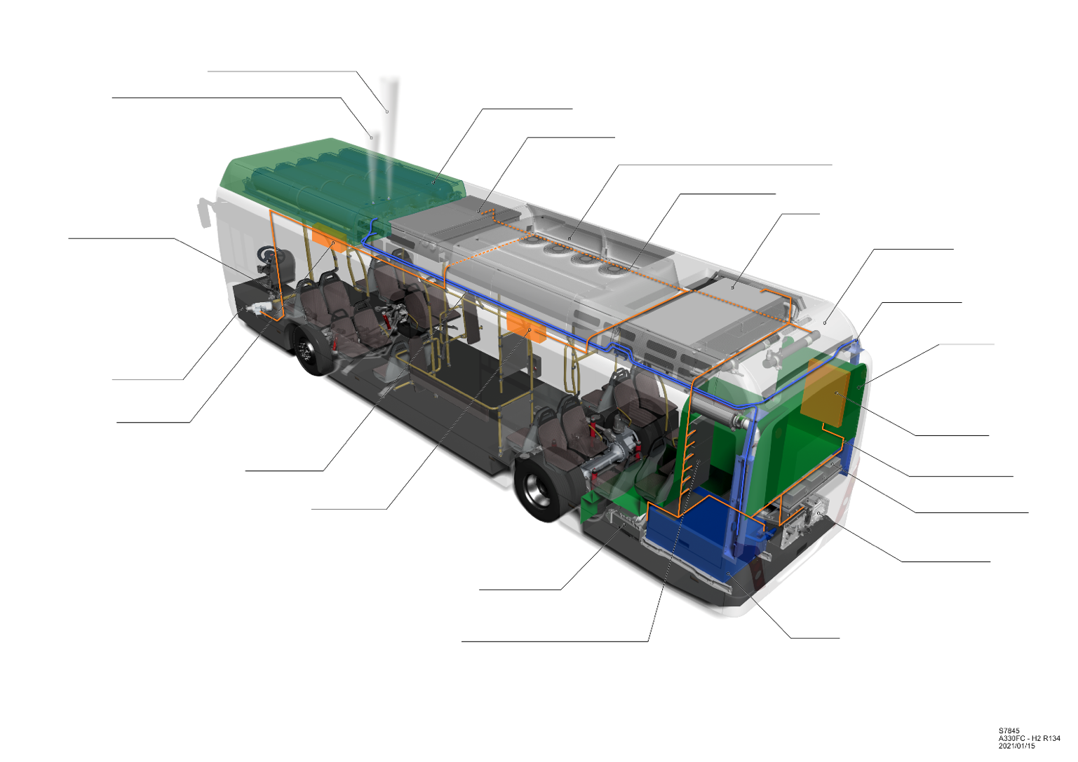

**High Voltage Lines**

Low-pressure blow-off Line (maintenance)

Hydrogen Tanks

Traction Battery

Climate control / Traction Battery Cooler

**High Voltage Lines**

Cooler

Brake Resistor

Hydrogen Line

Bulkhead

Junction Box

**High Voltage Line**s

Converters / Inverters

Air Compressor

Fuel Cell

Servo Pump

Junction Box

Junction Box

Hydrogen Line

Traction Motor

Converters secondary Consumers

High-pressure blow-off Line

"

*Table 1 (Results of Japanese Study),* amend to read (such that 5,500 is actually deleted and not just crossed out):

| *Vehicle Type* | *Max svc. Life* | *Max lifetime miles travelled* | *Lifetime No. of fills*  *("pressure test cycles")* | *Ref: UN GTR13 Phase 2 Proposal* |
| --- | --- | --- | --- | --- |
| HD Commercial | 15 yrs  20 yrs  25 yrs | --  3,500,000 km  4,000,000 km | --  8,450  9,750 | 11,000  11,000  11,000 |
| LD Commercial | 15 yrs  20 yrs  25 yrs | --  2,100,000 km  2,400,000 km | --  6,560  7,440 | 7,500 or 11,000  11,000  11,000 |

"

*Paragraph 78.(a)(iv),* amend to read:

"78. …

(a) …

(iv) … While it is difficult to get a single data-based fuelling interval value for hydrogen fuelled HDVs, an assumption of 400 km (250 mi.) can be a sufficiently conservative values; "

*Figure 10,* amend to read (such that x-axis label is consistent with the paragraph above it):

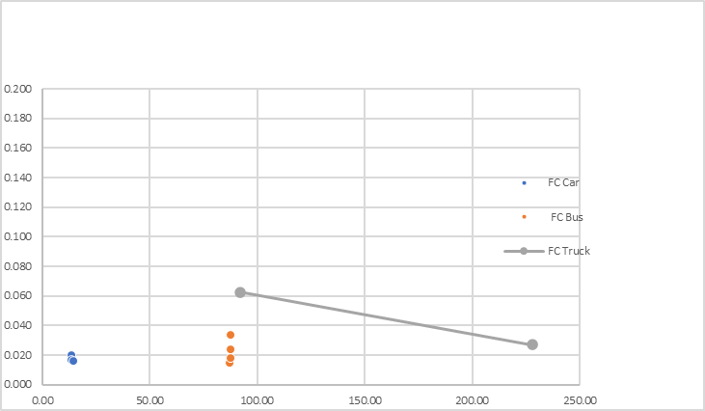

Ventilation Rate (1/Hour)

Vehicle Size (m3)

**46 mL/h/L** ~~mL/L/H~~ CHSS Permeation/Leakage

Less Than 25% LFL

*Less than 0.18 air exchanges per hour*

*House with "Tight" Attached Garage*

*Tractor Only*

*With Trailor*

"

*Figure 29 (Top View Showing Extension of the Engulfing Fire Zone Toward the Nearest TPRD on a Cylinder),* amend to read:

Extension for Engulfing

TPRD

Localized

*"Case 1*

*Nearest TPRD Located on the Axis of the Cylinder*

Localized

Extension for Engulfing

TPRD

*Case 2*

*Nearest TPRD Located Off -axis on the Cylinder Wall*

"

*Paragraph 3.28., amend to read:*

"3.28. "*Hydrogen-fuelled vehicle"* indicates any motor vehicle that uses compressed gaseous or liquefied hydrogen… Hydrogen fuel for the vehicles is specified in ISO 14687:2019 and SAE J2719\_202003."

*Figure 2 (Verification Test for Expected On-Road Performance (Pneumatic~~/hydraulic~~)),* amend to read:

"Figure 2  
**Verification Test for Expected On-Road Performance (Pneumatic)**"

*Figure 12 in paragraph 88,* amend to read (corrected labels, no changes to values):

"

"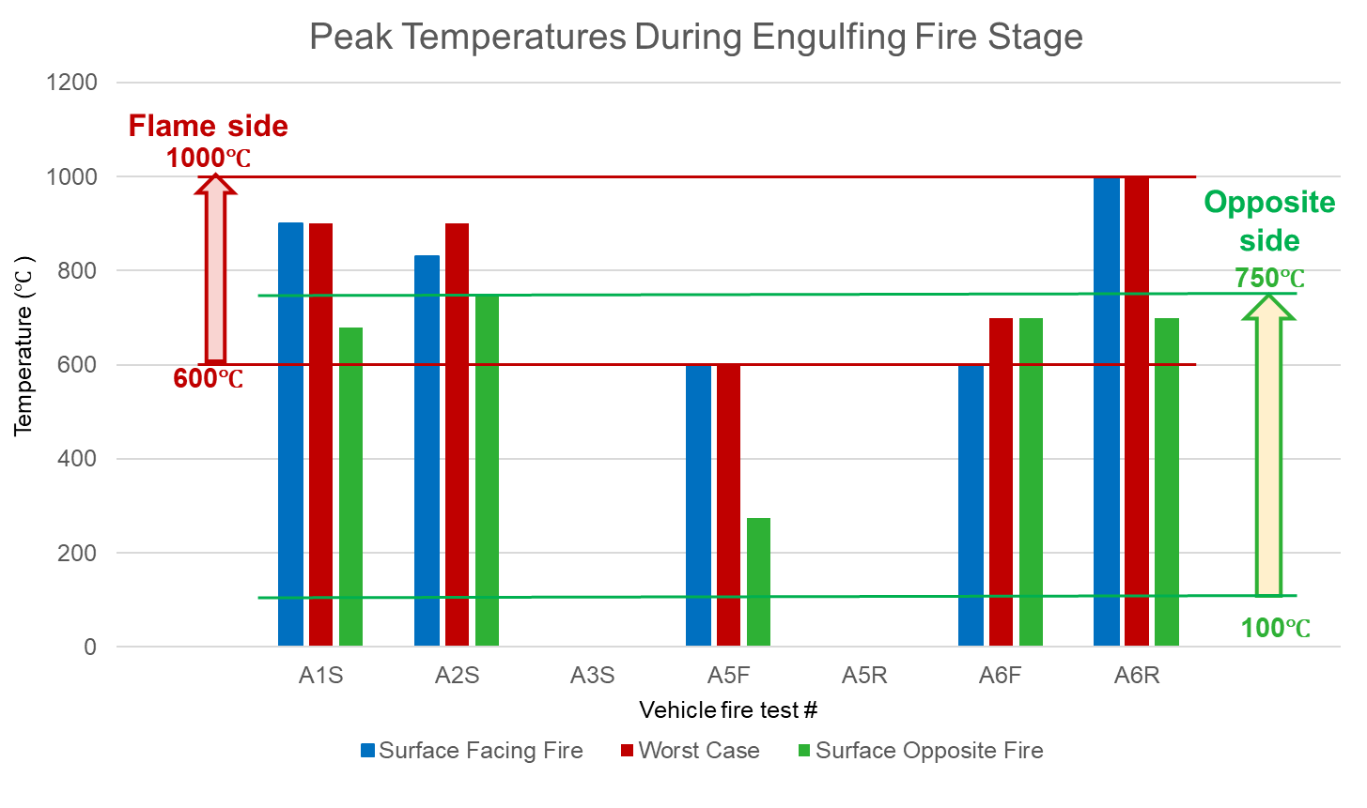

**Temperature (°C)**

**Surface Opposite Fire**

**Vehicle Fire test**

**Worst Case**

**Surface Facing Fire**

**Opposite side**

**Flame side**

Peak Temperatures During Engulfing Fire Stage

1. \* In accordance with the programme of work of the Inland Transport Committee for 2024 as outlined in proposed programme budget for 2024 (A/78/6 (Sect. 20), table 20.5), the World Forum will develop, harmonize and update UN Regulations in order to enhance the performance of vehicles. The present document is submitted in conformity with that mandate. [↑](#footnote-ref-2)