|  |  |  |  |
| --- | --- | --- | --- |
|  | United Nations | ECE/TRANS/WP.29/GRE/2024/4 | |
| Description: _unlogo | **Economic and Social Council** | | Distr.: General  6 February 2024  Original: English |

**Economic Commission for Europe**

Inland Transport Committee

**World Forum for Harmonization of Vehicle Regulations**

**Working Party on Lighting and Light-Signalling**

**Ninetieth session**

Geneva, 29 April – 3 May 2024

Item 6 (a) of the provisional agenda

**Installation UN Regulations: UN Regulation No. 48 (Installation of lighting and light-signalling devices)**

Proposal for a Supplement to the 06, 07 and 08 series of amendments to UN Regulation No. 48

Submitted by the experts from the International Automotive Lighting and Light-Signalling Expert Group [[1]](#footnote-2)\*

The text reproduced below was prepared by the experts from the International Automotive Lighting and Light-Signalling Expert Group (GTB) with the aim to align the requirements for off-road vehicles passing-beam vertical inclination between the 06, 07, 08 series and the 09 series of amendments to UN Regulation No. 48. The proposed modifications to the current text of the UN Regulations are marked in bold for new or strikethrough for deleted characters.

I. Proposal

*Paragraph 6.2.6.1.2.*, amend to read:

“6.2.6.1.2. Depending on the mounting height in metres (h) of the lower edge of the apparent surface in the direction of the reference axis of the dipped‑beam headlamp, measured on the unladen vehicles, the vertical inclination of the cut‑off of the dipped beam shall, under all the static conditions of Annex 5, remain between the following limits and the initial aiming shall have the following values:

h < 0.8

Limits: between ‑0.5 per cent and ‑2.5 per cent

Initial aiming: between ‑1.0 per cent and ‑1.5 per cent

0.8 < h < 1.0

Limits: between ‑0.5 per cent and ‑2.5 per cent

Initial aiming: between ‑1.0 per cent and ‑1.5 per cent

Or, at the discretion of the manufacturer,

Limits: between ‑1.0 per cent and ‑3.0 per cent

Initial aiming: between ‑1.5 per cent and ‑2.0 per cent

The application for the vehicle type‑approval shall, in this case, contain information as to which of the two alternatives is to be used.

h > 1.0

Limits: between ‑1.0 per cent and ‑3.0 per cent

Initial aiming: between ‑1.5 per cent and ‑2.0 per cent

The above limits and the initial aiming values are summarized in the diagram below.

For category **N2G,** N3G, **M2G, M3G** (off-road) vehicles where the headlamps exceed a height of 1,200 mm, the limits for the vertical inclination of the cut-off shall be between: -1.5 per cent and -3.5 per cent.

The initial aim shall be set between: -2 per cent and -2.5 per cent.

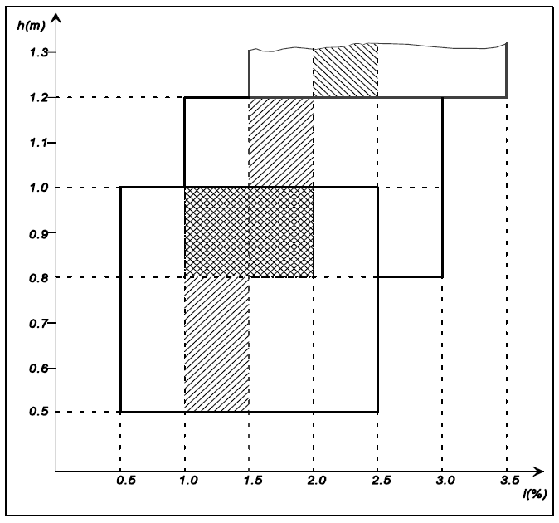

”

II. Justification

1. The 09 series of amendments to UN Regulation No. 48 has clarified the requirements for M2G, M3G, N2G and N3G (off-road) vehicles about the passing-beam vertical inclination depending on the mounting height of the headlamps.

2. This proposal is intended to align these requirements among the different series of amendments by extending the provisions in the 09 series to the 06, 07 and 08 series of amendments to UN Regulation No. 48.

\_\_\_\_\_\_\_\_\_\_\_\_\_

1. \* In accordance with the programme of work of the Inland Transport Committee for 2024 as outlined in proposed programme budget for 2024 (A/78/6 (Sect. 20), table 20.5), the World Forum will develop, harmonize and update UN Regulations in order to enhance the performance of vehicles. The present document is submitted in conformity with that mandate. [↑](#footnote-ref-2)