|  |  |  |  |
| --- | --- | --- | --- |
|  | United Nations | ECE/TRANS/WP.29/GRE/2024/2 | |
| Description: _unlogo | **Economic and Social Council** | | Distr.: General  6 February 2024  Original: English |

**Economic Commission for Europe**

Inland Transport Committee

**World Forum for Harmonization of Vehicle Regulations**

**Working Party on Lighting and Light-Signalling**

**Ninetieth session**

Geneva, 29 April – 3 May 2024

Item 5 of the provisional agenda

**UN Regulations on Light Sources and the Consolidated Resolution**

**on the Common Specification of Light Source Categories**

Proposal for Amendment [x] to the Consolidated Resolution on the common specification of light source categories (R.E.5)

**Submitted by the Task Force on Substitutes and Retrofits**[[1]](#footnote-2)\*

The text reproduced below was prepared by the Task Force on Substitutes and Retrofits (TF SR), with the aim to amend the Consolidated Resolution on the common specification of light source categories (R.E.5) (ECE/TRANS/WP.29/1127) by introducing an alternative configuration for the light emitting diode replacement (LEDr) light source category H11. This proposal is based on GRE-89-05, presented at the eighty-ninth session of the Working Party on Lighting and Light-Signalling (GRE). The technical provisions are based on the principle of “intelligent equivalence” as endorsed at the eighty-eighth and eighty-ninth sessions of GRE (refer to GRE-88-13 and GRE-89-06). The modifications to the existing H11 LEDr category of the R.E.5 are as follows:

* H11\_LEDr/3: to be replaced by the proposal in this document
* H11\_LEDr/6: to be replaced by the proposal in this document
* H11\_LEDr/7: to be replaced by the proposal in this document

Informal document GRE-90-02 contains all sheets and visualises the changes in coloured highlights. There are no associated amendments to UN Regulations Nos. 37, 99 or 128.

I. Proposal

*Sheet H11\_LEDr/3*, replace by a new sheet H11\_LEDr/3, to read:

**“ Category H11 Sheet H11\_LEDr/3**

Alternative configurations

Two alternative configurations are allowed and the technical description given by the manufacturer contains the information which of them applies. The differences between both configurations affect only the “Screen projection requirements” and “Normalized luminous intensity distribution”. For reference purposes in the relevant paragraphs, the alternatives are called Configuration-1 (based on full photometric light source equivalence) and Configuration-2 (based on bi-directional light source design).

Screen projection requirements

The following test is intended to define the requirements for the apparent light emitting area of the LED light source and to determine whether the light emitting area is correctly positioned relative to the reference axis and reference plane in order to check compliance with the requirements.

In case of Configuration-1 the position of the light emitting area is checked by a box system defined in Figure 4 when operated at test voltage, which shows the projections when viewing from B (see sheet H11 LEDr/1, Figure 1) and from A and –A (see sheet H11 LEDr/1, Figure 1), i.e. along the C-planes C0, C90 and C270 (as defined in Figure 6).

In case of Configuration-2 the position of the light emitting area is checked by a box system defined in Figure 4 when operated at test voltage, which shows the projections when viewing from A and –A (see sheet H11 LEDr/1, Figure 1), i.e. along the C-planes C90 and C270 (as defined in Figure 6). The distance z between the surfaces of the opposite light emitting areas shall not exceed 2.9 mm.

In both configurations, the proportion of the total luminous flux emitted into these viewing directions from the area(s) as defined in Figure 4:

* Total box area: (A+B+C) / E shall be not less than 90%
* Area A: A / (A+B+C) shall be not more than 10%
* Areas B1, B2 and B3: B1/B, B2/B, B3/B shall each be not less than 15%
* Area B: B / (A+B+C) shall be not less than 72 %
* Area C: C / (A+B+C) shall be not more than 22%

Figure 4

**Box definition of the light emitting area (dimensions given in Table 2)**

c1

x1

x2

c2

b1

b2

y1

y1

e

a1/2

a2

**E**

**B1**

**B2**

**B3**

**C**

**B**

**A**

Reference axis

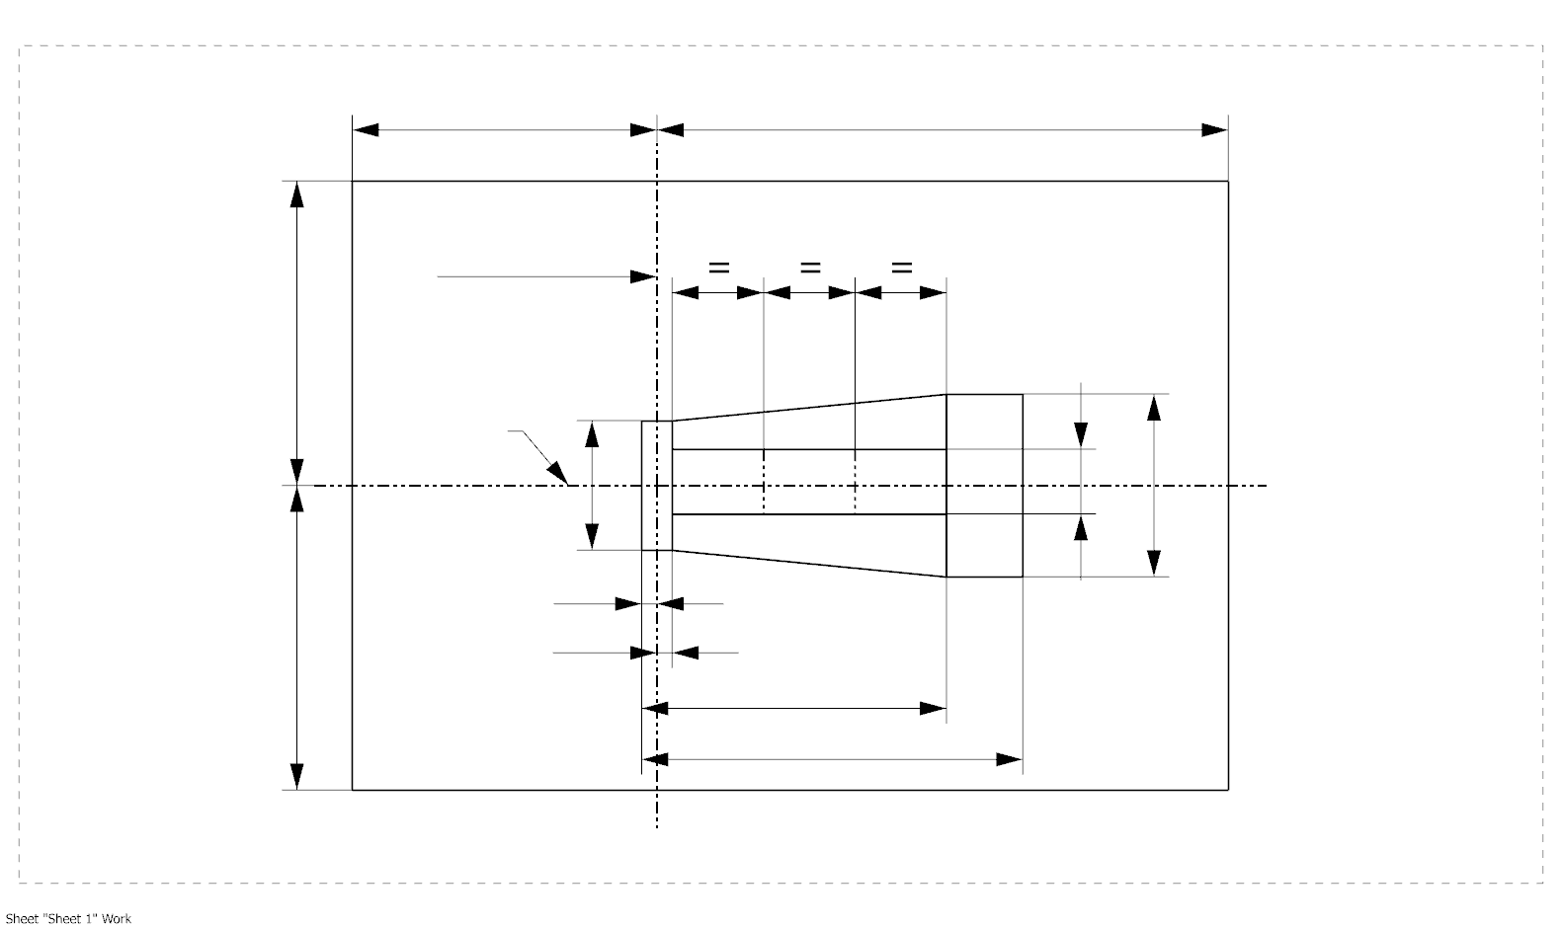

a1

In both configurations, the contrast is checked by a box system defined in Figure 5 when operated at test voltage, which shows the projections when viewing from A and –A (see sheet H11 LEDr/1, Figure 1), i.e. along the C-planes C90 and C270 (as defined in Figure 6).”

*Sheet H11\_LEDr/6*, replace by a new sheet H11\_LEDr/6, to read:

**“ Category H11 Sheet H11\_LEDr/6**

Table 3 – Part 1

**Test point values of normalized intensity (Black top area)**

|  |  |  |
| --- | --- | --- |
| *LED light source of normal production* | | |
|  | *Minimum intensity (cd/klm)* | *Maximum intensity (cd/klm)* |
|  | C0, C90, C180, C270 | C0, C90, C180, C270 |
| 0° | n/a | 10 |
| 10° | n/a | 10 |
| 20° | n/a | 10 |
| 30° | n/a | 10 |

The light pattern as described in Table 3 – part 1 shall be substantially uniform, i.e. in between two adjacent grid points the relative luminous intensity requirement is calculated by linear interpolation using the two adjacent grid points. In case of doubt this may be checked in addition to verification of the grid points given in Table 3 – part 1.

*Note: The angular range in Table 3 – Part 1 is equivalent to the black top of its counterpart H11 filament light source specified by 3 in sheet H11/3.*

Table 3 – Part 2

**Test point values of normalized intensity (Distortion free area)**

|  |  |  |  |  |
| --- | --- | --- | --- | --- |
|  | *LED light source of normal production* | | | |
|  | *Minimum intensity (cd/klm)* | | *Maximum intensity (cd/klm)* | |
|  | Configuration-1 | Configuration-2 | Configuration-1 | Configuration-2 |
|  | C0, C90, C270 | C90, C270 | C0, C90, C270 | C90, C270 |
| 50° | 80 | 100 | 130 | 160 |
| 60° | 80 | 115 | 130 | 175 |
| 70° | 80 | 125 | 130 | 185 |
| 80° | 80 | 130 | 130 | 190 |
| 90° | 80 | 130 | 130 | 190 |
| 100° | 80 | 130 | 130 | 190 |
| 110° | 80 | 125 | 130 | 185 |
| 120° | 80 | 115 | 130 | 175 |
| 130° | 80 | 100 | 130 | 160 |
| 140° | 80 | 80 | 130 | 145 |

The light pattern as described in Table 3 – part 2 (excluding the section between C90 and C270 and for Configuration-2 additionally excluding the section between C270 and C90) shall be substantially uniform, i.e. in between two adjacent grid points the relative luminous intensity requirement is calculated by linear interpolation using the two adjacent grid points. In case of doubt this may be checked in addition to verification of the grid points given in Table 3 – part 2.

*Note:* *The angular range in Table 3 – Part 2 is equivalent to the distortion free area of its counterpart H11 filament light source specified by* 2 *and* 1 *in sheet H11/3.”*

*Sheet H11\_LEDr/7*, replace by a new sheet H11\_LEDr/7, to read:

**“ Category H11 Sheet H11\_LEDr/7**

Table 3 – Part 3

**Test point values of normalized intensity (Shading area of the lead-in wire of the counterpart filament light source)**

|  |  |  |  |  |
| --- | --- | --- | --- | --- |
|  | *LED light source of normal production* | | | |
|  | *Minimum intensity (cd/klm)* | | *Maximum intensity (cd/klm)* | |
|  |  = 90° | |  |  = 90° |
| C-plane | Configuration-1 | Configuration-2 | Configuration-1 | Configuration-2 |
| C0 | 80 | n.a. | 130 | n.a. |
| C30 | 80 | 50 | 130 | 130 |
| C60 | 80 | 110 | 130 | 175 |
| C90 | 80 | 130 | 130 | 190 |
| C120 | 80 | 110 | 130 | 175 |
| C150 | 80 | 50 | 130 | 130 |
| C180 | n/a | n.a. | n/a | n.a. |
| C210 | 80 | 50 | 130 | 130 |
| C240 | 80 | 110 | 130 | 175 |
| C270 | 80 | 130 | 130 | 190 |
| C300 | 80 | 110 | 130 | 175 |
| C330 | 80 | 50 | 130 | 130 |
| C360 (= C0) | 80 | n.a. | 130 | n.a. |

The light pattern as described in Table 3 – part 3 (excluding the section between C150 and C210 and for Configuration-2 additionally excluding the section between C330 and C30) shall be substantially uniform, i.e. in between two adjacent grid points the relative luminous intensity requirement is calculated by linear interpolation using the two adjacent grid points. In case of doubt this may be checked in addition to verification of the grid points given in Table 3 – part 3.

*Note: Due to the shading area created by the lead-in wire of its counterpart H11 filament light source (opposite to the metal-free zone; see Figure 4 on sheet H11/2) there is no requirement in the C180-plane.*"

II. Justification

1. This proposal specifies an alternative approach (“configuration 2”) for the H11 LED replacement light source category, by amending the existing category sheet in the following sections:

* Screen projection requirements (near field characteristics; sheet H11\_LEDr/3)
* Normalized luminous intensity distribution (far field characteristics; sheets H11\_LEDr/6 and H11\_LEDr/7)

2. The existing approach for the H11 LED replacement light source category, based on full photometric equivalence, is kept, and it is referred to as “configuration 1”.

3. The following specifications exist already for “configuration 1” and will equally apply to “configuration 2”; accordingly, no changes are needed in the corresponding parts of the category sheet:

* Mechanical/geometrical
* Electrical
* Thermal
* Luminous flux, colour and contrast

4. The proposed specifications of “configuration 2” describe a bi-directional emission characteristic, which enables a more efficient beam generation for road illumination devices. In the recent past this was confirmed by numerous headlamp measurements, which are required for national type-approval of a LED replacement light source in Germany and France. All those measurements show full beam compliance with:

* Same or more light in the regulated range (25 to 75 m in front of the car)
* Same or less light in the unregulated range (less than 25 m in front of the car)
* No increase of intensity values in the glare zone of the beam

5. Further, the light technical principle was analysed and confirmed during a lab demo session of the TF SR with a selection of representative headlamps (see informal document TFSR-17-05).

1. \* In accordance with the programme of work of the Inland Transport Committee for 2024 as outlined in proposed programme budget for 2024 (A/78/6 (Sect. 20), table 20.5), the World Forum will develop, harmonize and update UN Regulations in order to enhance the performance of vehicles. The present document is submitted in conformity with that mandate. [↑](#footnote-ref-2)