|  |  |  |  |
| --- | --- | --- | --- |
|  | United Nations | ECE/TRANS/WP.15/AC.1/2024/8 | |
| _unlogo | **Economic and Social Council** | | Distr.: General  18 December 2023  Original: English |

**Economic Commission for Europe**

Inland Transport Committee

**Working Party on the Transport of Dangerous Goods**

**Joint Meeting of the RID Committee of Experts and the  
Working Party on the Transport of Dangerous Goods**

Bern, 25-28 March 2024

Item 5 (b) of the provisional agenda

**Proposals for amendments to RID/ADR/ADN:**

**New proposals**

New transitional measures for portable tanks in 6.7

Transmitted by the Government of Spain and the European Industrial Gases Association (EIGA)[[1]](#footnote-2)\*,[[2]](#footnote-3)\*\*

I. Introduction

1. In document ECE/TRANS/WP.15/AC.1/2023/23/Add.1, submitted to the September 2023 Joint Meeting, the Ad Hoc Working Group on the Harmonization of RID/ADR/ADN with the United Nations Recommendations on the Transport of Dangerous Goods proposed changes to RID/ADR/ADN on the use of the terms “degree of filling” and “filling ratio”.

2. While EIGA agreed to the proposed changes, there was an oversight of required transitional measures.

3. The amendments to 6.7.4.15.1 (i)(iv) would require a modification to the tank plates of existing portable tanks, specifically changing “Degree of filling” to “Maximum allowable mass of gas filled”; see picture below.

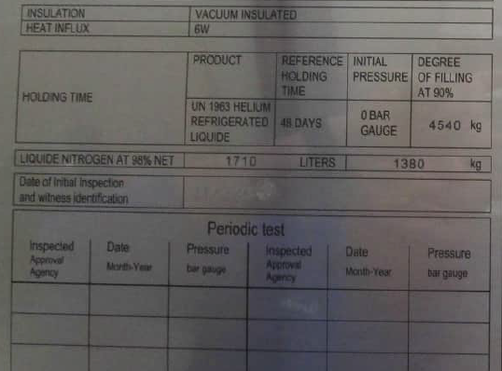

4. In most cases, the space on the current tank plates is limited and a completely new tank plate would have to be applied in cooperation with a notified body.

5. For some portable tanks already in use, the manufacturer of the unit no longer exists, making the creation of a new tank plate problematic.

6. Even if there is enough space on the existing tank plates, it will not be feasible to have these changes done on all portable tanks in use until 1 July 2025. Portable tanks are used worldwide and may only visit a site capable of changing the tank plates at the next periodic or intermediate inspection of the unit.

7. At its recent sixty-third session, the Sub-Committee of Experts on the Transport of Dangerous Goods adopted a transitional measure in this regard, as proposed in informal document INF.54 (sixty-third session). The proposal below is aimed at resolving the issue at hand and harmonising RID/ADR/ADN with the adopted text.

II. Proposal

8. In 1.6.4 insert a new transitional measure (underlined) as follows:

“1.6.4.XX Portable tanks constructed before 1 January 2027 in accordance with the requirements in force up to 31 December 2024, but which do not, however, meet the requirements of 6.7.4.15.1 (i)(iv) applicable as from 1 January 2025 may continue to be used.”

III. Justification

9. The changes proposed on “degree of filling” have no safety implications.

10. Having to perform changes on or replacing existing tank plates would put an unjustified burden on the operators of such units.

11. If the manufacturer of portable tanks in use no longer exists, this makes the required changes even more problematic.

1. \* A/78/6 (Sect. 20), table 20.5. [↑](#footnote-ref-2)
2. \*\* Circulated by the Intergovernmental Organisation for International Carriage by Rail (OTIF) under the symbol OTIF/RID/RC/2024/8. [↑](#footnote-ref-3)