|  |  |  |
| --- | --- | --- |
|  | E/ECE/324/Rev.1/Add.78/Rev.4/Amend.9−E/ECE/TRANS/505/Rev.1/Add.78/Rev.4/Amend.9 | |
|  |  | 16 February 2023 |

Agreement

Concerning the Adoption of Harmonized Technical United Nations Regulations for Wheeled Vehicles, Equipment and Parts which can be Fitted and/or be Used on Wheeled Vehicles and the Conditions for Reciprocal Recognition of Approvals Granted on the Basis of these United Nations Regulations[1]*

(Revision 3, including the amendments which entered into force on 14 September 2017)

_________

Addendum 78 – UN Regulation No. 79

Revision 4 - Amendment 9

Supplement 8 to the 03 series of amendments – Date of entry into force: 4 January 2023

Uniform provisions concerning the approval of vehicles with regard to steering equipment

This document is meant purely as documentation tool. The authentic and legal binding text is: ECE/TRANS/WP.29/2022/80.

**_________**

**UNITED NATIONS**

*Paragraph 2.4.17.,* amend to read:

“2.4.17. A "*Lane Change Manoeuvre*" is part of the *Lane Change Procedure* and,

(a) Starts when the outside edge of the tyre tread of the power driven vehicle’s front wheel closest to the lane markings touches the inside edge of the lane marking to which the vehicle is being manoeuvred,

(b) Ends when the rear wheels of the power driven vehicle (or combination) have fully crossed the lane marking.”

*Paragraph 2.7.*, amend to read:

“2.7. "*Electric control line*" means the electrical connection between two vehicles which provides the steering control function to a towed vehicle within a combination. It comprises the electrical wiring and connector and includes the parts for data communication and the electrical energy supply for the trailer control transmission.”

*Insert new paragraphs 2.8. and 2.9.*, to read:

“2.8. "*Data communication*" means the transfer of digital data under the rules of a protocol.

2.9. "*Point-to-point*" means a topology of a communication network with only two units. Each unit has an integrated termination resistor for the communication line.”

*Paragraph 5.1.6.1.1.*,amend to read:

“5.1.6.1.1. Every CSF intervention shall immediately be indicated to the driver by an optical warning signal which is displayed for at least 1 s or as long as the intervention exists, whichever is longer.

When a flashing mode is used, a lighting phase shall be visible at the end of the intervention or later.

In the case of a CSF intervention which is controlled by an Electronic Stability Control (ESC) or a Vehicle Stability Function as specified in the relevant UN Regulation (i.e. UN Regulations Nos. 13, 13-H or 140), the ESC flashing tell-tale indicating the interventions of ESC may be used, as long as the intervention exists, as an alternative to the optical warning signal specified above.”

*Paragraph 5.3.3.1.*, amend to read:

“5.3.3.1. The system shall be designed such that the vehicle cannot be driven indefinitely at speeds above 10 km/h where there is any fault which requires operation of the warning signal referred to in paragraph 5.4.2.1.1.”

*Paragraph 5.6.4.,* amend to read:

“5.6.4. Special Provisions for ACSF of Category C

Power-driven vehicles equipped with an ACSF of Category C and trailers supporting lane change function(s) shall fulfil the relevant following requirements.”

*Paragraph 5.6.4.1.1.,* amend to read:

“5.6.4.1.1. A power-driven vehicle equipped with an ACSF of Category C shall also be equipped with an ACSF of Category B1 complying with the requirements of this UN Regulation.”

*Insert a new paragraph 5.6.4.5.5.1.,* to read:

“5.6.4.5.5.1. In case the vehicle is coupled to a trailer of Category O3 or O4 supporting lane change function(s), the system failure signal transmitted from the trailer via the electric control line shall trigger the aforementioned warning signal accordingly.”

*Paragraph 5.6.4.8.1.(original) shall be restructured as follow*:

*Paragraph 5.6.4.8.1.,* amend to read:

“5.6.4.8.1. Rear detection and minimum operation speed”

*Insert new paragraph 5.6.4.8.1.1.*

*Paragraph 5.6.4.8.1.1.,* amend to read:

“5.6.4.8.1.1. Specific requirements applicable to power-driven vehicles able to assist lane change in solo condition and to trailers of Category O3 or O4 supporting lane change function(s)

The ACSF of Category C shall be able to detect vehicles approaching from the rear in an adjacent lane up to a distance Srear as specified below:

The minimum distance Srear shall be declared by the vehicle manufacturer. The declared value shall not be less than 55 m.

The declared distance shall be tested according to the relevant test in Annex 8 using a two-wheeled motor vehicle of Category L31 as the approaching vehicle.

Additionally, for trailers supporting lane change function, the detection area specified in paragraph 5.6.4.8.2. shall be extended to the sides of the trailer including the coupling device.”

*Insert new paragraph 5.6.4.8.1.2.,* to read:

“5.6.4.8.1.2. Specific requirements applicable to power-driven vehicles of Category N2 and N3 able to assist lane change when coupled to a trailer of Category O3 or O4 supporting lane change functions:

(a) The detection area specified in paragraph 5.6.4.8.2. shall apply to the sides of the power-driven vehicle, while the detection behind the rearmost point of the vehicle shall be deemed optional.

(b) The vehicle shall fulfil the requirements of paragraph 5.6.4.9.

(c) The ACSF of Category C shall be deactivated (off mode) if the coupled trailer of Category O3 or O4 is not fulfilling the requirements of paragraph 5.6.4.9. (Unless the power-driven vehicle is able to assist lane change when coupled to a trailer not supporting lane change functions, as specified in paragraph 5.6.4.8.1.3.).”

*Insert new paragraph 5.6.4.8.1.3.,* to read:

“5.6.4.8.1.3. Specific requirements applicable to power-driven vehicles of Category N2 and N3 able to assist lane change when coupled to a trailer of Category O3 or O4 not supporting lane change functions:

(a) The minimum distance Srear shall be declared by the vehicle manufacturer. The declared value shall be specified from to the rearmost point of the trailer and shall not be less than 55 m.

The declared distance Srear shall be tested with a trailer not supporting lane change function(s) according to the relevant test in Annex 8 using a two-wheeled motor vehicle of Category L31 as the approaching vehicle.

(b) The vehicle manufacturer shall also declare the maximum trailer length LT up to which the power-driven vehicle is able to perform a lane change manoeuvre. LT shall be specified as the distance between the coupling point of the trailer (e.g. the kingpin of a semi-trailer, the drawbar eye of a full-trailer) and its rearmost point.

The power-driven vehicle shall use the relevant information(s) transmitted from the trailer (e.g. via the electric control line) to assess the actual length of the coupled trailer or alternatively from detection means belonging to the towing vehicle. In case the coupled trailer is longer than the maximum trailer length LT or if the information of the actual trailer lengthis not available, the ACSF-C shall be deactivated (off mode).

The vehicle manufacturer shall demonstrate, to the satisfaction of the technical services (e.g. by simulating the relevant messages from the trailer), that the ACSF-C is deactivated once the trailer length is higher than the specified value LT or the trailer length is not known by the power-driven vehicle.

(c) Additionally, the detection area specified in paragraph 5.6.4.8.2. shall be extended to the sides of the combination.”

*Insert new paragraph 5.6.4.8.1.4. (former paragraph 5.6.4.8.1.),* to read:

“5.6.4.8.1.4. The minimum operation speed Vsmin , down to which the ACSF of Category C is permitted to perform a lane change manoeuvre, shall be calculated with minimum distance Srear using the following formula:

$$V_{Smin}= a*\left(t_{B}-t_{G}\right)+v_{app}-\sqrt{a^{2}*{(t_{B}-t_{G})}^{2}- 2*a*(v_{app}*t_{G}-S_{rear})}$$

Where:

Srear is The minimum distance declared by the manufacturer in [m];

Vapp = 36.1 m/s (The speed of the approaching vehicle is   
130 km/h *i.e.* 36.1 m/s);

a = 3 m/s² (Deceleration of the approaching vehicle);

tB = 0.4 s (Time after the start of the manoeuvre at which the deceleration of the approaching vehicle starts);

tG = 1 s (Remaining gap of the vehicles after the deceleration of the approaching vehicle);

Vsmin in [m/s] is The resulting minimum activation speed of the ACSF of Category C.

If the vehicle is operated in a country with a general maximum speed limit below 130 km/h, this speed limit may be used as an alternative for Vapp in the above formula to calculate the minimum operation speed Vsmin. In this case the vehicle shall be equipped with a means to detect the country of the operation and shall have information available on the general maximum speed limit of this country.

Notwithstanding the requirements above in paragraph 5.6.4.8.1., the ACSF of Category C is permitted to perform a lane change manoeuvre at speeds lower than the calculated Vsmin provided that the following conditions are met:

(a) The system has detected another vehicle in the adjacent lane into which the lane change is planned at a distance lower than Srear ; and

(b) The situation is not deemed to be critical according to paragraph 5.6.4.7. (e.g. at low speed differences and Vapp< 130 km/h);

(c) The declared value Srear is greater than the calculated value Scritical from paragraph 5.6.4.7. above.”

*Paragraph 5.6.4.8.2.,* amend to read:

“5.6.4.8.2. Detection area on ground level

The vehicle system detection area on ground level shall be at minimum as shown in the figure below.”

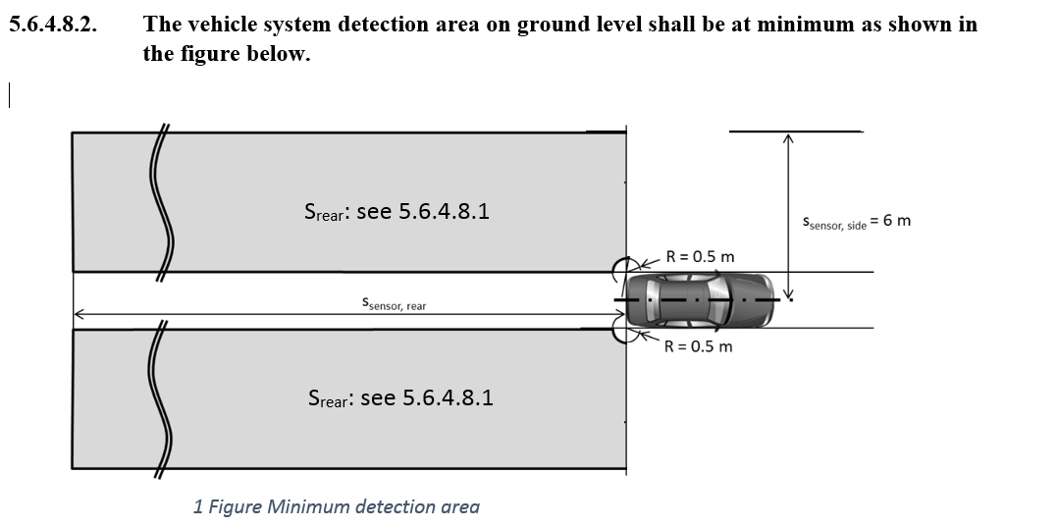

*Paragraph 5.6.4.8.3*., amend to read:

“5.6.4.8.3. After each vehicle new engine start/run cycle (other than when performed automatically, e.g. the operation of a stop/start systems), the ACSF of Category C function shall be prevented by the power-driven vehicle from performing a lane change manoeuvre until the system of the power driven vehicle or the trailer (as relevant) has detected, at least once, a moving object at a distance greater than the minimum distance Srear declared by the manufacturer in paragraph 5.6.4.8.1. above.”

*Paragraph 5.6.4.8.4.,* amend to read:

“5.6.4.8.4. The ACSF of Category C shall be able to detect blindness of the sensor (e.g. due to accumulation of dirt, ice or snow). The ACSF of Category C shall be prevented, upon detection of blindness on the power-driven vehicle or on the trailer, as relevant, from performing the lane change manoeuvre. The status of the system shall be signalled to the driver no later than on the initiation of the lane change procedure. The same warning as the one specified in paragraph 5.6.4.5.5. (system failure warning) may be used.”

*Insert new paragraphs 5.6.4.9., 5.6.4.9.1., 5.6.4.9.1.1., 5.6.4.9.1.2., 5.6.4.9.1.3., 5.6.4.9.1.4. 5.6.4.9.2., 5.6.4.9.2.1., 5.6.4.9.2.2. and 5.6.4.9.2.3.,* to read:

“5.6.4.9. Connections, for ACSF between power-driven vehicle and trailer

The following paragraphs apply to vehicles implementing lane change function(s) based on trailers supporting lane change function(s).

5.6.4.9.1. The data communication line shall conform to ISO 11992-1:2019 and ISO 11992-3:2021 and be a point-to-point type using:

(a) The fifteen-pin connector according to ISO 12098; or,

(b) In the case of systems where the connection of the electric control line is automated, the automated connector shall, as a minimum, provide the same number of pins as the abovementioned ISO 12098 connector.

5.6.4.9.1.1. The support of messages defined within ISO 11992-3:2021 is specified within Annex 9 to this Regulation for the power-driven vehicle and trailer as appropriate.

5.6.4.9.1.2. The functional compatibility of power-driven and towed vehicles equipped with electric control lines as defined above shall be assessed at the time of type approval by checking that the relevant provisions of ISO 11992-1:2019 and ISO 11992-3:2021 are fulfilled. Annex 10 of this Regulation provides an example of tests that may be used to perform this assessment.

5.6.4.9.1.3. When a power-driven vehicle is equipped with an electric control line connected to a trailer equipped with an electric control line, a continuous failure (> 40 ms) within the electric control line shall be detected in the power-driven vehicle and shall be signalled to the driver by the warning signal specified in Paragraph 5.6.4.5.5., when such vehicles are connected via the electric control line.

5.6.4.9.1.4. The Power-driven vehicles shall be able to use the data transmitted from a trailer to perform the functionality and the performance of an ACSF of Category C shall send the GPM 11 message to the trailer and receive the GPM 21 message prior to the enabling the ACSF-functionality of the motor vehicle if a trailer is coupled.

5.6.4.9.2. Special provisions for trailers supporting lane change function(s).

5.6.4.9.2.1. The functionality shall be enabled only if GPM 11 message is received and GPM 21 messages are sent as defined in ISO 11992-3:2021.

5.6.4.9.2.2. If a trailer provides data communication via the electric control line and is equipped with ACSF-sensors it shall be in conformance to ISO 11992-3:2021 and according to the Annex 9 of this Regulation. Failure warning signals required from the trailer by this Regulation shall be activated via the above connector. The requirement to be applied to trailers with respect to the transmission of failure warning signals shall be those, as appropriate, which are prescribed for motor vehicles in paragraph 5.6.4.5.5.

5.6.4.9.2.3. A system failure in the trailer shall be transmitted to the motor vehicle.”

*Renumbering of 5.6.4.9. and 5.6.4.10.,* to read:

5.6.4.10. System information data

5.6.4.10.1. The following data shall be provided, together with the documentation package required in Annex 6 of this UN Regulation, to the Technical Service at the time of type approval.

5.6.4.10.1.1. The conditions under which the system can be activated and the boundaries for operation (boundary conditions). The vehicle manufacturer shall provide values for Vsmax , Vsmin and aysmax for every speed range as mentioned in the table of paragraph 5.6.2.1.3. of this UN Regulation.

5.6.4.10.1.2. Information about how the system detects that the driver is holding the steering control.

5.6.4.10.1.3. The means to override and to suppress or cancel.

5.6.4.10.1.4. Information about how the failure warning signal status and the confirmation of the valid software version related ACSF performance can be checked via the use of an electronic communication interface.*

5.6.4.10.1.5. Documentation about which system software version related ACSF performance is valid. This documentation shall be updated whenever a software version was amended.*

* This paragraph shall be reviewed once the Task Force on Cyber Security and Over the Air issues (TF CS/OTA) reporting to the World Forum for the Harmonization of Vehicle Regulations

5.6.4.10.1.6. Information on the sensor range over lifetime. The sensor range shall be specified in such way that any influence on deterioration of the sensor shall not affect the fulfilment of paragraphs 5.6.4.8.3. and 5.6.4.8.4. of this UN Regulation.

5.6.4.11. The vehicle with ACSF of Category C shall be tested in accordance with relevant vehicle test(s) specified in Annex 8 of this UN Regulation. For driving situations not covered by the tests of Annex 8, the safe operation of the ACSF shall be demonstrated by the vehicle manufacturer on the base of Annex 6 of this UN Regulation."

*Insert new paragraphs 7.3, 7.3.1., 7.3.2. and 7.3.3. in Annex 1,* to read:

“7.3. The power-driven vehicle is equipped with an ACSF of Category C (yes/no).

If yes:

7.3.1. The power-driven vehicle supports lane changes according to paragraph 5.6.4.8.1.1. system in solo condition (i.e. without being coupled to a trailer of Category O3 or O4) (yes/no)

7.3.2. The power-driven vehicle supports lane changes when coupled to a trailer supporting lane change function(s) according to paragraph 5.6.4.8.1.2. and 5.6.4.9.2. (yes/no)

7.3.3. The power-driven vehicle supports lane changes when coupled to a trailer by fulfilling paragraph 5.6.4.8.1.3. without support of the trailer. This also includes the case, if the power-driven vehicle does not use the support of a trailer supporting lane change function(s) according to paragraph 5.6.4.8.1.1. and 5.6.4.9.2. (yes/no)”

*Insert a new paragraph 8.4. in Annex 1*, to read:

“8.4. The trailer is equipped with an ACSF of Category C supporting lane change function(s) according to paragraph 5.6.4.8.1.1. and 5.6.4.9.2. and the Annex 9 (yes/no)”

*Paragraph 3.5. in Annex 8,* amend to read:

“3.5. Tests for ACSF of Category C

If not specified otherwise, all vehicle test speeds shall be based on Vapp= 130 km/h.

If not specified otherwise, the approaching vehicle shall be a type-approved high volume series production vehicle.

A “vehicle under test” or “a test vehicle” normally driven as single vehicle/unit may be a part of a combination.

In case the power-driven vehicle supports lane changes according to paragraph 5.6.4.8.1.1. (system in solo condition), the power-driven vehicle shall be tested according to paragraphs 3.5.1. to 3.5.7. of this annex.

In case the power-driven vehicle supports lane changes when coupled to a trailer supporting lane change function (“yes” in paragraph 7.3.2. in Annex 1), the power-driven vehicle shall be tested with a trailer supporting lane change function (“yes” in paragraph 8.4 in Annex 1) coupled during the test according to paragraphs 3.5.1. to 3.5.8.1. of this annex.

In case the power-driven vehicle supports lane changes when coupled to a trailer without support of the trailer (“yes” in paragraph 7.3.3 in Annex 1), the power-driven vehicle shall be tested with a trailer not supporting lane change function (“no” in paragraph 8.4 in Annex 1) coupled during the test according to paragraphs 3.5.1. to 3.5.8.2. of this annex.

A trailer supporting lane change function (“yes” in paragraph 8.4 in Annex 1) shall fulfil the test of paragraphs 3.5.6. and 3.5.9. The tests according to paragraphs 3.5.1. to 3.5.5. and 3.5.7. are dedicated to the power-driven vehicle.

The vehicle manufacturer shall demonstrate to the satisfaction of the Technical Service that the requirements are fulfilled for the whole speed range. This may be achieved on the basis of appropriate documentation appended to the test report.”

*Paragraph 3.5.4.1. in Annex 8*, amend to read:

“3.5.4.1. The test vehicle shall be driven in a lane of a straight test track, which has at least two lanes in the same direction of travel, with road markings on each side of the lanes.

The vehicle speed shall be: Vsmin + 10km/h.

The ACSF of Category C shall be activated (standby mode) and, unless the system is already enabled according to paragraph 5.6.4.8.3., another vehicle shall approach from the rear in order to enable the system as specified in paragraph 5.6.4.8.3. above.

The approaching vehicle shall then pass the vehicle under test entirely.

A Lane Change Procedure shall then be initiated by the driver.

The test shall be repeated for each of the following conditions, which shall occur before the lane change manoeuvre has started:

(a) The system is overridden by the driver;

(b) The system is switched off by the driver;

(c) The vehicle speed is reduced to: Vsmin-10 km/h;

(d) The driver has removed his hands from the steering control and the hands-off warning has been initiated;

(e) The direction indicator lamps are manually deactivated by the driver;

(f) The lane change manoeuvre has not commenced within 5.0 seconds following the initiation of the lane change procedure. (e.g. another vehicle is driving in the adjacent lane in a critical situation as described in paragraph 5.6.4.7.) or 7.0 seconds if initiated by a second deliberate action.

(g) The second deliberate action for an appropriate system is performed later than 5.0 seconds after the initiation of the lane change procedure.”

*Insert new paragraphs 3.5.8., 3.5.8.1., 3.5.8.2., 3.5.9., 3.5.9.1. and 3.5.9.2. in Annex 8*, to read:

“3.5.8. Lane change suppression test

The test vehicle shall be driven in a lane of a straight test track, which has at least two lanes in the same direction of travel, with road markings on each side of the lanes.

The vehicle speed shall be: Vsmin + 10km/h.

The ACSF of Category C shall be activated (standby mode).

A Lane Change Procedure shall then be initiated by the driver.

The requirements of the test are fulfilled if the system inhibits any lane change procedures if:

3.5.8.1. In case the power-driven vehicle supports lane changes according to paragraph 7.3.2. when coupled to a trailer supporting lane change function(s) according to paragraph 8.4.

(a) The trailer is not supporting lane change function(s) according to paragraph 5.6.4.8.1.1. and paragraph 5.6.4.9.2. or

(b) The power-driven vehicle is not able to perform detection of areas specified in paragraph 5.6.4.8.1.1. or specified in paragraph 5.6.4.8.1.2. or

(c) A warning to the driver specified in paragraph 5.6.4.5.4. is provided

Provisions of ISO11992-3:2021 shall be respected.

The manufacturer shall demonstrate to the satisfaction of the Technical Service dimensions of areas on ground level those permit lane change procedures executed singularly or in combination with at least one trailer.

3.5.8.2. In case the power-driven vehicle supports lane changes according to paragraph 7.3.3. when coupled to a trailer not supporting lane change function(s) according to paragraph 8.4.

(a) The power-driven vehicle is not able to perform detection of areas specified in paragraph 5.6.4.8.1.3.

3.5.9. Object detection test for trailers supporting lane change function(s) according to paragraph 8.4.

3.5.9.1. Detection of targets on low speed above 10 km/h

The test vehicle shall be stationary within a lane of a straight track which has at least two lanes and road markings on each side of the lane.

Low speed moving objects with a RCS not greater than a type approved high volume series production motorcycle of Category L3 with an engine capacity not exceeding 600 cm3 without front fairing or windshield shall approach as follows:

(a) At the leading edge left and right at a distance of 0.5...4 m from vehicle under test;

(b) At the rear edge left and right at a distance of 0.5...4 m from vehicle under test;

(c) At the rear at a distance of 5 m and 55 m in the adjacent lane.

The requirements of the test are fulfilled if the trailer system or the towing vehicle system detects the approaching vehicles in all 6 positions in sequence.

3.5.9.2. Detection of moving targets in adjacent lanes

The test vehicle shall be stationary within a lane of a straight track which has at least two lanes and road markings on each side of the lane.

Another vehicle shall approach from the rear on the nearest adjacent lane, with a speed of 120 km/h.

The approaching vehicle shall be a type approved high volume series production motorcycle of Category L3 with an engine capacity not exceeding 600 cm3 without front fairing or windshield and shall aim to drive in the middle of the lane.

The distance between the rear end of the test vehicle and the front end of the approaching vehicle shall be measured (e.g. with a Differential Global Positioning System), and the value when the system detects the approaching vehicle shall be recorded.

The test shall be repeated with the approaching vehicle in the opposite adjacent lane.

The requirements of the test are fulfilled if the system detects the approaching vehicle no later than 55 m from the rear edge of the vehicle.”

*Insert a new Annex 9,* to read:

# “Annex 9

Compatibility between towing vehicles and trailers with regard to data transmission according to ISO 11992 for environmental monitoring

1. General

1.1. The requirements of this annex shall only apply to towing vehicles and trailers equipped with an electric control line as defined in paragraph 2.7 of the regulation.

1.2. The ISO 12098:2004 connector provides a power supply for the ASCF/environmental monitoring function of the trailer via pins 4 and 9. In the case of vehicles equipped with an electric control line as defined in paragraph 2.7 of the Regulation this connector also provides a data communication interface via pins 13, 14 and 15 — see paragraph 5.6.4.9.1. of the Regulation.

1.3. This annex defines requirements applicable to the towing vehicle and trailer with respect to the support of ASCF/environmental monitoring messages defined within ISO 11992-3:2021.

2. The parameters defined within iso 11992-3:2021 that are transmitted by the electric control line shall be supported as follows:

2.1. The following functions and associated messages are those specified within this Regulation that shall be supported by the towing vehicle or trailer as appropriate:

2.1.1. Messages transmitted from the towing vehicle to the trailer:

GPM11 message definition

|  |  |  |  |
| --- | --- | --- | --- |
| *Byte pos.* | *Bit pos.* | *Parameter ISO 11992-03:2021* | *Regulation No. 79 Reference* |
| 1 | 1 to 2 | Vehicle type | Regulation No. 79,  Paragraph 5.6.4.9.1.4. |
| 3 to 8 | Detailed Vehicle Type | Regulation No. 79,  Paragraph 5.6.4.9.1.4. |
| 2 | 5 to 8 | ODM version request | Regulation No. 79,  Paragraph 5.6.4.9.1.4. |

### 

Object Detection Message (ODM 11)

With this message, relevant information for the automated steering function is sent from the towing vehicle to the towed vehicle.

ODM 11 message definition

|  |  |  |
| --- | --- | --- |
| *Byte pos.* | *Bit pos.* | *Parameter ISO 11992-03:2021* |
| 1 | --- | CRC |
| 2 | 1 to 4 | sequence counter |
| 5 to 8 | ODM input |
| 3 to 4 | --- | longitudinal speed |
| 5 to 6 | --- | lateral speed |
| 7 to 8 | --- | yaw rate |

2.1.2. Messages transmitted from the trailer to the towing vehicle:

GPM21 message definition

|  |  |  |  |
| --- | --- | --- | --- |
| *Byte pos.* | *Bit pos.* | *Parameter ISO 11992-03:2021* | *Regulation No. 79 Reference* |
| 1 | 1 to 2 | Vehicle Type | Regulation No. 79,  Paragraph 5.6.4.9.2.1. |
| 3 to 8 | Detailed Vehicle Type | Regulation No. 79,  Paragraph 5.6.4.9.2.1. |
| 2 | 5 to 8 | ODM Version Information | Regulation No. 79,  Paragraph 5.6.4.9.2.1. |
| 7 | 1 to 8 | Identification Data Index | Regulation No. 79,  Paragraph 5.6.4.9.2.1. |
| 8 | 1 to 8 | Identification Data Content | Regulation No. 79,  Paragraph 5.6.4.9.2.1. |

ODM 21, ODM 23, ODM 25, ODM 27, ODM 29, ODM 211, ODM 213, ODM  215 message definition

| *Byte pos.* | *Bit pos.* | *Parameter ISO 11992-03:2021* |
| --- | --- | --- |
| 1 | --- | Cyclic Redundancy Check (CRC-8) |
| 2 | 1 to 4 | Sequence Counter |
| 2 | 5 to 8 | Status Indicator |
| 3 to 4 | --- | Automated Steering Longitudinal Distance Object |
| 5 to 6 | --- | Automated Steering Lateral Distance Object |
| 7 | 1 to 4 | Automated Steering Standard Deviation of Longitudinal and Lateral Distance |
| 7 | 5 to 8 | reserved by this document |
| 8 | 1 to 8 | Track ID |

ODM 22, ODM 24, ODM 26, ODM 28, ODM210, ODM 212, ODM 214, ODM 216 message definition

|  |  |  |
| --- | --- | --- |
| *Byte pos.* | *Bit pos.* | *Parameter ISO 11992-03:2021* |
| 1 | --- | Cyclic Redundancy Check (CRC-8) |
| 2 | 1 to 4 | Sequence Counter |
| 2 | 5 to 8 | Status Indicator |
| 3 to 4 | --- | Automated Steering Absolute Longitudinal Speed Object |
| 5 to 6 | --- | Automated Steering Absolute Lateral Speed Object |
| 7 | 1 to 4 | Automated Steering Normal Deviation of Longitudinal and Lateral Speed |
| 7 | 5 to 7 | reserved by this document |

2.1.2.1. General

IMPORTANT — If ISO 11992-1 is used as a data link and physical layer only one trailer (towed vehicle) can be supported due to bandwidth overload of the CAN bus between towing and towed vehicles.

The towing vehicle shall not rely on any sorting of the objects communicated by the towed vehicle.

2.1.2.2. Objects to the side of the towed vehicle

The following rule shall be applied for left-hand and right-hand side separately:

If any object is next to the towed vehicle, the one with minimum lateral distance to the towed vehicle shall be selected.

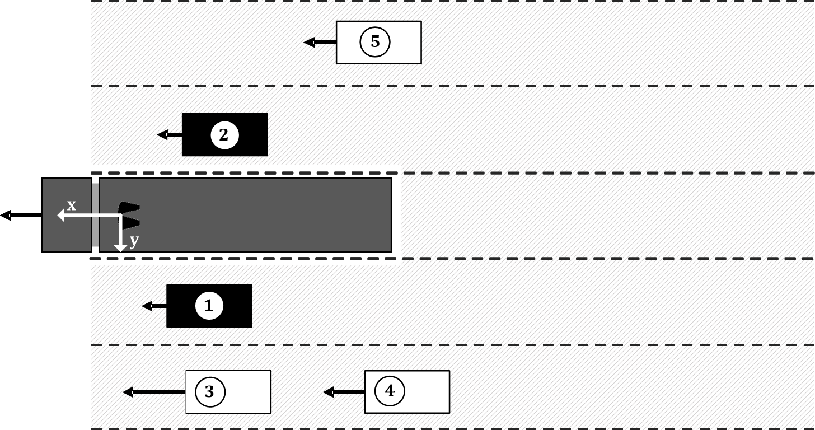

2.1.2.3. Objects behind the towed vehicle

The area behind the towed vehicle is split into five ranges. From each range an object shall be selected, if present. If the absolute velocity of the towed vehicle > 10 km/h only moving objects shall be selected. An object is moving if its absolute velocity is not zero. The five ranges are specified by the lateral position relatively to the towed vehicle:

(a) –0.5 × w – 7 m ≤ y < –0.5 × w – 3.5 m

(b) –0.5 × w – 3.5 m ≤ y < – 0.5 × w

(c) behind the towed vehicle

(d) 0.5 × w < y ≤ 0.5 × w + 3.5 m

(e) 0.5 × w + 3.5 m < y ≤ 0.5 × w + 7 m

Where y is the lateral position [m] and w is the width [m] of the towed vehicle.

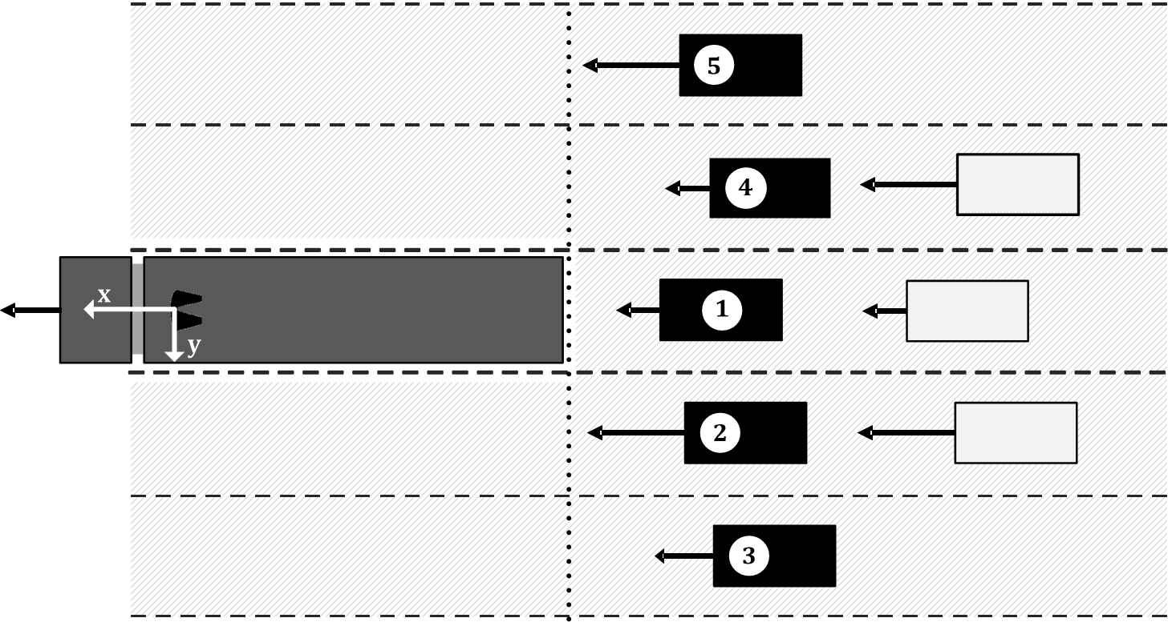

No objects are detected, sensor system not ready:

In case no objects are detected or the sensor system is not ready all object values shall be set to SNA (system not available).

2.2. Under the following conditions the towed vehicle shall transmit the status indicator according to the ODM messages defined in paragraph 2.1.2. above:

2.2.1. Communication error:

If a communication persistent error is reported by an underlying layer (e.g. bus-off by the CAN controller), the application shall perform a reset. After the reset, the same initialisation procedure as on power-up shall be performed. The delay between the persistent error is reported and the reset executed shall be at least 100 ms.

2.2.2. Sensor error:

The sensors providing ODM information shall be equipped with mechanisms for sensor failure detection (e.g. blockage, malfunction). A detected sensor error shall be reported by the ODM status indicator. Different states. If the sensors are equipped with integrated recovery mechanism, these should be supported.

2.3. The following messages defined in ISO 11992-3:2021 shall be supported by the towing vehicle or trailer if available:

2.3.1. Messages transmitted from the trailer to the towing vehicle:

ODM 217 message definition

|  |  |  |
| --- | --- | --- |
| *Byte pos.* | *Bit pos.* | *Parameter ISO 11992-03:2021* |
| 1 | --- | Cyclic Redundancy Check (CRC-8) |
| 2 | 1 to 4 | Sequence Counter |
| 2 | 5 to 8 | Status Indicator |
| 3 to 4 | --- | Geometric Item #1 |
| 5 to 6 | --- | Geometric Item #2 |
| 7 to 8 | --- | Geometric Item #3 |

Multiplexing rules for geometric distances

| *Sequence counter* | *Item* | *Parameter ISO 11992-03:2021* |
| --- | --- | --- |
| 1 or 9 | #1 | distance to rear coupling point |
| 1 or 9 | #2 | distance to centre of rotation |

2.4. The following messages shall be supported by the towing vehicle or trailer as appropriate when the vehicle is installed with a function associated with that parameter:

2.4.1. Messages transmitted from the towing vehicle to the trailer:

GPM11 message definition

|  |  |  |
| --- | --- | --- |
| *Byte pos.* | *Bit pos.* | *Parameter ISO 11992-03:2021* |
| 3 to 4 | 1 to 16 | Articulation Angle between towing and towed vehicle |
| 5 to 6 | 1 to 16 | Angle between towing vehicle and drawbar |
| 7 to 8 | 1 to 16 | Angle between drawbar and towed vehicle |

2.4.2. Messages transmitted from the trailer to the towing vehicle:

GPM21 message definition

|  |  |  |
| --- | --- | --- |
| *Byte pos.* | *Bit pos.* | *Parameter ISO 11992-03:2021* |
| 3 to 4 | 1 to 16 | Articulation Angle between towing and towed vehicle |
| 5 to 6 | 1 to 16 | Articulation Angle drawbar and towed vehicle |

2.5. The support of all other messages defined within ISO 11992-3:2021 is optional for the towing vehicle and trailer.”

*Insert a new Annex 10,* to read:

“Annex 10

Test procedure to assess the functional compatibility of vehicles equipped with ACSF control lines

1. General

1.1. This annex defines a procedure that may be used to check towing and towed vehicles equipped with an electric control line against the functional and performance requirements referred to in paragraph 5.6.4.1. of this Regulation. Alternative procedures may be used at the discretion of the Technical Service if an equivalent level of checking integrity can be established.

1.2. The references to ISO 12098:2004 within this annex apply to ISO 12098 for 24V applications and ISO 12098 for 12V applications.

2. Information document

2.1. The vehicle manufacturer/system supplier shall supply to the Technical Service an information document that contains at least the following:

2.1.1. A schematic of the vehicle ACSF;

2.1.2. Evidence that the interface, including the physical layer, data link layer and the application layer and the respective position of supported messages and parameters, complies with ISO 11992;

2.1.3. A list of supported messages and parameters; and

3. Towing vehicles

3.1. ISO 11992 trailer simulator

The simulator shall:

3.1.1. Have a connector meeting ISO 12098:2004 (15 pin) to connect to the vehicle under test. Pins 13, 14 and 15 of the connector shall be used to transmit and receive messages complying with ISO 11992-3:2021.

3.1.2. Be capable of receiving all of the messages transmitted by the motor vehicle to be type approved and be capable of transmitting all trailer messages defined within ISO 11992-3:2021.

3.1.3. Provide a direct or indirect readout of messages, with the parameters in the data field shown in the correct order relative to time; and

3.2. Checking procedure

3.2.1. Confirm that the manufacturer's/supplier's information document demonstrates compliance with the provisions of ISO 11992 with respect to the physical layer, data link layer and application layer.

3.2.2. Check the following, with the simulator connected to the motor vehicle via the ISO 12098:2004 interface and whilst all trailer messages relevant to the interface are being transmitted:

3.2.2.1. Control line signalling:

3.2.2.1.1. The parameters defined in GPM 11 byte 1 bit 5 -8 and byte 3-8 bit 1 – 16 of ISO 11992-3:2021 shall be checked against the specification of the vehicle

3.2.2.2. Failure warning:

3.2.2.2.1. Simulate a permanent failure in the communication line to pin 14 of the ISO 12098 connector and check that the warning signal of the ACSF specified in paragraph 5.6.4.5.5.1. of this Regulation is displayed.

3.2.2.2.2. Simulate a permanent failure in the communication line to pin 15 of the ISO 12098 connector and check that the warning signal of the ACSF specified in paragraph 5.6.4.5.5.1. of this Regulation is displayed.

3.2.2.2.3. Simulate the failure message required in paragraph 5.6.4.9.2.2. (according to ISO 11992-3:2021) from the trailer and check that the warning signal specified in paragraph 5.6.4.5.5. is displayed.

3.2.3. Additional checks

3.2.3.1. At the discretion of the Technical Service the checking procedures defined above may be repeated with the non-ACSF functions relevant to the interface in different states or switched off.

3.2.3.2. Paragraph 2.4.1 of Annex 9 defines additional messages that shall under specific circumstances be supported by the towing vehicle. Additional checks may be carried out to verify the status of supported messages to ensure the requirements of paragraph 5.6.4.9.1.2. of the Regulation are fulfilled.

4. Trailers

4.1. ISO 11992 towing vehicle simulator

The simulator shall:

4.1.1. Have a connector meeting ISO 12098:2004 (15 pin) to connect to the vehicle under test. Pins 13, 14 and 15 of the connector shall be used to transmit and receive messages complying with ISO 11992-3:2021.

4.1.2. Have a failure warning display and an electrical power supply for the trailer;

4.1.3. Shall be capable of receiving all of the messages transmitted by the trailer to be type approved and be capable of transmitting all motor vehicle messages defined within ISO 11992-3:2021.

4.1.4. Provide a direct or indirect readout of messages with the parameters in the data field shown in the correct order relative to time; and

4.2. Checking procedure

4.2.1. Confirm that the manufacturer's/supplier's information document demonstrates compliance with the provisions of ISO 11992 with respect to the physical layer, data link layer and application layer.

4.2.2. Check the following, with the simulator connected to the trailer via the ISO 12098 interface and whilst all towing vehicle messages relevant to the interface are being transmitted:

4.2.2.1. Control line signalling:

Simulate the required messages according to ISO 11992-3:2021 and described in the Annex 9 paragraph 2.1.2., 2.3.1. and 2.4.2. of this Regulation.

4.2.2.2. Failure warning:

4.2.2.2.1. Simulate a permanent failure in the communication line to pin 14 of the ISO 12098 connector and check that the warning signal of the ACSF specified in paragraph 5.6.4.5.5.1. of this Regulation is displayed.

4.2.2.2.2. Simulate a permanent failure in the communication line to pin 15 of the ISO 12098 connector and check that the warning signal of the ACSF specified in paragraph 5.6.4.5.5.1. of this Regulation is displayed.

4.2.2.2.3. Simulate the failure message required in paragraph 5.6.4.9.2.2. (according to ISO 11992-3:2021) from the trailer and check that the warning message specified in paragraph 5.6.4.5.5.1. is sent.

4.2.3. Additional checks

4.2.3.1. At the discretion of the Technical Service the checking procedures defined above may be repeated with the non-ACSF functions relevant to the interface in different states or switched off.

4.2.3.2. Paragraph 2.4.1.2. of Annex 9 defines additional messages that shall under specific circumstances be supported by the towing towed vehicle. Additional checks may be carried out to verify the status of supported messages to ensure the requirements of paragraph 5.6.4.9.1.2. of the Regulation are fulfilled.”

1. * Former titles of the Agreement:

   Agreement concerning the Adoption of Uniform Conditions of Approval and Reciprocal Recognition of Approval for Motor Vehicle Equipment and Parts, done at Geneva on 20 March 1958 (original version);

   Agreement concerning the Adoption of Uniform Technical Prescriptions for Wheeled Vehicles, Equipment and Parts which can be Fitted and/or be Used on Wheeled Vehicles and the Conditions for Reciprocal Recognition of Approvals Granted on the Basis of these Prescriptions, done at Geneva on 5 October 1995 (Revision 2).