Proposal for supplement 1 to the [09] Series of Amendments to UN Regulation No. 16 (Safety-belts) *
Submitted by the expert from Germany
The text reproduced below was prepared by the expert from Germany, to clarify, how to perform the buckle-opening test under point 7.8. of the regulation. The modifications to the existing text of the UN Regulation are marked in “bold“ for new or strikethrough for deleted characters.

- Proposal

Paragraph 7.8.2., amend to read:
“7.8.2. The belt assembly shall be removed from the test trolley without the buckle being opened.
In case of a two-point lap belt Aa load shall be applied to each side of the buckle by direct traction via the straps tied to it, so that all each of the two the straps are subjected to thea force of 60/n30 daN. (It is understood that n is the number of straps linked to the buckle when it is in a locked position.)
In case of a three-point belt, the upper and lower strap of the diagonal belt part shall be clamped together, so that the two straps together are subjected to the force of 30 daN.
S-type belts shall be tested depending on its geometry analogously to the above-mentioned procedures, with forces, agreed between the manufacturer and the technical service simulating a similar load on the buckle. An additional crotch strap shall be not taken into account for this test.
In the case where the buckle is connected to a rigid part, the load shall be applied at the same angle as the one formed by the buckle and the rigid end during the dynamic test. A load shall be applied at a speed of 400 ± 20 mm/min to the geometric centre of the buckle-release button along a fixed axis running parallel to the initial direction of motion of the button. During the application of the force needed to open the buckle, the buckle shall be held by a rigid support. The load quoted above shall not exceed the limit indicated in paragraph 6.2.2.5. above. The point of contact of the test equipment shall be spherical in form with a radius of 2.5 mm ± 0.1 mm. It shall have a polished metal surface.”
II. Justification
- This proposal aims to clarify, how to perform the buckle-opening test, simulating the load caused by 60 kg body, described under point 7.8. of the regulation,

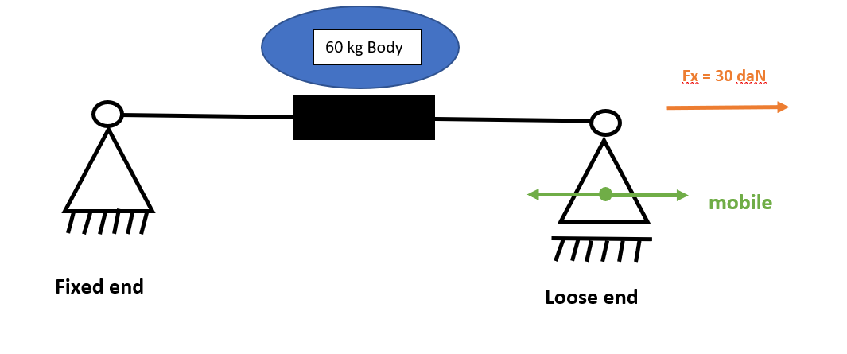

* In accordance with the programme of work of the Inland Transport Committee for 2023 as outlined in proposed programme budget for 2023 (A/77/6 (Sect. 20), table 20.6), the World Forum will develop, harmonize and update UN Regulations in order to enhance the performance of vehicles. The present document is submitted in conformity with that mandate.

