Proposal for Supplement 11 to the 03 series of amendments and Supplement 1 to the 04 series of amendments to UN Regulation No. 129 (Enhanced Child Restraint Systems)
Submitted by the expert from France
The text reproduced below was prepared by the expert from France. The proposal aims to allow installation of a dummy protective device on the bench of UN Regulation No. 129 in the dynamic frontal test with a universal booster cushion. The modifications to the current text of the UN Regulation are marked in “(bold) blue” for new or strikethrough for deleted characters.
- Proposal
Insert new paragraphs 7.1.3.1.1.8., to read:
“7.1.3.1.1.8. When testing a booster cushion in frontal impact tests on the test bench prescribed in Annex 6, an optional dummy protective device, as described in Annex 6 paragraph 3.4, may be installed on the test bench, at the decision of the technical service.”

Annex 6, Insert new paragraphs 3.4., to read:
"3.4. Optional dummy protective device
An optional dummy protective device may be installed on the test bench for the dynamic frontal test of universal booster cushion when tested on the test bench described in this Annex.
The dummy protective device may be covered with the Polychloropren foam of the lateral impact door as defined in Appendix 3 of this Annex, or an alternative material, at the decision of the technical service.
The dimensions of the dummy protective device are given in Appendix 3 of this Annex.
The forward face of the dummy protective device shall be parallel with the back of the backrest. The design of the dummy protective device shall be such that it does not interfere with the manikin when positioned on the test bench. Furthermore, the dummy protective device shall not interfere with the dummy and/or the adult 3-point belt during the dynamic test until the maximum horizontal head excursion has been reached.
[Any other device giving equivalent results can be accepted]."

Insert new Annex 6 – Appendix 5, to read:
" Annex 6 - Appendix 5
Optional dummy protective device

Figure 1
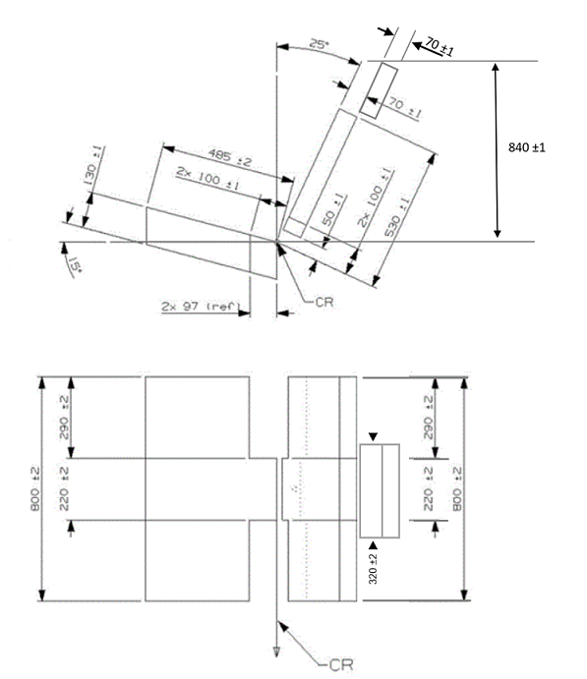
“

- Justification
- Universal Booster cushion (without a back rest) were integrated into Supplement 3 to the 03 series of amendments to UN Regulation No. 129.
In this regulation, it is required that the Universal Booster cushion shall be tested on the bench in frontal dynamic testing :
§ 6.6.4.1.3. The Enhanced Child Restraint System of the i-Size booster seat and Universal booster cushion categories shall be tested on the test bench described in Annex 6, and in conformity with paragraph 7.1.3.1. below.
The UN Regulation No. 129 imposes that all the criteria (head displacements and injury criterias) of Q10 and Q6 must be respected within a time interval of 300 ms, which includes the rebound phase (at the end of the time interval).
But during the rebound phase of the test, an important extension of the neck of Q10 can be observed, due to the absence of headrest positioned on the bench. This could damage the Q10 neck.
The problem was presented during GRSP 73th session in the following document:
https://unece.org/transport/documents/2023/05/informal-documents/france-testing-universal-booster-cushions-q10
In order to test the universal booster cushion in the UN Regulation No. 129. test bench without damaging the neck, the solution consists in allowing to install a dummy protective device on the bench for the dynamic frontal test of universal booster cushion with Q10. It shall be up to the technical service to use the additional segment.
In this proposal, the minimum requirements for the geometry / material of the headrest were defined. There is no modification of the test requirements because the injury assessment criteria reach their maximum values during the forward extension of the dummy’s head and before the rebound phase. This proposal does not have influence the already approved seats, and therefor is integrated as a supplement.

