Proposal for the 10 series of amendments to UN Regulation No. 16 (Safety-belts) [1]*

Submitted by the expert from Japan

The text reproduced below was prepared by the expert from Japan aiming to add an editorial corrections and clarify the transitional provisions to the working document ECE/TRANS/WP.29/GRSP/2023/32．The modifications to the working document by this document are marked in red.

**I. Proposal**

*Insert new paragraphs 2.55. and 2.58*., to read:

"**2.55. "*Effective belt anchorage*” *（ EA ）* means the point used to determine conventionally, as specified in paragraph 5.4. of UN regulation No. 14, the angle of each part of the safety-belt in relation to the wearer, that is, the point to which a strap would need to be attached to provide the same lie as the intended lie of the belt when worn, and which may or may not be the actual belt anchorage depending on the configuration of the safety-belt hardware at its attachment to the belt anchorage.**"

**2.56. "*Buckle point*" means the centre point of the connecting part between the buckle and the buckle strap.**

**2.57. "Bd point" means the position of the buckle point when the occupant (Hybrid III fiftieth percentile male dummy or Hybrid III fifth percentile female dummy, at the manufacturer's discretion) is restrained in the design seat belt route.**

**2.58. "strap length" means the length along the centre line of the surface of buckle strap."**

*Paragraph 5.3.2*., amend to read:

"5.3.2. An approval number shall be assigned to each type approved **in accordance with Schedule 4 of the Agreement (E/ECE/TRANS/505/Rev.3)**. "

*Insert new paragraphs 8.2.3. to 8.2.3.2*., to read:

"**8.2.3. The requirement below relating to the strap between the buckle point and the effective belt anchorage is only applicable to the rear seating positions of M1 category vehicles.**

**8.2.3.1. The difference between the actual strap length and the straight line distance between the point EA and Bd point shall be 80 mm or less.**

**The above requirements may be shown by the actual vehicle, parts, drawings, or 3D data at the manufacturer's discretion.**

**The correlation between actual vehicle and/or parts and the drawing or 3D data shall be demonstrated by the manufacturer.**

**8.2.3.2. The requirement of paragraph 8.2.3.1. shall not apply if any of the following conditions are satisfied;**

**(a) The safety-belt assembly is equipped with a Pre-loading device.**

**(b) The manufacturer demonstrates to the satisfaction of the Technical Service through the use of experimental data, simulation, or desktop strength calculations that the buckle strap assembly has the same performance as the requirement in point (c) below.**

**(c) When the buckle strap assembly is tested using the method described in Annex 19 of this Regulation, the buckle point movement shall be no greater than 80 mm at a tensile load of 1,000 N +/-50 N.”**

*Insert new paragraphs 15.7. to 15.7.5.,* to read:

"**15.7. As from the official date of entry into force of the 10 series of amendments, no Contracting Party applying this UN Regulation shall refuse to grant or refuse to accept type approvals under this Regulation as amended by the 10 series of amendments.**

**15.7.1. As from [1 September 2026], Contracting Parties applying this UN Regulation shall not be obliged to accept type approvals to the preceding series of amendments, first issued after [1 September 2026].**

**15.7.2. Contracting Parties applying this UN Regulation shall continue to accept type-approvals of vehicles, safety-belts, and restraint systems according to any of the preceding series of amendments, first issued before [1 September 2026], provided the transitional provisions in these respective previous series of amendments foresee this possibility.**

**15.7.3. Notwithstanding the transitional provisions above, Contracting Parties who start to apply this UN Regulation after the date of entry into force of the most recent series of amendments are not obliged to accept type approvals which were granted in accordance with any of the preceding series of amendments to this Regulation / are only obliged to accept type approvals granted in accordance with the 10 series of amendments.**

**15.7.4. Contracting Parties applying this UN Regulation may grant type approvals according to any preceding series of amendments to this UN Regulation.**

**15.7.5. Contracting Parties applying this UN Regulation shall continue to grant extensions of existing approvals to any preceding series of amendments to this UN Regulation.**"

*Annex 2,* amend to read:

"Annex 2

Arrangements of the approval marks

1. Arrangements of the vehicle approval marks concerning the installation of safety-belts

# Model A

(See paragraph 5.2.4. of this Regulation)

**10** 2439

The above…amended by the **10** series of amendments.

# Model B

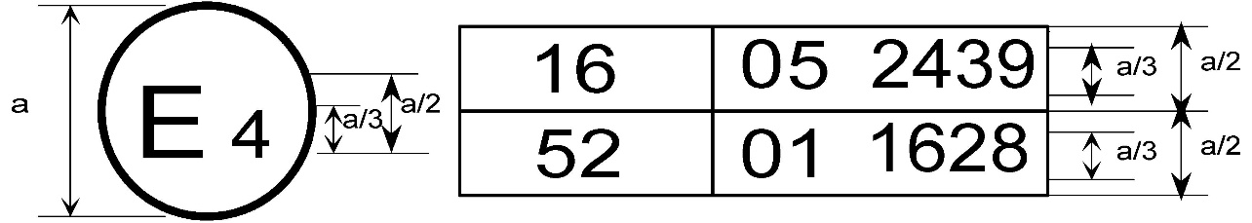(See paragraph 5.2.5. of this Regulation)

**10** 2439

The above …included the **10**~~09~~ series of amendments and UN Regulation No. 52 the 01 series of amendments.

…

2. Arrangements of the safety-belt approval marks (see paragraph 5.3.5. of this Regulation)



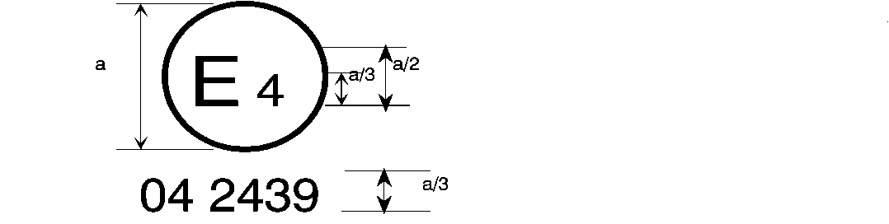

**10** 2439

a = 8 a = 8 mm min.

The belt …the 08, 09**,** or **10** series of amendments at the time of approval.

B → 4 m



**10** 2489

The belt …the 08, 09**,** or **10** series of amendments at the time of approval.

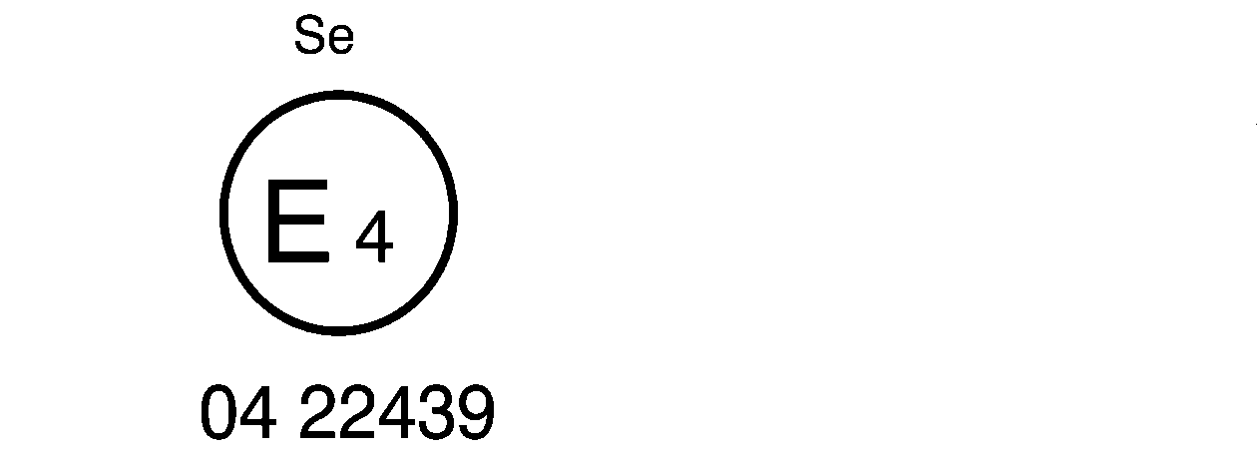

**10** 22439

The belt bearing …the 07**,**08, 09 or **10** series of amendments at the time of approval.

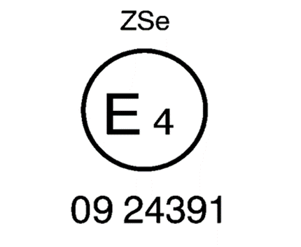

**10** 24391

The belt …the 07**,** 08, 09 or **10** series of amendments at the time of approval.



a ≥ 8 mm

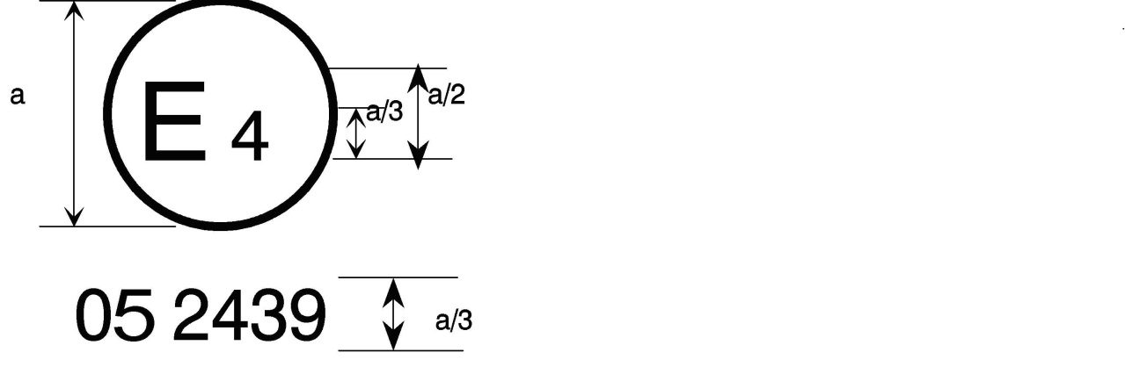

**10** 2439

a = 8 mm min.



The belt…the 07**,** 08, 09 or **10** series of amendments at the time of approval. This belt shall not be fitted to vehicles of category M1.

**Aer4m**

**E4**

**102439**

**AIRBAG**

The safety-belt …the 07, 08, 09 or **10** series of amendments at the time of the approval. This safety-belt has to be fitted to a vehicle equipped with an airbag in the given seating position."

*Insert new Annex 19.,* to read

**Annex 19 Tensile Test method of the buckle strap assembly**

**1. General**

**1.1. The test procedure in this annex shall be used for the tensile test of the buckle strap assembly described in paragraph 8.2.3.2. of this Regulation.**

**2. Test procedure**

**2.1. Fix the bracket of the buckle strap assembly that was attached to the vehicle anchorage to the lower part of the tensile testing machine.**

**2.2. Fix the buckle at a position on the loading line of the tensile testing machine, such that the distance between the buckle point and EA point is the same as the straight line distance between the EA and Bd point described in paragraph 8.2.3.1. of this Regulation.**

**2.3. Attach the tongue to the buckle and set the belt of the tongue to the upper part of the tensile testing machine. The tension on the belt of the tongue is 4 ± 3 N. After that, the buckle is released.**

**2.4. Perform a tensile test and measure the load and the movement of the buckle.**

**II. Justification**

1. The strap’s paths between the effective safety-belt anchorage and the buckle are normally straight like the test bench specified in UN Regulation No. 129 (Figure 1). However, the strap’s paths between the effective belt-anchorage and the buckle of some vehicles in the market are not straight and are curved along the cushion (Figure 2).

|  |  |
| --- | --- |
| Figure 1 **Photo of the Buckle Strap Path of the UN Regulation No. 129 Test Bench** | Figure 2 **Photo of the Buckle Strap Path When Not Straight** |

2. When the strap’s paths between the effective belt anchorage and the buckle are not straight, the occupants may move significantly forward during a frontal impact accident. If an occupant is seated in the booster seat attached by ISOFIX, there are cases in which the seatbelt slips up to the neck and in which submarining occurs (referred to in GRSP-69-24). These phenomena would increase the risk of injuries to the neck and abdomen of a child occupant. In addition, the dummy chest injury increases. Figure 3 shows the relation between the amount of slack of the buckle strap and dummy 3 ms chest maximum acceleration for two types of CRS. When the slack of the buckle belt was 50 mm in left graph, the chest maximum acceleration approached UN Regulation No. 129 criteria in one CRS. When the slack of the buckle belt was around 80 mm in both graphs, the chest maximum acceleration exceeded the above-mentioned criteria.

Figure 3  
**Relation between the Amount of Slack of the Buckle Strap and Dummy 3ms Chest Maximum Acceleration**



3. The slack of the buckle belt makes the passenger’s excursion larger, negatively affecting the safety of the occupant (referred to in GRSP-70-32).

4. Therefore, we propose to limit the slack of the buckle-belt.

5. These amendments prevent the negative affects to the safety of the occupants.

1. * In accordance with the programme of work of the Inland Transport Committee for 2023 as outlined in proposed programme budget for 2023 (A/77/6 (Sect. 20), table 20.6), the World Forum will develop, harmonize and update UN Regulations in order to enhance the performance of vehicles. The present document is submitted in conformity with that mandate.