|  |  |  |  |
| --- | --- | --- | --- |
|  | United Nations | ECE/TRANS/2024/16 | |
| _unlogo | **Economic and Social Council** | | Distr.: General  6 December 2023  Original: English |

**Economic Commission for Europe**

Inland Transport Committee

**Eighty-sixth session**

Geneva, 20-23 February 2024

Item 10 (a) of the provisional agenda

**Strategic questions of a horizontal and  
cross-sectoral policy or regulatory nature:  
Status of accession to international United Nations   
inland transport conventions and agreements**

Status of Accession to International United Nations Inland Transport Legal Instruments[[1]](#footnote-2)

Note by the secretariat

|  |
| --- |
| *Summary* |
| This document presents the status of accessions by ECE and non-ECE member States to the United Nations transport agreements and conventions administered by ECE.  On 1 December 2023, sixty transport legal instruments were under the purview of the Inland Transport Committee. The total number of contracting parties was 1,831, with ten new contracting parties to eight legal instruments.1  The Committee may wish to **invite countries**, which have not yet done so, to accede to the United Nations conventions and other legal instruments in inland transport administered by the Committee and its subsidiary bodies. |
|  |

I. Overview

1. On 1 December 2023, there were sixty transport legal instruments on inland transport concluded under the purview of the Inland Transport Committee (ITC). Figure I below shows the growth of the total number of contracting parties to these legal instruments.1 On 1 December 2023, there were 1,831 contracting parties, with ten new contracting parties to eight legal instruments (see annex for details). Out of the sixty legal instruments, ten have not yet entered into force. The summary tables on the status of signatures, ratifications and accessions for all legal instruments are available at [www.unece.org/trans/conventn/intro.html](http://www.unece.org/trans/conventn/intro.html).

Figure I

**Annual Growth of Contracting Parties to Legal Instruments on Inland Transport under the purview of the Inland Transport Committee**

****

2. Figure II below illustrates the evolution of accessions by ECE and non-ECE member States since 1950.

Figure II

**Accession of ECE and non-ECE Contracting Parties,   
1950–2023**

**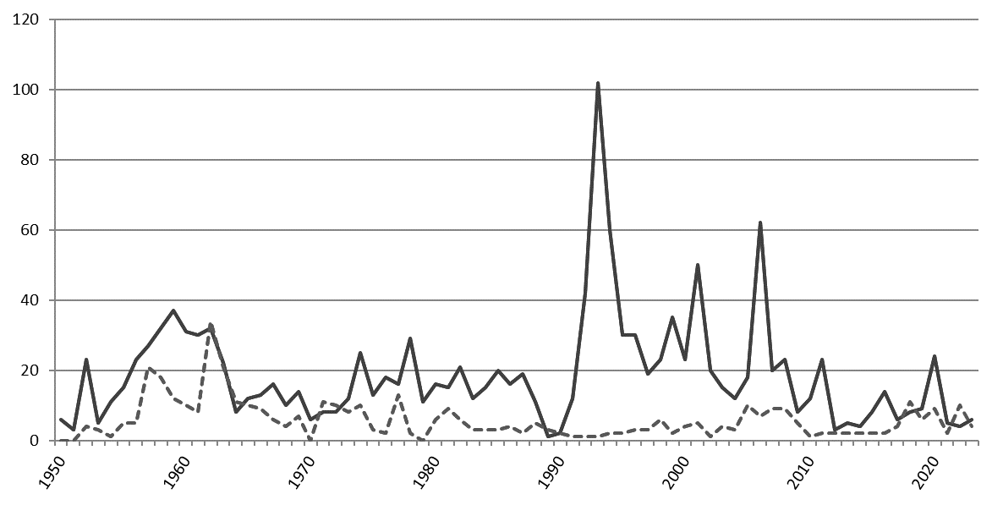**

*Legend:* Solid line: ECE member States - Dotted line: non-ECE member States.

*Source*: ECE.

3. Of the 193 United Nations Member States, 152 States (78 per cent) are contracting parties to at least one legal instrument on inland transport, in addition to two Permanent Observers to the United Nations and one non-State contracting party. Eleven per cent of the United Nations Member States are contracting parties to at least thirty legal instruments.

II. Geographical Distribution of Contracting Parties

4. The total number of contracting parties to the legal instruments on inland transport under the purview of ITC is 1,831 (as of 1 December 2023). Of these, 1,400 are ECE member States and 431 are non-ECE member States.

5. Of the 152 United Nations Member States that are contracting parties, 96 (63 per cent) are non-ECE member States.

6. Out of the sixty legal instruments under the purview of ITC, forty-nine are in force. Non-ECE member States are contracting parties to thirty transport legal instruments in force, representing thirty-one per cent of the total number of contracting parties to these conventions. This also means that about sixty-three per cent of the United Nations transport legal instruments serviced by ECE and in force, have a geographical coverage beyond the territory of ECE. On average, each ECE member State is party to twenty-five legal instruments, while each non-ECE member State is party to 4.4 legal instruments.

Figure 3

**ECE and non-ECE Contracting Parties  
to At Least One United Nations Transport Convention**

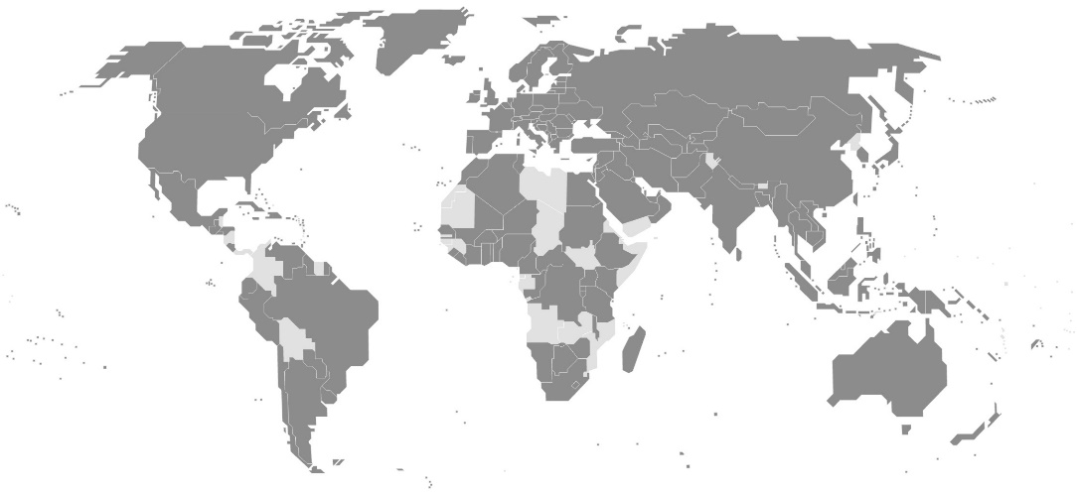

*Legend:* Dark grey: contracting parties. Light grey: non-contracting parties.

*Source*: ECE.

7. The European Union is currently the only non-State contracting party to United Nations legal instruments under the purview of the Committee. It is party to seven legal instruments.

8. Forty-one United Nations Member States are not contracting parties to any legal instruments on inland transport concluded under the purview of ITC: Angola, Belize, Bhutan, Bolivia (Plurinational State of), Chad, Colombia, Comoros, Democratic People’s Republic of Korea, Djibouti, Dominica, Equatorial Guinea, Eritrea, Gabon, Gambia, Grenada, Guinea, Guinea-Bissau, Kiribati, Libya, Marshall Islands, Mauritania, Micronesia (Federated States of), Mozambique, Nauru, Nicaragua, Palau, Panama, Saint Kitts and Nevis, Saint Lucia, Saint Vincent and the Grenadines, Samoa, Sao Tome and Principe, Somalia, South Sudan, Suriname, Swaziland, Timor-Leste, Tuvalu, Vanuatu, Yemen, Zambia.

9. The Committee may wish to consider this information and provide guidance on ways to increase the number of new accessions to the legal instruments under its purview.

Annex

Accessions Registered from 1 January to 1 December 2023

| *Date* | *Contracting party* | *Legal Instrument* |
| --- | --- | --- |
|  |  |  |
| 23 October 2023 | Greece | Additional Protocol to the CMR concerning the electronic consignment note (e-CMR) |
| 21 August 2023 | Belarus | Convention on the facilitation of border crossing procedures for passengers, luggage and load-luggage carried in international traffic by rail, of 22 February 2019 |
| 26 July 2023 | Viet Nam | Agreement concerning the Adoption of Harmonized Technical United Nations Regulations for Wheeled Vehicles, Equipment and Parts which can be Fitted and/or be Used on Wheeled Vehicles and the Conditions for Reciprocal Recognition of Approvals Granted on the Basis of these United Nations Regulations, of 20 March 1958 |
| 17 May 2023 | Türkiye | Convention on Road Signs and Signals, of 8 November 1968 |
| 17 May 2023 | Türkiye | European Agreement supplementing the Convention on Road Signs and Signals (1968), of 1 May 1971 European Agreement supplementing the Convention on Road Signs and Signals (1968), of 1 May 1971 |
| 17 May 2023 | Türkiye | Protocol on Road Markings, Additional to the European Agreement supplementing the Convention on Road Signs and Signals, of 1 March 1973 |
| 11 April 2023 | Andorra | Agreement concerning the Adoption of Harmonized Technical United Nations Regulations for Wheeled Vehicles, Equipment and Parts which can be Fitted and/or be Used on Wheeled Vehicles and the Conditions for Reciprocal Recognition of Approvals Granted on the Basis of these United Nations Regulations, of 20 March 1958 |
| 27 March 2023 | Iraq | Customs Convention on the International Transport of Goods under Cover of TIR Carnets (TIR Convention), of 14 November 1975 |
| 9 January 2023 | Maldives | Convention on Road Traffic, of 8 November 1968 |
| 9 January 2023 | Maldives | Convention on Road Signs and Signals, of 8 November 1968 |

1. The figures, charts and maps in this document are based on data collected for the 59 legal instruments under Inland Transport Committee purview and monitored on https://treaties.un.org. The sixtieth legal instrument “Model Rules on the Permanent Identification of Railway Rolling Stock” is not included in these data. [↑](#footnote-ref-2)