Submitted by the representatives from Australia, the Republic of Korea and China |  | Informal document WP.29-191-10  191st WP.29, 14-16 November 2023  Agenda item 18.2
Global information and statistics – Children left in vehicles
Submitted by the experts from Australia, the Republic of Korea and China in response to the call to take part in the work to be done to collect global information and statistics on this issue of children left in vehicles as endorsed at the 190th WP.29 session.
This document is a summary of key points in the submissions made by Australia, China, CLEPA, Forvia, Italy, Japan, the Republic of Korea, Switzerland and the United Kingdom with regard to information and statistics on children left in vehicles.
Global information and statistics – Children left in vehicles
Introduction
1. GRSP agreed in the 73rd session to continue gathering global information and statistics for its next sessions as the first step as requested by WP.29 in the 190th session. Australia collaborated with the representative from the Republic of Korea and suggested to develop solutions in framework of the 1998 Agreement. WP.29 endorsed the initiative of GRSP and agreed to resume discussion in AC.3.
2. Australia and the Republic of Korea held virtual meetings to discuss common interest and initiated information collection on the issue for WP.29 consideration in November 2023.
3. Australia, the Republic of Korea and China held an online meeting in October to discuss the global severity of children left in vehicles, technology research and vehicle applications of systems to prevent children being left in vehicles.
4. 9 submissions were received on the issue, 2 from industry and 7 from government bodies. Industry submissions were from Forvia and CLEPA. Government submissions were from Australia, China, Italy, Japan, the Republic of Korea, Switzerland and the United Kingdom.
5. The statistics used in the submissions and presented here were primarily gathered with online news searches of electronic media and supplemented with other sources.
6. A brief review of the literature on the issue shows a significant number of reports into children left in vehicles and associated paediatric heatstroke. It is clear that there are other additional cases that go unrecorded for most countries because most fatalities and serious injuries do not occur on the road. Therefore the numbers presented are a conservative estimate.
Australia
- Averages 2-3 fatalities per year (light vehicles and buses)
- ANCAP Test and Assessment Protocol for CPD 2023 – 2025
- See GRSP 72-26 (Australia) for further information.

Some government bus contracts specify fitment of child detection warning systems. In simple terms the sleeping child safety system requires the driver to walk to the back of the bus when the bus is turned off. The system requirements are as follows:
- The alarm must be an audible alarm that is hard wired into the vehicle where it must activate when the engine ignition switch is turned off.
- The alarm disabling switch must be located inside and at the rear of the vehicle in such a position that it requires the driver to walk along the aisle to the rear of the vehicle to activate the alarm disabling switch.
- There may be a delay of up to 30 seconds before the alarm sounds in order to provide time to conduct an inspection and disable the alarm.
- The audible alarm can be either the vehicle horn or sound emitted from the child alarm.
- The audible alarm must be loud enough for a person to hear it from a distance of up to 10 metres and should, as a minimum, emit 95 decibels.
- The operating procedure for the child alarm must be affixed as a decal in a location which is clearly visible by the driver to enable the driver to deactivate the alarm system.
- Child alarms such as a Doran Sleeping Child Check Monitor or Ashley Group Child Alarm are considered suitable.
China
The severity of child vehicular heatstroke incidents within China cannot be overstated. In recent years, there are 35 cases of children being trapped inside vehicles collected from public media in China, which have attracted widespread attention and concern. And 22 of the cases occurred within the last five years. The main reason for these cases is that children were forgotten and the car or door was locked by mistake and could not be opened, and more than 80% of the forgotten children end up dying from heat stroke and shock, and only a few were effectively rescued.
In order to prevent the occurrence of children accidentally left in the car, Chinese vehicle manufacturers have conducted a lot of research. Detection systems have been developed and now are used to detect and avoid children left in cars. In the Chinese auto market, there are more than 15 new vehicle models released in the past two years by Volkswagen, Geely, etc, equipped with these systems. Volkswagen and Audi in China also plan to equip them. These detection systems equipped in the car encompasses various manufacturers, sensing types, sensor data, monitoring objects, alert types, intervention methods, and unique features. These systems feature various sensing methods, either indirect methods based on logic and door, seat belt, sensors interactions or direct methods employing advanced sensors like ultrasonic, UWB, carbon dioxide concentration monitoring, and cameras.
At present, it is planned to add the assessment requirements, including general requirements, warning requirements, indirect induction system test procedures, test methods and test scenarios, into the China New Car Assessment Program (C-NCAP 2024). Technologies and standards related to child detection are also being studied and updated at the same time.
CLEPA
CLEPA provided regulatory information on the following countries:
- Italy has introduced a law in 2019 obliging parents, transporting children up to the age of four, to use/install a "car seat reminder device" (can be CRS-based, vehicle-based, or aftermarket device).
- In 2021, the US Congress passed the “Invest in America” Act, including language from the HOT CARS Act, asking NHTSA to initiate rulemaking on "check rear seat" systems and to evaluate technologies used to reduce the risk of children being left in a vehicle.
- Japan has adopted a law in 2022, requiring kindergarten and daycare vans/buses to be equipped with technology helping to prevent that children are left unattended.
CLEPA provided statistical information on the following countries:
- Italy (June 7th): father forgot to drop the 14-month-old girl at the daycare
- Belgium (June 7th): mother forgot to drop the 6-month-old baby at the daycare
- Slovenia (June 20th): child less than two years old, no info on circumstances
- Germany (June 26th): father forgot 18-month-old boy in the car
- Spain (July 6th): mother forgot to drop the 3 year old boy at the daycare
- French-Guiana (August 5th): 2 year old child managed to get into car
- Portugal (September 12th): father forgot to drop the 10-month-old girl at the daycare
Forvia
Forvia noted in their submission they would like to actively participate in a working group on the issue of children left in vehicles.
Italy
Italy submitted research results collected from different continents and some informal statistics on Italian cases.
- No official Italian data-base available.
- Over the period from 1998 to 2023, data collected from Italian news report about 11 fatalities.
- A 2013 research (Ferrara P, Vena F, Caporale O, et al. Children left unattended in 10. parked vehicles: a focus on recent Italian cases and a review of literature. Ital J Pediatr 2013; 39: 71.), on the analysis of 16 cases identified between 1 May 2011 and 31 August 2012, clearly shows a distinctive element that characterizes the results of the Italian research.
- In 75% of the cases (12 out of 16) the abandonment of the children in the vehicle by the adult is intentional, in absolute contrast to what emerged from all the other international researches as highlighted previously.
- For more information see GRSP 69-16e
- France data –
  - Over the period from 2007 to 2019, data collected from news report 40 cases (42 children involved), including 10 fatalities.

- Israel data –
  - According to the Beterem child safety activism group, from 2010 to 2020, 35 children died from being forgotten or trapped in vehicles in Israel, out of over 800 recorded incidents.
  - Heatstroke represents 6% of the total child injury and fatalities and 5% of total injured children.
  - 84% are under 4 years of age.
  - 5 fatalities recorded in 2013 due to heatstroke.
- US data –
  - On average, in the U.S.A., 38 is the number of child hyperthermia fatalities per year
  - Recent studies listed the total number of deaths caused by hyperthermia the United States and identified 897 cases from the 1998 up to 2020.
  - 53% forgot that their child was in vehicle
  - 20% left child in vehicle on purpose
  - Data used from the Department of Meteorology and Climate Science, San Jose State University for US specific cases (Source: http://Noheatstroke.org):
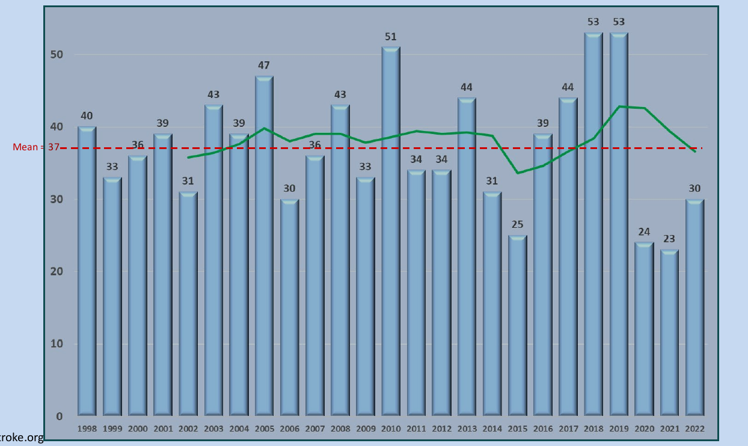
- Brazil data –
  - Over the period from 2006 to 2015, data collected from news report 31 cases, including 21 fatalities.
  - On average 3 is the number of child hyperthermia fatalities per year.
  - 71% forgot that their children were in vehicle
  - 23% left child in vehicle on purpose

Japan
Japan submitted information and documentation specifying technical requirements for two types of system to prevent children being left in buses.
- Incidents occurred in July 2021 and September 2022, in which children were left in nursery school buses and died inside the vehicles.
- In response to the death of a girl who was left behind in a school bus in Shizuoka Prefecture this September, the fourth meeting held on October 12 of the relevant ministries and agencies to discuss measures against such incidents decided on urgent measures to be taken, i.e., make the installation of safety devices in school buses mandatory and develop guidelines for the specifications of such safety devices based on the decision.
- The Children and Families Agency, a ministry that oversees kindergartens, has issued "Guidelines for Safety Devices to Help Prevent Nursery School Bus Passengers from Being Left Behind" for a total of approximately 44,000 buses used by kindergartens nationwide, which will be compliant with the Guidelines from April 2023.
- The requirements cover two types of safety devices:
  - check-on-disembarkation type and
  - automatic detection type
- Outline of the requirements:
  - Operation of Check-on-disembarkation type devices (e.g., push-button type)
    - After the motor is stopped, an alarm should be given to the driver or other crew members (“the crew”) an alarm urging them to verify whether all the passengers have disembarked.
    - The crew walks to the back of the bus making sure there are no children left behind and, that confirmed, turns off the alarm by operating a device at the back of the bus.
    - If a certain period of time elapses without the crew checking the entire vehicle and turning off the alarm, an additional alarm goes off to warn people outside.
  - Operation of automatic detection type devices
    - A certain period of time after the motor is stopped, an automatic detection system starts checking inside the bus with a camera or other sensors to see if there are any children left behind.
    - When a child left behind is detected, an alarm goes off to alert people outside.
  - Requirements common to both types of devices
    - If the crew fails to verify all the seats, etc., the device must immediately alert the crew onboard and, within 15 minutes, alert people outside (*In the case of the automatic detection type, the sensor must start operating within 15 minutes).
    - The alarm cancelling device must be installed in a location where children cannot tamper with it.
    - The device must have sufficient durability (temperature resistance from -30°C to 65°C, vibration resistance, waterproof, dust-proof, etc.).
    - In the event of a malfunction or loss of power, an alarm or other means must notify the crew of the malfunction.

Republic of Korea
The Republic of Korea submitted information, fatality statistics and documentation specifying technical requirements for systems to prevent children being left in buses which was presented in the 65th session of GRSP.
- Recorded 3 fatalities occurred in 2012, 2018 and 1 coma in 2016 (unknown afterward). All under the age of 5 years old.
- All children were left and forgotten. Among those, two were by their family members, and two were left in school buses by kindergarten and nursery.
- After the fatality in 2018, Ministry of Land, Infrastructure, and Transport amended vehicle safety regulation and made the child check devices mandatory.
- Korean Motor Vehicle Safety Standards: Article 53-4
  - Application: school bus
  - Requirements: If the button located near the rearmost seats in the compartment is not pushed within 3 minutes after turning off the propulsion system of school buses, warning sound and light (hazard lamp/school bus warning lamp) shall be activated.
  - Enforcement date: 17th April 2019
- Korea has implemented the first regulation to ensure the safety of children in school buses
- For more information see GRSP-65-22e.
Switzerland
Switzerland made a submission informing that heat-related deaths in vehicles are not listed in the road accident statistics in Switzerland, as they are not traffic accidents in the true sense. Hence, there is no corresponding selection option in the standardized accident reports.
Noted that cases such as this are very rare in Switzerland and when such a tragic case occurs, it causes a great media response. Reported statistics:
- August 2014, girl, age 16 months, forgotten in a car for several hours.
- July 2015, girl, age 5 years, overlooked in vehicle/misunderstanding, outside temperature over 33 degrees, died within 20 minutes.
- No data on cases where rescues were possible.
Concluding Observations
Common factors observed across many countries:
- No systematic collection of vehicular heatstroke fatalities in the Asian, Australian, European continents, neither by NGO, individual countries or the EU.
- Unknown how many fatalities/incidents really occur around the globe.
- It is also known that pets and elderly occupants can die in overheated vehicles.
Primary scenarios:
- FORGOTTEN (Forgotten baby syndrome): parents can be out of their normal routine or can be distracted while the child is simply quiet
- KIDS FIND THEIR WAY INTO A VEHICLE: there is a risk they could become locked in the vehicle, fall asleep, or simply want to play a game like hide-and-seek
- LEFT ON PURPOSE: Despite how it sounds, this is generally not malicious. The parent or guardian needs to run inside a store, the house, or the office for a few minutes, and they think it’ll be safe if they crack the windows and only leave for a few minutes.

