|  |
| --- |
| **UN/SCETDG/63/INF.20** |
| **Committee of Experts on the Transport of Dangerous Goods and on the Globally Harmonized System of Classification and Labelling of Chemicals**  **Sub-Committee of Experts on the Transport of Dangerous Goods 8 November 2023**  **Sixty-third session**  Geneva, 27 November-6 December 2023  Item 2 (e) of the provisional agenda  **Explosives and related matters:**  **Energetic samples** |

Transport of energetic samples

Transmitted by the European Chemical Industry Council (Cefic)

I. Introduction

1. Research and development (R&D) departments in industry, public institutes and universities frequently need to transport substances for the purpose of testing i.e., the determination of physical, chemical, biological, toxicological or ecotoxicological properties, and behavior, fitness for use, or application.

2. These substances usually consist of organic molecules that are building blocks, intermediates, or active ingredients for pharmaceutical or agricultural chemicals. Although not designed to be explosives of Class 1, many of these substances carry functional groups listed in tables A6.1 or A6.3 in Annex 6 (screening procedures) of the *Manual of Tests and Criteria*, indicating potential explosive or self-reactive properties.

3. The amounts of substance handled in the research phase are small (typically in the range 10 to 100 g), and reliable information about the proper classification is not available due to the lack of test data. Nevertheless, important decisions concerning the further development and application of these substances are made in this phase. Larger amounts of substance first become available in later stages of process scale-up and development.

4. Proper classification of these substances for transport when such limited amounts are available remains a challenge. Table 1 below specifies the amount of substance needed for classification testing of explosives and self-reactive substances. Obviously, the amount required for this purpose by far exceeds the availability of such substances in research. On the other hand, at a later stage of development, amounts of 2–4 kg have to be transported to a test lab to fulfil the legal requirements for classification.

**Table 1: Typical amounts of substance required for classification testing**

|  |  |  |  |  |  |
| --- | --- | --- | --- | --- | --- |
| **Class 1 Acceptance procedure** | | | **Testing of self-reactive substances** | | |
| UN Test | Name | Amount (g) | UN Test | Name | Amount (g) |
| 2 (a) | UN gap test | 1000 | A.1 | BAM 50/60 steel tube | 2000 |
| 2 (b) | Koenen test | 200 | C.1 | Time/pressure test | 15 |
| 2 (c) (i) | Time/pressure test | 15 | C.2 | Deflagration test | 350 |
| 3 (a) (ii) | BAM Fallhammer | 1 | E.1 | Koenen test | 200 |
| 3 (b) (i) | BAM friction apparatus | 1 | E.2 | Dutch pressure vessel test | 200 |
| 3 (c) (i) | Thermal stability test | 50 | F.3 | BAM Trauzl test | 10 |
| 3 (d) | Small scale burning test | 220 | H.4 | Heat accumulation storage test (SADT) | 1000 |
| Sum |  | **1487** | Sum |  | **3775** |

5. Section 2.0.4.3 of the *Model Regulations* gives simplified provisions for the transport of very small amounts of samples (up to 56 samples of 1 g each in a cushioning matrix with a very robust outer packaging) following a proposal from Cefic (ST/SG/AC.10/C.3/2016/61), but these provisions are obviously not adequate for shipping the amounts of substance needed for proper classification.

6. Certain untested energetic samples can theoretically be transported as potentially new explosives with special approval from a competent authority. While this route would cover the transport of the amounts of substance needed for classification, the process would be challenging for institutions with little experience in dangerous goods regulations. Furthermore, given the very large number of samples that are transported worldwide by R&D facilities for testing purposes (> 1000 per year and company), requiring approval for all these samples would represent an inordinate demand on the resources of the authorities, and would also delay scientific development at all levels of academic and industrial research.

7. Samples of self-reactive compounds and organic peroxides can be transported in relatively large amounts (Packing Method OP2, 500 g per package, 10 kg per transport unit) according to the provisions of sections 2.4.2.3.2.4 (b) and 2.5.3.2.5.1 of the *Model Regulations*. The need for temperature control can be checked even for small amounts of samples using the procedure described in section 20.3.4 of the *Manual of Tests and Criteria*, which also follows a proposal from Cefic (ST/SG/AC.10/C.3/2019/64). While these amounts would be suitable for most R&D purposes, these provisions require at least a partial classification of the substance, since it must be known to be a self-reactive or organic peroxide that is not more dangerous than Type B. Furthermore, strictly speaking, these provisions would not apply to substances whenever the screening provisions in Annex 6 effectively rule out classification of the substance as a self-reactive or an organic peroxide.

8. Further complicating the issue, many small companies, universities, and research institutes generally have limited knowledge of dangerous good regulations, and therefore these substances are frequently transported by regular mail or other delivery services under completely inappropriate conditions.

9. Due to this situation, Cefic emphasizes the need for a practical solution in this matter that is readily understood and applied by organizations less familiar with dangerous goods regulations. Towards this goal Cefic has already submitted proposals for the transport of small amounts of samples (as mentioned in paragraph 5 above) and also for a practical and easily applicable approach to determine thermal stability and possible temperature control requirements for samples (as mentioned in paragraph 7 above). These proposals were accepted by the Sub-Committee in previous biennia and are already included in the *Model Regulations* and the *Manual of Tests and Criteria*.

10. In the current biennium, Cefic takes the next step towards a comprehensive solution by introducing their concept for samples in larger amounts. Encouraged by discussions both in the International Group for Unstable Substances: Energetic and Oxidizing Substances (IGUS EOS Working Group) and the Working Group on Explosives of the TDG Sub-Committee, Cefic submitted a proposal for a flow chart along with detailed justifications. As a result of these discussions, the Working Group on Explosives requested more time to examine the issue and suggested that Cefic submit a formal proposal to facilitate the discussions. Following this request, Cefic now presents this informal document to further facilitate the discussions.

11. Cefic requests the Subcommittee to carefully review the proposal laid out in this paper. Written comments by the delegations are highly appreciated and should be sent by e‑mail to the Cefic representative. Based on the feedback, Cefic will submit a formal proposal for the subsequent summer session.

II. Discussion

Explosives, self-reactive substances, and stable energetic substances

12. An overview of the current classification criteria is shown in Figure 1 below. To simplify the discussion, special cases such as pyrotechnics, articles, and ammonium nitrate emulsions, suspensions or gels (ANEs) are summarized as “intentional explosives” and not further discussed here since the focus of this proposal is on energetic research samples that are not intentional explosives.

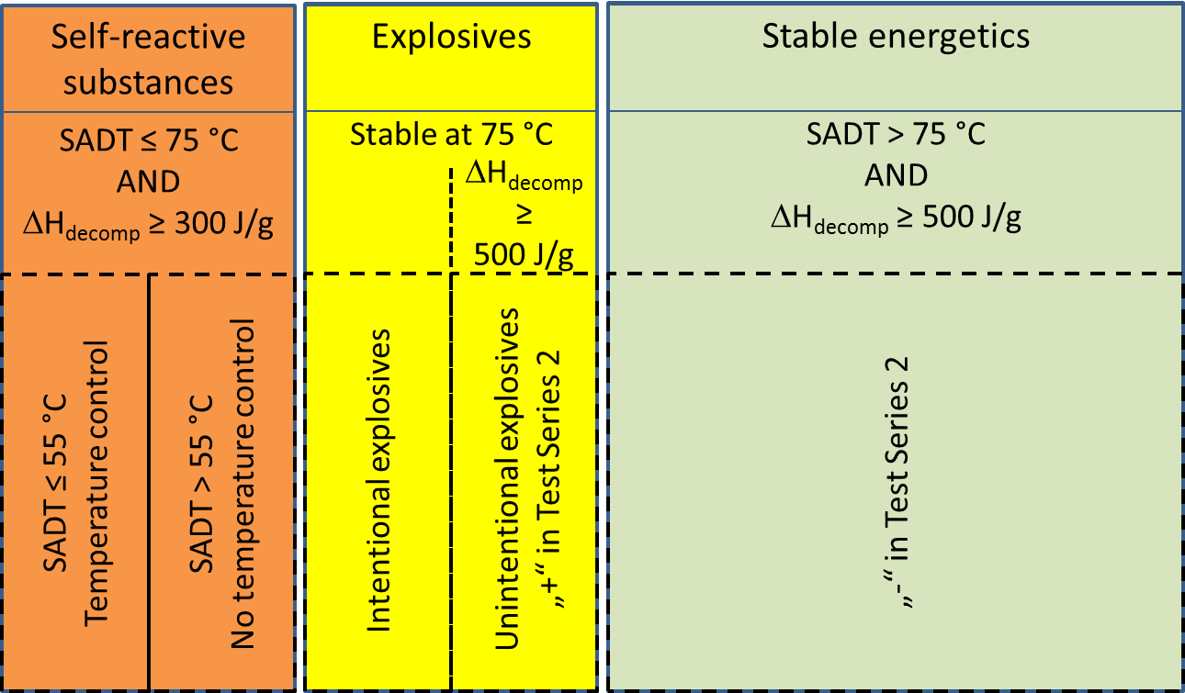

Figure 1: Classes of energetic substances

13. As already mentioned in the introduction of this document, the samples under consideration contain substances carrying functional groups indicating potential explosive or self-reactive properties (tables A6.1 and A6.3 in Annex 6 of the *Manual of Tests and Criteria*).

14. According to 2.1.1.5 of the *Model Regulations* and 10.2.1 (b) of the *Manual of Tests and Criteria*, any substance should be first considered for inclusion in Class 1.

15. Appendix 6, section 3.3 (c) of the *Manual of Tests and Criteria* states that for organic substances containing chemical groups associated with explosive properties the Class 1 acceptance procedure does not have to be applied:

(a) When the exothermic decomposition energy is less than 500 J/g, or

(b) When the onset of exothermic decomposition is 500 °C or above as indicated by Table A6.2.

16. If both of these conditions are not met, then classification of the substance must follow the acceptance procedure as described in sections 2.1.3.2 and 2.1.3.3 of the *Model Regulations*; a flow chart showing this procedure is given in Figure 10.2 of the *Manual of Tests and Criteria*. For possible non-intentional explosives, test series 2 determines whether a substance is to be considered for Class 1 (Box 7 of that flow chart).

17. Subsequently, the thermal stability and mechanical sensitivity of the substance are determined (test series 3 and 4). If the substance is not thermally stable, Class 1 is rejected (box 12). However, section 10.3.3.4 of the *Manual of Tests and Criteria* suggests that for “a substance, not designed to have an explosive effect … it is more appropriate to start the testing procedure with test series 3” to ensure safe handling during testing.

18. If Class 1 is rejected due to insufficient thermal stability, a classification as a self-reactive substance will apply.

19. Self-reactive substances are defined in 2.4.2.3.1.1 of the *Model Regulations* as “thermally unstable substances liable to undergo a strongly exothermic decomposition even without participation of oxygen (air)”. Apart from differentiation criteria from other classes, substances should be classified as self-reactive if they have a decomposition energy of 300 J/g or more in combination with an self-accelerating decomposition temperature (SADT) of 75 °C or less. The decomposition energy should be determined by differential scanning calorimetry (DSC) according to section 20.3.3.3 of the *Manual of Tests and Criteria*, while the SADT should be determined by one of the H-series tests.

20. Section 5.1 (b) in Appendix 6 of the *Manual of Tests and Criteria* and section 2.4.2.3.1.1 of the *Model Regulations* state that classification as a self-reactive substance does not apply if either one of the two criteria described above is not fulfilled. Temperature control is required if the SADT is less than or equal to 55 °C (see 2.4.2.3.4) as shown in Figure 1 above.

21. If a substance is thermally stable at 75 °C and passes Test Series 2, a classification as explosive (Class 1) and self-reactive (Division 4.1) is not applicable. Such substances would be assigned to the box denoted “stable energetics” in Figure 1.

22. Experience in industry has shown that the vast majority (> 95%) of substances in the scope of this document would be characterized as such stable energetics, a small percentage (< 5 %) as self-reactive and a negligible amount (less than 0.1 %) as explosive (Figure 2).

Figure 2: Distribution of research samples following testing

Issues to be solved for the transport of energetic samples

23. Whereas the transport of samples of self-reactive substances and organic peroxides is permitted under the provisions of 2.4.2.3.2.4 (b) and 2.5.3.2.5.1, respectively, substances considered to meet the criteria for Class 1 are prohibited for transport by 2.0.4.2 (b).

24. The classification depicted above as presented in Figure 1 works on the presumption that all necessary data are available for a proper classification.

25. Section 2.4.2.3.2.4 (b) permits the transport of self-reactive substances as type C provided that:

(a) Available data indicate that the sample would not be more dangerous than type B;

(b) Packing method OP2 is applied with an upper limit of 10 kg per cargo transport unit; and

(c) Temperature control and dangerous phase separation are considered.

Similar provisions are provided in section 2.5.3.2.5.1 for the transport of organic peroxides.

26. As the text is written, it presumes that a classification as self-reactive is already established, i.e., decomposition energy ≥ 300 J/g and SADT ≤ 75 °C and subsequent measures for temperature control have been determined by measurement. As shown in Figure 1 above, full testing in this context requires roughly 4 kg of substance. However, what has to be done in order to transport this amount of sample to the test lab for SADT determination in the first place?

27. On the other hand, for a substance that is thermally stable, about 2 kg of material are necessary to perform test series 2. While UN 0190 offers a legal yet conservative provision for the transport of unclassified energetic substances, its application in such cases would be an intolerable burden both for industry and competent authorities and is by no means appropriate, especially with samples in the research phase when only small amounts (generally 10 to 100 g) are to be carried. As shown in Figure 2, only for a very small percentage of samples would the classification as explosive be justified; and in all those cases a very high decomposition energy (> 2500 J/g) had been measured.

28. Following numerous discussions with competent authorities and international experts, Cefic has developed the concept of transporting energetic samples under the regime of self-reactive substances of division 4.1. Reasons are:

(a) Provisions for the safe transport of self-reactive substances already exist (see above and 2.0.4.2 (c));

(b) Self-reactive substances may have explosive properties (see 2.4.2.3.1.2), and appropriate packing instructions (P520) are prescribed;

(c) Temperature control is applicable for substances of low thermal stability.

29. It should be also noted that type B self-reactives may be carried in limited quantities of 100 g (solids, UN 3222) and 25 ml (liquids, UN 3221), respectively.

30. The Sub-Committee has supported this approach and adopted Cefic’s proposals in documents ST/SG/AC.10/C.3/2016/61 and ST/SG/AC.10/C.3/2019/64 in previous biennia. The new provisions in section 2.0.4.3 allow for the transport of small amounts of samples (up to 1 g or 1 ml) as self-reactive substances type C under certain restrictions in a very specific package, while the provisions in section 20.3.4 of the *Manual of Tests and Criteria* describe a practical method of estimating the thermal stability of new energetic samples and determining a control temperature for their transport.

31. The adopted solution in section 2.0.4.3 for small samples (up to 1 g scale) is built on a safe package design:

(a) The package is sufficiently strong to survive the detonation even of an intentional explosive (see document ST/SG/AC.10/C.3/2016/61), and

(b) The inner design of the package prevents a propagation of detonation from one sample to another.

32. For larger amounts of samples, this concept is obviously not practical. Therefore, further proceedings have to be based on increased knowledge about safety-relevant properties of the sample. It seemed obvious to use the decomposition energy as an assessment criterion since the effects of an incident correlate with the amount of energy involved.

33. Generally, the decomposition energy and the onset of decomposition can be easily determined by DSC methods with very small amounts of substance (see *Manual of Tests and Criteria*, section 20.3.3.3). This document describes how information derived from these tests may be used as the basis for a preliminary assessment of new energetic samples.

Decomposition energy

34. A representative set of R&D samples (369 substances) was investigated with respect to their decomposition energy. For this purpose, screening DSCs were measured at heating rates of 3-5 K/min in agreement with the requirements outlined in the *Manual of Tests and Criteria*, section 20.3.3.3.

35. For comparison, the self-reactive substances listed in section 2.4.2.3.2.3 of the *Model Regulations* were evaluated with respect to their decomposition energies (Figure 3). Where available, measurement data were taken; in other cases, literature data were used or bond increment methods applied (see table 3 in the annex to this document).

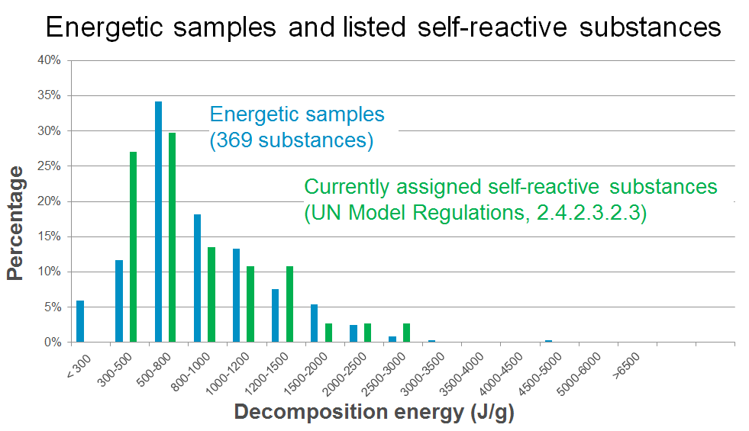

Figure 3: Decomposition energies of energetic samples vs. listed self-reactives

36. Evidently, the shape and position of the distributions form an excellent match. The coherence with the curve for the self-reactive substances justifies the treatment of energetic samples under the same provisions as self-reactives and strongly supports the approach taken by Cefic (see paragraph 28 above).

37. As a further comparison, literature data for known explosives were compiled and evaluated (J. Köhler, R. Meyer, Explosivstoffe, Wiley-VCH). The results are shown in Figure 4:

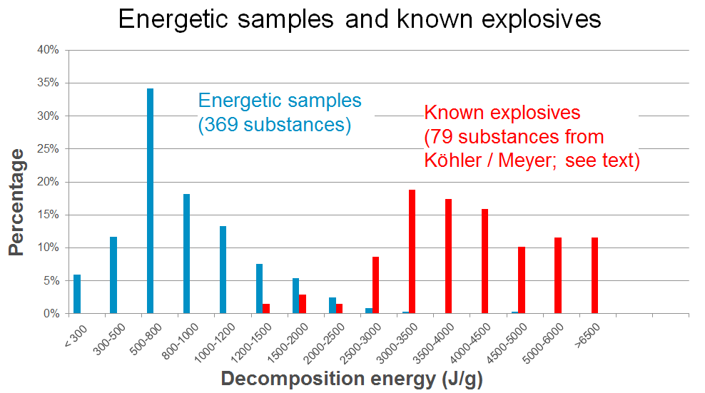

Figure 4: Decomposition energy of energetic samples vs. known explosives

38. Figure 5 shows a similar comparison of energetic R&D samples with desensitized explosives and stable energetic compounds (data for these last two taken from the *Model Regulations*; see Tables 4 and 5 in the annex to this document). The stable energetics in the context of this document are substances exhibiting a decomposition energy of more than 1000 J/g outside of Class 1 and Self-reactives of Division 4.1. Note that some of these products, such as nitromethane and derivatives of nitrobenzene, are currently produced and transported in huge volumes. Numerous polymerizing substances exhibit large heats of reaction as well (see informal document UN/SCETDG/47/INF.27).

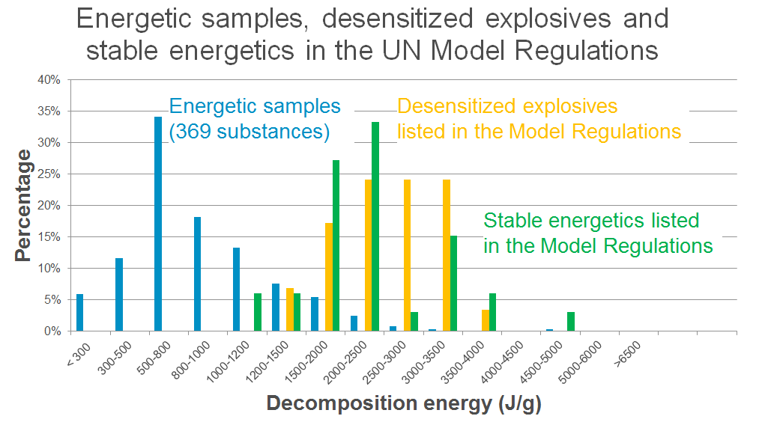

Figure 5: Decomposition energies of energetic samples vs.   
desensitized explosives and stable energetics

39. Evidently, the energetic R&D samples form a group of lower decomposition energies clearly separated from the explosives and stable energetics with much higher energies (Figures 4 and 5). Except for one substance (the salt lead trinitroresorcinate, 1480 J/g), no known explosive could be identified with a decomposition energy < 1500 J/g. In the group of the desensitized explosives, the salts silver picrate, zirconium picramate and barium azide exhibit similar low decomposition energies. As intentional initiating explosives, these substances are clearly outside of the scope of 2.0.4.3.

40. The decomposition energies of the desensitized forms of sodium pricramate, ammonium perchlorate, and sodium dinitrocresolate are found in the range 1900-2000 J/g. All these compounds can be chemically characterized as salts. For the non-salts 4‑nitrophenylhydrazine and 1-hydroxybenotriazole in their desensitized form, a lower energy limit of 2000 J/g is found as well. These considerations lead to the conclusion that for the samples as described in 2.0.4.3.1 (a) a safe transport is warranted for decomposition energies:

(a) Below 1500 J/g for salts and complexes, and

(b) Below 2000 J/g for substances other than salts and complexes.

41. Evidently, in terms of possible energy release the R&D samples are not more dangerous that self-reactive substances of types B to E which is in agreement with 2.4.2.3.2.4 (b)(i).

42. As discussed above, the large majority of known explosives have a decomposition energy above 2000 J/g. Samples exhibiting such energies have an increased chance of being explosive substances and would need closer inspection before transport.

43. Therefore, it appears justified to allow the transport of energetic samples as self-reactive substances Type C under the provisions of 2.4.2.3.2.4 (b) depending on their energy content (decomposition enthalpy ΔHdecomp) as follows:

Table 2: Suggested thresholds for testing of energetic samples

|  |  |  |
| --- | --- | --- |
| **Testing requirements** | **Salts** | **Other organic substances** |
| No testing required | ΔHdecomp < 1500 J/g | ΔHdecomp < 2000 J/g |
| Additional testing required | ΔHdecomp ≥ 1500 J/g | ΔHdecomp ≥ 2000 J/g |

44. If additional testing becomes necessary according to the criteria laid down in table 2, what appears to be a reasonable way forward? Considering that only limited amounts of substance are available in early stages for such testing, it is suggested to obtain a preliminary assessment for the sample transport based on the test for explosive power (Test F.3) and time/pressure test for assessing the ability to deflagrate rapidly (Test C.1). Since soft packagings are prescribed in packing instruction P520, the Koenen test (Test E.1) appears less useful in this context.

45. If in Test C.1 the result “yes, rapidly” OR in Test F.3 the result “not low” would be obtained, two possible options emerge: Options 1 would be to contact the competent authority for a special permit as per UN 0190; as an alternative, the substance may be dissolved in an appropriate solvent or diluted with an inert compound to obtain a homogeneous mixture to be submitted again to the assessment procedure starting from box 10 in the proposed flow chart below. If the result obtained indicates no critical values, the available data would justify a sample transport under the established provisions of 2.4.2.3.2.4 (b) as self-reactive substance Type C, packing method OP2, packing instruction P520.

46. Based on these considerations, a tentative flowchart incorporating already existing provisions has been drafted (see Figure 6).

47. Boxes 1 through 9, 11 and 12 refer to already existing provisions in the *Model Regulations*.

48. Box 4 refers to section 5.1 (b) of Appendix 6 of the *Manual of Tests and Criteria*. Since the approach applies the self-reactives regime for all energetic compounds, the SADT criterion is not relevant in this context. Below a decomposition energy of 300 J/g, a classification as a self-reactive substance or as explosive can be ruled (see also Figure 1 above).

49. Box 4 is not meant to have a mandatory measured value for the substance under concern. Possible valid ways to escape to box 5 would be, for example, experience with data from similar compounds or an extrapolation from data of a small molecule to a larger one.

50. Boxes 6 through 9 refer to the provisions in section 2.0.4.3.

51. Box 10 would be new text requiring the determination of the decomposition behavior (energy and onset) of the sample for amounts exceeding 1 g or 1 ml per sample.

52. Box 11 identifies low energy samples that:

(a) Are not candidates for self-reactive substances due to their thermal stability (see paragraph 53 below), and

(b) Do not require the Class 1 acceptance procedure based on the criteria outlined in table 6.2 of Annex 6 of the *Manual of Tests and Criteria* (see paragraph 54 below).

53. According to the “100 K rule” applied in worldwide chemical safety assessment, keeping a distance of 100 K from the decomposition onset has proven a practical rule of thumb to avoid thermal runaway reactions. With an additional safety margin of 20 K for the decomposition onset of 200 °C, an SADT above 75 °C is ensured and consequently, a classification as self-reactive according to 2.4.2.3.1.1 (e) can be ruled out.

54. For explosives, a lower energy limit of 500 J/g applies according to section 3.3 (c) in appendix 6 of the *Manual of Tests and Criteria* (yellow box in Figure 1). In this context, see the discussion in paragraph 15 in this document.

55. In box 13, possible temperature control requirements are determined as described in section 20.3.4 in the *Manual of Tests and Criteria*.

56. Boxes 14 to 21 establish the criteria suggested in paragraphs 40 to 45 above. Boxes 15 and 19 refer to the existing provisions concerning the transport of samples of self-reactive substances.



Figure 6: Tentative flowchart for energetic samples



Figure 6: Tentative flowchart for energetic samples (continued)

III. Proposal

57. Insert a new section 2.0.4.3.2 to read:

“Samples of organic substances carrying functional groups listed in tables A6.1 and/or A6.3 in Appendix 6 (Screening Procedures) of the *Manual of Tests and Criteria* may be assigned to one of the appropriate entries for self-reactive substances type C (UN 3223, UN 3224, UN 3233, UN 3234 as applicable) of Division 4.1 and transported under the provisions of 2.4.2.3.2.4 (b) provided that:

(a) They fulfil the criteria of 2.0.4.3.1 (a) through (c), and

(b) Their decomposition energy is

(i) Less than 1500 J/g for salts or complexes of organic compounds, or

(ii) Less than 2000 J/g for other organic substances, or

(iii) 1500 J/g or more for salts or complexes of organic compounds, and in test UN C.1 the result is not “yes, rapidly” and in test UN F.3 the result is not “not low”, or

(iv) 2000 J/g or more for other organic substances, and in test UN C.1 the result is not “yes, rapidly” and in test UN F.3 the result is not “not low”.

The assessment in (iii) and (iv) may be based on a single test C.1 and F.3 each. If the criteria in (b) above are fulfilled, it can be assumed that the sample is not more dangerous that self-reactive substances type B.

An appropriate method to determine temperature control requirements is described in section 20.3.4 of the *Manual of Tests and Criteria*.

Samples not passing the criteria in (iii) or (iv) above may be transported by an approval issued by the competent authority of the country of origin. The statement of approval shall be based on the available information and contain the classification and the relevant transport conditions. Alternatively, the sample may be dissolved or diluted with an inert compound to form a homogenous mixture in agreement with the criteria in 2.0.4.3.2 (b) (i) or (ii) as applicable.”

58. Insert a new section 2.0.4.3.3 to read:

“A flow chart describing the classification of energetic samples is shown in figure 2.0.4.”

59. Insert the flow chart in Figure 6 of this proposal as figure 2.0.4.

IV. Justification

60. The proposal presents a comprehensive and practical solution for the transport of energetic samples.

61. The vast majority of these R&D substances never make it to further stages of development for economic or business reasons. From this point of view, extensive testing for formal classification is not justified in this early phase of development, and a simplified and efficient testing regime to ensure safe handling and transport would be beneficial.

62. In the discussion above, it has been shown that the decomposition energies of these samples match the regime of existing self-reactive substances (Figure 3 of this document), whereas the decomposition energies of known Class 1 explosives are found at much higher energies. The discussion has further led to the conclusion that below the energy values listed in table 2 candidates for Class 1 can be excluded for substances and amounts in the scope of this proposal.

63. For samples of higher energies, further tests in limited amounts allow a safe, initial assessment. In critical cases, an approval by the competent authority will be required. Dilution with an inert compound has been identified as an alternative option.

64. By referring to the regime of self-reactive substances, existing provisions and packing instructions are applied, which should facilitate the implementation in the modal regulations.

65. The proposed flow charts guide classifiers through the relevant steps and should be helpful for organizations less familiar with dangerous goods regulations, thus increasing the safety during the transport of research samples.

Annex

Table 3: Decomposition energies of self-reactive substances  
(*Model Regulations*, section 2.4.2.3.2.3)

| Name | Concen-tration  (%) | Packing method | UN generic entry | Decom-position energy (estimate) (J/g) | Type |
| --- | --- | --- | --- | --- | --- |
| ACETONE-PYROGALLOL COPOLYMER 2-DIAZO-1-NAPHTHOL-5-SULPHONATE | 100 | OP8 | 3228 | 521 | E |
| AZODICARBONAMIDE FORMULATION TYPE B | 100 | OP5 | 3232 | 1400 | B |
| AZODICARBONAMIDE FORMULATION TYPE C | 100 | OP6 | 3224 | 1400 | C |
| AZODICARBONAMIDE FORMULATION TYPE D | 100 | OP7 | 3226 | 1400 | D |
| 2,2' -AZODI(2,4-DIMETHYL- 4-METHOXYVALERONITRILE) | 100 | OP7 | 3236 | 584 | D |
| 2,2' -AZODI(2,4-DIMETHYL- VALERONITRILE) | 100 | OP7 | 3236 | 725 | D |
| 2,2' -AZODI(ETHYL- 2-METHYLPROPIONATE) | 100 | OP7 | 3235 | 697 | D |
| 1,1-AZODI(HEXAHYDROBENZONITRILE) | 100 | OP7 | 3226 | 768 | D |
| 2,2'-AZODI(ISOBUTYRONITRILE) | 100 | OP6 | 3234 | 1096 | C |
| 2,2'-AZODI(2-METHYLBUTYRONITRILE) | 100 | OP7 | 3236 | 936 | D |
| BENZENESULPHONYL HYDRAZIDE | 100 | OP7 | 3226 | 1061 | D |
| 4-(BENZYL(ETHYL)AMINO)-3-ETHOXY-BENZENEDIAZONIUM ZINC CHLORIDE | 100 | OP7 | 3226 | 396 | D |
| 4-(BENZYL(METHYL)AMINO)-3-ETHOXYBENZENEDIAZONIUM ZINC CHLORIDE | 100 | OP7 | 3236 | 409 | D |
| 3-CHLORO-4-DIETHYLAMINOBENZENE-DIAZONIUM ZINC CHLORIDE | 100 | OP7 | 3226 | 508 | D |
| 2-DIAZO-1-NAPHTHOL-4- SULPHONYL-CHLORIDE | 100 | OP5 | 3222 | 930 | B |
| 2-DIAZO-1-NAPHTHOL-5- SULPHONYL CHLORIDE | 100 | OP5 | 3222 | 930 | B |
| 2,5-DIBUTOXY-4-(4-MORPHOLINYL) BENZENEDIAZONIUM, TETRACHLOROZINCATE (2:1) | 100 | OP8 | 3228 | 411 | E |
| 2,5-DIETHOXY-4-MORPHOLINO- BENZENEDIAZONIUM ZINC CHLORIDE | 100 | OP7 | 3236 | 376 | D |
| 2,5-DIETHOXY-4-MORPHOLINO- BENZENEDIAZONIUM TETRAFLUOROBORATE | 100 | OP7 | 3236 | 458 | D |
| 2,5-DIETHOXY-4-(4-MORPHOLINYL)- BENZENEDIAZONIUM SULPHATE | 100 | OP7 | 3226 | 508 | D |
| 4-(DIMETHYLAMINO)-BENZENE-DIAZONIUM TRICHLOROZINCATE (-1) | 100 | OP8 | 3228 | 563 | E |
| 4-DIMETHYLAMINO-6-(2-DIMETHYL-AMINOETHOXY) TOLUENE- 2-DIAZONIUM ZINC CHLORIDE | 100 | OP7 | 3236 | 427 | D |
| N,N'-DINITROSO-N,N'-DIMETHYL TEREPHTHALAMIDE, | 72 | OP6 | 3224 | 1755 | C |
| N,N'-DINITROSOPENTAMETHYLENE-TETRAMINE | 82 | OP6 | 3224 | 2687 | C |
| DIPHENYLOXIDE-4,4'-DISULPHONYL HYDRAZIDE | 100 | OP7 | 3226 | 1020 | D |
| 4-DIPROPYLAMINOBENZENE- DIAZONIUM ZINC CHLORIDE | 100 | OP7 | 3226 | 479 | D |
| N-FORMYL-2-(NITROMETHYLENE) -1,3-PERHYDROTHIAZINE | 100 | OP7 | 3236 | 2261 | D |
| 2-(2-HYDROXYETHOXY)-1- (PYRROLIDIN-1-YL)BENZENE-4- DIAZONIUM ZINC CHLORIDE | 100 | OP7 | 3236 | 443 | D |
| 3-(2-HYDROXYETHOXY)-4- (PYRROLIDIN-1-YL)BENZENE DIAZONIUM ZINC CHLORIDE | 100 | OP7 | 3236 | 443 | D |
| 2-(N,N-METHYLAMINOETHYL- CARBONYL)-4-(3,4-DIMETHYL- PHENYLSULPHONYL)BENZENE- DIAZONIUM HYDROGEN SULPHATE | 96 | OP7 | 3236 | 368 | D |
| 4-METHYLBENZENESULPHONYL- HYDRAZIDE | 100 | OP7 | 3226 | 981 | D |
| 3-METHYL-4-(PYRROLIDIN-1-YL) BENZENEDIAZONIUM TETRAFLUOROBORATE | 95 | OP6 | 3234 | 622 | C |
| 4-NITROSOPHENOL | 100 | OP7 | 3236 | 1210 | D |
| PHOSPHOROTHIOIC ACID, O-[(CYANOPHENYL METHYLENE) AZANYL] O,O-DIETHYL ESTER | 82-91 | OP8 | 3227 | 1100 | E |
| SODIUM 2-DIAZO-1-NAPHTHOL- 4-SULPHONATE | 100 | OP7 | 3226 | 661 | D |
| SODIUM 2-DIAZO-1-NAPHTHOL- 5-SULPHONATE | 100 | OP7 | 3226 | 661 | D |
| TETRAMINE PALLADIUM (II) NITRATE | 100 | OP6 | 3234 | 857 | C |

**Table 4: Decomposition energies of desensitized explosives  
in Dangerous Goods List of the *Model Regulations***

| Name | Concen-tration  (%) | UN generic entry | Decomposition energy (estimate)  (J/g) |
| --- | --- | --- | --- |
| AMMONIUM PICRATE, WETTED with not less than 10% water, by mass | <90 | 1310 | 2538 |
| DINITROPHENOL, WETTED with not less than 15% water, by mass | <85 | 1320 | 3195 |
| DINITRORESORCINOL, WETTED with not less than 15% water, by mass | <85 | 1322 | 2939 |
| NITROGUANIDINE (PICRITE), WETTED with not less than 20% water, by mass | <80 | 1336 | 2450 |
| NITROSTARCH, WETTED with not less than 20% water, by mass | <80 | 1337 | 3251 |
| TRINITROPHENOL (PICRIC ACID), WETTED with not less than 30% water, by mass | <70 | 1344 | 2482 |
| SILVER PICRATE, WETTED with not less than 30% water, by mass | <70 | 1347 | 1244 |
| SODIUM DINITRO-o-CRESOLATE, WETTED with not less than 15% water, by mass | <85 | 1348 | 1968 |
| SODIUM PICRAMATE, WETTED with not less than 20% water, by mass | <80 | 1349 | 1895 |
| TRINITROBENZENE, WETTED with not less than 30% water, by mass | <70 | 1354 | 2749 |
| TRINITROBENZOIC ACID, WETTED with not less than 30% water, by mass | <70 | 1355 | 2078 |
| TRINITROTOLUENE (TNT), WETTED with not less than 30% water, by mass | <70 | 1356 | 2608 |
| UREA NITRATE, WETTED with not less than 20% water, by mass | <80 | 1357 | 2570 |
| ZIRCONIUM PICRAMATE, WETTED with not less than 20% water, by mass | <80 | 1517 | 1848 |
| BARIUM AZIDE, WETTED with not less than 50% water, by mass | <50 | 1571 | 1078 |
| NITROCELLULOSE WITH WATER (not less than 25% water, by mass) | <75 | 2555 | 3266 |
| DIPICRYL SULPHIDE, WETTED with not less than 10% water, by mass | <90 | 2852 | 3191 |
| ISOSORBIDE DINITRATE MIXTURE with not less than 60% lactose, mannose, starch or calcium hydrogen phosphate | <60 | 2907 | 2046 |
| 2-AMINO-4,6-DINITROPHENOL, WETTED with not less than 20% water, by mass | <80 | 3317 | 2104 |
| TRINITROPHENOL (PICRIC ACID), WETTED, with not less than 10% water by mass | <90 | 3364 | 3191 |
| TRINITROCHLOROBENZENE (PICRYL CHLORIDE), WETTED, with not less than 10% water by mass | <90 | 3365 | 3042 |
| TRINITROTOLUENE (TNT), WETTED, with not less than 10% water by mass | <90 | 3366 | 3353 |
| TRINITROBENZENE, WETTED, with not less than 10% water by mass | <90 | 3367 | 3534 |
| TRINITROBENZOIC ACID, WETTED, with not less than 10% water by mass | <90 | 3368 | 2672 |
| SODIUM DINITRO-o-CRESOLATE, WETTED, with not less than 10% water by mass | <90 | 3369 | 2083 |
| UREA NITRATE, WETTED, with not less than 10% water by mass | <90 | 3370 | 2892 |
| 4-NITROPHENYLHYDRAZINE, with not less than 30% water, by mass | <70 | 3376 | 1960 |
| 1-HYDROXYBENZOTRIAZOLE MONOHYDRATE | <88 | 3474 | 1993 |
| NITROGLYCERIN MIXTURE, DESENSITIZED, LIQUID, FLAMMABLE, N.O.S. with not more than 30% nitroglycerin, by mass | <30 | 3343 | 2003 |

**Table 5: Decomposition energies of stable energetic compounds  
in Dangerous Goods List of the *Model Regulations***

|  |  |  |
| --- | --- | --- |
| Name | UN generic entry | Decomposition energy (estimate) (J/g) |
| DIMETHYLHYDRAZINE, UNSYMMETRICAL | 1163 | 1148 |
| METHYLHYDRAZINE | 1244 | 2152 |
| NITROMETHANE | 1261 | 4811 |
| p-NITROSODIMETHYLANILINE | 1369 | 1931 |
| GUANIDINE NITRATE | 1467 | 2449 |
| CHLORODINITROBENZENES, LIQUID | 1577 | 3209 |
| CHLORONITROBENZENES, SOLID | 1578 | 2063 |
| CHLOROPICRIN | 1580 | 1977 |
| DINITROANILINES | 1596 | 3331 |
| DINITROBENZENES, LIQUID | 1597 | 3510 |
| DINITRO-o-CRESOL | 1598 | 3079 |
| DINITROTOLUENES, MOLTEN | 1600 | 3459 |
| NITROANILINES (o-, m-, p-) | 1661 | 2208 |
| NITROBENZENE | 1662 | 2356 |
| NITROPHENOLS (o-, m-, p-) | 1663 | 2085 |
| NITROTOLUENES, LIQUID | 1664 | 2297 |
| NITROXYLENES, LIQUID | 1665 | 2084 |
| AMMONIUM DINITRO-o-CRESOLATE, SOLID | 1843 | 2928 |
| HYDRAZINE, ANHYDROUS | 2029 | 2340 |
| DINITROTOLUENES, LIQUID | 2038 | 3459 |
| CHLORONITROANILINES | 2237 | 1767 |
| NITROBENZENESULPHONIC ACID | 2305 | 1723 |
| NITROBENZOTRIFLUORIDES, LIQUID | 2306 | 1596 |
| 3-NITRO-4-CHLOROBENZOTRIFLUORIDE | 2307 | 1352 |
| DIMETHYLHYDRAZINE, SYMMETRICAL | 2382 | 1148 |
| CHLORONITROTOLUENES, LIQUID | 2433 | 1836 |
| NITROCRESOLS, SOLID | 2446 | 1992 |
| NITROTOLUIDINES (MONO) | 2660 | 2005 |
| NITROANISOLES, LIQUID | 2730 | 2057 |
| NITROBROMOBENZENES, LIQUID | 2732 | 1510 |
| NITROETHANE | 2842 | 3930 |
| AZODICARBONAMIDE | 3242 | 1400 |
| ISOSORBIDE-5-MONONITRATE | 3251 | 1596 |
| NITROBENZOTRIFLUORIDES, SOLID | 3431 | 1596 |
| NITROCRESOLS, LIQUID | 3434 | 1992 |
| DINITROBENZENES, SOLID | 3443 | 3510 |
| NITROTOLUENES, SOLID | 3446 | 2297 |
| NITROXYLENES, SOLID | 3447 | 2084 |
| DINITROTOLUENES, SOLID | 3454 | 3459 |
| CHLORONITROTOLUENES, SOLID | 3457 | 1836 |
| NITROANISOLES, SOLID | 3458 | 2057 |
| NITROBROMOBENZENES, SOLID | 3459 | 1510 |