|  |  |  |  |
| --- | --- | --- | --- |
|  | United Nations | ECE/TRANS/WP.15/AC.2/2024/11 | |
| _unlogo | **Economic and Social Council** | | Distr.: General  10 November 2023  Original: English |

**Economic Commission for Europe**

Inland Transport Committee

**Working Party on the Transport of Dangerous Goods**

**Joint Meeting of Experts on the Regulations annexed to the   
European Agreement concerning the International Carriage   
of Dangerous Goods by Inland Waterways (ADN)  
(ADN Safety Committee)**

**Forty-third session**

Geneva, 22-26 January 2024

Item 5 (b) of the provisional agenda

**Proposals for amendments to the Regulations annexed to ADN:**

**other proposals**

Proposed changes to 9.3.4 of ADN

Transmitted by the Recommended ADN Classification Societies[[1]](#footnote-2)\*, [[2]](#footnote-3)\*\*

Introduction

1. At the forty-first session of the ADN Safety Committee the Dutch Institute of Applied Science (TNO) has delivered a presentation with an overview of the results of the investigation on the update of 9.3.4 of ADN. This investigation has been done to cope with the changed circumstances on the inland waterways with respect to available collision energy.

2. In the study, the possibility of increasing the cargo tank limits beyond 1.000 m3 has been also considered. It was concluded that for specific cargoes this may be an option. However, this needs to be further investigated.

3. In the same study, energy statistics and crashworthiness calculation methods were investigated. Both subjects resulted in proposed changes to 9.3.4 of ADN for the longer and shorter terms. In this document all proposed changes are given.

4. The report with the summary and recommendations of this investigation is included in informal document INF.2 (TNO-2023-R10366 dated 18 May 2023), as well as the background document on collision energy statistics (TNO-2022-R12238 dated 9 December 2022).

Proposed changes

5. 9.3.4.1.1 Add the following sentence:

**“However, in case of tanks intended for only one substance, of which it can be demonstrated that effect distances remain within a radius of 135 m from the outflow location in case of a loss of containment, larger tank capacities may be acceptable. The effect distance calculation method and assumptions made for the calculations are to be agreed upon by the recognised classification society.”**

6. 9.3.4.3.1.2.2.2 Amend to read as follows:

**“For a tank vessel type G, three vertical collision locations shall be assumed; 1) at half tank height, 2) half stringer spacing below half tank height and 3) half stringer spacing above half tank height.”**

7. 9.3.4.3.1.2.4.2 Replace “~~1 x 3 collision locations”~~ by **“3 x 3 = 9 collision locations.”**

8. 9.3.4.3.1.3.2.2 Replace the first sentence by:

**“The weighting factor for each of the three vertical collision locations has the value of 0.333.”**

The second sentence should be deleted.

9. 9.3.4.3.1.5.1 Amend to read as follows::

**“For each collision energy absorbing capacity Eloc(i), the associated probability of exceedance is to be determined. For this purpose the values for the cumulative probability density functions (CPDF) from the tables in 9.3.4.3.1.5.6 shall be used.”**

10. 9.3.4.3.1.5.6 Replace the existing tables by the tables and the text given in the Annex.

11. 9.3.4.4.1.1 Change the last sentence as follows:

**“The code shall also be capable to simulate rupture realistically and of calculating and outputting (plastic) strain energy (energy by material deformation), friction energy and, in case of type G tankers, energy dissipated by tank deformation and fluid compression.”**

12. 9.3.4.4.2.4 Replace “~~200~~” by **“100”** in the second sentence.

13. 9.3.4.4.2.5 Add the following sentence:

**“Shell elements shall have at least 5 integration points through-thickness.”**

14. 9.3.4.4.2.6 Amend to read as follows:

**“In the finite element calculation a suitable contact algorithm that includes self-contact shall be used.”**

15. Add a new 9.3.4.4.2.7 to read:

**“Tank vessel type G. For a tank vessel type G, the internal tank pressure shall be modelled by means of a compressible fluid volume. The corresponding pressure-volume relation shall be based on a full tank with minimal ullage. The initial pressure shall be set at max. design pressure of the tank.”**

16. 9.3.4.4.3.1 Replace “~~Ag = the maximum uniform strain related to the ultimate tensile stress Rm and~~” by

**“Rm = the ultimate tensile stress [N/m2]”**

**“Ag = the uniform strain [-] at Rm”**

And add the following sentence:

**“The stress-strain relation shall be described by a power law directly or equivalent representation discretised by at least a 100 data points up to a plastic strain of 1.”**

17. 9.3.4.4.3.2 Add the following sentence:

**“Tensile tests are to be carried out in accordance with the regulations of a recognised classification society.”**

18. 9.3.4.4.3.3 Replace the first sentence by:

**“If only the ultimate tensile stress Rm is available, for shipbuilding steel with a yield stress not exceeding 355 [N/mm2], the following approximation may be used to obtain the Ag value for a known ultimate tensile stress Rm with Rm in [N/mm2]:”**

Note: The given formula should remain the same.

19. 9.3.4.4.4.1 Amend to read as follows::

**“The rupture of an element in a FEA is defined by the failure strain value. If the calculated strain, i.e. plastic effective strain, principal strain or the strain in the thickness direction, of this element exceeds its defined failure strain value at at least half of the through-thickness integration points, the element shall be deleted from the FE model. The deformation energy in deleted elements shall no longer change in subsequent calculation steps.”**

20. 9.3.4.4.4.2 Add the following sentence:

**“To avoid element deletion of elements in compression, rupture shall be ignored for all stress states with a triaxiality below -0.33, i.e. all stress states between equibiaxial compression and uniaxial compression.”**

21. 9.3.4.4.4.6 Replace the last sentence by:

**“To avoid element deletion of elements in compression, rupture shall be ignored for all stress states with a triaxiality below -0.33, i.e. all stress states between equibiaxial compression and uniaxial compression.”**

22. Add a new 9.3.4.4.4.7 to read:

**“Tank vessel type G. Other rupture criteria for the pressure tank may be accepted by the recognised classification society if proof from adequate tests is provided.”**

23. 9.3.4.4.5.1 Replace “~~DC = 0.01~~” by **“DC = 10 [s/m]”** and add “[m/s]” after “relative friction velocity”.

24. 9.3.4.4.5.2 Replace “The ~~force penetration~~ curves resulting from…” by **“The energy-penetration curves…”**

25. 9.3.4.4.5.3.2 Add “V0 = **vapour** volume” and “V1 = **vapour** volume”

26. 9.3.4.4.6.2 Replace in the second sentence “Only for special situations, where the struck vessel has an ~~extremely strong~~ **exceptionally stiff side** structure…”

Annex

CDF tables to be used in 9.3.4.3.1.5.6

1. The probability for collision energies between the listed energy values shall be obtained through linear interpolation or by selecting the probability for the next higher energy listed.

2. The probability for collision energies between the listed effective mass values shall be obtained through linear interpolation or by selecting the probability density function for the next higher effective mass listed.

**Table B.1**: Cumulative probability density functions for collision energy.

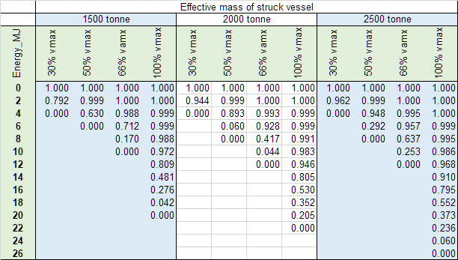

3. The probability for collision energies between the listed energy values shall be obtained through linear interpolation or by selecting the probability for the next higher energy listed.

4. The probability for collision energies between the listed effective mass values shall be obtained through linear interpolation or by selecting the probability density function for the next higher effective mass listed.

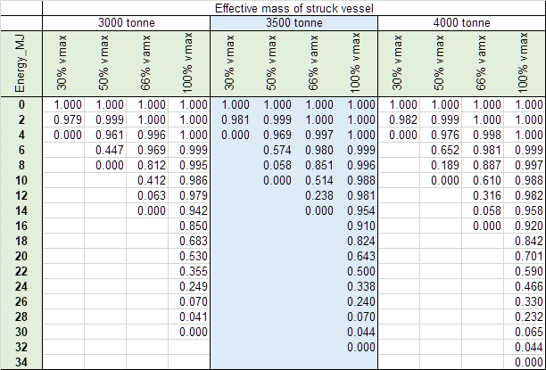

5. The probability for collision energies between the listed energy values shall be obtained through linear interpolation or by selecting the probability for the next higher energy listed.

6. The probability for collision energies between the listed effective mass values shall be obtained through linear interpolation or by selecting the probability density function for the next higher effective mass listed.

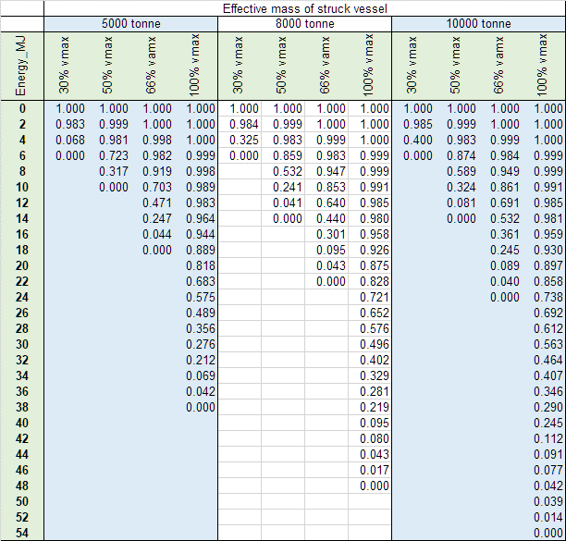

7. The probability for collision energies between the listed energy values shall be obtained through linear interpolation or by selecting the probability for the next higher energy listed.

8. The probability for collision energies between the listed effective mass values shall be obtained through linear interpolation or by selecting the probability density function for the next higher effective mass listed.

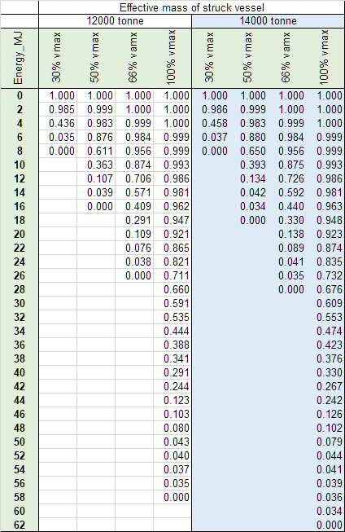

1. \* Distributed in German by the Central Commission for the Navigation of the Rhine under the symbol CCNR-ZKR/ADN/WP.15/AC.2/2024/11 [↑](#footnote-ref-2)
2. \*\* A/78/6 (Sect. 20), table 20.5 [↑](#footnote-ref-3)