Proposal for Amendments to GRE/2023/27
The text reproduced below was prepared by the experts from IWG on EMC, with the aim to develop a new 07 series of amendments to UN Regulation No.10. The proposed modifications to the current text of the UN Regulation are marked in bold for new or strikethrough for deleted characters.
I. Proposal
Insert new paragraphs 2.26. to 2.32., to read:
"2.26 “Automated Driving System (ADS)” means the vehicle hardware and software that are collectively capable of performing the entire Dynamic Driving Task (DDT) on a sustained basis. ⁽¹⁾
NOTE: ADS means the driver, during the driving, is not responsible for Dynamic Driving Task, unless otherwise specified in other UN Regulations.
2.27. “Dynamic Driving Task (DDT)” means the real-time operational and tactical functions required to operate the vehicle. ⁽¹⁾
2.28. “Failure situations” involve those in which the ADS or another vehicle system experiences a fault or failure that removes or reduces the ADS’s ability to perform the DTT, such as sensor or computer failure or a failed propulsion system.
2.29. “Residential environment” refers to clause 3.1.14 of IEC 61000-6-3: 2020.
Area of land designated for domestic dwellings where the mains power within these locations is directly connected to the low-voltage (lower than 1000Va.c. and 1500 Vd.c.) public mains network.
Note 1 to entry: Examples of residential locations are: houses, apartments, farm buildings housing people.
Note 2 to entry: A dwelling can be a single building, separate building or a separate section of a larger building.
Note 3 to entry: Within these locations it is expected to operate a radio receiver within a distance of 10 m from the equipment.
Note 4 to entry: Domestic dwellings are places for one or more people to live.
2.30. “Non-residential environment” refers to clause 3.1.12 of IEC 61000-6-4: 2018.
Location characterized by a separate power network, supplied from a high- or medium-voltage transformer, dedicated for the supply of the installation
Note 1 to entry: Industrial locations can generally be described by the existence of an installation with one or more of the following characteristics:
• items of equipment installed and connected together and working simultaneously;
• significant amount of electrical power generated, transmitted and/or consumed;
• frequent switching of heavy inductive or capacitive loads;
• high currents and associated magnetic fields;
• presence of industrial, high power scientific and medical (ISM) equipment (for example, welding machines).
The electromagnetic environment at an industrial location is predominantly produced by the equipment and installation present at the location. There are types of industrial locations where some of the electromagnetic phenomena appear in a more severe degree than in other installations.
Example locations include metalworking, pulp and paper, chemical plants, car production, farm building, high voltage areas of airports.
2.31. “Acoustic Vehicle Alerting System (AVAS)” as defined in the latest series of amendments to UN Regulation No. 138.
2.32. “Accident Emergency Call Systems (AECS)” as defined in the latest series of amendments to UN Regulation No. 144.
2.33. “Auxiliary Equipment (AE)” means equipment needed to exercise or monitor the operation of the test object."
Paragraph 3.2.1., amend to read:
"3.2.1. Applicability of this Regulation to ESA:
"
No
Yes
No
No
Yes
No
Yes
No
Yes
Yes
No
No
Yes
Yes
No application of Regulation No. 10
Connected permanently or temporarily to the vehicle wiring harness?
Connected via an interface type approved to this Regulation as amended?
Electrical/electronic sub assembly (ESA) classification
ESA intended for fitment in vehicles?
Mechanically fastened to the vehicle which cannot be disassembled or removed without use of tools?
Passive ESA or system (e.g. spark plugs, cables, passive antenna)?
Use restricted by technical means to immobilized vehicle
Application of Regulation No. 10
Not concerned
No marking
No type approval
Provides a coupling system for charging the REESS?
ESA used for charging the REESS
R10 not applicable. Use other EMC regulations apply

Paragraph 6.1.2., amend to read:
"6.1.2. Before testing, the Technical Service has to prepare a test plan in conjunction with the manufacturer, which contains at least mode of operation, stimulated function(s), monitored function(s), pass/fail criterion(criteria) and intended emissions.
Depending on the intended operating conditions of the propulsion system, the test plan shall define the minimum number of steady state operating conditions of the vehicle, selectable by the driver or by the control system. This(ese) test conditions shall consider multiple propulsion system operating strategies which can be activated permanently by the driver or the vehicle control system and shall be based on documentation provided in Annexes 2A and 2B (e.g. risk analysis)."
Paragraph 6.4.2.1., amend to read:
"6.4.2.1. If tests are made using the method described in Annex 6, with ISO 11451-2 method, the field strength shall be 30 volts/m rms (root mean squared) in over 90 per cent of the 20 to 2,000 MHz frequency band and a minimum of 25 volts/m rms over the whole 20 to 2,000 MHz frequency band. The field strength shall be 10 volts/m rms (root mean squared) in over 90 per cent of the 2,000 to 6,000 MHz frequency band and a minimum of 8 volts/m rms over the whole 2,000 to 6,000 MHz frequency band.
If tests are made using the method described in Annex 6, with ISO 11451-4 BCI method the current shall be 60 mA rms (root mean squared)."
Paragraph 6.8.2.1., amend to read:
"6.8.2.1. If tests are made using the methods described in Annex 9, the immunity test levels shall be 60 volts/m root-mean-square (rms) for the 150 mm stripline testing method, 15 volts/m rms for the 800 mm stripline testing method, 75 volts/m rms for the Transverse Electromagnetic Mode (TEM) cell testing method, 60 mA rms for the bulk current injection (BCI) testing method and 30 volts/m rms for the free field testing method in over 90 per cent of the 20 to 2,000 MHz frequency band, and to a minimum of 50 volts/m rms for the 150 mm stripline testing method, 12.5 volts/m rms for the 800 mm stripline testing method, 62.5 volts/m rms, for the TEM cell testing method, 50 mA rms for the bulk current injection (BCI) testing method and 25 volts/m rms for the free field testing method over the whole 20 to 2,000 MHz frequency band.
The immunity to electromagnetic radiation of ESA representative of its type shall be tested by the method(s) as described in Annex 9.:
Test severity in over 90 per cent of the 20 to 6,000 MHz frequency band are given in Table 2a.
Test severity for the minimum test Level over the whole 20 to 6,000 MHz frequency band given in Table 2b.
Table 2a
 | Test Level in over 90 per cent of the 20 to 6,000 MHz frequency band
Frequency range | Stripline | TEM cell | BCI | ALSE | Reverberation chamber
20 to 2,000 MHz | 60 V/m | 75 V/m | 60 mA | 30 V/m | 21 V/m
2,000 to 6,000 MHz | Not applicable | Not applicable | Not applicable | 10 V/m | 7 V/m

Table 2b
 | Minimum Test Level over the whole 20 to 6,000 MHz frequency band
Frequency range | Stripline | TEM cell | BCI | ALSE | Reverberation chamber
20 to 2,000 MHz | 50 V/m | 62,5 V/m | 50 mA | 25 V/m | 18 V/m
2,000 to 6,000 MHz | Not applicable | Not applicable | Not applicable | 8 V/m | 6 V/m

Paragraph 6.9.1., amend to read:
"6.9.1. Method of testing
The immunity of ESA representative of this type shall be tested by the method(s) according to ISO 7637-2:2004 for pulse 4 and ISO 7637-2:2011 for pulses 1, 2a, 2b, 3a and 3b, as described in Annex 10, with the test levels given in Table 23. Functional Performance Status Classification (FPSC) as in ISO 7637-1 shall be applied.

Table 23
Immunity of ESA
Test pulse number | Immunity test level  III | Functional status for systems
 |  | Related to immunity related function | Related to immunity related function
4 | III | B (for ESA which shall be operational during engine start phases)  C  (for other ESA) | D

Test pulse number | Immunity test level | Functional status for systems:
 |  | Related to immunity related functions | Not related to immunity related functions
1 | III | C | D
2a | III | B | D
2b | III | C | D
3a/3b | III | A | D
4 | III | B  (for ESA which shall be operational during engine start phases)  C  (for other ESA) | D

Test pulse number | Immunity test level |  | Test duration/  number of pulses | FPSC for systems:
 | 12V system | 24V system |  | Related to immunity related functions | Not related to immunity related functions
1 | -75 V | -300 V | 500 pulses | III | III
2a | +37 V | +37 V | 500 pulses | I | III
2b | +10 V | + 20 V | 10 pulses | II | III
3a | -112 V | -150 V | 1 h | I | III
3b | + 75 V | +150 V | 1 h | I | III
"
Paragraph. 6.10.4., to be deleted.
Paragraph 7.3.2.2., amend to read:
"7.3.2.2. If measurements are made using the method described in Annex 11, the limits for input current > 16 A and ≤ 75 A per phase are those defined in IEC 61000-3-12, and given in given in Table 45, Table 56 and Table 67.

Table 45

Maximum allowed harmonics (input current > 16 A and ≤ 75 A per phase) for single phase or other than balanced three-phase equipment
Minimum R_{sce} | Acceptable individual harmonic current I_{n}/I₁  % |  |  |  |  |  | Maximum current harmonic ratio  %
 | I₃ | I₅ | I₇ | I₉ | I₁₁ | I₁₃ | THD | PWHD
33 | 21.6 | 10.7 | 7.2 | 3.8 | 3.1 | 2 | 23 | 23
66 | 24 | 13 | 8 | 5 | 4 | 3 | 26 | 26
120 | 27 | 15 | 10 | 6 | 5 | 4 | 30 | 30
250 | 35 | 20 | 13 | 9 | 8 | 6 | 40 | 40
≥ 350 | 41 | 24 | 15 | 12 | 10 | 8 | 47 | 47
Relative values of even harmonics lower or equal to 12 shall be lower than 16/n %. Even harmonics greater than 12 are taken into account in the Total Harmonic DistorsionDistortion (THD) and Partial Weighted Harmonic Distortion (PWHD) the same way than odd harmonics.
Linear interpolation between successive values of Short Circuit Ratio of an Equipment (R_{sce}) is authorized.

Table 56

Maximum allowed harmonics (input current > 16 A and ≤ 75 A per phase) for balanced three-phase equipment
Minimum R_{sce} | Acceptable individual harmonic current I_{n}/I₁  % |  |  |  | Maximum current harmonic ratio  %
 | I₅ | I₇ | I₁₁ | I₁₃ | THD | PWHD
33 | 10.7 | 7.2 | 3.1 | 2 | 13 | 22
66 | 14 | 9 | 5 | 3 | 16 | 25
120 | 19 | 12 | 7 | 4 | 22 | 28
250 | 31 | 20 | 12 | 7 | 37 | 38
≥ 350 | 40 | 25 | 15 | 10 | 48 | 46
Relative values of even harmonics lower or equal to 12 shall be lower than 16/n %. Even harmonics greater than 12 are taken into account in the THD and PWHD the same way than odd harmonics.
Linear interpolation between successive values of R_{sce} is authorized.

Table 67

Maximum allowed harmonics (input current > 16 A and ≤ 75 A per phase) for balanced three-phase equipment under specific conditions
Minimum R_{sce} | Acceptable individual harmonic current I_{n}/I₁ % |  |  |  | Maximum current harmonic ratio %
 | I₅ | I₇ | I₁₁ | I₁₃ | THD | PWHD
33 | 10.7 | 7.2 | 3.1 | 2 | 13 | 22
≥ 120 | 40 | 25 | 15 | 10 | 48 | 46
Relative values of even harmonics lower or equal to 12 shall be lower than 16/n %. Even harmonics greater than 12 are taken into account in the THD and PWHD the same way than odd harmonics."
Paragraphs 7.5.3. to 7.5.3.4., remove square brackets.
Paragraph 7.7.2.1., amend to read:
"7.7.2.1. If tests are made using the method described in Annex 6, the field strength shall be 30 volts/m rms (root mean squared) in over 90 per cent of the 20 to 2,000 MHz frequency band and a minimum of 25 volts/m rms over the whole 20 to 2,000 MHz frequency band. The field strength shall be 10 volts/m rms in over 90 per cent of the 2,000 to 6,000 MHz frequency band and a minimum of 8 volts/m rms over the whole 2,000 to 6,000 MHz frequency band.
If tests are made using the method described in Annex 6, with ISO 11451-4 BCI method the current shall be 60 mA rms in over 90 per cent of the 20 to 2,000 MHz frequency band and a minimum of 50 mA rms over the whole 20 to 2,000 MHz frequency band."
Paragraph 7.19.1., amend to read:
"7.19.1 Method of testing
The immunity of ESA representative of its type shall be tested by the method(s) according to ISO 7637-2:2011, as described in Annex 10 with the test levels given in Table 1820. Functional Performance Status Classification (FPSC) as in ISO 7637-1 shall be applied.

Table 1820

Immunity of ESA
Test pulse number | Immunity test level | Functional status for systems:
 |  | Related to immunity related functions | Not related to immunity related functions
1 | III | C | D
2a | III | B | D
2b | III | C | D
3a/3b | III | A | D

Test pulse number | Immunity test level |  | Test duration /  Number of pulses | FPSC for systems:
 | 12V system | 24V system |  | Related to immunity related functions | Not related to immunity related functions
1 | -75 V | -300 V | 500 pulses | III | III
2a | +37 V | +37 V | 500 pulses | I | III
2b | +10 V | + 20 V | 10 pulses | II | III
3a | -112 V | -150 V | 1 h | I | III
3b | + 75 V | +150 V | 1 h | I | III
"
Insert new paragraphs 13.3. to 13.3.5., to read:
"[13.3. Transitional provisions applicable to the 07 series of amendments
13.3.1. As from the official date of entry into force of the 07 series of amendments, no Contracting Party applying this UN Regulation shall refuse to grant or refuse to accept UN type-approvals under this UN Regulation as amended by the 07 series of amendments.
13.3.2. As from 1 September 2029, Contracting Parties applying this UN Regulation shall not be obliged to accept UN type-approvals to the preceding series of amendments, first issued after 1 September 2029.
13.3.3. Contracting Parties applying this Regulation shall continue to accept type approvals issued according to any of the preceding series of amendments to this Regulation first issued before 1 September 2029.
13.3.4. Contracting Parties applying this Regulation may grant type approvals according to any preceding series of amendments to this Regulation.
13.3.5. Contracting Parties applying this Regulation shall continue to grant extensions of existing approvals to any preceding series of amendments to this Regulation.]"
Appendix 1, amend to read:
"Appendix 1
List of standards referred to in this Regulation
1. CISPR 12 "Vehicles', motorboats' and spark-ignited engine-driven devices' radio disturbance characteristics - Limits and methods of measurement", fifth edition 2001 and AmdMD1: 2005.
2. CISPR 16-1-4 "Specifications for radio disturbance and immunity measuring apparatus and methods - Part 1: Radio disturbance and immunity measuring apparatus apparatus - Antennas and test sites for radiated disturbances mesaurements", thirdfourth edition 20102019+AMD1:2020+AMD2:2023.
3. CISPR 25 "Limits and methods of measurement of radio disturbance characteristics for the protection of receivers used on board vehicles", second edition 2002 and corrigendum 2004.
4. ISO 7637-2 "Road vehicles - Electrical disturbance from conduction and coupling - Part 2: Electrical transient conduction along supply lines only on vehicles with nominal 12 V or 24 V supply voltage", second edition 2004, only for pulse 4.
ISO 7637-1 "Road vehicles - Electrical disturbance from conduction and coupling - Part 1: Definitions and general configurations", third edition 2015.
ISO 7637-2 "Road vehicles - Electrical disturbance from conduction and coupling - Part 2: Electrical transient conduction along supply lines only", third edition 2011.
5. ISO/IEC-EN 17025 "General requirements for the competence of testing and calibration laboratories", secondthird edition 20172005 and Corrigendum: 2006.
6. ISO 11451 "Road vehicles - Electrical disturbances by narrowband radiated electromagnetic energy - Vehicle test methods":
Part 1: General and definitions (ISO 11451-1, thirdfourth edition 2005 and Amd1: 2008)2015;
Part 2: Off-vehicle radiation source (ISO 11451-2, fourth edition 2015);
Part 4: Bulk current injection (BCI) (ISO 11451-4, thirdfourth edition 20132022).
7. ISO 11452 "Road vehicles - Electrical disturbances by narrowband radiated electromagnetic energy - Component test methods":
Part 1: General and definitions (ISO 11452-1, thirdfourth edition 2005 and Amd1: 2008)2015;
Part 2: Absorber-lined chamber (ISO 11452-2, secondthird edition 20042019);
Part 3: Transverse electromagnetic mode (TEM) cell (ISO 11452-3,
third edition 2016);
Part 4: Bulk current injection (BCI) (ISO 11452-4, thirdfifth edition 20112020);
Part 5: Stripline (ISO 11452-5, second edition 2002).
Part 11: Reverberation chamber (ISO 11452-11, first edition 2010).

8. ITU Radio Regulations, edition 20082020.
9. IEC 61000-3-2 "Electromagnetic Compatibility (EMC) - Part 3-2 - Limits for harmonic current emissions (equipment input current ≤ 16 A per phase)", edition 3.2 - 2005 + A1: 2008 + A2: 2009. 5.1 – 2018+AMD1:2020.
10. IEC 61000-3-3 "Electromagnetic Compatibility (EMC) - Part 3-3 - Limits - Limitation of voltage changes, voltage fluctuations and flicker in public low-voltage systems for equipment with rated current ≤ 16 A per phase and not subjected to conditional connection", edition 2.0 – 2008 3.2 – 2013+AMD1:2017+AMD2:2021+COR1:2022.
11. IEC 61000-3-11 "Electromagnetic Compatibility (EMC) - Part 3-11 - Limits - Limitation of voltage changes, voltage fluctuations and flicker in public low-voltage systems - Equipment with rated current ≤ 75 A per phase and subjected to conditional connection", edition 1.0 – 2000 2.0 - 2017.
12. IEC 61000-3-12 "Electromagnetic Compatibility (EMC) - Part 3-12 - Limits for harmonic current emissions produced by equipment connected to public low-voltage systems with input current > 16 A and ≤ 75 A per phase", edition 1.0 – 2004 2.1 – 2011+AMD1:2021.
13. IEC 61000-4-4 "Electromagnetic Compatibility (EMC) - Part 4-4 - Testing and measurement techniques - Electrical fast transients/burst immunity test", edition 2.0 – 2004 3.0 - 2012.
14. IEC 61000-4-5 "Electromagnetic Compatibility (EMC) - Part 4-5 - Testing and measurement techniques - Surge immunity test", edition 2.0 – 2005 3.1 – 2014+AMD1:2017.
15. IEC 61000-6-3 "Electromagnetic Compatibility (EMC) - Part 6-3 - Generic standards Emission standard for residential, commercial and light-industrial environments", edition 2.0 – 2006 3.0 - 2020.
16. IEC 61000-6-4 “Electromagnetic compatibility (EMC) - Part 6-4: Generic standards - Emission standard for industrial environments”, edition 3.0 – 2018.
17. CISPR 16–2–1 "Specification for radio disturbances and immunity measuring apparatus and methods - Part 2-1 - Methods of measurement of disturbances and immunity - Conducted disturbances measurement", edition 2.0 – 2008 3.1 – 2014+AMD1:2017+COR1:2020.
18. CISPR 22 "Information Technology Equipment - Radio disturbances characteristics - Limits and methods of measurement", edition 6.0 - 2008.
19. CISPR 16-1-2 "Specification for radio disturbance and immunity measuring apparatus and methods - Part 1-2: Radio disturbance and immunity measuring apparatus - Ancillary equipment - Conducted disturbances", edition 2.01 – 2014+AMD1:2017.
20. IEC 61851-1 "Electric vehicle conductive charging system – Part 1: General requirements ", edition 3.0 - 2017.
21. IEC 61851-21-2 "Electric vehicle conductive charging system - Part 21-2: Electric vehicle requirements for conductive connection to an AC/DC supply - EMC requirements for off board electric vehicle charging systems", edition 1.0 - 2018.
22. CISPR 32 "Electromagnetic compatibility of multimedia equipment – Emission requirements”, edition 2.01 – 2015+AMD1:2019.
23. CISPR 16-1-1 “Specification for radio disturbance and immunity measuring apparatus and methods - Part 1-1: Radio disturbance and immunity measuring apparatus - Measuring apparatus ", edition 4.0 2015-09."
Annex 2A, add new paragraph 73., amend to read:
"73. Environment of charging (residential, non-residential)

Annex2A, add new sub-paragraph, to read:
"
The applicant for type approval shall also supply, where appropriate:
Appendix 1 A list with make(s) and type(s) of all electrical and/or electronic components concerned by this Regulation (see paragraphs 2.9. and 2.10. of this Regulation) and not previously listed.
Appendix 2: Schematics or drawing of the general arrangement of electrical and/or
electronic components (concerned by this Regulation) and the general wiring harness arrangement.
Appendix 3: Description of vehicle chosen to represent the type:
Body style:
Left or right hand drive:
Wheelbase:
Appendix 4: Relevant test report(s) supplied by the manufacturer from a test laboratory accredited to ISO 17025 and recognized by the Type Approval Authority for the purpose of drawing up the type approval certificate."

Annex 3A, amend to read:
"Annex 3A
Communication
(Maximum format: A4 (210 x 297 mm))
issued by: Name of administration:
......................................
......................................
......................................
Concerning: Approval granted
Approval extended
Approval refused
Approval withdrawn
Production definitively discontinued
of a type of vehicle/component/separate technical unit² with regard to Regulation No. 10.
Approval No.: …………………........... Extension No.: ...........................................
1. Make (trade name of manufacturer):
2. Type:
3. Means of identification of type, if marked on the vehicle/component/separate
technical unit²
3.1. Location of that marking:
4. Category of vehicle:
5. Name and address of manufacturer:
6. In the case of components and separate technical units, location and method of
affixing of the approval mark:
7. Address(es) of assembly plant(s):
8. Additional information (where applicable): See appendix below
9. Technical Service responsible for carrying out the tests:

10. Date of test report:
11. Number of test report:
12. Remarks (if any): See appendix below
13. Place:
14. Date:
15. Signature:
16. The index to the information package lodged with the Approval Authority,
which may be obtained on request is attached:
17. Reasons for extension:
Appendix to type approval communication form No.........
concerning the type approval of a vehicle under Regulation No. 10
1. Additional information:
2. Electrical system rated voltage: ..............................................V. pos/neg ground²
3. Environment of charging for REESS of EV and PHEV:
Type of vehicle valid for residential environment:
Type of vehicle valid for non-residential environment:
34. Type of bodywork:
45. List of electronic systems installed in the tested vehicle(s) not limited to the items
in the information document:
45.1. Vehicle equipped with 24 GHz short-range radar equipment: yes/no/optional²
56. Laboratory accredited to ISO 17025 and recognized by the Approval Authority
responsible for carrying out the tests:
67. Remarks: (e.g. valid for both left-hand drive and right-hand drive vehicles): "
Annex 4, Paragraph 2.1.1., amend to read:
"2.1.1. EnginePropulsion System
The Enginepropulsion System shall be in operation according to CISPR 12.
For vehicle with an electric propulsion motor or hybrid propulsion system, if this is not appropriate (e.g. in case of busses, trucks, two- and three wheel vehicles), transmission shafts, belts or chains may be disconnected to achieve the same operation condition for the propulsion.
If operating mode defined in CISPR 12 (e.g.i.e. 40 km/h) does not activate all traction motors or auxiliary battery charging engines, an alternative, steady state operating mode shall be agreed between the Technical Service and vehicle manufacturer."
Annex 4, Paragraph 2.2., amend to read:
"2.2. Vehicle in configuration "REESS charging mode coupled to the power grid".
The vehicle shall be tested in the charging mode configuration (if available on vehicle) as defined in flowchart of figure 1
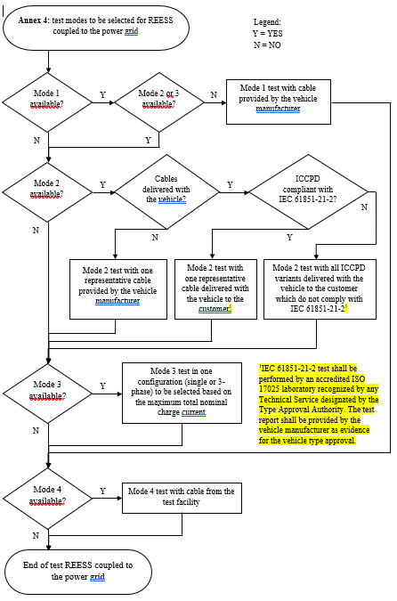
Figure 1
Charging mode configuration for Annex 4
The state of charge (SOC) of the traction battery shall be kept between 20 per cent and 80 per cent of the maximum SOC during the whole frequency range measurement (this may lead to splitting the measurement into different sub-bands with the need to discharge the vehicle's traction battery before starting the next sub-bands).
If the current consumption can be adjusted, then the current shall be set to at least 80 per cent of its nominal maximum rated charging/input current value for AC charging.
If the current consumption can be adjusted, then the current shall be set to at least 80 20 per cent of its nominal value or to a minimum of 16 A (if the 20 per cent of its nominal value cannot be achieved in the test facility) for DC charging unless another value is agreed with the type approval authorities.
In case of multiple batteries the average state of charge must be considered.
The vehicle shall be immobilized, the engine(s) (ICE and / or electrical engine) shall be OFF and in charging mode. All other equipment which can be switched ON by the driver or passengers shall be OFF.
The test set-up for the connection of the vehicle in configuration "REESS charging mode coupled to the power grid" is shown in Figures 3a to 3h (depending of AC or DC power charging mode, location of charging plug and charging with or without communication) of Appendix 1 to this Aannex."
Annex 6, paragraph 1.3., amend to read:
"1.3. Alternative test methods
The test may be alternatively performed in an outdoor test site for all vehicles (including “large vehicles”). The test facility shall comply with (national) legal requirements regarding the emission of electromagnetic fields. The test shall be performed according to ISO 11451-2 in an OTS:
      - with front irradiation for vehicle not considered as “large vehicles”
      - with front irradiation and with additional antenna positions for “large vehicles”. Additional antenna position(s) shall be chosen by the manufacturer in conjunction with the Type Approval Authority after considering the distribution of electronic systems with immunity related functions and the layout of any wiring harness. Tests shall be performed with levels defined in paragraph 6.4.2.1. of this Regulation.
For “large vehicles”, the following alternative methods may be chosen by the manufacturer in conjunction with the Type Approval Authority:
      - Harness excitation methods (BCI) according to ISO 11451-4 in the frequency range 20 to 2,000 MHz and immunity to external sources according to ISO 11451-2 in ALSE or OTS in the frequency range 2,000 to 6,000 MHz with additional antenna position(s). Additional antenna positions shall be chosen by the manufacturer in conjunction with the Type Approval Authority after considering the distribution of electronic systems with immunity related functions and the layout of any wiring harness. Tests shall be performed with levels defined in paragraph 6.4.2.1. of this Regulation.
      - Harness excitation methods (BCI) according to ISO 11451-4 in the frequency range 20 to 2,000 MHz and ESA immunity to external sources according to Annex 9 in the frequency range 2,000 to 6,000 MHz for all ESA involved in immunity related functions. ESA involved in immunity related functions shall be chosen by the manufacturer in conjunction with the Type Approval Authority. Vehicle test shall be performed with levels defined in paragraph 6.4.2.1. of this Regulation. ESA shall be performed with levels defined in paragraph 6.8.2.1. of this Regulation.
      - Immunity to external sources according to ISO 11451-2 in ALSE or OTS in the frequency range 20 to 6,000 MHz with front irradiation and ESA immunity to external sources according to Annex 9 in the frequency range 20 to 6,000 MHz for ESA with immunity related functions out antenna beamwidth. Concerned ESA shall be chosen by the manufacturer in conjunction with the Type Approval Authority Vehicle test shall be performed with levels defined in paragraph 6.4.2.1. of this Regulation. ESA tests shall be performed with levels defined in paragraph 6.8.2.1. of this Regulation.
[Alternative method using ESA immunity to external sources according to Annex 9 does not require E-marking of the concerned ESA. The test report shall be prepared or approved by a laboratory accredited to ISO 17025 and recognized by the Approval Authority responsible for carrying out the tests and provided along with the information document shown in Annex 2B. The same test method (vehicle type approval in combination with ESA test report for Annex9) shall be applied during Conformity of Production test or any applicable test method according to this Annex]
If a vehicle is longer than 12 m and/or wider than 2.60 m and/or higher than 4.00 m, BCI (bulk current injection) method according to ISO 11451-4 shall be used in the frequency range 20 to 2,000 MHz with levels defined in paragraph 6.8.2.1. of this Regulation."
Annex 6, paragraph 2.1.1.2., amend to read:
"2.1.1.2. Basic vehicle conditions
The paragraph defines minimum test conditions (as far as applicable) and failure criteria for vehicle immunity tests. Other vehicle systems, which can affect immunity related functions, shall be tested in a way to be agreed between manufacturer and Technical Service.
"50 km/h mode" vehicle test conditions | Failure criteria
Vehicle speed 50 km/h (respectively 25 km/h for L₁, L₂ vehicles) ±20 per cent (vehicle driving the rollers). If the vehicle is equipped with a cruise control system, it shall be used to maintain the required constant vehicle speed and maintained without any deactivation. | Speed variation greater than ±10 per cent of the nominal speed. In case of automatic gearbox: change of gear ratio inducing a speed variation greater than ±10 per cent of the nominal speed.
Dipped beams ON (manual mode) | Lighting OFF (front light and rear light)
Specific warning (e.g Rotating/flashing light, signaling bar, siren…) ON | Specific warning OFF
Cluster operate in normal mode | Unexpected warning  Inconsistent variation of the odometer
Rear view system | Unexpected movement of rear view mirror  Loss or freezing of the display (CMS)
Front wiper ON (manual mode) maximum speed | Complete stop of front wiper
Direction indicator on driver's side ON | Frequency change (lower than 0.75 Hz or greater than 2.25 Hz). Duty cycle change (lower than 25 per cent or greater than 75 per cent).
Adjustable suspension in normal position | Unexpected significant variation
Driver's seat and steering wheel in medium position | Unexpected variation greater than 10 per cent of total range
Alarm unset | Unexpected activation of alarm
Horn OFF | Unexpected activation of horn
Airbag and safety restraint systems operational with inhibited passenger airbag if this function exists | Unexpected activation
Automatic doors closed | Unexpected opening
Adjustable endurance brake lever in normal position | Unexpected activation
Brake pedal not depressed | Unexpected activation of brake and unexpected activation of stop lights
ADS shall be operational ⁽¹⁾ | ADS failure situation
⁽¹⁾: ADS are turned on by the driver but some or all ADS functions may revert to a mode where system is monitoring sensors but is not actively ‘driving’ the vehicle due to plausibility issues caused by the EMC laboratory environment.

"Brake mode" vehicle test conditions | Failure criteria
Vehicle in a state that allows the braking system to operate normally, parking brake released, vehicle speed 0 km/h.  Brake pedal depressed to activate the brake function and the stop lights without any dynamic cycle. | Stop lights inactivated during mode  Brake warning light ON with loss of brake function.
Day running light (DRL) ON | DRL inactivated during mode
ADS shall be operational ⁽¹⁾ | ADS failure situation
⁽¹⁾: ADS are turned on by the driver but some or all ADS functions may revert to a mode where system is monitoring sensors but is not actively ‘driving’ the vehicle due to plausibility issues caused by the EMC laboratory environment.

" Emergency calling systems " vehicle test conditions | Failure criteria
Accident Emergency Call Systems (AECSs) shall be tested over the air transmission for MSD and voice call via a real PLMN or via a network simulator and using a private safety answering point (PSAP).  A manual triggering and operationfollowed by the MSD emissiontransmission assessment before and after the test shall be performed.  During the test, the warning signal device (tell-tale that provides a failure indication) shall be monitored.  SIM call number shall be changed to dedicated PSAP number in order to avoid false calls to the emergency services. | The MSD emissiontransmission assessment shall include the verification of at least the following:  vehicle location data is transmitted correctly, and  time stamp is transmitted correctly, and  vehicle identification number is transmitted correctly.  The hands-free voice communication assessment (subjective test) shall include verification of the following:  Voice originating inside the vehicle can be clearly heard by the remote listener with satisfactory intelligibility, and  Speech of the remote speaker can be clearly heard in the vehicle with satisfactory intelligibility  HMI operation assessment shall include a verification of the emergency call status indication operation: system is processing (accident emergency call is triggered, connection is being set up or data transmission is in progress or completed or voice call is in progress).

[

]

AVAS test conditions | Failure criteria
Vehicle is tested in an operating state where the  AVAS Function/sound is active (if applicable) ⁽¹⁾ | Loss of AVAS function (sound or system error indicator)
(1) This test may be incorporated into Brake or 50 km/h mode if AVAS system is active in these modes. If AVAS system is not operational during these two modes, the operating conditions (e.g. vehicle speed) shall be agreed between the Technical Service and the Vehicle Manufacturer.
"
Annex 6,iInsert a new paragraph 2.1.1.5., to read:
"2.1.1.5. If the vehicle is equipped with an ADS, the immunity test shall demonstrate the vehicle stays in a failure safe mode or expected failure operational mode during the test in 50km/h mode or Brake mode. If it is not possible to activate the ADS due to another function (e.g. turn lamp, wiper, etc), these function(s) may be turned off. Then additional test run(s) may be necessary to cover untested function(s) (e.g. turn lamp, wiper, etc). Lateral and longitudinal vehicle motion control and braking may be deactivated if necessary to ensure a safe test environment."
Annex 6, Insert a new paragraph 3.4., to read:
"3.4. If a vehicle is longer than 12 m and/or wider than 2.60 m and/or higher than 4.00 m, and tested according to ISO 11451-2, then additional Rreference point(s) shall be chosen by the manufacturer in conjunction with the Type Approval Authority after considering the distribution of electronic systems with immunity related functions and the layout of any wiring harness (see Appendix 1, Figure 5)."
Annex 6, paragraph 4.1.1., amend to read:
4.1.1. The Technical Service shall perform the test at the intervals specified in ISO 11451-1 throughout the frequency range 20 to 26,000 MHz.
Alternatively, if the manufacturer provides measurement to data for the whole frequency band from a test laboratory accredited to the applicable parts of ISO 17025 and recognized by the Type Approval Authority, the Technical Service may choose a reduced number of spot frequencies in the range, (e.g. 27, 45, 65, 90, 120, 150, 190, 230, 280, 380, 450, 600, 750, 900, 1,300, and 1,800, 2,360, 2,600, 3,000, 3,600, 5,200 and 5,900 MHz) to confirm that the vehicle meets the requirements of this Aannex.
If the manufacturer provides measurement data for the whole frequency band from a test laboratory accredited to the applicable parts of ISO 17025 and recognized by the Type Approval Authority for all the charging modes configurations defined in paragraph 2.2.1.1, the Technical Service may perform tests only for one charging mode configurations defined in paragraph 2.2.1.2 and for a reduced number of spot frequencies in the range (e.g. 27, 45, 65, 90, 120, 150, 190, 230, 280, 380, 450, 600, 750, 900, 1,300, 1,800, 2,360, 2,600, 3,000, 3,600, 5,200 and 5,900 MHz) to confirm that the vehicle meets the requirements of this Annex.
If a vehicle fails the test defined in this Aannex, it shall be verified as having failed under the relevant test conditions and not as a result of the generation of uncontrolled fields."
Annex 6, Appendix 1, amend to read:
"Annex 6 – Appendix 1
…

[Figure 4 Example of a selection of antenna placements for lateral illumination of a large vehicle

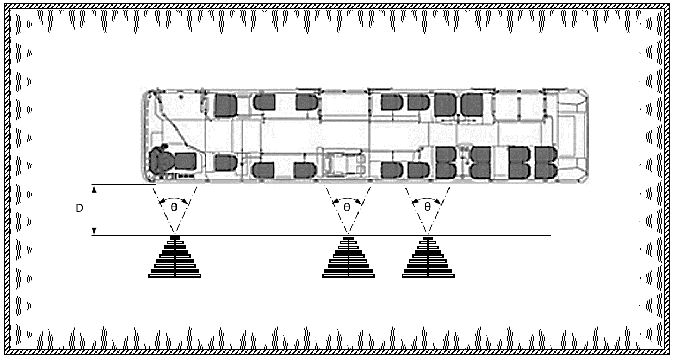

Key
θ 3 dB antenna beamwidth
D: the distance between the tip or phase centre of the antenna and the nearest part of the vehicle body without considering small extruding elements (such as side mirrors or fenders)
]
Annex 9, paragraph 3.2., amend to read:
3.2. The Technical Service shall perform the test at the intervals specified in
ISO 11452-1, throughout the frequency range 20 to 26,000 MHz.
Alternatively, if the manufacturer provides measurement to data for the whole frequency band from a test laboratory accredited to the applicable parts of ISO 17025, and recognized by the Type Approval Authority, the Technical Service may choose a reduced number of spot frequencies in the range, (e.g. 27, 45, 65, 90, 120, 150, 190, 230, 280, 380, 450, 600, 750, 900, 1,300, and 1,800, 2,360, 2,600, 3,000, 3,600, 5,200 and 5,900 MHz) to confirm that the ESA meets the requirements of this Aannex."
Annex 9, paragraph 4.5. to 4.5.2.24., to be deleted.
Annex 10, paragraph 2., amend to read:
"2. Immunity against transient disturbances conducted along 12/24 V supply lines.
Apply the test pulses 1, 2a, 2b, 3a, and 3b and 4 according to the International Standard ISO 7637-2, third edition 2011 to the supply lines as well as to other connections of ESAs which may be operationally connected to supply lines.
Apply the test pulses 4 according to the International Standard ISO 7637-2, second edition 2004 to the supply lines as well as to other connections of ESAs which may be operationally connected to supply lines.
ESAs that are exclusively reserved for mounting on electric vehicles (vehicles without 12V/24V starter motor) are not subject to pulse 4."
Annex 11, paragraph 2.1., amend to read:
"2.1. The vehicle shall be in configuration "REESS charging mode coupled to the power grid".
For two-wheeled vehicles, a non-conductive insulating support with a thickness of 5 – 20mm shall be used between stand and ground plane.
The vehicle shall be tested in the charging mode configuration (if available on vehicle) as defined in flowchart of figure 1
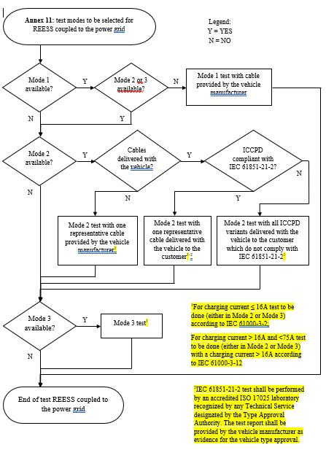

Figure 1
Charging mode configuration for Annex 11
The state of charge (SOC) of the traction battery shall be kept between 20 per cent and 80 per cent of the maximum SOC during the whole time duration of the measurement (this may lead to the measurement being splitting into different time slots with the need to discharge the vehicle’s traction battery before starting the next time slot). If the current consumption can be adjusted, then the current shall be set to at least 80 per cent of its nominal maximum rated charging/input current value for AC charging.
In case of multiple batteries the average state of charge must be considered.
The vehicle shall be immobilized, the engine(s) (ICE and / or electrical engine) shall be OFF and in charging mode.
All other equipment which can be switched ON by the driver or passengers shall be OFF."
Annex 12, Paragraph 2.1., amend to read:
"2.1. The vehicle shall be in configuration "REESS charging mode coupled to the power grid".
For two-wheeled vehicles, a non-conductive insulating support with a thickness of 5 – 20mm shall be used between stand and ground plane.
The vehicle shall be tested in the charging mode configuration (if available on vehicle) as defined in flowchart of figure 1

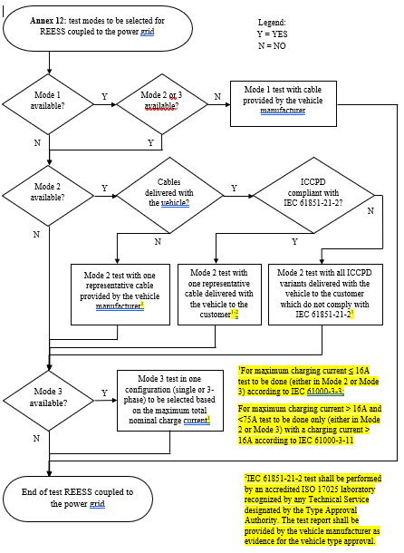

Figure 1
Charging mode configuration for Annex 12
The state of charge (SOC) of the traction battery shall be kept between 20 per cent and 80 per cent of the maximum SOC during the whole time duration of the measurement (this may lead to the measurement being splitting into different time slots with the need to discharge the vehicle’s traction battery before starting the next time slot). If the current consumption can be adjusted, then the current shall be set to at least 80 per cent of its nominal maximum rated charging/input current value for AC charging.
In case of multiple batteries the average state of charge must be considered.
The vehicle shall be immobilized, the engine(s) (ICE and / or electrical engine) shall be OFF and in charging mode.
All other equipment which can be switched ON by the driver or passengers shall be OFF."
Annex 13, Paragraph 2.1., amend to read:
"2.1. The vehicle shall be in configuration "REESS charging mode coupled to the power grid".
For two-wheeled vehicles, a non-conductive insulating support with a thickness of 5 – 20mm shall be used between stand and ground plane.
The vehicle shall be tested in the charging mode configuration (if available on vehicle) as defined in flowchart of figure 1
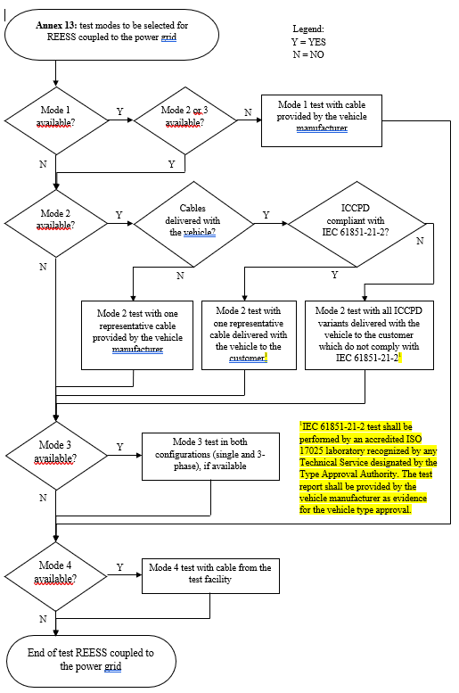
Figure 1: Charging mode configuration for Annex 13
The state of charge (SOC) of the traction battery shall be kept between 20 per cent and 80 per cent of the maximum SOC during the whole frequency range measurement (this may lead to splitting the measurement in different sub-bands with the need to discharge the vehicle's traction battery before starting the next sub-bands).
If the current consumption can be adjusted, then the current shall be set to at least 80 per cent of its nominal maximum rated charging/input current value for AC charging.
If the current consumption can be adjusted, then the current shall be set to at least 80 20 per cent of its nominal value or to a minimum of 16 A (if the 20 per cent of its nominal value cannot be achieved in the test facility) for DC charging unless another value is agreed with the type approval authorities.
In case of multiple batteries the average state of charge must be considered.
The vehicle shall be immobilized, the engine(s) (ICE and / or electrical engine) shall be OFF and in charging mode.
All other equipment which can be switched ON by the driver or passengers shall be OFF."
Annex 13, insert a new paragraph 4.3., to read:
"4.3. If the manufacturer provides measurement data for the whole frequency band for all applicable charging mode configurations from a test laboratory accredited to the applicable parts of ISO 17025 and recognized by the Type Approval Authority for all the available charging modes configurations defined in paragraph 2.1, the Technical Service may perform tests only for one of the available charging mode configuration defined in paragraph 2.1 to confirm that the vehicle meets the requirements of this Annex."
Annex 15, paragraph 2., amend to read:
"2. Vehicle state during tests in configuration "REESS in charging mode coupled to the power grid"
The vehicle shall be tested in the charging mode configuration (if available on vehicle) as defined in flowchart of figure 1
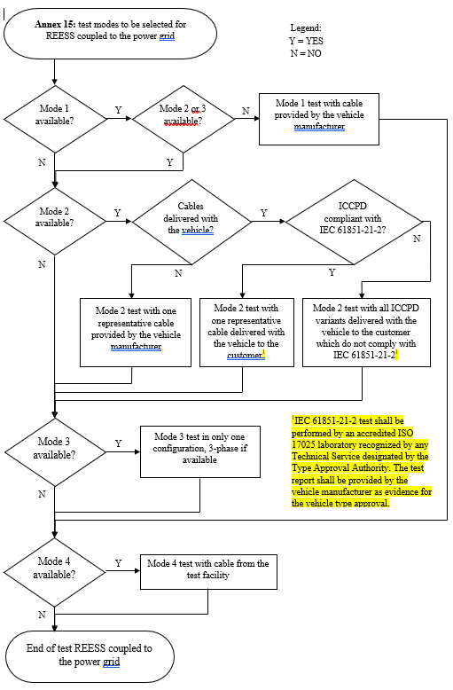
Figure 1
Charging mode configuration for Annex 15"

Annex 15, paragraph 2.1.2., amend to read:
"2.1.2. Basic vehicle conditions
The paragraph defines minimum test conditions (as far as applicable) and failures criteria for vehicle immunity tests. Other vehicle systems, which can affect immunity related functions, shall be tested in a way to be agreed between manufacturer and Technical Service.
"REESS charging mode" vehicle test conditions | Failure criteria
The REESS shall be in charging mode. The state of charge (SOC) of the traction battery shall be kept between 20 per cent and 80 per cent of the maximum SOC during the whole time duration of the measurement (this may lead to the measurement being split into different time slots with the need to discharge the vehicle’s traction battery before starting the next time slot). If the current consumption can be adjusted, then the current shall be set to at least 20 per cent of its nominal maximum rated charging/input current value for AC charging.  If the current consumption can be adjusted, then the current shall be set to at least 20 per cent of its nominal value or to a minimum of 16 A (if the 20 per cent of its nominal value cannot be achieved in the test facility) for DC charging unless another value is agreed with the type approval authorities.  In case of multiple batteries the average state of charge must be considered. | Vehicle sets in motion.  Unexpected release of the parking brake.  Loss of Parking position for automatic transmission.
"
Annex 15, insert a new paragraph 6., to read:
"6. If the manufacturer provides measurement data for the whole frequency bandfor all applicable charging mode configurations from a test laboratory accredited to the applicable parts of ISO 17025 and recognized by the Type Approval Authority for all the available charging modes configurations defined in paragraph 2.1, the Technical Service may perform tests only for one of the available charging mode configuration defined in paragraph 2.1 to confirm that the vehicle meets the requirements of this Annex."

Annex 16, Paragraph 2., amend to read:
"2. Vehicle state during tests in configuration "REESS in charging mode coupled to the power grid"
The vehicle shall be tested in the charging mode configuration (if available on vehicle) as defined in flowchart of figure 1
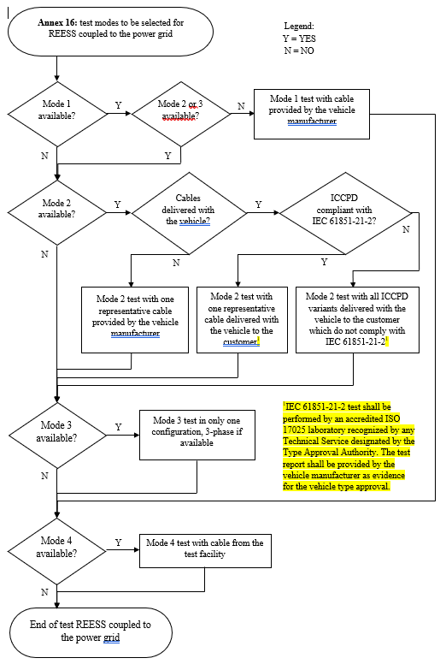
Figure 1
Charging mode configuration for Annex 16"

Annex 16, insert a new paragraph 6., to read:
6. If the manufacturer provides measurement data for the whole frequency bandfor all applicable charging mode configurations from a test laboratory accredited to the applicable parts of ISO 17025 and recognized by the Type Approval Authority for all the available charging modes configurations defined in 2.1, the Technical Service may perform tests only for one of the available charging mode configuration defined in 2.1 to confirm that the vehicle meets the requirements of this Annex."
II. Justification
- Editorial changes in the whole regulation: renumbering paragraphs and references to other paragraphs, tables and figures.
- Paragraph 1.3: Introduction of a note on functional safety to clarify the relationship with EMC.
- Paragraph 2.12: The definition of emergency calling systems was generalised to ensure applicability for all existing systems.
- Paragraph 2.20: The abbreviation AE was updated to “Auxiliary Equipment” for consistency with international EMC standards.
- Paragraphs 2.26 to 2.28.: Introduction of definitions in regard to automated driving. These were adopted from guideline ECE/TRANS…WP.29/2022/58, Annex 1. A note was added to clarify the responsibility of the driver and that ADS is not same as a driving assistance system. Paragraph 2.28. is an additional definition suggested by FRAV.
- Paragraphs 2.29 and 2.30: Definitions for “residential environment” and “non-residential environment” to clarify the applicability of different emission limits.
- Paragraphs 2.31 and 2.32: The definitions of AVAS and AECS were included, because new failure criteria were added to Annex 6.
- Paragraph 3.2.1.: the flow chart is updated for clarification of wording “coupling system”. Furthermore, it may be necessary to apply other EMC regulations if R10 is not applicable.
- Paragraph 6.1.2 was amended to clarify the minimum number of steady state operating conditions of vehicle propulsion systems which must be considered in the test plan. This is necessary because the default test conditions may not trigger all intended operating modes. E.g. in some vehicles only one propulsion motor is active at constant speed of 40 km/h.
- Paragraph 6.9.1: due to calibration and availability of test equipment, the reference to ISO 7637-2 shall be updated. The test levels referred in R10.06 match the immunity test level I/II of edition 2011. Pulse 4 no longer included in ISO 7637-2:2011 the reference to the edition from 2004 shall be kept. Pulse 4 (start pulse) will be only applied to vehicles without combustion engine.
- Paragraph 7.1.2 was amended for REESS charging mode coupled to the power grid for the same reason. Annex 2A was amended as a consequence of these new requirements, requesting vehicle manufacturers to provide further information.
- Paragraph 6.3.2.4 was deleted, because measuring only in the FM band from 76 to 108 MHz is not sufficient determine the narrowband emission for the whole frequency band from 30 to 1000 MHz.
- The frequency range of electromagnetic immunity test (vehicle and ESA) was extended to 6 GHz in order to ensure robustness regarding state-of-the-art mobile services (e.g. LTE, 5G, WiFi). The test level of 10 V/m was determined based on the requirements in IEC 61000-6-2:2015 multiplied by 3 as it is for the lower frequencies.
- Paragraph 6.8.2.1: Suppression of the 800 mm stripline for ESA immunity test. This method is no longer used by EMC laboratories.
- Paragraph 6.8.2.1: Introduction of the reverberation chamber for ESA electromagnetic immunity test according to ISO 11452-11. This test method is a state-of-the-art immunity test method. The extension of the frequency range to 6 GHz requires additional test time. This method helps to keep the test time at an acceptable range. The test level of 21 V/m was derived from detailed studies comparing currents induced in vehicle harnesses with reverberation and ALSE (ISO 11452-2) test methods.
- Paragraph 6.8.2.1: The wording concerning ESA electromagnetic immunity test methods was replaced by two tables in order to give a better overview and to clarify the test severity and applicability of 5 different test methods in two frequency ranges.
- Paragraph 6.10.7: New exception for configurations other than REESS charging mode coupled to the power grid: “Trolleybuses: AC / DC mains portion of the vehicle propulsion system shall be excluded from this Regulation.” because other product standards, e.g. railway standards apply.
- The paragraph 7.1.3 was updated to account for the changes introduced by new flow charts in each concerned annex to clarify which REESS charge mode must be conducted with which cable.
- Paragraph 7.1.4: The asymmetric artificial network (AAN) for signal port lines, control port lines or wired network port lines was added to the list of artificial networks for termination purposes.
- Paragraph 7.6 and 7.14: Measuring conducted emissions on signal port lines is not applicable, because AC or DC power lines are combined with signal port lines in one cable harness Therefore paragraphs 7.6 and 7.14 were deleted with suppression of the Annexes 14 and 20. State of the art and future passenger cars are not connected directly to a communication network. In general, the signalling between charging equipment is always a peer-to-peer connection. It was confirmed by all GRE IWG EMC members the method is not applied for any type-approval test.
- Paragraphs 7.5.3: Introduction of new conducted emission limits for vehicles which are charged only in non-residential environments. These limits were adopted from the generic standard IEC 61000-6-4. They are not applicable for the majority of vehicles e.g. passenger cars or motorbikes. But the limits may be applicable for large vehicles where the manufacturer provides a statement that the vehicle shall be charged in non-residential environment only (see Annex 3A).
- Paragraph 7.7.2.1: the same test method can be used for REESS in charging mode.
- Paragraph 13: Transitional provisions: Changes proposed (especially extension of the frequency range and failure criteria for ADS) for radiated immunity tests require significant change not only to vehicle electronics but also to test laboratories. Vehicle manufacturers requested a five-year transition period to implement the necessary changes. For ADS a special test software may be necessary to set the sensors in an operational state.
- Appendix 1: Update of all other references to the latest version is considered to ensure state of the art tests. When referring to an international standard the standardization organizations require to take the latest standards. This reduces efforts for management and calibration of test laboratories and ensures availability of test equipment.
- Appendix 8: correction of figures and legend, because a HV-AN is never applied to vehicle tests. For DC charging tests on vehicle or ESA level the DC-charging-AN is applied. This is consistent with CISPR 25.
- Annex 1: correction of diameter requirement of approval marks. The given value for the diameter is a minimum requirement. The wording must be updated for 07 series of amendments.
- Annex 4:
  - For two-wheeled vehicles, a non-conductive insulating support with a thickness of 5 – 20mm shall be used between stand and ground plane. This is necessary because the vehicle is normally not electrically grounded when it is parked on a public road. The only ground connection then is the charging interface.
  - New requirement to ensure all traction motors or auxiliary battery charging engines are activated during the measurements.
  - Introduction of a flow chart for clarification of the charging mode configurations to be tested:
If a vehicle is equipped with charging mode 2 or 3, this will also cover mode 1. The test cable for mode 1 must be provided by the vehicle manufacturer for the EMC measurements.
It is very common that the vehicles offer the possibility to be charged in mode 2 via an In Cord – Control and Protection Device (ICCPD). The only difference to mode 3 is the portability of mode 2 cables. But the electronics inside the ICCPD is comparable to a common wall box (see also IEC 61851-1). They are interchangeable and an extensive range of products are commercially available on the market. It is not possible to type approve all vehicle and ICCPD cables combinations. Flowcharts have been introduced in order to find a suitable way to ensure vehicles comply with the emission limits in all charge modes. Flowcharts offer three paths to ensure at least one test is carried out in mode 2:
- If charging mode 2 is available and the cable is not delivered with the vehicle to the customer, then the test shall be carried out with one representative cable provided by the vehicle manufacturer.
- The 06 series of amendments does not offer any test setup for ICCPD cables because the international standards CISPR 25 (component emission) and ISO 11452 series (component immunity) do not provide test setups for ICCPD cables. The relevant product standard for ICCPD cables is IEC 61851-21-2. If the emission and immunity was tested according to the IEC standard before one representative cable shall be used for the vehicle test in order to type approve the vehicle mode 2 interface.
- If the cables do not comply with IEC 61851-21-2 then the flow chart offers the possibility to test the vehicle with ICCPD(s) representing the types sold with the vehicle.
For mode 3 it is sufficient to perform tests with at least 80 per cent of the maximum total nominal charge current to cover the main influence of AC current level.
Normally mode 4 cables are not delivered to the customer with the vehicle because they are part of the DC charging station. Therefore, the test facility should provide the charging infrastructure including the cable.
  - Reduction of the charging current to at least 20 per cent for DC charging; Results of multiple measurement confirmed that the major contribution to the electromagnetic emission comes from the communication between charging station and vehicle and not from the DC current. At the same time, EMC test laboratories face practical issue around delivering ever increasing DC fast charge currents with existing infrastructure. Expensive investments would have been necessary for high power DC charging stations which are suitable for the EMC environment. It was therefore agreed that if the 20 per cent of its nominal value cannot be achieved in the test facility, it would be sufficient to charge with 16A.
  - The requirements for test setups with longer charging cables were updated for consistency with ISO (e.g. first edition of ISO 11451-5) and CISPR standards.
  - Introduction of FFT based measuring instruments, because they are state of the art and have been verified to produce the same outcome as legacy measurement methods.
  - Introduction of an alternative approach where the vehicle manufacturer provides measurement data for each charging mode and the technical service confirms by a spot check.
  - Clarification of the total vehicle length.
  - Figure 2b for two-wheeled vehicles to be deleted because it provides no additional information. Furthermore, the location of the mid-point of the engine is not correct. According to paragraph 4.6 the antenna shall be aligned with the middle of the total vehicle (in many cases the length of two-wheeled vehicles is smaller than the 3 dB beamwidth of the antenna).
  - Updates of figures 3a to 3h for consistency with ISO (e.g. first edition of ISO 11451-5) and CISPR standards.
- Annex 5:
  - Suppression of 1.3: see paragraph 6.3.2.4.
  - For two-wheeled vehicles, a non-conductive insulating support with a thickness of 5 – 20mm shall be used between stand and ground plane. This is necessary because the vehicle is normally not electrically grounded when it is parked on a public road. The only ground connection then is the charging interface.
  - Introduction of FFT based measuring instruments, because they are state of the art and have been verified to produce the same outcome as legacy measurement methods.
  - Clarification of the total vehicle length.
- Annex 6
  - The definition “long vehicle” was changed to “large vehicle” because height and width of test vehicles also contribute to the reasons why alternative test methods are required. Fundamental dimensions remain unchanged.
  - In regard to the frequency range extension the alternative test modes were updated and a flow chart was introduced.
For normal and large vehicle, the regular test mode according to ISO 11451-2 could be applied in an ALSE or OTS with front and rear illumination (if applicable). For large vehicles additional reference points shall be established if ESAs with immunity related functions are not illuminated by the antenna in the region of the default reference point.
For large vehicles three alternative test methods can be chosen:
- Vehicle BCI test up to 2 GHz (same as 06 series of amendments) complimented with vehicle radiated immunity test from 2 to 6 GHz with additional antenna positions.
- Vehicle BCI test up to 2 GHz (same as 06 series of amendments) complimented with ESA radiated immunity test from 2 to 6 GHz according to Annex 9
- Vehicle radiated immunity test as the regular front exposure test method complimented with ESA radiated immunity test for each ESA with immunity related functions outside antenna beamwidth according to Annex 9 instead of establishing additional antenna reference points for vehicle level.
The combination of different test methods provides more flexibility to the test facilities when the vehicle is too large to be tested in an ALSE or OTS according to the regular test method.
Replacing the vehicle test for individual ESA tests is acceptable because a vehicle can be fully type approved by only type approving ESA. But the aim here is only to replace the radiated immunity test. It is not necessary to do a full ESA type approval by E-marking the ESA. To ensure proper quality of the ESA test, the test report shall be prepared or approved by a laboratory accredited to ISO 17025 and recognized by the Approval Authority responsible for carrying out the tests and provided along with the information document shown in Annex 2B.
  - For two-wheeled vehicles, a non-conductive insulating support with a thickness of 5 – 20mm shall be used between stand and ground plane. This is necessary because the vehicle is normally not electrically grounded when it is parked on a public road. The only ground connection then is the charging interface.
  - Additional operating conditions and failure criteria have been defined for Autonomous Driving System, Accident Emergency Calling Systems and Acoustic Vehicle Alerting System.
  - Introduction of a flow chart for clarification of the charging mode configurations to be tested:
The failure criteria for charging are not related to the charging mode but to vehicle control systems. It is therefore sufficient to test the vehicle once in AC and again in DC charge modes.

  - For reduction of the charging current: see Annex 4.
  - The requirements for test setups with longer charging cables were updated for consistency with ISO (e.g. first edition of ISO 11451-5) and CISPR standards.
  - Update of the pulse modulations according to decision from ISO TC22/SC32/WG3 to suppress “PM1” and introduce “PM2” and “PM3”. ISO 11451-1 is currently under revision in DIS stage and it is likely to be published in 2024.
  - Introduction of an alternative test method where the vehicle manufacturer provides measurement data for each charging mode and the technical service confirms by a spot check. The frequencies selected are based on existing mobile services.
  - Updates of figures 5a to 5h for consistency with ISO (e.g. first edition of ISO 11451-5) and CISPR standards.
- Annex 6, paragraph 2.1.1.5
FRAV recommends changing ‘automated steering’ by ‘lateral and longitudinal vehicle motion control’.
- Annex 7
  - For reduction of the charging current: see Annex 4.
  - Introduction of FFT based measuring instruments as stated earlier in Annex 4.
- Annex 8
  - Introduction of FFT based measuring instruments as stated earlier in Annex 4..
- Annex 9
  - Suppression of 800 mm stripline and introduction of reverberation chamber test (see 11 and 12). The default test condition in reverberation chamber test shall be a test setup with ground plane for comparability to ALSE component test.
  - For reduction of the charging current: see Annex 4.
  - Introduction of new failure criteria that no incorrect charging condition shall occur. This is different to the vehicle failure criteria because it is not possible to check the reaction of the vehicle system by a single ESA test.
  - Update of the pulse modulations according to decision from ISO TC22/SC32/WG3 to suppress “PM1” and introduce “PM2” and “PM3”. ISO 11452-1 is currently under revision in DIS stage and it is likely to be published in 2024.
- Introduction of an alternative test method where the vehicle manufacturer provides measurement data for each charging mode and the technical service confirms by a spot check. The frequencies selected are based on existing mobile services.
- Annex 10
  - Pulse 4 is not relevant for xEVs (start impulse of the combustion engine)
- Annex 11
  - For two-wheeled vehicles, a non-conductive insulating support with a thickness of 5 – 20mm shall be used between stand and ground plane. Refer to Annex 4.
  - Introduction of a flow chart for clarification of the charging mode configurations to be tested:
For general explanation of the flow chart see Annex 4 with the following deviation:
It is sufficient to test the harmonics of the vehicle interface in one AC mode 2 or 3 for each range of the charging current. The harmonics of the vehicle interface are independent from the charging equipment, which can be tested separately. For ICCPD cables IEC 61851-21-2 is the applicable product standard.
  - Updates of figures 1a and 1d for consistency with international ISO (e.g. first edition of ISO 11451-5) and CISPR standards.
- Annex 12
  - For two-wheeled vehicles, a non-conductive insulating support with a thickness of 5 – 20mm shall be used between stand and ground plane. See annex 4
  - Introduction of a flow chart for clarification of the charging mode configurations to be tested:
For general explanation of the flow chart see Annex 4 with the following deviation:
It is sufficient to test the emission of voltage changes, voltage fluctuations and flicker on AC power lines from the vehicle interface in one AC mode 2 or 3 for each range of the charging current. The emissions from the vehicle interface are independent from the charging equipment, which can be tested separately. For ICCPD cables IEC 61851-21-2 is the applicable product standard.
  - Updates of figures 1a and 1d for consistency with international ISO (e.g. first edition of ISO 11451-5) and CISPR standards.
- Annex 13: See Annex 4
- Annex 14: to be suppressed, see 17.
- Annex 15 and 16:
  - Introduction of a flow chart for clarification of the charging mode configurations to be tested:
For general explanation of the flow chart see Annex 4 with the following additional explanation:
It is sufficient to test the immunity of the vehicle charging interface to fast transient/burst and surge in one AC mode 2 and 3. The scope of this test must be the vehicle interface independent from the charging equipment, which can be tested separately. For ICCPD cables IEC 61851-21-2 is the applicable product standard.
  - For reduction of the charging current: see Annex 4.
  - For two-wheeled vehicles, a non-conductive insulating support with a thickness of 5 – 20mm shall be used between stand and ground plane. This is necessary because the vehicle is normally not electrically grounded when it is parked on a public road. The only ground connection then is the charging interface.
  - Editorial changes to remove duplications by specifying that the test shall be conducted in accordance with the applicable IEC standard and test severity specified in the body of the regulation. In the test method specification, the details on pulse shape and pulse application is provided. Since the testing is made corresponding to vehicle standstill, and with the regulation strictly being a safety requirement (related to ISO 26262)
    - The testing needs only verify that the vehicle does not turn into a dangerous state.
    - From a safety perspective, only the highest test levels are needed for verification, to check that no dangerous situation arises.

  - Introduction of an alternative test method where the vehicle manufacturer provides measurement data for each charging mode and the technical service confirms by a spot check.
  - Updates of figures 1a and 1d for consistency with international ISO (e.g. first edition of ISO 11451-5) and CISPR standards.
- Annex 17 and 18: only editorial improvement of the wording regarding the required input current.
- Annex 19:
  - For reduction of the charging current: see Annex 4.
  - Introduction of FFT based measuring instruments, see annex 4.
- Annex 20: to be suppressed, see 17.
- Annex 21 and 22:
  - Introduction of new failure criteria that no incorrect charging condition shall occur, but loss of charging function is allowed. This is different to the vehicle failure criteria because it is not possible to check the whole charging system by single ESA test. Editorial changes to remove duplications by specifying that the tests shall be conducted in accordance with the applicable IEC standard and test severity specified in the body of the regulation.

Distinguishing number of the country which has granted/extended/refused or withdrawn approval (see Regulation, provisions on approval).
Strike out what does not apply.

