|  |  |  |  |
| --- | --- | --- | --- |
|  | United Nations | ECE/TRANS/WP.29/2023/105 | |
| _unlogo | **Economic and Social Council** | | Distr.: General  29 August 2023  Original: English |

**Economic Commission for Europe**

Inland Transport Committee

**World Forum for Harmonization of Vehicle Regulations**

**191st session**

Geneva, 14–16 November 2023

Item 4.8.1 of the provisional agenda

**1958 Agreement:**

**Consideration of draft amendments to existing**

**UN Regulations submitted by GRSP**

Proposal for 09 series of amendments to UN Regulation No. 16 (Safety-belts)

Submitted by the Working Party on Passive Safety [[1]](#footnote-2)\*

The text reproduced below was adopted by the Working Party on Passive Safety (GRSP) at its seventy-third session (ECE/TRANS/WP.29/GRSP/73 paras. 16-19). It is based on ECE/TRANS/WP.29/GRSP/2023/9 as amended by annex III to the report, on ECE/TRANS/WP.29/GRSP/2023/3 as amended by para. 17 to the report, ECE/TRANS/WP.29/GRSP/2023/15 as amended by para. 18 to the report and ECE/TRANS/WP.29/GRSP/2023/17 as amended by annex III to the report. It is submitted to the World Forum for Harmonization of Vehicle Regulations (WP.29) and to the Administrative Committee (AC.1) for consideration at their November 2023 sessions

*Reference to Consolidated Resolution on the Construction of Vehicles (R.E.3.)*, *in all the text of the UN Regulation*, amend to read:

"As defined in the Consolidated Resolution on the Construction of Vehicles (R.E.3.), document ECE/TRANS/WP.29/78/Rev.7, … - https://unece.org/transport/standards/transport/vehicle-regulations-wp29/resolutions"

*Paragraph 2.34.,* amend to read:

"2.34. "*Anti-rotation device*"

(a) An anti-rotation device for an ISOFIX universal child restraint system consists of the ISOFIX top-tether;

(b) An anti-rotation device for an ISOFIX semi-universal child restraint system consists of a top tether, the vehicle dashboard or a support leg intended to limit the rotation of the restraint during a frontal impact;

(c) An anti-rotation device for an i-Size Enhanced Child Restraint System consists of either a top tether or a support leg, which is intended to limit the rotation of the restraint during a frontal impact;

(d) An anti-rotation device for a "specific vehicle" (Enhanced) Child Restraint System may comprise a top tether, a support leg, lower tether strap(s) or, any other means capable of limiting the rotation;

(e) For ISOFIX, i-Size, universal and semi-universal, (Enhanced) Child Restraint Systems the vehicle seat itself does not constitute an anti-rotation device."

*Insert new paragraphs 2.48. to 2.54.,* to read:

"2.48. "Lower tether anchorage (LTA)": anchorage on the vehicle seat track or on or close to the vehicle floor to which a lower tether bracket can be attached or is integrated. The lower tether bracket may or may not be part of the vehicle approval.

2.49. "Lower tether": type of anti-rotation device intended to restrict the rearward rotation of a rearward-facing (E)CRS.

2.50. "Lower tether strap": a webbing strap (or equivalent) which extends from the back of a Specific Vehicle (E)CRS to the lower tether anchorage in the vehicle and which is equipped with an adjustment device, a tensioning-relieving device, and a lower tether connector.

2.51. "Lower tether connector" means a device intended to be attached to a lower tether bracket.

2.52. "Lower tether hook" means a connector typically used to attach a lower tether strap to a lower tether bracket and which is the same and has the same dimensions as the ISOFIX top tether hook as defined in figure 3 of Annex 4 of UN Regulation No. 145.

2.53. "Lower tether bracket" means the bracket that is attached to or integrated with the lower tether anchorage.

2.54. "Generic lower tether bracket" means the generic bracket provided by the ECRS manufacturer together with the ECRS, to be attached to the LTA as indicated by the vehicle manufacturer."

*Insert new paragraphs 5.3.5.,* amend to *read*:

"5.3.5. The approval mark prescribed in paragraph 5.3.4. above may not be replaced by a Unique Identifier (UI) as referred to in Schedule 5 of the 1958 Agreement."

*Paragraphs 5.3.5., 5.3.6. and 5.3.7. (former),* renumber as paragraphs 5.3.6., 5.3.7. and 5.3.8. respectively.

*Insert new paragraphs 8.1.8.*, to read:

"8.1.8. For M2 and M3 vehicles of all classes, forward-facing seats facing Built-in Child Restraint Systems shall be equipped with at least Ar seat belts."

*Paragraph 8.1.8.,* renumber as paragraph 8.1.9.

*Paragraph 8.1.8.1.,* renumber as paragraph 8.1.9.1.

*Paragraph 8.1.8.2.,* renumber as paragraph 8.1.9.2.

*Paragraph 8.1.8.3.,* renumber as paragraph 8.1.9.3.

*Paragraph 8.1.8.4.,* renumber as paragraph 8.1.9.4.

*Paragraph 8.1.9.,* renumber as paragraph 8.1.10.

*Paragraphs 8.4.2.1.1.,* amend to read (delete the figure at the end of the paragraph):

"8.4.2.1.1. The visual warning shall be so located as to be readily visible and recognisable in the daylight and at night time by the driver and distinguishable from other alerts."

*Paragraphs 8.4.4.3.,* amend to read:

"8.4.4.3. The colour of the visual warning may be other than red and the symbol of the visual warning for safety-belts covered by paragraph 8.4.1.2. may contain different symbols other than defined in Regulation No.121. In addition, the first level warning of seating positions covered by paragraph 8.4.1.2. may be cancellable by the driver by a deliberate action.

*Paragraphs 8.4.4.5.,* amend to read:

"8.4.4.5. The second level warning shall be activated when a safety-belt becomes unfastened while the vehicle is in normal operation, or at the choice of the manufacturer when the safety-belt is or becomes unfastened while the vehicle is in normal operation, and while, at the same time, any one condition or any combination of the conditions, at the choice of the manufacturer, set out in paragraphs 8.4.2.4.1.1. to 8.4.2.4.1.3. is satisfied."

*Insert new paragraphs 8.4.6. to 8.4.6.4*., to read:

"8.4.6. Requirement for the connection of a safety-belt reminder system for removable seats.

8.4.6.1. Removable seats without manual connection.

8.4.6.1.1. The connection shall be automatic when the seat is installed in the vehicle.

8.4.6.2. Removable seats with manual connection.

8.4.6.2.1. The connectors of the removable seats shall be easily visible during the installation process.

8.4.6.2.2. The vehicle shall carry a label indicating the purpose of the connection, and the connection and disconnection methods of the safety-belt reminder system, in the form of a pictogram which may include explanatory text.

8.4.6.2.3. The label shall be permanently attached to the vehicle and located such that it is clearly visible during the installation process.

8.4.6.2.4. In case a connector is misconnected or disconnected for removable seating positions covered by paragraph 8.4.1.1., a warning visible to the driver shall be activated for 30 seconds when the ignition switch or master control switch is activated.

8.4.6.2.5. When a seat is removable for seating positions covered by paragraph 8.4.1.2., the visual warning of paragraph 8.4.4.2. shall indicate at least all rear seating position to allow the driver to identify, while facing forward as seated on the driver seat, any removable seating position in which the connector is misconnected or disconnected and it shall be activated for 60 seconds when the ignition switch or master control switch is activated.

For seats, which can be fixed to different designated seating positions within the vehicle (e.g. floor rail mounted), the visual warning shall at least indicate when any rear removable seating position connector is misconnected or disconnected.

8.4.6.3. The presence or absence of the removable seat shall not adversely affect the functioning of the safety-belt reminder system of other seating position.

8.4.6.4. The safety-belt reminder system of the removable seats shall not give any false indication of belt use, whether the seats are installed in the vehicle or not."

*Paragraph 15.5.7*., shall be deleted

*Insert new paragraphs 15.6. to 15.6.4.,* to read:

"15.6 As from the official date of entry into force of the 09 series of amendments, no Contracting Party applying this Regulation shall refuse to grant or refuse to accept UN type approvals under this Regulation as amended by the 9 series of amendments.

15.6.1. As from 1 September 2026, Contracting Parties applying this Regulation shall not be obliged to accept UN type approvals to the preceding series of amendments that were first issued on or after 1 September 2026.

15.6.2. Contracting Parties applying this Regulation shall continue to accept type-approvals of vehicles, safety-belts, and restraint systems according to any of the preceding series of amendments, first issued before 1 September 2026, provided the transitional provisions in these respective previous series of amendments foresee this possibility.

15.6.3. Contracting Parties applying this Regulation may grant type-approvals according to any preceding series of amendments to this Regulation.

15.6.4. Contracting Parties applying this Regulation shall continue to grant extensions of existing approvals to any preceding series of amendments to this Regulation."

*Annex 2*, amend to read:

"Annex 2

…

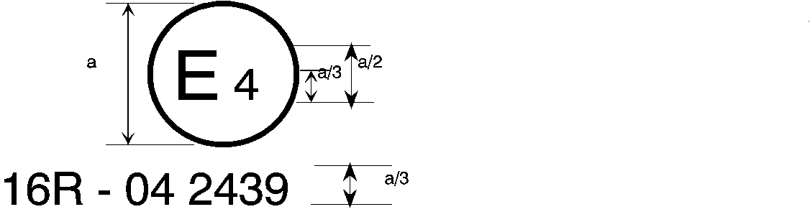

09 2439

The above … amended by the 09 series of amendments.

…

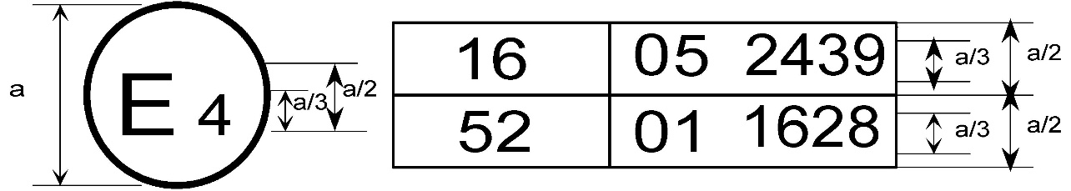

09 2439

The above … included the 09 series of amendments and Regulation No. 52 the 01 series of amendments.

…

2. Arrangements of the safety-belt approval marks (see paragraph 5.3.5. of this Regulation)



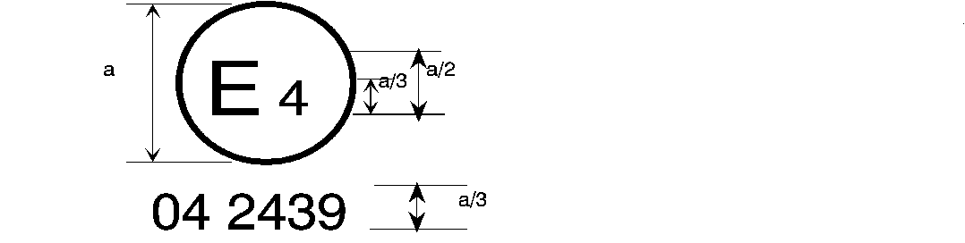

09 2439

a = 8 mm min.

The belt … the 06, 07**,** 08 or 09 series of amendments at the time of approval.

###### B → 4 m



**09** 2489

The belt … 06, 07**,** 08 or 09 series of amendments at the time of approval.

…

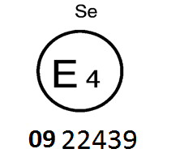

The belt bearing … the 06, 07, 08 or 09 series of amendments at the time of approval.

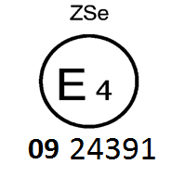

The belt … the 06, 07**,** 08 or 09 series of amendments at the time of approval.



09 2439

a ≥ 8 mm

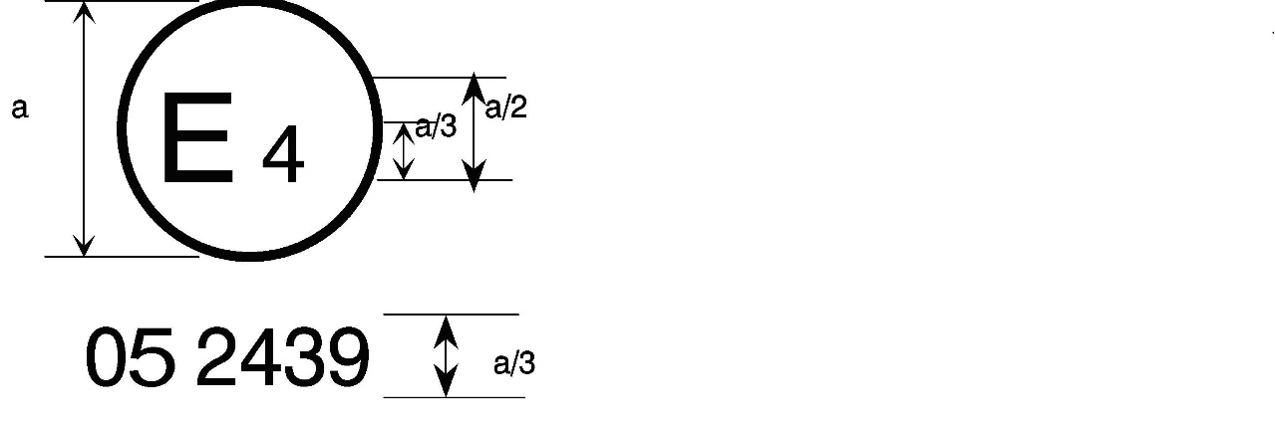

a = 8 mm min.



The belt … the 06, 07**,** 08 or 09 series of amendments at the time of approval. This belt shall not be fitted to vehicles of category M1.

Aer4m

**E4**

AIRBAG

**09**2439

The … 06, 07**,** 08 or 09 series of amendments at the time of the approval. This safety-belt has to be fitted to a vehicle equipped with an airbag in the given seating position."

## *Annex 16*, amend to read:

"Annex 16

Safety-Belt Installation Showing the Belt Types and Retractor Types

| *Minimum requirements for safety-belts and Retractors* | | | | | | | | |
| --- | --- | --- | --- | --- | --- | --- | --- | --- |
| *Vehicle category* | *Forward facing seating positions* | | | | | | *Rearward-facing*  *seating positions* | *Side-facing seating position* |
| *Outboard seating positions* | | | *Centre seating position* | | |
| *Front* | | *Other than front* | *Front* | | *Other than front* |
| M1 | Ar4m | | Ar4m | Ar4m | | Ar4m | B, Br3, Br4m | - |
| M2 < 3.5 t | Ar4m, Ar4Nm | | Ar4m, Ar4Nm | Ar4m, Ar4Nm | | Ar4m, Ar4Nm | Br3, Br4m, Br4Nm | - |
| M2 > 3.5 t | Br3, Br4m, Br4Nm, or Ar4m or Ar4Nm ● | | Br3, Br4m, Br4Nm, or Ar4m or Ar4Nm ● | Br3, Br4m, Br4Nm or Ar4m or Ar4Nm ● | | Br3, Br4m, Br4Nm or Ar4m or Ar4Nm ● | Br3, Br4m, Br4Nm | - |
| M3 | Br3, Br4m, Br4Nm, or Ar4m or Ar4Nm ●  See para. 8.1.7. for conditions when a lap belt is permitted | | Br3, Br4m, Br4Nm, or Ar4m or Ar4Nm ●  See para. 8.1.7. for conditions when a lap belt is permitted | Br3, Br4m, Br4Nm or Ar4m or Ar4Nm ●  See para. 8.1.7. for conditions when a lap belt is permitted | | Br3, Br4m, Br4Nm or Ar4m or Ar4Nm ●  See para. 8.1.7. for conditions when a lap belt is permitted | Br3, Br4m, Br4Nm | B, Br3, Br4m, Br4Nm |
| N1 | Ar4m, Ar4Nm | | Ar4m, Ar4Nm, Br4m, Br4Nm Ø | B, Br3, Br4m, Br4Nm or A, Ar4m, Ar4Nm\* 1 | | B, Br3, Br4m, Br4Nm | B, Br3, Br4m, Br4Nm | - |
|  | | Para. 8.1.2.1. lap belt permitted if seat is inboard of a passageway | Para. 8.1.6. lap belt permitted if the windscreen is not in the reference zone | |  |  |  |
| N2 | Br3, Br4m, Br4Nm orAr4m, Ar4Nm\*  Para. 8.1.6. lap belt permitted if the windscreen is outside the reference zone and for the driver's seat | | B, Br3, Br4m, Br4Nm | B, Br3, Br4m, Br4Nm, or A, Ar4m, Ar4Nm\*  Para. 8.1.6. lap belt permitted if the windscreen is not in the reference zone | | B, Br3, Br4m, Br4Nm | B, Br3, Br4m, Br4Nm | - |
| N3 | Br3, Br4m, Br4Nm orAr4m, Ar4Nm\*  Para. 8.1.6. lap belt permitted if the windscreen is outside the reference zone and for the driver's seat | | B, Br3, Br4m, Br4Nm | B, Br3, Br4m, Br4Nm, or A, Ar4m, Ar4Nm\*  Para. 8.1.6. lap belt permitted if the windscreen is not in the reference zone | | B, Br3, Br4m, Br4Nm | B, Br3, Br4m, Br4Nm | - |
| A: three-point (lap and diagonal) belt 3: automatically locking retractor | | B: 2-point (lap) belt 4: emergency locking retractor | | | r: retractor N: higher response threshold | | m: emergency locking retractor with multiple sensitivity | |
| \*: Refers to para. 8.1.6. of this Regulation 2 | | Ø: Refers to para. 8.1.2.1. of this Regulation | | | ●: refers to para. 8.1.7. of this Regulation2 | | (see UN Regulation No. 16, paras. 2.14.3. and 2.14.5.) | |
| 1 Erratum to Supplement 12 to the 04 series of amendments, applicable "ab initio."  2 Erratum to Revision 4, applicable "ab initio."  Note a ~~1~~: In all cases all S-type belts may be fitted in place of all possible A or B type belts, provided their anchorages comply with UN Regulation No. 14.  Where a harness belt has been approved as a S-type belt according to this Regulation, using the lap belt strap, the shoulder belt straps and possibly one or more retractors, one or two additional crotch straps including their attachments for their anchorages may be provided by the manufacturer/applicant. These additional anchorages need not meet the requirements of UN Regulation No. 14 (Erratum to Supplement 14 to the 04 series of amendments, applicable "ab initio.")."  Note b: For M2 and M3 vehicles of all classes, forward facing Seats facing Built in Child Restraint Systems shall be equipped with at least Ar seat belts. " | | | | | | | | |

## *Annex 17, paragraph 1.1. and 1.2.,* amend to read:

"Annex 17

Requirements for the Installation of Safety-Belts and Restraint Systems for Adult Occupants of Power-Driven Vehicles on Forward Facing Seats, for the Installation of Child Restraint Systems

1. Compatibility with child restraint systems

1.1. The vehicle manufacturer shall include in the vehicle handbook, simple advice to the vehicle user on the suitability of each passenger seating position for the fitting of child restraint systems. This information shall be given by pictograms or in the national language, or at least one of the national languages, of the country in which the vehicle is offered for sale.

For each forward-facing passenger seating position, and for each specified ISOFIX position, the vehicle manufacturer shall indicate:

(a) If the seating position is suitable for child restraints of the "universal" category (see paragraph 1.2. below); and/or

(b) If the seating position is suitable for i-size child restraint systems (see paragraph 1.4. below); and/or

(c) If the seating position is suitable for child restraint systems equipped with lower tether attachments; and/or

(d) If the seating position is suitable for child restraint systems other than those specified above (e.g. see paragraph 1.3. below).

…

1.2. A child restraint system of the universal category means a child restraint approved to the "universal" category of UN Regulation No. 44, 04 series of amendments or to one of the universal categories of UN Regulation No. 129 (or subsequent amendments). Positions, which are indicated by the vehicle manufacturer as being suitable for the installation of child restraints systems of the universal category shall comply with the provisions of Appendix 1 and Appendix 5 to this annex."

*Annex 17 – Appendix 3,* amend to read:

"Annex 17 – Appendix 3

Example of detailed information e.g. for child restraint system manufacturers

# Table 1

**Technical Information Specifically for e.g. Child Restraint System Manufacturers  
(and as such, translation into national languages is not required)**

|  | *Seating position* | | | | | | | | |
| --- | --- | --- | --- | --- | --- | --- | --- | --- | --- |
| Seat position number | 1 | 2 | 3 | 4 | 5 | 6 | 7 | 8 | 9 |
| Seating position suitable for universal belted (yes/ no) |  |  |  |  |  |  |  |  |  |
| i-Size seating position (yes/ no) |  |  |  |  |  |  |  |  |  |
| Seating position suitable for lateral fixture (L1/ L2) |  |  |  |  |  |  |  |  |  |
| Largest suitable rearward facing fixture (R1/ R2X/ R2/ R3) |  |  |  |  |  |  |  |  |  |
| Largest suitable forward facing fixture (F2X /F2/ F3) |  |  |  |  |  |  |  |  |  |
| Largest suitable booster fixture (B2/B3) |  |  |  |  |  |  |  |  |  |

1. Add information for each non i-size seating position compatible with a support leg, as described in this regulation.

2. Add information for each seating position equipped with lower ISOFIX anchorages but without top tether, according to this regulation.

3. Add information if the adult safety belt buckles are located laterally in between both ISOFIX lower anchorages.

4. Add information where any seating position is provided with lower tether anchorages and/or lower tether brackets and/or in case the top tether anchorage of the front seat (if available) may be used as LTA.

Note:

1. Orientation is normal driving direction; columns for seating positions not available in a vehicle can be deleted.

… "

*Annex 18,*

*Paragraph 1.,* amend to read:

"1. The first level warning shall be tested according to the following conditions:

(a) Safety-belt is not fastened;

(b) Engine or propulsion system is stopped or idling, and the vehicle is not in forward or reverse motion;

(c) Transmission is in neutral position;

(d) Ignition switch or master control switch is activated.

(e) A load of 40 kg is placed on each seat cushion in the same row as the driver's seat, or the state in which occupants are on board the vehicle is simulated by an alternative method specified by the vehicle manufacturer, provided an occupant’s load does not exceed 40 kg.

This may also be done for the rear seats at the request of the vehicle manufacturer.

Or alternatively (at the choice of the manufacturer):

An object or human representing a 5th percentile adult female [[2]](#footnote-3)1 is placed on each seat cushion as specified by the manufacturer in the same row as the driver seat, or

the state in which occupants representing a 5th percentile adult female 1 are on board the vehicle is simulated by an alternative method specified by the vehicle manufacturer as agreed by the technical service and the approval authority.

This may also be done for the rear seats at the request of the vehicle manufacturer.

(f) The state of the safety-belt reminder is checked for all of the relevant seat(s), in conditions (a) to (e)…"

*Paragraphs 2.1.1.2*., amend to read:

"2.1.1.2. The test vehicle is driven forward at least 500m in normal operation from a halt position."

*Paragraphs 2.1.2.,* amend to read:

"2.1.2. Testing the driver’s seat when the safety-belt becomes unbuckled during the journey.

(a) The safety-belts of the driver’s seat and seats other than the driver’s seat are fastened;

(b) the vehicle is in normal operation;

(c) The safety-belt of the driver’s seat is unbuckled;

(d) The test vehicle is driven, at the choice of the manufacturer, under one of the conditions in paragraphs 2.1.2.1. to 2.1.2.3. of this Annex or a combination thereof.

2.1.2.1. Accelerate the test vehicle to 25 -0/+10 km/h continue on the same speed.

2.1.2.2. The test vehicle is driven forward at least 500m from the safety-belt unbuckling.

2.1.2.3. The test vehicle is driven forward for at least 60 seconds from the safety-belt unbuckling."

*Paragraph 2.2.1.,* amend to read:

"2.2.1. Testing the seat(s) in the same row as the driver's seat when the safety-belt is unfastened before the journey:

(a) The safety-belt(s) of the seat(s) in the same row as the driver's seat is/are not fastened;

(b) The safety-belts of the seats other than the seat(s) in the same row as the driver's seat are fastened;

(c) A load of 40 kg is applied to the seat(s) in the same row as the driver's seat, or the state in which occupants are on board the vehicle is simulated by a method specified by the manufacturer, provided an occupant’s load does not exceed 40 kg.

… "

*Paragraph 2.2.2.,* amend to read:

"2.2.2. Testing the seating position in the same row as the driver’s seat when the safety-belt becomes unbuckled during the journey.

(a) The safety-belts of the driver’s seat and seats other than the driver’s seat are fastened;

(b) A load of 40 kg is applied to the seat(s) in the same row as the driver's seat, or the state in which occupants are on board the vehicle is simulated by a method specified by the manufacturer, provided an occupant’s load does not exceed 40 kg;

Or alternatively (at the choice of the manufacturer):

An object or human representing a 5th percentile adult female is placed on each seat cushion as specified by the manufacturer in the same row as the driver seat, or the state in which occupants representing a 5th percentile adult female 1 are on board the vehicle is simulated by an alternative method specified by the vehicle manufacturer as agreed by the technical service and the approval authority. This may also be done for the rear seats at the request of the vehicle manufacturer;

(c) The vehicle is in normal operation;

(d) The safety-belt of seats other than the driver’s seat is unbuckled;

(e) The test vehicle is driven, at the choice of the manufacturer, under one of the conditions in paragraphs 2.1.2.1. to 2.1.2.3. of this Annex or a combination thereof;

(f) The state of the safety-belt reminder is checked for all of the seat(s) in the same row as the driver's seat, for each condition (a) to (e)… "

1. \* In accordance with the programme of work of the Inland Transport Committee for 2023 as outlined in proposed programme budget for 2023 (A/77/6 (Sect. 20), table 20.6), the World Forum will develop, harmonize and update UN Regulations in order to enhance the performance of vehicles. The present document is submitted in conformity with that mandate. [↑](#footnote-ref-2)
2. 1 The technical specifications and detailed drawings of Hybrid III, corresponding to the principal dimensions of a fifth percentile female of the United States of America, and the specifications for its adjustment for this test are deposited with the Secretary-General of the United Nations and may be consulted on request at the secretariat of the Economic Commission for Europe, Palais des Nations, Geneva, Switzerland. A female who weighs between 46.7 and 51.25 kg, and who is between 139.7 and 150 cm tall may be used. [↑](#footnote-ref-3)