|  |  |  |  |
| --- | --- | --- | --- |
|  | United Nations | ECE/TRANS/WP.29/GRE/2023/15 | |
| Description: _unlogo | **Economic and Social Council** | | Distr.: General  7 August 2023  Original: English |

**Economic Commission for Europe**

Inland Transport Committee

**World Forum for Harmonization of Vehicle Regulations**

**Working Party on Lighting and Light-Signalling**

**Eighty-ninth session**

Geneva, 24-27 October 2023

Item 4 of the provisional agenda

**Simplification of lighting and light-signalling UN Regulations**

Proposal for a Supplement to the 00 and 01 series of amendments to UN Regulation No. 149

Submitted by the Informal Working Group on Simplification of Lighting and Light-Signalling Regulations[[1]](#footnote-2)\*

The text reproduced below was prepared by the Informal Working Group on Simplification of Lighting and Light-Signalling Regulations (IWG SLR) with the aim to clarify and to correct the text of the 00 and 01 series of amendments to UN Regulation No. 149. The proposed modifications to the current text of the UN Regulations are marked in bold for new or strikethrough for deleted characters.

I. Proposal

A. Proposal for a Supplement to the 00 series of amendments to UN Regulation No. 149

*Paragraph 3.2.2.,* amend to read:

“3.2.2. An approval number shall be assigned to each type approved and shall be marked on the device following the requirements of paragraph 3.3. The same Contracting Party shall not assign the same number to another type of device covered by this Regulation **except in the case of an extension of the approval to a front fog lamp differing only in the colour of the light emitted by the lamp**.”

B. Proposal for a Supplement to the 01 series of amendments to UN Regulation No. 149

*Paragraph 3.2.,* amend to read*:*

“3.2. Approval

A separate approval is required for each lamp **~~(function)~~** listed in **~~Table~~ paragraph** 1.

When two or more lamps are part of the same assembly of grouped, combined or reciprocally incorporated lamps, approval is granted only if each of these lamps satisfies the requirements of this Regulation or of another Regulation. Lamps not satisfying any one of those Regulations shall not be part of such an assembly of grouped, combined or reciprocally incorporated lamps.”

*Paragraph 5.3.3.4.*, amend to read:

“5.3.3.4. The system shall be so made that the lighting unit(s) of the right side and of the left side each provide at least ~~1.62~~**1.60**∙104 cd at the point HV. In case of ADB for vehicles of category L3, each installation unit~~(s)~~ shall provide at least ~~1.62~~**1.60**∙104 cd at the point HV.”

*Table 36, Part B*, amend to read:

*“…*

| Part B | ***Element a*** | ***Angular coordinates***  ***in deg.*** | | ***~~Max~~.Min. luminous intensity b in cd*** | | |
| --- | --- | --- | --- | --- | --- | --- |
| ***Column A*** | ***Column B*** | ***Column C*** |
| ***vertical*** | ***horizontal*** | ***≙ 0% CoP*** | ***≙ 20% CoP*** | ***≙ 30% CoP*** |
| 50L | 0.86°D | 3.43°L | 2.55∙103 | 2.04∙103 | 1.79∙103 |
| 50V | 0.86°D | 0° | 5.10∙103 | 4.08∙103 | 3.57∙103 |
| 50R | 0.86°D | 1.72°R | 5.10∙103 | 4.08∙103 | 3.57∙103 |
| 25LL | 1.72°D | 16°L | 1.18∙103 | 9.44∙102 | 8.26∙102 |
| 25RR | 1.72°D | 11°R | 1.18∙103 | 9.44∙102 | 8.26∙102 |

…”

*Paragraph 6.2.1.1.4.4.*, amend to read:

“6.2.1.1.4.4. As an alternative to the re-alignment procedure as described in paragraph 4.1. of Annex 5, the intensity requirement of column A, B or C of Tables ~~23 to 38~~ **21 to 36** for a particular direction of observation shall be deemed to be satisfied if that requirement is met in a direction deviating by not more than one-quarter of a degree from the direction of observation.”

*Figure A13-III*, *marking examples 3-a and 3-b*, replace examples to read:

**“Marking example 3-a**

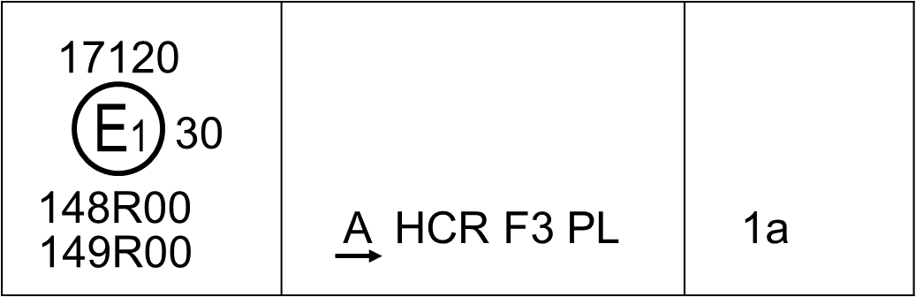

**Marking example 3-b**



”

*Annex 1, paragraph 9.4.7*., amend to read:

“9.4.7. Luminous flux of the light source (see paragraph 4.5.3.~~4~~**5**. of this Regulation)

greater than 2.00∙103 lumens: yes/no2 ”

II. Justification

*00 series of amendments, paragraph 3.2.2.*

1. During the simplification process of the lighting regulations, the introduction of this exemption in the new UN Regulation No. 149 was overlooked, possibly because this provision is just related to front fog lamps. In order to take account of the GRE decision, that the 00 series of amendments to the new UN Regulations Nos. 148, 149 and 150 shall reflect the provisions contained in the old “frozen” lighting and light-signalling regulations in their latest status, it is proposed to reinsert this exemption provision for front fog lamps in paragraph 3.2.2. of UN Regulation No. 149.

*01 series of amendments, paragraph 3.2.*

2. The proposed correction is targeting the alignment with the corresponding text in paragraph 3.2. of the 01 series of amendments to UN Regulation No. 148. With this correction the text will allow to grant one single approval for a headlamp with both passing-beam and driving-beam or for an adaptive front-lighting system (AFS) with different classes. Such kind of approvals are commonly granted and accepted for road illumination devices according to the old UN Regulations and to the 00 series of amendments to UN Regulation No. 149.

*Paragraph 5.3.3.4.*

3. With the transition to scientific notation, for simplicity, the minimum value required for the Class “B” driving-beam has been rounded from 40,500 cd to 4.00∙104 cd (see Table 5). By applying this principle, in paragraph 5.3.3.4. the value which represents 40% of 4.00∙104 should be 1.60∙104 (not 1.62∙104).

*Table 36, Part B*

4. Part B of Table 36 describes the conformity of production (CoP) requirements for the adaprtive driving beam (ADB). It should refer to the minimum luminous intensity requirements, as it is done in Part B of Table 13.

*Paragraph 6.2.1.1.4.4.*

5. The CoP values are provided in Tables 21 to 36, not 23 to 38.

*Figure A13-III*

6. In the current marking example 3-a and 3-b there is a double pointed arrow indicating a passing-beam approved for both right-hand and left-hand traffic. However, the text below the figure (in the “note (b)”) just refers to “a passing-beam designed for right-hand traffic only”. Since the marking example with a double pointed arrow is already provided in Figure A13-I, it is proposed to remove this arrow in both examples 3-a and 3-b of Figure A13-III. The entire “note” below these two examples remains unchanged.

*Annex 1, paragraph. 9.4.7.*

7. A wrong paragraph reference number has been corrected.

1. \* In accordance with the programme of work of the Inland Transport Committee for 2023 as outlined in proposed programme budget for 2023 (A/77/6 (Sect. 20), table 20.6), the World Forum will develop, harmonize and update UN Regulations in order to enhance the performance of vehicles. The present document is submitted in conformity with that mandate. [↑](#footnote-ref-2)