|  |  |  |  |
| --- | --- | --- | --- |
|  | United Nations | ECE/TRANS/WP.29/2023/99 | |
| _unlogo | **Economic and Social Council** | | Distr.: General  24 August 2023  Original: English |

**Economic Commission for Europe**

Inland Transport Committee

**World Forum for Harmonization of Vehicle Regulations**

**191st session**

Geneva, 14–16 November 2023

Item 4.7.2 of the provisional agenda

**1958 Agreement:**

**Consideration of draft amendments to existing**

**UN Regulations submitted by GRSG**

Proposal for Supplement 11 to the 01 series of amendments to UN Regulation No. 43 (Safety glazing)

Submitted by the Working Party on General Safety [[1]](#footnote-2)\*

The text reproduced below was adopted by the Working Party on General Safety (GRSG) at its 125th session (ECE/TRANS/WP.29/GRSG/104 para. 8). It is based on ECE/TRANS/WP.29/GRSG/2023/7 as amended by Annex II to the report. It is submitted to the World Forum for Harmonization of Vehicle Regulations (WP.29) and to the Administrative Committee (AC.1) for consideration at their November 2023 sessions.

*Annex 3,*

*Paragraph 9.1.2.2.*, amend to read:

"9.1.2.2. For the windscreens of M1 Vehicles [[2]](#footnote-3)18 the test shall be carried out in Test Area B defined in Annex 21, Paragraph 2.3., excluding any opaque obscuration impinging on it.

For the windscreens of N1 Vehicles, the manufacturer may request that the same test may be carried out either in Test Area B defined in Annex 21, Paragraph 2.3, or in the Zone I defined in Paragraph 9.2.5.2.3. of this annex, excluding any opaque obscuration impinging on it.

For windscreens of other categories of vehicles, the test shall be carried out in the Zone I defined in Paragraph 9.2.5.2.3. of this annex, excluding any opaque obscuration impinging on it.

However, for agricultural and forestry tractors and for construction-site vehicles for which it is not possible to determine Zone I, the test shall be carried out in Zone I' as defined in Paragraph 9.2.5.3. of this annex."

*Paragraph 9.2.5.2.3,* amend to read and insert a new figure 22:

"9.2.5.2.3. Zone I is the windscreen zone determined by the intersection of the windscreen with the four planes defined below:

In addition, opaque obscuration can be exempted in Zone I. It is the limited areas where it is intended that a sensing device, e.g. a rain-drop detector, rear view mirror or autonomous sensors, will be bonded to the inner side of the windscreen. The opaque obscuration where such devices may be applied is defined in paragraph 9.2.5.2.4. of this annex.

Pl – A vertical plane passing through 0 and forming an angle of 15° to the left of the

median longitudinal plane of the vehicle;

P2 – A vertical plane symmetrical to Pl about the median longitudinal plane of the vehicle.

If this is not possible (in the absence of a symmetrical median longitudinal plane, for

instance) P2 shall be the plane symmetrical to Pl about the longitudinal plane of the vehicle

passing through Point 0.

P3 – A plane passing through the straight Line OQ and forming an angle of 10° above the

horizontal plane;

P4 – A plane passing through the straight Line OQ and forming an angle of 8° below the

horizontal plane.

Figure 22  
**Determination of Zone I**

" 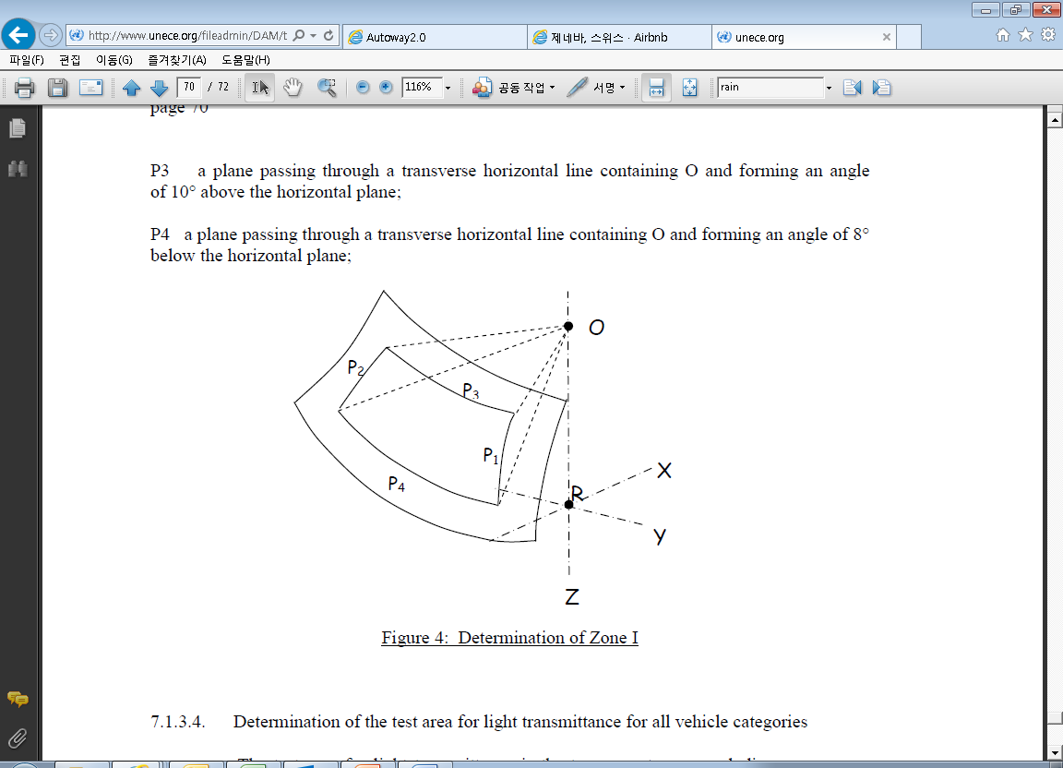

*Insert new paragraphs 9.2.5.2.4., to 9.2.5.2.4.1*., amend to read and insert a new Figure 23:

"9.2.5.2.4. Determination of the opaque obscuration

P5 – a plane passing through a transverse horizontal line containing O and forming an angle of 5° above the horizontal plane

P6 – a vertical plane passing through O and inclined at 20° to the right of the X axis in the case of left-hand drive vehicles and to the left of the X axis in the case of right-hand drive vehicles.

P7 – a plane symmetrical to P6 in relation to the longitudinal median plane of the vehicles.

9.2.5.2.4.1. Any opaque obscuration bounded downwards by P5 and laterally by P6 and P7. (See figure 23)

Figure 23  
**Zone I (example of a left-hand steering control vehicle)  
(Upper obscuration area as defined in paragraph 9.2.5.2.4.1.)**

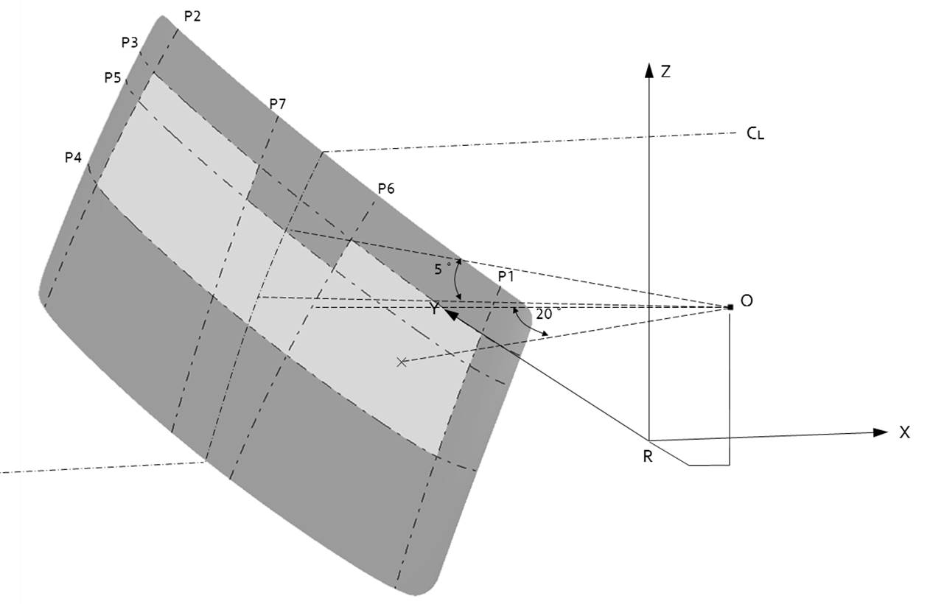

"

*Paragraph 9.3.1.1.1., the references of Figures 22(a), 22(b) and 25*, renumber as Figures 24(a), 24(b) and 27

*Paragraph 9.3.1.1.3.*, *the references of Figures 22(a) and 22(b) and Figures 22(a) to 24*, renumber as Figures 24(a) and 24(b) and as Figures 24(a) to 26.

*Paragraph 9.3.1.2.1*., *the reference of Figure 24*, renumber as Figure 26

*Paragraph 9.3.1.2.2*., *the reference of Figure 25*, renumber as Figure 27

*Paragraph 9.3.4*., *Figure 25*, renumber as Figure 27

*Paragraph 10.4.1*., *the references of Figures 26 to 28 and Figure 26*, renumber as Figures 28 to 30 and as Figure 28

*Paragraph 10.4.2*., *the references of Figures 26, 27, 29 and 30*, renumber as Figures 28, 29, 31 and 32

*Paragraph 10.4.3*., *the reference of Figures 27*, renumber as Figure 29

*Paragraph 10.4.5*., *Figures 27 to 30*, renumber as Figures 29 to 32

*Paragraph 10.5.1*., *the references of Figure 31 and Figure 31*, renumber as Figure~~s~~ 33

*Paragraph 11.2.4.1*., *the references of Figure 32 and Figure 32*, renumber as Figure 34

*Paragraph 11.2.4.3*., *the references of Figure 33 and Figure 33*, renumber as Figure 35

*Paragraph 12.4*., *the references of Figure 34*, renumber as Figure 36

*Paragraph 13.2.*, *the reference of Figure 35 and Figures 34 and 35*, renumber as Figure 37 and as Figures 36 and 37

1. \* In accordance with the programme of work of the Inland Transport Committee for 2023 as outlined in proposed programme budget for 2023 (A/77/6 (Sect. 20), table 20.6), the World Forum will develop, harmonize and update UN Regulations in order to enhance the performance of vehicles. The present document is submitted in conformity with that mandate. [↑](#footnote-ref-2)
2. 18 As defined in the Consolidated Resolution on the Construction of Vehicles (R.E.3), document ECE/TRANS/WP.29/78/Rev.7, para. 2 - https://unece.org/transport/vehicle-regulations/wp29/resolutions [↑](#footnote-ref-3)