|  |  |  |  |
| --- | --- | --- | --- |
|  | United Nations | ECE/TRANS/WP.29/GRVA/2023/21 | |
| _unlogo | **Economic and Social Council** | | Distr.: General  11 July 2023  Original: English |

**Economic Commission for Europe**

Inland Transport Committee

**World Forum for Harmonization of Vehicle Regulations**

**Working Party on Automated/Autonomous and Connected Vehicles**

**Seventeenth session**

Geneva, 25-29 September 2023

Item 6(b) of the provisional agenda

**Advanced Driver Assistance Systems and UN Regulation No. 79:**

**UN Regulation No. 79 (Steering equipment)**

Proposal for a supplement to the 03 and to the 04 series of amendments to UN Regulation No. 79 (Steering equipment)

Submitted by the experts from the European Association of Automotive Suppliers and from the International Organization of Motor Vehicle Manufacturers[[1]](#footnote-2)\*

The text reproduced below was prepared by the experts from the European Association of Automotive Suppliers (CLEPA) and the International Organization of Motor Vehicle Manufacturers (OICA) and is based on informal document GRVA-16-08. The proposed amendments aim to clarify provisions on Automatically Commanded Steering Function (ACSF) of category A. The modifications to the exiting text of the Regulation are indicated in bold for new characters.

I. Proposal

*Paragraphs 2.4.8. and 2.4.9.,* amend to read:

“2.4.8. "*Remote Controlled Parking (RCP)*" means an ACSF of category A, actuated by the driver, providing parking or low speed manoeuvring. The actuation is made in close proximity to the vehicle **or the vehicle combination**.

2.4.9. "*Specified maximum RCP operating range (SRCPmax)*" means the maximum distance between the nearest point of the motor vehicle **or of the contour of both vehicles in case of vehicle combination** and the remote control device or alternatively the driver (for systems based on detection of driver position and movement), up to which ACSF is designed to operate.”

II. Justification

1. The proposal aims to clarify the provisions for ACSF of category A Remote Controlled Parking (RCP) for vehicle combinations. The current definition for RCP SRCPmax sets a maximum limit of 6m distance to the motor vehicle, which is insufficient in situations where the operation is supervised by the driver located behind the vehicle combination.

2. In reverse parking / manoeuvring-situations this condition offers safety advantages, as the driver can see better what is behind the trailer.

3. All paragraphs providing requirements for a Remote-Controlled Parking system remain unchanged and applicable to the vehicle combination.

4. Most notably, collision avoidance and obstacle detection in the manoeuvring area as required by paragraph 5.6.1.1.4. is to be proven during the approval process.

5. The demonstration of safe system behaviour under fault and non-fault conditions and appropriate measures to allow adequate sensor visibility of the manoeuvring area remains to be subject to discussion and agreement between the manufacturer and the Technical Service and shall be described in Annex 6.

6. Overhanging cargo remains under the driver’s responsibility, when driving reverse, with or without a trailer.

Figure 1

**Illustration of the situation for the vehicle combination and the driver and of the “specified maximum RCP operating range (SRCPmax)” in this case**

$S_{RCPmax}$ = 6m around the contour of the vehicle combination

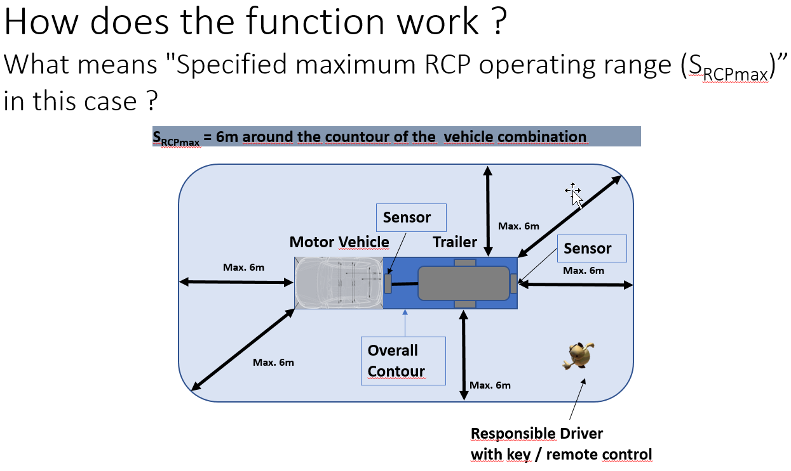

1. \* In accordance with the programme of work of the Inland Transport Committee for 2023 as outlined in proposed programme budget for 2023 (A/77/6 (part V sect. 20) para 20.6), the World Forum will develop, harmonize and update UN Regulations in order to enhance the performance of vehicles. The present document is submitted in conformity with that mandate. [↑](#footnote-ref-2)