Transmitted by IWG MU | Informal document GRBP-78-05  (78th GRBP, 30 August – 1 September 2023  Item 7 (c) of the provisional agenda)

Proposal to replace document ECE/TRANS/WP.29/GRBP/2023/19

The changes are marked in bold for added text and strike through for deleted text, all in red font.

Economic Commission for Europe
Inland Transport Committee
World Forum for Harmonization of Vehicle Regulations
Working Party on Noise and Tyres
Seventy-eighth session
Geneva, 30 August – 1 September 2023
Item 7 (c) of the provisional agenda
Tyres: UN Regulation No. 117 (Tyre rolling resistance, rolling noise and wet grip)

Proposal for Supplement 2 to the 04 series of amendments to
UN Regulation No. 117
Submitted by the Informal Working Group on Measurement Uncertainties*
The text below has been prepared by the experts of the Informal Working Group on Measurement Uncertainties (IWG MU) in order to introduce measures to reduce variability. The modifications to the existing text of the UN Regulation are marked in bold for new or strikethrough for deleted characters.

- Proposal
Table of contents, Annexes, amend to read:
"
[…]
4 ReservedSpecifications for the test site
[…]"

Paragraph 8.3.4., amend to read:
"8.3.4. In the case of verification tests with regard to approvals in accordance with paragraph 6.1. of this Regulation, these may be carried out, upon request of the tyre manufacturer, using the same temperature correction formula (see Annex 3 to this Regulation) as that adopted for the original approval."
Add new paragraphs 12.18. to 12.20., to read:
"12.18. Until [6 July 2025], Contracting Parties applying this Regulation shall continue to grant type approvals based on the tyre-rolling sound emissions using only the temperature correction formula specified in Annex 3, paragraph 4.2.1.
12.19. As from [7 July 2025], Contracting Parties applying this Regulation shall grant type approvals based on the tyre-rolling sound emissions using only the temperature correction formula specified in Annex 3, paragraph 4.2.2.
12.20. Contracting Parties applying this Regulation shall continue to grant extensions to existing type approvals first granted before [7 July 2025] based on the tyre-rolling sound emissions using the temperature correction formula specified in Annex 3, paragraph 4.2.1. In case a new test has to be performed on a different representative tyre size for an extension to be granted after [6 July 2025], the temperature correction formula specified in Annex 3, paragraph 4.2.2. shall be used."
Annex 3,
Paragraph 2.1., amend to read:
"2.1. Test site
[…]
The test track shall be such that the conditions of a free sound field between the sound source and the microphone are attained to within 1 dB(A). These conditions shall be deemed to be met if there is no large sound reflecting objects, such as fences, rocks, bridges or building within 50 m of the centre of the measuring section. The surface of the test track and the dimensions of the test site shall be in accordance with ISO 10844:2021. Until the end of the period indicated in paragraph 12.8. of this Regulation the specifications for the test site may be in accordance with Annex 4 to this Regulation.
[…]"
Paragraph 4.2., amend to read:
"4.2. Temperature correction
4.2.1. Until the date indicated in paragraph 12.18. of this Regulation, for For class C1 and class C2 tyres, the rolling sound levels L_{i}(ϑ_{i}) obtained at the test surface temperature $ϑ$_{i} (where i denotes the number of the single measurement) shall be normalized to a test surface reference temperature $ϑ$_{ref} by applying a temperature correction, according to the following formula:
$$L_{i}\left(ϑ_{\text{ref}}\right)=L_{i}\left(ϑ_{i}\right)+K\left(ϑ_{\text{ref}}-ϑ_{i}\right)$$
where:
$ϑ$_{ref} = 20 °C,
For class C1 tyres, the coefficient K is:
− 0.03 dB(A)/°C when $ϑ$ _{i} > $ϑ$_{ref} and
− 0.06 dB(A)/°C when $ϑ$ _{i} < $ϑ$_{ref}.
For class C2 tyres, the coefficient K is −0.02 dB(A)/°C.
4.2.2. From the date indicated in paragraph 12.19., for class C1 and class C2 tyres, the rolling sound levels L_{i}(ϑ_{i}) obtained at the test surface temperature $ϑ$_{i} (where i denotes the number of the single measurement) shall be normalized to a test surface reference temperature $ϑ$_{ref} by applying a temperature correction, according to the following formula:
$$L_{i}\left(ϑ_{\text{ref}}\right)=L_{i}\left(ϑ_{i}\right)-K_{1}∙\lg\left(\frac{ϑ_{\text{ref}}+K_{2}}{ϑ_{i}+K_{2}}\right)$$
where:
$ϑ$_{ref} = 20 °C,
and the coefficients K₁ and K₂ are given in the tables below.

Class C1 tyres | K₁  (°C) | K₂  (°C)
Tyres that are classified as tyre for use in severe snow conditions | 1.35 | 2.29
Other tyres | [2.18]2.25 | 0

Class C2 tyres | K₁  (°C) | K₂  (°C)
Tyres that are classified as tyre for use in severe snow conditions | 0 | 0
Other tyres | 1.22 | 0

4.2.3. Notwithstanding the above procedure, the temperature correction may be made only on the final reported tyre rolling sound level L_{R}, utilizing the arithmetic mean value of the measured temperatures, if the measured test surface temperature does not change more than 5 °C within all measurements necessary for the determination of the sound level of one set of tyres. In this case the regression analysis below shall be based on the uncorrected rolling sound levels L_{i}($ϑ$_{i}).
There will be no temperature correction for class C3 tyres."

Annex 4, amend to read:
" Annex 4
Reserved Specifications for the test site
1. Introduction
This annex describes the specifications relating to the physical characteristics and the laying of the test track. These specifications based on a special standard describe the required physical characteristics as well as the test methods for these characteristics.
2. Required characteristics of the surface
A surface is considered to conform to this standard provided that the texture and voids content or sound absorption coefficient have been measured and found to fulfil all the requirements of paragraphs 2.1. to 2.4. below and provided that the design requirements (paragraph 3.2. below) have been met.
2.1. Residual voids content
The residual Voids Content (VC) of the test track paving mixture shall not exceed 8 per cent. For the measurement procedure, see paragraph 4.1. of this Annex.
2.2. Sound absorption coefficient
If the surface fails to comply with the residual voids content requirement, the surface is acceptable only if its sound absorption coefficient is α ≤ 0.10. For the measurement procedure, see paragraph 4.2. below. The requirements of this paragraph 2.1. above are met also if only sound absorption has been measured and found to be α ≤ 0.10.
Note: The most relevant characteristic is the sound absorption, although the residual voids content is more familiar among road constructors. However, sound absorption needs to be measured only if the surface fails to comply with the voids requirement. This is motivated because the latter is connected with relatively large uncertainties in terms of both measurements and relevance and some surfaces therefore erroneously may be rejected when based only on the voids measurement.
2.3. Texture depth
The Texture Depth (TD) measured according to the volumetric method (see paragraph 4.3. below) shall be:
TD ≥ 0.4 mm
2.4. Homogeneity of the surface
Every practical effort shall be taken to ensure that the surface is made to be as homogeneous as possible within the test area. This includes the texture and voids content, but it should also be observed that if the rolling process results in more effective rolling at some places than others, the texture may be different and unevenness causing bumps may also occur.
2.5. Period of testing
In order to check whether the surface continues to conform to the texture and voids content or sound absorption requirements stipulated in this standard, periodic testing of the surface shall be done at the following intervals:
(a) For residual VC or sound absorption (α):
When the surface is new:
If the surface meets the requirements when new, no further periodical testing is required. If it does not meet the requirement when it is new, it may do so later because surfaces tend to become clogged and compacted with time;
(b) For TD:
When the surface is new:
When the noise testing starts (Note: Not before four weeks after laying);
Then every twelve months.
3. Test surface design
3.1. Area
When designing the test track layout it is important to ensure that, as a minimum requirement, the area traversed by the vehicles running through the test strip is covered with the specified test material with suitable margins for safe and practical driving. This will require that the width of the track is at least 3 m and the length of the track extends beyond lines AA and BB by at least 10 m at either end. Figure 1 shows a plan of a suitable test site and indicates the minimum area which shall be machine laid and machine compacted with the specified test surface material. According to Annex 3, paragraph 3.2., measurements have to be made on each side of the vehicle. This can be made either by measuring with two microphone locations (one on each side of the track) and driving in one direction, or measuring with a microphone only on one side of the track but driving the vehicle in two directions. If the latter method is used, then there are no surface requirements on that side of the track where there is no microphone.

Figure 1
Minimum requirements for test surface area. The shaded part is called "Test area"
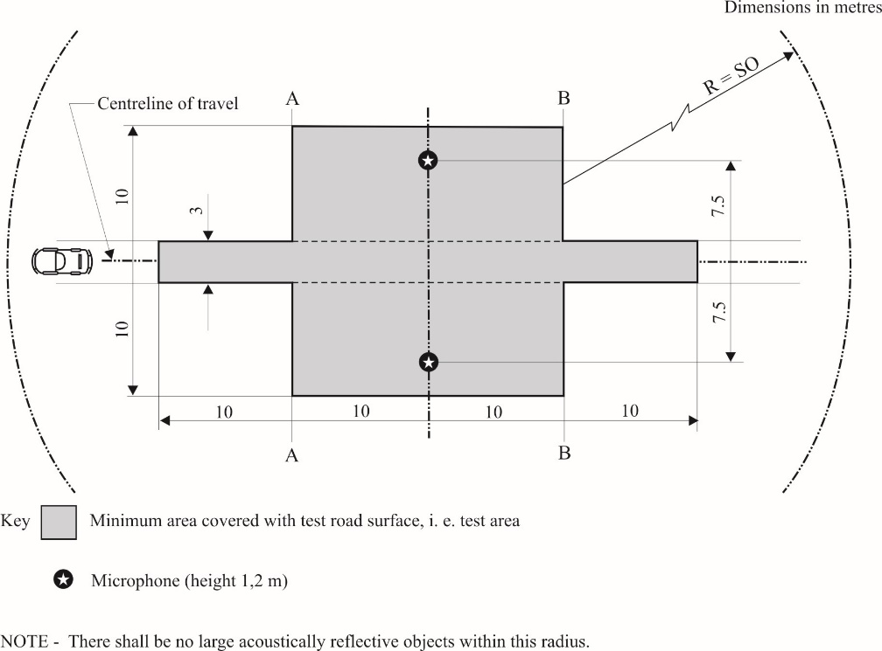
3.2. Design and preparation of the surface
3.2.1. Basic design requirements
The test surface shall meet four design requirements:
3.2.1.1. It shall be a dense asphaltic concrete.
3.2.1.2. The maximum chipping size shall be 8 mm (tolerances allow from 6.3 mm to 10 mm).
3.2.1.3. The thickness of the wearing course shall be ≥ 30 mm.
3.2.1.4. The binder shall be a straight penetration grade bitumen without modification.
3.2.2. Design guidelines
As a guide to the surface constructor, an aggregate grading curve which will give desired characteristics is shown in Figure 2. In addition, Table 1 gives some guidelines in order to obtain the desired texture and durability. The grading curve fits the following formula:
P (% passing) = 100 · (d/d_{max}) 1/2
Where:
d | = | square mesh sieve size, in mm
d_{max} | = | 8 mm for the mean curve
 | = | 10 mm for the lower tolerance curve
 | = | 6.3 mm for the upper tolerance curve

Figure 2
Grading curve of the aggregate in the asphaltic mix with tolerances
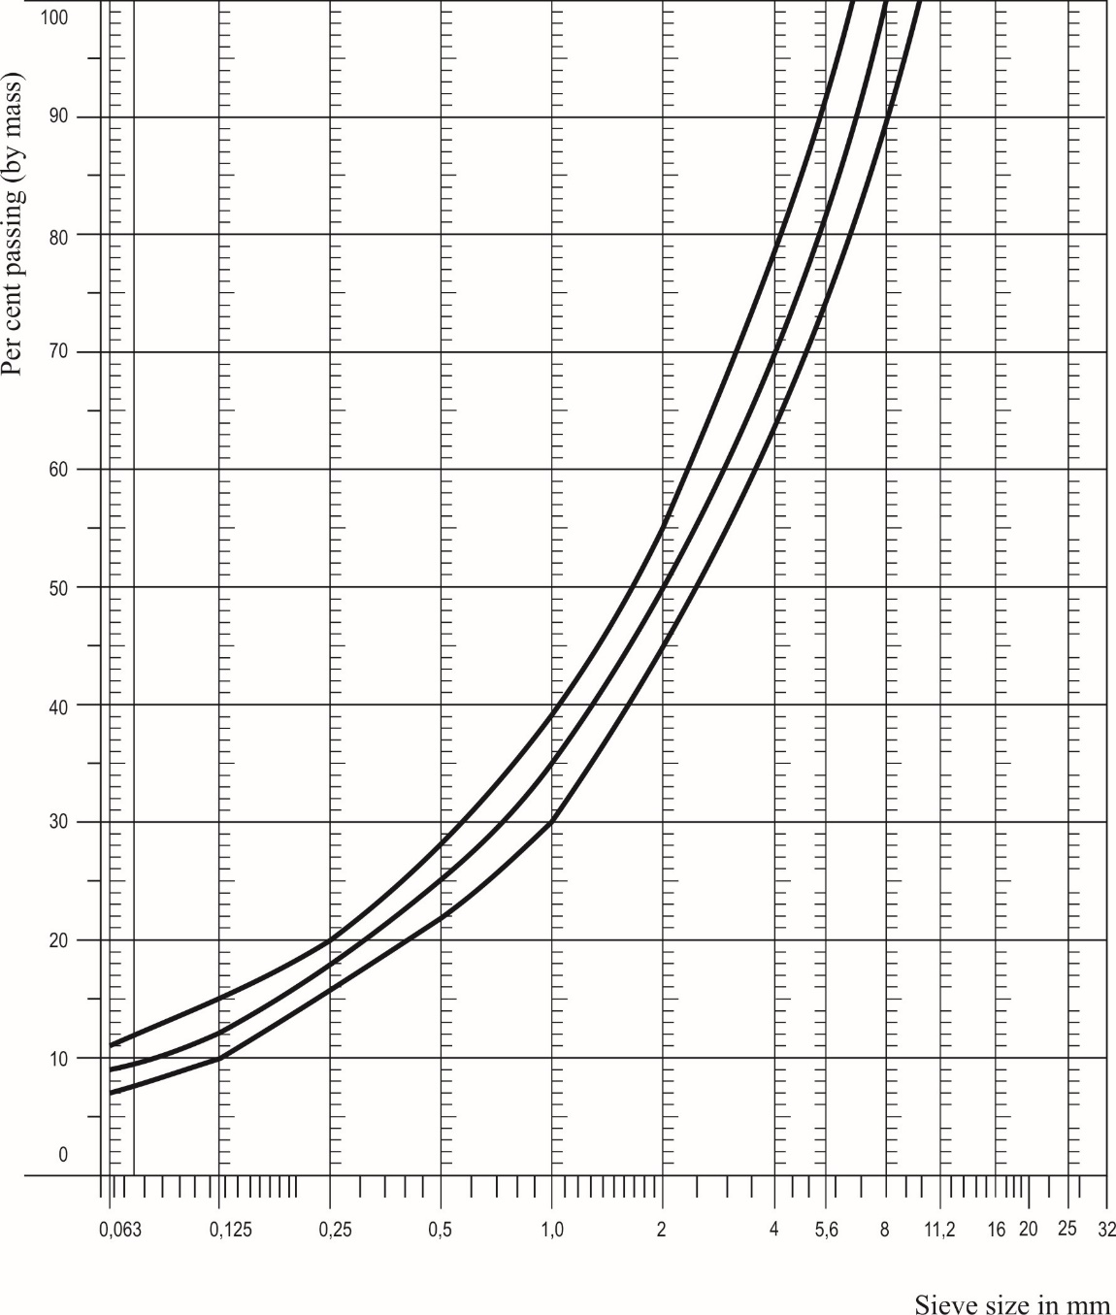

In addition to the above, the following recommendations are given:
(a) The sand fraction (0.063 mm < square mesh sieve size < 2 mm) shall include no more than 55 per cent natural sand and at least 45 per cent crushed sand;
(b) The base and sub-base shall ensure a good stability and evenness, according to best road construction practice;
(c) The chippings shall be crushed (100 per cent crushed faces) and of a material with a high resistance to crushing;
(d) The chippings used in the mix shall be washed;
(e) No extra chippings shall be added onto the surface;
(f) The binder hardness expressed as PEN value shall be 40 - 60, 60 - 80 or even 80 - 100 depending on the climatic conditions of the country. The rule is that as hard a binder as possible shall be used, provided this is consistent with common practice;
(g) The temperature of the mix before rolling shall be chosen so as to achieve by subsequent rolling the required voids content. In order to increase the probability of satisfying the specifications of paragraphs 2.1. to 2.4. above, the compactness shall be studied not only by an appropriate choice of mixing temperature, but also by an appropriate number of passings and by the choice of compacting vehicle.

Table 1
Design guidelines
 | Target values |  | Tolerances
 | By total mass  of mix | By mass of the aggregate
Mass of stones,  square mesh sieve (SM) > 2 mm | 47.6 % | 50.5 % | ±5 %
Mass of sand 0.063 < SM < 2 mm | 38.0 % | 40.2 % | ±5 %
Mass of filler SM < 0.063 mm | 8.8 % | 9.3 % | ±5 %
Mass of binder (bitumen) | 5.8 % | N.A. | ±0.5 %
Max. chipping size | 8 mm |  | 6.3 - 10 mm
Binder hardness | (see paragraph 3.2.2. (f))
Polished Stone Value (PSV) | > 50
Compactness, relative to Marshall  Compactness | 98 %

4. Test method
4.1. Measurement of the residual voids content
For the purpose of this measurement, cores have to be taken from the track in at least four different positions, which are equally distributed in the test area between lines AA and BB (see Figure 1). In order to avoid in homogeneity and unevenness in the wheel tracks, cores should not be taken in wheel tracks themselves, but close to them. Two cores (minimum) should be taken close to the wheel tracks and one core (minimum) should be taken approximately midway between the wheel tracks and each microphone location.
If there is a suspicion that the condition of homogeneity is not met (see paragraph 2.4. above), cores shall be taken from more locations within the test area.
The residual voids content has to be determined for each core, then the average value from all cores shall be calculated and compared with the requirement of paragraph 2.1. of this Annex. In addition, no single core shall have a voids value, which is higher than 10 per cent.
The test surface constructor is reminded of the problem, which may arise when the test area is heated by pipes or electrical wires and cores shall be taken from this area. Such installations shall be carefully planned with respect to future core drilling locations. It is recommended to leave a few locations of size approximately 200 mm x 300 mm where there are no wires/pipes or where the latter are located deep enough in order not to be damaged by cores taken from the surface layer.
4.2. Sound absorption coefficient
The sound absorption coefficient (normal incidence) shall be measured by the impedance tube method using the procedure specified in ISO 10534-1:1996 or ISO 10534-2:1998.
Regarding test specimens, the same requirements shall be followed as regarding the residual voids content (see paragraph 4.1. above). The sound absorption shall be measured in the range between 400 Hz and 800 Hz and in the range between 800 Hz and 1,600 Hz (at least at the centre frequencies of third octave bands) and the maximum values shall be identified for both of these frequency ranges. Then these values, for all test scores, shall be averaged to constitute the final result.
4.3. Volumetric macro-texture measurement
For the purpose of this standard, texture depth measurements shall be made on at least 10 positions evenly spaced along the wheel tracks of the test strip and the average value taken to compare with the specified minimum texture depth. See Standard ISO 10844:2014 for description of the procedure.
5. Stability in time and maintenance
5.1. Age influence
In common with any other surfaces, it is expected that the tyre rolling sound level measured on the test surface may increase slightly during the first
6-12 months after construction.
The surface will achieve its required characteristics not earlier than four weeks after construction. The influence of age on the noise from trucks is generally less than that from cars.
The stability over time is determined mainly by the polishing and compaction by vehicles driving on the surface. It shall be periodically checked as stated in paragraph 2.5. above.
5.2. Maintenance of the surface
Loose debris or dust, which could significantly reduce the effective texture depth shall be removed from the surface. In countries with winter climates, salt is sometimes used for de-icing. Salt may alter the surface temporarily or even permanently in such a way as to increase noise and is therefore not recommended.
5.3. Repaving the test area
If it is necessary to repave the test track, it is usually unnecessary to repave more than the test strip (of 3 m width in Figure 1) where vehicles are driving, provided the test area outside the strip met the requirement of residual voids content or sound absorption when it was measured.
6. Documentation of the test surface and of tests performed on it
6.1. Documentation of the test surface
The following data shall be given in a document describing the test surface:
6.1.1. The location of the test track;
6.1.2. Type of binder, binder hardness, type of aggregate, maximum theoretical density of the concrete (DR), thickness of the wearing course and grading curve determined from cores from the test track;
6.1.3. Method of compaction (e.g. type of roller, roller mass, number of passes);
6.1.4. Temperature of the mix, temperature of the ambient air and wind speed during laying of the surface;
6.1.5. Date when the surface was laid and contractor;
6.1.6. All or at least the latest test result, including:
6.1.6.1. The residual voids content of each core;
6.1.6.2. The locations in the test area from where the cores for voids measurements have been taken;
6.1.6.3. The sound absorption coefficient of each core (if measured). Specify the results both for each core and each frequency range as well as the overall average;
6.1.6.4. The locations in the test area from where the cores for absorption measurement have been taken;
6.1.6.5. Texture depth, including the number of tests and standard deviation;
6.1.6.6. The institution responsible for tests according to paragraphs 6.1.6.1. and 6.1.6.2. above and the type of equipment used;
6.1.6.7. Date of the test(s) and date when the cores were taken from the test track.
6.2. Documentation of vehicle noise tests conducted on the surface
In the document describing the vehicle noise test(s) it shall be stated whether all the requirements of this standard were fulfilled or not. Reference shall be given to a document according to paragraph 6.1. above describing the results which verify this."
- Justification
1. In line with what was already anticipated in informal document GRBP-77-11 (IWG MU), the proposed introduction of a dedicated three-mountain-peak snowflake (3PMSF) temperature correction reduces the measurement uncertainty for class C1 tyres. The proposed update from a bi-linear towards a logarithmic function for the temperature correction is in line with the temperature behaviour of rubber, observed both in material testing as well as in tyre rolling noise measurements.
2. As anticipated in informal document GRBP-77-11 (IWG MU), further investigation was needed for class C2 tyres. For class C2 non-3PMSF tyres a logarithmic function for the temperature correction is introduced. For class C2 3PMSF tyres, and similarly to C3 tyres, no necessity to introduce a temperature correction formula was observed due to their low temperature sensitivity.
3. Regarding class C3 tyres, no necessity to introduce a temperature correction formula was observed due to the low temperature sensitivity of C3 compounds in addition to the high thermal inertia of these tyres.
4. Considering that conformity of production (COP) can occur much later in time than the mandatory application of the new correction formula, this proposal will give each manufacturer the opportunity to use the old or new temperature correction, depending on the acquisition and elaboration system available at the time of COP, independently of the one used at the time of the type approval.
5. Because of possible amendments to UN Regulation No. 117 already scheduled for the session of the Working Party on Noise and Tyres (GRBP) in February 2024, we suggest that this proposal for a supplement be submitted for voting at the June 2024 session of the World Forum (WP.29). The entry into force would then be around January 2025. Considering the accreditation of technical services according to standard ISO 17025, a 6-month transitional provision considering the date of [6 July 2025] is proposed after the entry into force of this supplement.
6. The content of Annex 4 was removed, references to it were deleted, as well as the one to paragraph 12.8. whose current content has changed and does not have anything to do with Annex 4. A blank Annex 4 is kept and reserved for future utilisation.
7. Due to a mistake in the calculation of the originally presented coefficient for the “C1 non 3PMSF” temperature correction, IWGMU would like to propose to change the coefficient “K1” as shown in the table below.
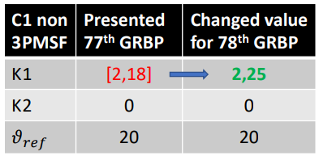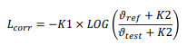
The max. difference between the originally proposed coefficient and the now proposed change is 0,042 dB.
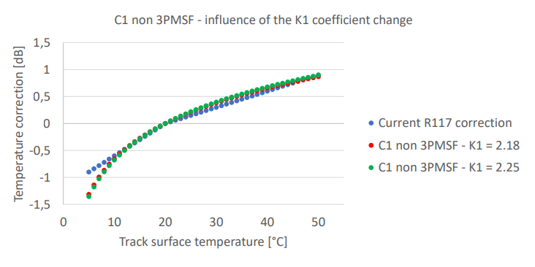
_________________

* In accordance with the programme of work of the Inland Transport Committee for 2023 as outlined in proposed programme budget for 2023 (A/77/6 (Sect.20), table 20.6), the World Forum will develop, harmonize and update UN Regulations in order to enhance the performance of vehicles. The present document is submitted in conformity with that mandate.
The specifications for the test site reproduced in this annex are valid until the end of the period indicated in paragraph 12.8. of this Regulation.
ISO 10844:2014.

