|  |  |  |  |
| --- | --- | --- | --- |
|  | United Nations | ECE/TRANS/WP.29/GRVA/2023/28 | |
| _unlogo | **Economic and Social Council** | | Distr.: General  13 July 2023  Original: English |

**Economic Commission for Europe**

Inland Transport Committee

**World Forum for Harmonization of Vehicle Regulations**

**Working Party on Automated/Autonomous and Connected Vehicles**

**Seventeenth session**

Geneva, 25-29 September 2023

Item 4(e)(ii) of the provisional agenda

**Automated/autonomous and connected vehicles:**

**Vehicle subcategories for ADS**

**Proposal for new vehicle subcategories for vehicles equipped with automated driving systems**

**Submitted by the experts from European Association of Automotive Suppliers (CLEPA) and the International Organization of Motor Vehicle Manufacturers (OICA)**[[1]](#footnote-1)\*

The text reproduced below was prepared on the basis of the informal documents GRVA‑16-47, tabled by the experts from the European Association of Automotive Suppliers (CLEPA) and the International Organization of Motor Vehicle Manufacturers (OICA) at the sixteenth session of the Working Party on Automated/Autonomous and Connected Vehicles (GRVA). GRVA requested, at its May 2023 session that the presentation (GRVA-16-47) is distributed with an official symbol at the seventeenth session of GRVA.

I. Proposal aimed to introduced new subcategories regarding Automated Driving System within the vehicle categories managed by WP.29

A. Introduction

1. At the sixteenth session of GRVA, the experts from CLEPA and OICA presented a proposal for new vehicle subcategories aimed at characterizing the variety of Automated Driving System (ADS) equipped vehicles for the purpose of vehicle regulations.

2. The proposal was based on the review of existing vehicle categories leading to the conclusion that a new approach was needed for addressing different ADS vehicle use cases. The suggested concept for categorization includes the following items:

(a) Balanced approach between the number of Automated Vehicle (AV) categories vs. ADS use-case specific requirements in each individual regulation;

(b) Keeping the current logic for basic vehicle categorization;

(c) Resolving existing issues for categories, e.g. issue of small shuttles with standing passengers;

(d) Easy application in existing Whole Vehicle Type Approval (WVTA) frameworks.

3. The initial proposal was presented in the form of amendments to the vehicle categories defined in the Consolidated Resolution on the Construction of Vehicles (R.E.3), as reproduced in Part B below.

B. Amendments to the Consolidated Resolution on the Construction of Vehicles (R.E.3)

4. The proposed modifications to the existing text of R.E.3 – currently ECE/TRANS/WP.29/2021/144 – are marked in **bold** for new or ~~strikethrough~~ for deleted characters.

*Paragraph 2.2.,* amend to read:

“2.2. Category M - Power-driven vehicles having at least four wheels and used for the carriage of passengers

2.2.1. "*Category M1*": Vehicles used for the carriage of passengers and comprising not more than ~~eight~~ **nine** seats ~~in addition to the driver's seat~~.

2.2.2. "*Category M2*": Vehicles used for the carriage of passengers, comprising more than ~~eight~~ **nine** seats ~~in addition to the driver's seat~~ **or designed to carry standing passengers**, and having a maximum mass not exceeding 5,000 kg.

2.2.3. "*Category M3*": Vehicles used for the carriage of passengers, comprising more than ~~eight~~ **nine** seats ~~in addition to the driver's seat~~ **or designed to carry standing passengers**, and having a maximum mass exceeding 5,000 kg.

2.2.4. Vehicles of categories M2 and M3 belong to:

2.2.4.1. For vehicles having a capacity exceeding **[23] occupants** ~~22 passengers in addition to the driver~~, there are three classes of vehicles:

2.2.4.1.1. "*Class I*": Vehicles constructed with areas for standing passengers, to allow frequent passenger movement.

2.2.4.1.2. "*Class II*": Vehicles constructed principally for the carriage of seated passengers, and designed to allow the carriage of standing passengers in the gangway and/or in an area which does not exceed the space provided for two double seats.

2.2.4.1.3. "*Class III*": Vehicles constructed exclusively for the carriage of seated passengers.

2.2.4.1.4. A vehicle may be regarded as belonging in more than one class. In such a case it may be approved for each class to which it corresponds.

2.2.4.2. For vehicles having a capacity not exceeding **[23] occupants** ~~22 passengers in addition to the driver~~, there are two classes of vehicles:

2.2.4.2.1. "*Class A*": Vehicles designed to carry standing passengers; a vehicle of this class has seats and shall have provisions for standing passengers.

2.2.4.2.2. "*Class B*": Vehicles not designed to carry standing passengers; a vehicle of this class has no provision for standing passengers.”

*Insert a new paragraph 2.10.,* to read:

“**2.10. Dual-mode vehicles with Automated Driving Systems**

**2.10.1. Definition**

**“*Dual-mode vehicles*” means vehicles of category M or N [or L], which can be driven manually and which are equipped with an Automated Driving System (ADS) not designed to issue Transition Demands/ Transition Of Control (allowing the vehicle to be driven in an automated mode). Such ADS would not require an interaction by a driver** **(i.e. a fallback-ready user) to take back manual control.**

**2.10.2. Categorization**

**Dual-mode vehicles are categorized into two sub-categories, based on the maximum operational design speed of the ADS. In cases where the ADS consists of multiple features, e.g. low-speed and high-speed ADS features, the feature with the highest maximum design speed is defining the maximum design speed of the ADS and therefore considered for the dual-mode categorization.**

**2.10.2.1. Category D vehicles are dual mode vehicles having a maximum operational speed of the ADS exceeding [25] km/h.**

**2.10.2.2. Category Z vehicles are dual mode vehicles having a maximum operational speed of the ADS not exceeding [25] km/h.**

**2.10.3. Combined designation**

**Categories M and N may be combined with the categories D or Z. For example, a vehicle of Category M1, which is suited for dual-mode use having a maximum operational speed of the ADS exceeding [25] km/h shall be designated as M1D.**”

*Insert a new paragraph 2.11.,* to read:

“**2.11. Category A – Driverless vehicles with Automated Driving Systems**

**2.11.1. Definition**

***“Driverless vehicles”* are vehicles of Category M or N [or L], which are equipped with an ADS and [cannot be driven manually under nominal conditions/are not falling under the definition of dual mode vehicles]. Such an ADS allows the vehicle to be driven in an automated mode, it is not designed to issue Transition Demands/ Transition Of Control and it would not require an interaction by a driver (i.e. a fallback-ready user) to take back manual control.**

**2.11.2. Combined designation**

**Category M and N may be combined with the Category A. For example, a vehicle of Category M1, which is considered a driverless vehicle, shall be designated as M1A.**”

*Insert a new paragraph 2.12.,* to read:

“**2.12. Low-speed driverless vehicles with Automated Driving Systems**

**2.12.1. Definition**

**2.12.1.1. Category X vehicles are vehicles belonging to Category A, but having a maximum design speed not exceeding [25] km/h.**

**2.12.1.2. Category Y vehicles are vehicles belonging to Category A, having a maximum design speed exceeding [25] km/h but not exceeding [50] km/h.**

**2.12.2. Combined designation**

**The Categories M and N may be combined with the Category X or Y. For example, a vehicle of category M1 which is considered a low-speed driverless vehicle of Category Y shall be designated as M1Y.**”

II. Justification

A. General considerations

1. Clarification of the application of requirements in the case of dual mode vehicles

5. Requirements for a dual mode vehicle: A dual mode vehicle will have to comply, due to the possibility of being driven manually, with the full set of requirements (non-ADS Regulations) applicable to a conventional (manual driven) vehicle and in addition with the respective ADS requirements (ADS Regulation). Depending on the use case the requirements set out in the non-ADS Regulations may have to be (re-)assessed additionally in the automated mode (ADS active).

2. Considerations regarding the moderate complexity of the proposal

6. OICA/CLEPA assessed that the complexity of the proposal is limited, since only two main subcategories are introduced: Category D for Dual Mode vehicles and Category A for driverless automated vehicles. The three additional subcategories are specifically targeting low speed applications, which from OICA/CLEPA point of view, should be addressed differently compared to the main subcategories A and D. This is justified by the limited maximum design speed and/or limited maximum operational speed of the ADS, since performance requirements are expected to be adapted accordingly. This could even support the development of (a) new Regulation(s) covering vehicles with a maximum design speed below 25 km/h. The three subcategories X, Y and Z are intended to highlight this need for adequate performance requirements adapted to the use-cases.

7. Regarding the need for a Category Z: OICA and CLEPA assessed that for the low-speed use cases of Category Z, addressing parking applications with a maximum operational ADS design speed not exceeding [25] km/h, a re-assessment of the non-ADS Regulation requirements in low-speed automated mode is not required, especially since dedicated test scenarios for such functionalities are expected to be introduced. Examples for requirements already established/ under preparation are given through the European Union activity on ADS (dedicated Annex to the European Union Regulation 2022/1426, as well as the German ordinance on regulating the operation of motor vehicles with automated and autonomous driving functions (Verordnung zur Regelung des Betriebs von Kraftfahrzeugen mit automatisierter und autonomer Fahrfunktion und zur Änderung straßenverkehrsrechtlicher Vorschriften (AFGBV), dealing with the ADS approval, as well as dedicated requirements catalogue issued by the German Type Approval Authority KBA).

8. Automated vehicles without occupants: OICA/CLEPA have also considered a new category dedicated to vehicles not designed to carry occupants. However, the current proposal does not introduce such dedicated category due to a balanced approach (increasing the number of categories vs. addressing the applicability via dedicated amendments of the scope in the non-ADS Regulations). OICA/CLEPA are open to further discussions, if a new dedicated (sub-) category for driverless automated vehicles not designed to carry occupants would be more appropriate.

3. Clarification regarding the use of the term “Transition Demand”

9. Reference is made to Transition Demands in the definitions of the subcategories A and D. The intention of using the term Transition Demand, as defined in UN Regulation No. 157, was to clarify that vehicles with systems issuing such Transition Demands and requiring a fall back (ready) user are not to be covered by these categories. Since some vehicles were already approved according to UN Regulation No. 157 and are already in operation, it is seen as demonstrated that such vehicles do not need to be assigned to any new specific vehicle category. It is noted that the Informal Working Group on Functional Requirements for Automated Vehicles (IWG on FRAV) drafted definitions, which once finalized, could also be used for the proposed definitions of automated vehicle categories.

4. Specific provisions for the Category L

10. The CLEPA/OICA proposal did not include an amendment to Category L. Since the basic categorization concept is not changed no implications on Category L vehicles should be expected.

5. Considerations beyond the strict vehicle regulation aspect

11. Support of other needs, e.g. law enforcement, by the proposed categorization: The proposed categorization is supporting these needs, since only Category D vehicles will have the Dynamic Driving Task (DDT) performed either by a driver or the ADS (not requiring a Transition Demand, as defined in UN Regulation No. 157, or Transition Of Control, as defined (draft) by the IWG on FRAV).

B. Amendments to R.E.3

12. The CLEPA and OICA proposal aims at introducing the following amendments to R.E.3:

(a) Modifications to the existing text of R.E.3, i.e. to “Category M - Power-driven vehicles having at least four wheels and used for the carriage of passengers in paragraph”,

(b) Addition of two new main subcategories, Category A for “driverless automated vehicles” and Category D for “dual mode vehicles”,

(c) Introduction of three additional subcategories, Category X and Y for “low speed driverless vehicles”, and Category Z for “low speed dual mode vehicles”

13. An overview of the different subcategories proposed is provided in Figure 1 below.

Figure 1  
**Proposed vehicle categorization under R.E.3**

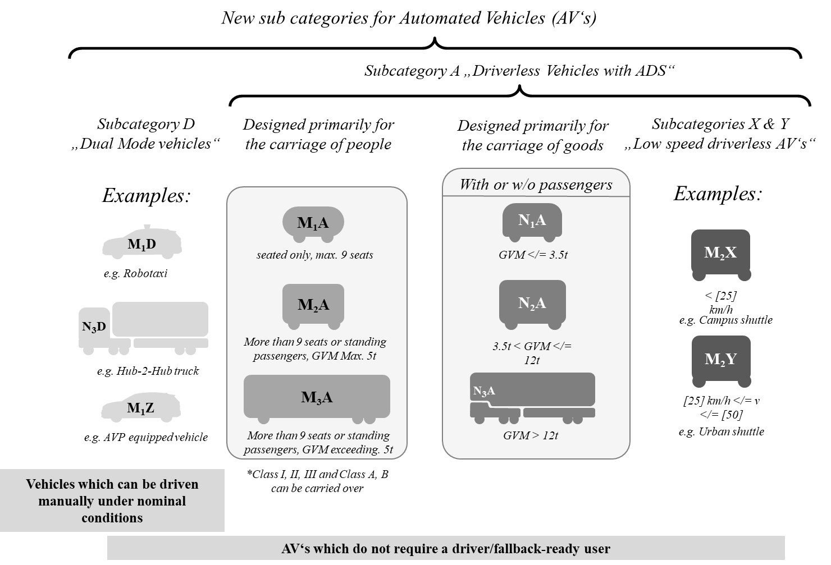

C. Amendments to S.R.1

14. CLEPA and OICA suggested at the sixteenth session of GRVA to also amend S.R.1.

15. It is hereby recalled that paragraph 2.4. of the Special Resolution No. 1 concerning the Common Definitions of Vehicle Categories, Masses and Dimensions (S.R.1), titled “Amendments to S.R.1” stipulates that amending S.R.1 shall be pursuant to the procedure prescribed in paragraph 6.4., Article 6 of the 1998 Agreement, and states that the Contracting Party proposing the amendments to S.R.1, shall also submit the amendment proposals related to the definitions of all UN Global Technical Regulations in force to date.

1. \* In accordance with the programme of work of the Inland Transport Committee for 2023 as outlined in proposed programme budget for 2023 (A/77/6 (part V sect. 20) para 20.6), the World Forum will develop, harmonize and update UN Regulations in order to enhance the performance of vehicles. The present document is submitted in conformity with that mandate. [↑](#footnote-ref-1)