|  |  |  |  |
| --- | --- | --- | --- |
|  | United Nations | ECE/TRANS/WP.29/GRSG/2023/22 | |
| _unlogo | **Economic and Social Council** | | Distr.: General  19 July 2023  Original: English |

**Economic Commission for Europe**

Inland Transport Committee

**World Forum for Harmonization of Vehicle Regulations**

**Working Party on General Safety Provisions**

**126th session**

Geneva, 10-13 October 2023

Item 5(a) of the provisional agenda

**Amendments to External Projections Regulations:  
UN Regulation No. 26 (External projections of passenger cars)**

Proposal for the 05 of amendments to UN Regulation No. 26 (External projections of passenger cars)

Submitted by the expert from Germany on behalf of the Task Force on UN Regulation No. 46[[1]](#footnote-2)\*

The text reproduced below was prepared by the expert from Germany on behalf of the Task Force on UN Regulation No. 46 (TF UN-R 46). It is based on the discussions, which took place during the meeting of the Task Force on UN-R 46 on May 4 and 5, 2023 held in-person and online in Cologne, Germany. Participants of the task force were experts from China, France, Germany, India, the Republic of Korea, The Netherlands, Sweden, European Association of Automotive Suppliers (CLEPA) and International Organization of Motor Vehicle Manufacturers (OICA). The modifications to the current text of the UN Regulation are marked in bold for new or strikethrough for deleted characters.

I. Proposal

*Paragraph 1.1.,* amend to read:

"1.1. This **UN** Regulation applies to external projections of category M1 vehicles.1 It does not apply to exterior devices for indirect vision **approved to UN Regulation No. 46** or to the ball of towing devices.

*Insert new paragraphs 2.13. and 2.14.*, to read:

"**2.13. "Surveillance camera-monitor-recording device" means a camera and either a monitor or recording equipment other than the camera-monitor system defined in [paragraph 2.1.2. of] UN Regulation No. 46, which can be fitted to the inside or outside of the vehicle in order to provide fields of vision other than those specified in UN Regulation No. 46 or to provide a security system within or around the vehicle.**

**2.14. "Surveillance mirror" means a mirror other than the ones defined in [paragraph 2.1.1. of] UN Regulation No. 46, which can be fitted to the inside or outside of the vehicle in order to provide fields of vision other than those specified in UN Regulation No. 46.**"

*Paragraph 4.1.2.*, amend to read:

"4.1.2. An approval number shall be assigned to each **approved type in accordance with Schedule 4 of the Agreement (E/ECE/TRANS/505/Rev.3).** ~~vehicle type approved. Its first two digits (at present 03, corresponding to the 03 series of amendments) shall indicate the series of amendments incorporating the most recent major technical amendments made to the Regulation at the time of issue of the approval. The same Contracting Party may not assign the same number to another vehicle type.~~"

*Insert new paragraphs 6.19.to 6.19.2.,* to read:

"**6.19. Surveillance mirror(s) and surveillance camera-monitor-recording device(s)**

**6.19.1 An exterior surveillance camera shall not project more than 50 mm beyond the overall width of the vehicle measured without this device.**

6.19.2. Edges of fixing holes or recesses of which the diameter or longest diagonal is less than 12 mm are exempt from paragraph 5.4. provided that they are blunted."

*For information only*, to read:

"12.8. As from the official date of entry into force of the 04 series of amendments, no Contracting Party applying this Regulation shall refuse to grant approval under this Regulation as amended by the 04 series of amendments.

12.9. As from 1 September 2022, Contracting Parties applying this Regulation shall not be obliged to accept type approvals to the preceding series of amendments, first issued after 1 September 2022.

12.10. Contracting Parties applying this Regulation shall continue to accept type approvals issued according to the preceding series of amendments to this Regulation first issued before 1 September 2022.

12.11. Contracting Parties applying this Regulation shall not refuse to grant type approvals according to any preceding series of amendments to this Regulation or extensions thereof."

*Insert new paragraphs 12.12. to 12.15.*, to read:

"12.12. As from the official date of entry into force of the 05 series of amendments, no Contracting Party applying this Regulation shall refuse to grant or refuse to accept type approvals under this UN Regulation as amended by the 05 series of amendments.

12.13. As from 1 September [202X], Contracting Parties applying this UN Regulation shall not be obliged to accept type approvals to the preceding series of amendments, first issued after 1 September [202X].

12.14. Until 1 September [202Y], Contracting Parties applying this UN Regulation shall accept type approvals to the preceding series of amendments, first issued before 1 September [202x].

12.15. As from 1 September [202Y], Contracting Parties applying this UN Regulation shall not be obliged to accept type approvals issued to the preceding series of amendments to this UN Regulation.

12.16. Notwithstanding paragraph 12.15., Contracting Parties applying this UN Regulation shall continue to accept type approvals issued according to the preceding series of amendments to this UN Regulation, for the vehicles which are not affected by the changes introduced by the 05 series of amendments.

[12.17. Contracting Parties applying this UN Regulation may grant type approvals according to any preceding series of amendments to this UN Regulation.

12.18. Contracting Parties applying this UN Regulation shall continue to grant extensions of existing approvals to any preceding series of amendments to this UN Regulation.]"

*Annex 2*, amend to read:

"Annex 2

Arrangements of the approval marks

# Model A

(See paragraphs 4.1.4. and 4.2.4. of this Regulation)

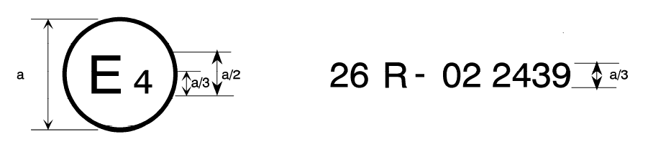

05

a= 8 mm min

The above approval mark affixed to a vehicle shows that the vehicle type concerned has been approved in the Netherlands (E 4) pursuant to UN Regulation No. 26 and under approval number 0**5**2439. The first two digits of the approval number indicate that UN Regulation No. 26 already included the 04 series of amendments when the approval was granted.

# Model B

# (See paragraph 4.1.5. of this Regulation)

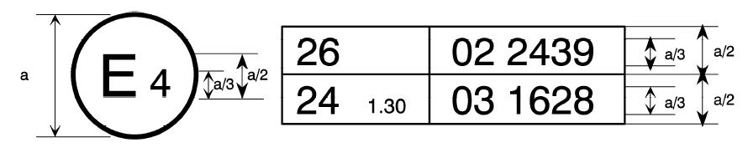

05 2439

a= 8 mm min

The above approval mark affixed to a vehicle shows that the vehicle type concerned has been approved in the Netherlands (E 4) pursuant to UN Regulation No. 26 and UN Regulation No. 24.[[2]](#footnote-3) The first two digits of the approval numbers indicate that, at the dates when the respective approvals were given, UN Regulation No. 26 included the 0**5** series of amendments, while UN Regulation No. 24 already included the 03 series of amendments."

**II. Justification**

The Task Force of the Working Party on General Safety provisions on UN Regulation No. 46 proposes to delete the contents regarding the surveillance cameras/mirrors in UN Regulation No. 46. Currently there is a provision made that no surveillance camera/mirror shall be handled under UN Regulation No. 46, but then stating some specific requirements. For the sake of clarity, these requirements shall be moved to the UN Regulations dealing with the external projections, namely UN Regulation No. 26 for passenger cars and UN Regulation No. 61 for commercial vehicles.

1. \* In accordance with the programme of work of the Inland Transport Committee for 2023 as outlined in proposed programme budget for 2023 (A/77/6 (Sect. 20), table 20.6), the World Forum will develop, harmonize and update UN Regulations in order to enhance the performance of vehicles. The present document is submitted in conformity with that mandate. [↑](#footnote-ref-2)
2. The second Regulation number is given merely as an example; the corrected absorption coefficient is 1.30 m-1. [↑](#footnote-ref-3)