UN/SCETDG/62/INF.23

Committee of Experts on the Transport of Dangerous Goods
and on the Globally Harmonized System of Classification
and Labelling of Chemicals 20 June 2023
Sub-Committee of Experts on the Transport of Dangerous Goods
Sixty-second session
Geneva, 3-7 July 2023
Item 4 (a) of the provisional agenda
Electric storage systems: Transport provisions
Lithium ion batteries testing – amendment to the T.5 short circuit test
Submitted by RECHARGE the Advanced Rechargeable & Lithium Batteries Association and PRBA – The Rechargeable Battery Association
Introduction
1. Based on the principle underlying the UN Manual of Tests and Criteria, section 38.3, the product testing for cells and batteries should be simple: "the product should be tested as designed".
2. The fast changes in the lithium batteries technologies, supporting the strong development of new applications, generates questions about the applicability of the current UN Manual of Tests and Criteria, paragraph 38.3. Particularly, the development of large batteries for various applications, like electric vehicles and truck , or stationary Energy Storage Systems require the transport of batteries or batteries parts that cannot be tested as transported.

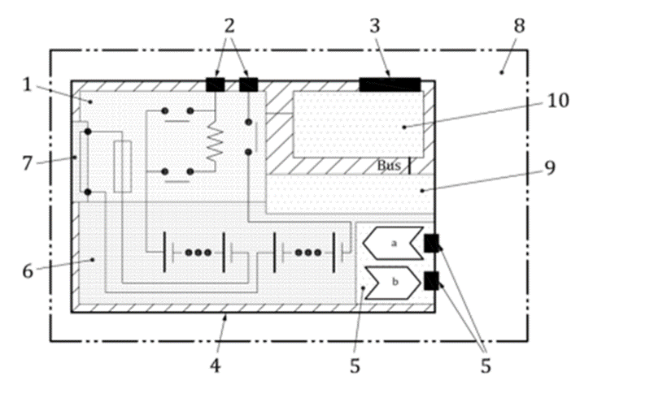
3. Of course, cells can always be tested and verified for the short circuit test. However, their assembly as a battery, or as a component-battery, may preclude the possibility of applying a short circuit, without dismantling components that are part of the design.
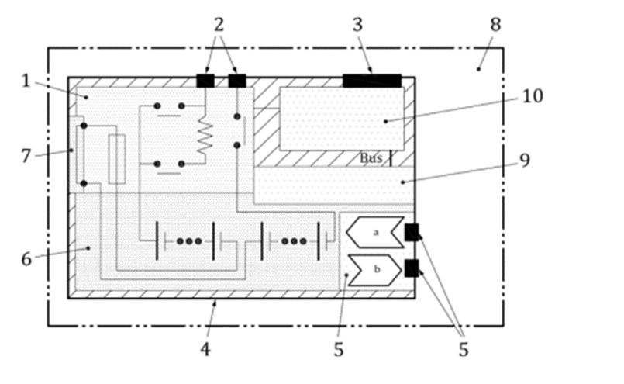
4. The safety system that is part of high voltage batteries is often designed to protect against an external short-circuit. As a result, test is passed without current flow, because the protective components, (red shaded box in illustration 6 above) are preventing it, via a fast reaction-rate open-circuit disconnect. This is the best technical way to prevent the risks related to the application of an external short circuit.
5. The component-battery (or battery-module) can be of a high voltage but is of course not equipped with these protective parts. Nevertheless, it needs to be transported for manufacturing or maintenance purposes. These component-batteries can be designed in a way that no short-circuit set-up is possible, with protective parts that are part of the design preventing possible application of a short-circuit. In this case, the requirement to make the test possible to complete the UN 38.3 series of tests seems to be going against the technical approach of safety.
6. It may be argued that the testing laboratories could open the system for testing purpose. However, this cannot be required for high voltage batteries, as this may end up in a configuration where the open component-battery will present an electrical risk. For example, when removing the battery casing, high voltage systems may be exposed in open air, and/or present arcing risks because of lack of insulation, and require special protections or special equipment to safely handle the risk.
7. The UN Global Technical Regulation for the safety of the high voltage batteries in use also requires the system to be protected by design against the risk of external short. The text of the paragraph 5.4.5 for external short circuit test is reported here for convenience:
“5.4.5. External short circuit protection.
The test shall be conducted in accordance with paragraph 6.2.5.
During the test there shall be no evidence of; electrolyte leakage, rupture (applicable to high voltage REESS only), venting (for REESS other than open-type traction battery), fire or explosion.
The short circuit protection control of the REESS shall terminate the short circuit current, or the temperature measured on the casing of the Tested-Device or the REESS shall be stabilized, such that the temperature gradient varies by less than 4 °C through 2 hours after introducing the short circuit. [….]
6.2.5.3.1. For testing with a complete REESS or REESS subsystem(s), at the beginning of the test, all protection devices which would affect the function of the Tested-Device and which are relevant to the outcome of the test shall be operational”.
8. This text clearly highlights the possibility to prevent the short circuit current by a protective devices that should not be dismantled for the test, as mentioned in paragraph 6.2.5.3.1.
9. Finally, the approach requiring the test laboratory to open the equipment, or the component-battery batteries and remove parts that are part of the design, is also against the principle of the test, which is supposed to test the battery as transported, to define the tested type.
10. In addition, wireless charging of batteries is developing. The example of a power bank designed without external poles can be found in the following links:
https://www.hyreglobal.com/eu-products/power-bank
https://assets.website-files.com/5c0929157fe1665e2830d576/61c2f354852df8df3ba20541_user%20manual%20startpakke.pdf

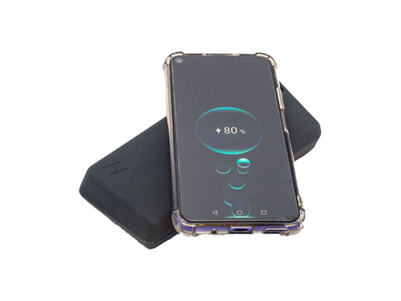
11. The testing of these products for the external short circuit test also requires clarification. Particularly, the internal inductive charging system doesn’t allow to apply a low resistance circuit for a short circuit test, without dismantling the battery.
Conclusion
12. Some batteries are constructed in a way that prevents the application of a short circuit by design (wireless charging batteries, protected component-batteries with a design with no access to the electrical terminal) and cannot be tested without removing parts included in the design. This situation prevents in principle the possibility of demonstrating that these batteries are of a tested type, because components that are part of the design need to be removed for the test.
13. We therefore propose to identify in the Manual of Tests and Criteria that such battery designs should be exempted from the external short circuit test:
- The concern that an added protective feature may not be in place for transport would be eliminated, as this would correspond to the transport of a partially dismantled battery: indeed, if the protection by design was not included, this battery or module would not comply with the transport of the tested type.
Proposal
14. Add in the Manual of Tests and Criteria a new paragraph at the end of 38.3.3 (b) as follows:
“Batteries equipped with non-removable protective parts that prevent any access to the terminals, and that can be used as such, or are part of a battery or equipment or vehicle that is equipped with short-circuit protection, are not subject to the requirements of Test T.5.”

