|  |  |  |  |
| --- | --- | --- | --- |
|  | United Nations | ST/SG/AC.10/C.3/2023/19 | |
| _unlogo | **Secretariat** | | Distr.: General  20 April 2023  Original: English |

**Committee of Experts on the Transport of Dangerous Goods  
and on the Globally Harmonized System of Classification  
and Labelling of Chemicals**

**Sub-Committee of Experts on the Transport of Dangerous Goods**

**Sixty-second session**

Geneva, 3-7 July 2023

Item 2 (h) of the provisional agenda

**Explosives and related matters:  
miscellaneous**

Proposal to extend the entry for UN 3375 to provide for all potential packing groups

Transmitted by the Australasian Explosives Industry Safety Group Inc. (AEISG)[[1]](#footnote-2)\*

Introduction

1. At the forty-third session of the Sub-Committee, AEISG sought a discussion and review of the packing group for the entry UN 3375, AMMONIUM NITRATE EMULSION or SUSPENSION or GEL (ANE), intermediate for blasting explosives based on informal document INF.32 (forty-third session).

2. The Working Group on Explosives (EWG) discussions as outlined in its report (INF.61-Rev.1 of the forty-third session) determined that there was no scientific rationale to assign packing group (PG) II to this entry. It agreed that AEISG could prepare a future proposal to alter the packing group and further recommended that such proposal should be based on test data using test O.3 for oxidising solids as outlined in the *Manual of Tests and Criteria* (MTC). This was subsequently endorsed by the Sub-Committee in its report of the forty-third session (ST/SG/AC.10/C.3/86, para. 35).

Background

3. ANEs are relatively insensitive explosives precursors which have enabled a significant reduction in the transport and storage of explosives by enabling the manufacture of explosives to take place closer to, or at, the point of use.

4. In document ST/SG/AC.10/1998/45, the expert from France proposed that a new UN number be introduced for ANEs and, depending on the ‘sensitivity’ of the material, that an appropriate packing group of either I, II or III be used. The recommendation of placing ANEs into Division 5.1 was fully supported by the work carried out by the International Group of Experts on the Explosion Risks of Unstable Substances (IGUS) under the umbrella of the Organisation for Economic Co-operation and Development (OECD) (see informal document INF.9, sixteenth session); where it was demonstrated, based on tests O.1 and O.2 in the MTC, that the typical family of ANEs could be deemed to be “oxidizing substances of Division 5.1”.

5. Thus, in document ST/SG/AC.10/C.3/2000/21, the Chair of the EWG, in supporting the recommendation of the expert from France, recommended the introduction of a new UN number for ANEs within Division 5.1 and with PG III. Within this recommendation the formulation for ANEs and a series of tests (later known as test series 8) to determine the dangerous goods classification of ANEs were defined. These requirements were later listed in special provision 309 (SP 309) of the ‘Recommendations on the Transport of Dangerous Goods, *Model Regulations*’.

6. Following further discussions within the EWG, the tests to determine the dangerous goods classification of ANEs as detailed in document ST/SG/AC.10/C.3/2000/21 were further refined and an updated recommendation as detailed in document ST/SG/AC.10/C.3/2001/6 was made by the Chair of the EWG. The packing group in this recommendation given to ANEs was PG II. The change from PG III in document ST/SG/AC.10/C.3/2000/21 to PG II in document ST/SG/AC.10/C.3/2001/6 is unclear and is not supported by the various informal documents tabled in support of the recommendations made in document ST/SG/AC.10/C.3/2001/6. It can only be assumed that a typographical error occurred, and this has been forwarded into subsequent revised editions of the *Model Regulations*.

7. UN 3375 with name and description ‘AMMONIUM NITRATE EMULSION or SUSPENSION or GEL, intermediate for blasting explosives’ (ANE) was introduced by the Committee of Experts on the Transport of Dangerous Goods into the fifteenth revised edition of the *Model Regulations*. UN 3375 was deemed to belong to Division 5.1 with PG II. Before a material can be assigned UN 3375 it must meet the requirements of SP 309 with respect to its formulation and physical characteristics.

Discussion

8. The entry in the *Model Regulations* for UN 3375 is not for a single substance but rather is a generic entry for a group of substances defined as outlined in SP 309. Most, if not all, ANEs can be deemed to be viscous or pasty substances when tested in accordance with section 2.3.4 ‘Tests for determining fluidity’ of the ‘Agreement concerning the International Carriage of Dangerous Goods by Road (ADR)’. It had been found that, with a comprehensive range of ANEs tested in accordance with test O.1 ‘Test for oxidizing solids’ in the fifth revised edition of the MTC, all exhibited PG III characteristics and in accordance with test O.1 some could in fact be deemed to be ‘non-oxidizers’.

9. The principal component of all ANEs is ammonium nitrate (AN), which has been allocated PG III. It would seem logical that ANEs have a similar determination based on their formulations as defined by SP 309.

10. Most, if not all, ANEs are stored and transported in intermediate bulk containers (IBCs) or tanks. The packing group of ANEs is required to determine testing requirements for IBCs. Further, the determination of the packing group also reflects the hazard category for classification and labelling purposes as outlined in chapters 2.13 and 2.14 of the *United Nations Globally Harmonised System of Classification and Labelling of Chemicals (GHS)*.

11. The results of tests conducted to date on identified ‘worst case’ ANEs (e.g., high AN content, low water, low fuel) are shown in figures 1 and 2 below.

**Figure 1: The calculated burning rate and means for the three packing group reference mixtures and two ANE product mixtures**

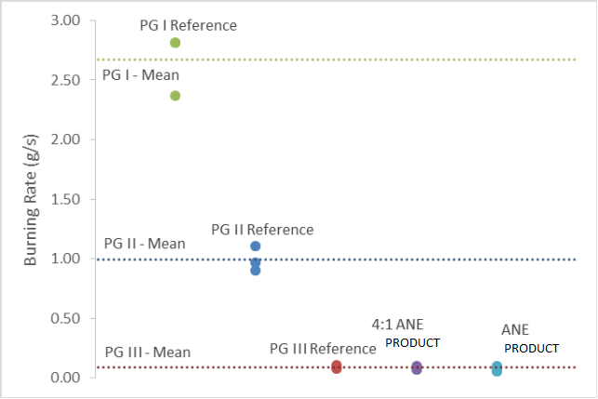

PG III Mean

PG II Mean

PG I Reference

PG I Mean

ANE

Product

4:1 ANE

Product

Burning rate (g/s)

PG III Reference

PG II Reference

**Figure 2: The calculated burning rate and means for the three packing group reference mixtures and two ANE product mixtures. The average result for this ANE product is seen to be below the PG III designation, qualifying to be classed as non 5.1**

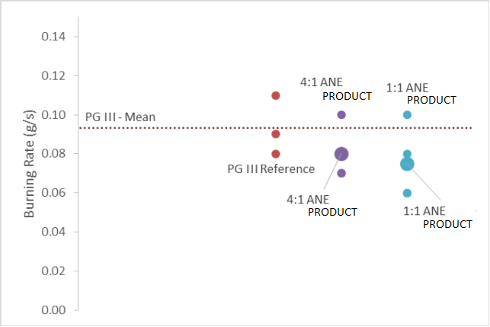

1:1 ANE

Product

4:1 ANE

Product

1:1 ANE

Product

4:1 ANE

Product

PG III Reference

Burning rate (g/s)

PG III Mean

12. Given the broad range of UN 3375 formulations allowed by the generic entry for ANEs as reflected in SP 309, including use of various inorganic nitrates and perchlorates, AEISG believes it is appropriate to provide for all potential packing groups for the UN 3375 entry and that the relevant packing group determination be based on the results of the tests for oxidizing liquids (O.2) and Oxidizing solids (O.3), as relevant, outlined in the MTC. Further, AEISG believes such tests should **not** be used to enable ANE products to qualify as non-oxidizing substances and hence escape this entry.

13. To cater for variations in packing groups presented by products covered by generic entries in the Dangerous Goods List in chapter 3.2 of the *Model Regulations*, such generic entries are listed two or three times as relevant for the different packing groups. There are over 330 such entries in the current twenty-second revised edition of the *Model Regulations*. AEISG considers this same approach should be taken for UN 3375 products.

Proposal

14. It is proposed that in 3.2 Dangerous Goods List, the entry for UN 3375 be extended to cover all possible packing groups as outlined below (new text in **bold**):

|  |  |  |  |  |  |  |  |  |  |  |  |
| --- | --- | --- | --- | --- | --- | --- | --- | --- | --- | --- | --- |
| UN No. | Name and description | Class or division | Subsi-diary hazard | UN packing group | Special provi-sions | Limited and excepted quantities | | Packagings and IBCs | | Portable tanks and bulk containers | |
| Packing instruction | Special packing provisions | Instructions | Special provisions |
| (1) | (2) | (3) | (4) | (5) | (6) | (7a) | (7b) | (8) | (9) | (10) | (11) |
| **3375** | **AMMONIUM NITRATE EMULSION or SUSPENSION or GEL, intermediate for blasting explosives** | **5.1** |  | **I** | **309 3XX** | **0** | **E2** | **P505 IBC02** | **B16** | **T1** | **TP1 TP9 TP17 TP32** |
| 3375 | AMMONIUM NITRATE EMULSION or SUSPENSION or GEL, intermediate for blasting explosives | 5.1 |  | II | 309 **3XX** | 0 | E2 | P505 IBC02 | B16 | T1 | TP1 TP9 TP17 TP32 |
| **3375** | **AMMONIUM NITRATE EMULSION or SUSPENSION or GEL, intermediate for blasting explosives** | **5.1** |  | **III** | **309 3XX** | **0** | **E2** | **P505 IBC02** | **B16** | **T1** | **TP1 TP9 TP17 TP32** |

15. It is also proposed to insert in chapter 3.3 of the *Model Regulations* a new special provision to read as follows:

“3XX The applicable packing group is to be determined using the tests for oxidizing liquids (O.2) or oxidizing solids (O.3) as relevant, outlined in section 34 of the *Manual of Tests and Criteria*. Products which exhibit test results indicating the product is not an oxidizing liquid or not an oxidizing solid are to be included in this entry as packing group III.”

\_\_\_\_\_\_\_\_\_\_\_\_\_\_\_

1. \* A/77/6 (Sect. 20), table 20.6. [↑](#footnote-ref-2)