Transmitted by the expert from Japan

Informal document GRSP-73-28-Rev.1

(73rd GRSP, 15-19 May 2023,

agenda item 6)

Proposal for the 09 series of amendments to UN Regulation No. 16

Submitted by the experts from Japan[1]*

The text reproduced below was originally based on the informal document GRSP-69-23 distributed during the sixty-ninth session of the Working Party on Passive Safety (GRSP). Further amendments are added as a result of the Interested Parties meeting held on April 8, 2022. The modifications to the current text of the UN Regulation are marked in bold for new characters.

**I. Proposal**

*Insert new paragraphs 2.48. and 2.49*., to read:

"**2.48. "*Effective belt anchorage（ EA ）*" means the point used to determine conventionally, as specified in paragraph 5.4. of UN regulation No. 14, the angle of each part of the safety-belt in relation to the wearer, that is, the point to which a strap would need to be attached to provide the same lie as the intended lie of the belt when worn, and which may or may not be the actual belt anchorage depending on the configuration of the safety-belt hardware at its attachment to the belt anchorage.**"

**2.49. "*Bc point*" means the centre point of the hole of the buckle which fasten between the buckle strap and buckle.**

**2.50. "*Bd point*" means the location of the Bc point at the buckle position when the occupant (AM50 or AF05 at the manufacturer’s choice) is restrained in the design seatbelt path.**

**2.51. "*Strap length*" means the length of the buckle strap along the centreline on the strap face.**”

*Paragraph 5.3.2*., amend to read:

"5.3.2. An approval number shall be assigned to each type approved. Its first two digits (at present 0**9** corresponding to the 0**9** series of amendments) shall indicate the series ..."

*Insert new paragraphs 8.2.3. to 8.2.3.3*., to read:

"**8.2.3. The requirement of the strap between the buckle and effective belt anchorage at seats except for the front raw of vehicles of categories M1.**

**8.2.3.1. The difference between the actual strap length and the straight line distance between the EA and Bd point should be 50 mm or less**

**The above requirements may be shown by the actual vehicle, parts, drawings or 3D data at the manufacturer's choice.**

**The correlation between actual vehicle and/or parts and the drawing or 3D data shall be presented by manufacturer, in case of that technical service needs the correlation.**

**8.2.3.2. If the difference between the actual strap length and the straight line distance between the EA and Bd point is greater than 50 mm, the requirements of paragraph 8.2.3.1. need not be satisfied as long as one of the following conditions is met. The applicant may demonstrate that the conditions are met by means of experimental data, simulation data, strength calculations, etc., subject to agreement with the Technical Service.**

**1. When the buckle strap assembly is tested according to the method described in Annex 19, the movement of the Bc point is 50 mm or less; or**

**2. The applicant demonstrates to the Technical Service that the buckle strap assembly has the same performance as the requirement in 1., and obtains the approval of the Technical Service.**”

*Insert new paragraphs 15.6. to 15.14.,* to read:

"**15.6. As from the official date of entry into force of the 09 series of amendments, no Contracting Party applying this UN Regulation shall refuse to grant or refuse to accept type approvals under this Regulation as amended by the 09 series of amendments.**

**15.7. As from [1 September 2024], Contracting Parties applying this UN Regulation shall not be obliged to accept type approvals to the preceding series of amendments, first issued after [1 September 2024].**

**15.8. Until [1 September 2026], Contracting Parties applying this UN Regulation shall accept type approvals to the preceding series of amendments, first issued before [1 September 2024].**

**15.9. As from [1 September 2026], Contracting Parties applying this UN Regulation shall not be obliged to accept type approvals issued to the preceding series of amendments to this UN Regulation.**

**15.10. Notwithstanding the transitional provisions above, Contracting Parties who start to apply this UN Regulation after the date of entry into force of the most recent series of amendments are not obliged to accept type approvals which were granted in accordance with any of the preceding series of amendments to this Regulation / are only obliged to accept type approvals granted in accordance with the 09 series of amendments.**

**15.11. Notwithstanding paragraph 15.9., Contracting Parties applying this Regulation shall continue to accept type approvals issued according to the preceding series of amendments to this UN Regulation, for vehicles that are not affected by the changes introduced by the 09 series of amendments.**

**15.12. Notwithstanding paragraph 15.9., Contracting Parties applying this UN Regulation shall continue to accept type approvals of safety-belts and restraint systems to the preceding series of amendments to the UN Regulation.**

**15.13. Contracting Parties applying this UN Regulation may grant type approvals according to any preceding series of amendments to this UN Regulation.**

**15.14. Contracting Parties applying this UN Regulation shall continue to grant extensions of existing approvals to any preceding series of amendments to this UN Regulation.**"

*Annex 2,* amend to read:

"Annex 2

Arrangements of the approval marks

1. Arrangements of the vehicle approval marks concerning the installation of safety-belts

# Model A

(See paragraph 5.2.4. of this Regulation)

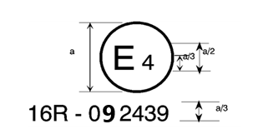

a = 8 mm

The above approval mark affixed to a vehicle shows that the vehicle type concerned has, with regard to safety-belts, been approved in the Netherlands (E 4) pursuant to UN Regulation No. 16. The approval number indicates that the approval was granted according to the requirements of UN Regulation No. 16 as amended by the 0~~8~~**9** series of amendments.

# Model B

(See paragraph 5.2.5. of this Regulation)

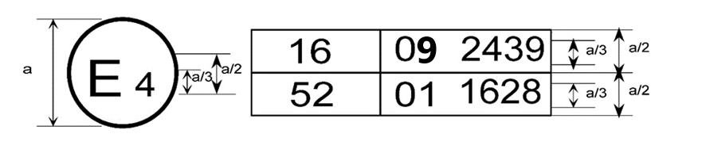

a = 8 mm min.

The above approval mark affixed to a vehicle shows that the vehicle type concerned has been approved in the Netherlands (E 4) pursuant to UN Regulations Nos. 16 and 52[2]F The approval numbers indicate that, at the dates when the respective approvals were given, UN Regulation No. 16 included the 0~~8~~**9** series of amendments and UN Regulation No. 52 the 01 series of amendments.

2. Arrangements of the safety-belt approval marks (see paragraph 5.3.5. of this Regulation)



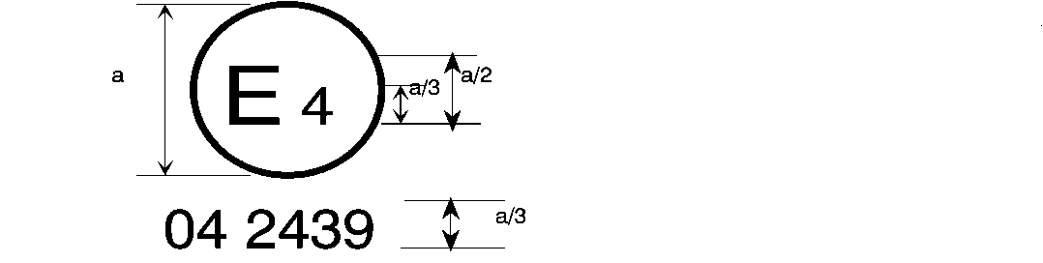

0**9** 2439

a = 8

mm min.

The belt bearing the above approval mark is a three-point belt ("A"), fitted with an energy absorber ("e") and approved in the Netherlands (E 4) under the number 0~~8~~**9**2439, this Regulation already incorporating the 06, 07**,** ~~or~~ 08 or **09** series of amendments at the time of approval.

B → 4 m



0**9** 2489

The belt bearing the above approval mark is a lap belt ("B"), fitted with a retractor, type 4, with multiple sensitivity (m) and approved in the Netherlands (E 4) under the number 0~~8~~**9**2489, this Regulation already incorporating the 06, 07**,** ~~or~~ 08 or **09** series of amendments at the time of approval.

*Note:* The approval number and additional symbol(s) shall be placed close to the circle and either above or below the "E" or to left or right of that letter. The digits of the approval number shall be on the same side of the "E" and orientated in the same direction. The additional symbol(s) shall be diametrically opposite the approval number. The use of roman numerals as approval numbers should be avoided so as to prevent any confusion with other symbols.

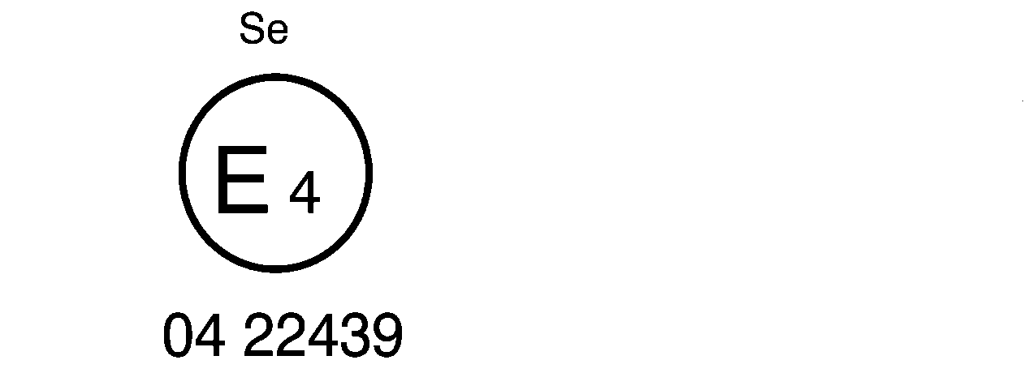

0**9** 22439

The belt bearing the above approval mark is a special type belt ("S"), fitted with an energy absorber ("e") and approved in the Netherlands (E 4) under the number 0~~8~~**9**22439, this Regulation already incorporating the 06, 07**,** ~~or~~ 08 or **09** series of amendments at the time of approval.

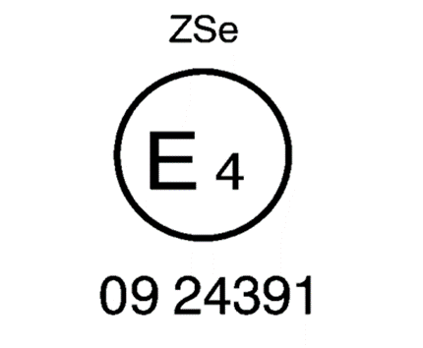

The belt bearing the above approval mark is part of a restraint system ("Z"), it is a special type belt ("S") fitted with an energy absorber ("e"). It has been approved in the Netherlands (E 4) under the number 0~~8~~**9**24391, this Regulation already incorporating the 06, 07**,** ~~or~~ 08 or **09** series of amendments at the time of approval.



a ≥ 8 mm

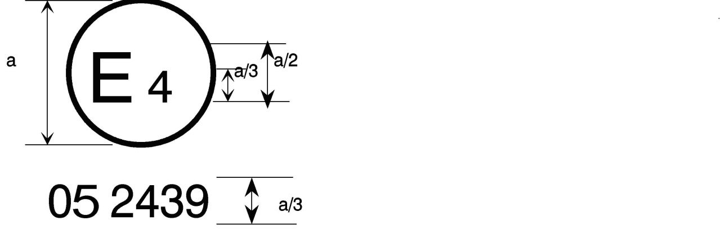

0**9** 2439

a = 8 mm min.



The belt bearing this type approval mark is a three-point belt ("A") with a multiple-sensitivity ("m") type 4N ("r4N") retractor, in respect of which type approval was granted in the Netherlands ("E 4") under number 0~~8~~**9**2439, this Regulation already incorporating the 06, 07**,** ~~or~~ 08 or **09** series of amendments at the time of approval. This belt shall not be fitted to vehicles of category M1.

**Aer4m**

**E4**

**092439**

**AIRBAG**

The safety-belt bearing this type approval mark is a three-point belt ("A") fitted with an energy absorber ("e"), approved as meeting the specific requirements of paragraph 6.4.1.3.3. or 6.4.1.3.4. of this Regulation, and with a multiple-sensitivity ("m") type 4 ("r4") retractor, in respect of which type approval was granted in the Netherlands ("E 4") under the approval number 0~~8~~**9**2439. The first two digits indicate that the **UN** Regulation already incorporated the 06, 07, 08 or **09** series of amendments at the time of the approval. This safety-belt has to be fitted to a vehicle equipped with an airbag in the given seating position."

Annex 19 Tensile test method

1. General

1.1. The test procedure in this Annex shall be used for the tensile test of the buckle strap assembly described in paragraph 8.2.3.2. of this Regulation.

2. Test procedure

2.1. Fix the EA bracket side of the buckle strap assembly on the fixed clamp of the tensile test machine, and the Bc point on the moving clamp of the machine.

2.2. The initial distance between the EA point and the buckle point of the buckle strap assembly which is attached to the tensile test machine shall be the same as the straight distance between the EA and Bd points on the drawing (with a tolerance of ± [5] mm).

2.3. Perform a tensile test until a load of [8] kN is applied.

.

**II. Justification**

1. The strap’s paths between the effective safety-belt anchorage and the buckle are normally straight like the test bench specified in UN Regulation No. 129 (Figure 1). However, the strap’s paths between the effective belt-anchorage and the buckle of some vehicles in the market are not straight and are curved along the cushion (Figure 2).

|  |  |
| --- | --- |
| Figure 1 **Photo of the Buckle Strap Path of the UN Regulation No. 129 Test Bench** | Figure 2 **Photo of the Buckle Strap Path When Not Straight** |

2. When the strap’s paths between the effective belt anchorage and the buckle are not straight, the occupants may move significantly forward during a frontal impact accident. If an occupant is seated in the booster seat attached by ISOFIX, there are cases in which the seatbelt slips up to the neck and in which submarining occurs (referred to in GRSP-69-24). These phenomena would increase the risk of injuries to the neck and abdomen of a child occupant. In addition, the dummy chest injury increases. Figure 3 shows the relation between the amount of slack of the buckle strap and dummy 3 ms chest maximum acceleration for two types of CRS. When the slack of the buckle belt was over [50] mm, the chest maximum acceleration approached UN Regulation No. 129 criteria in one CRS. When the slack of the buckle belt was over [80] mm, the chest maximum acceleration exceeded the above-mentioned criteria.

Figure 3  
**Relation between the Amount of Slack of the Buckle Strap and Dummy 3ms Chest Maximum Acceleration**



3. The slack of the buckle belt makes the passenger’s excursion larger, negatively affecting the safety of the occupant (referred to in GRSP-70-32).

4. Therefore, we propose to limit the slack of the buckle-belt.

5. These amendments prevent the negative affects to the safety of the occupants.

1. * In accordance with the programme of work of the Inland Transport Committee for 2022 as outlined in proposed programme budget for 2022 (A/76/6 (part V, sect. 20) para. 20.76), the World Forum will develop, harmonize and update UN Regulations in order to enhance the performance of vehicles. The present document is submitted in conformity with that mandate.
2. The second number is given merely as an example.