Frontal protection in buses.

We have previously in GRSG raised the issue of better protection for bus drivers when it comes to collision safety. (GRSG-125-10). As this relates to passive safety, it was recommended from GRSG that this should be taken up for discussion in GRSP.

Norway considers that the absence of requirements for protection of the driver in case of frontal collisions in the current regulations is a shortcoming that should be addressed.

Active security measures have been shown to have limited effect in such cases. Therefore, it is necessary to take other measures to increase safety.

While active safety measures can be effective in preventing certain types of accidents, such as those caused by driver inattention or distraction, they may not be as effective in situations where a collision is unavoidable. In these cases, passive safety measures can help to reduce the severity of injuries sustained by the driver and other occupants of the bus.

Experience shows that special protection devices need to be designed for the driver protection in the front of bus since driver safety is not adequately considered in current regulations.

Norway considers that the absence of requirements to protect the driver in frontal collisions in the current regulations is a deficiency that should be rectified.

We believe that passive safety must be built into the bus to improve protection for the driver as a contribution to reducing the extent of this type of accident.

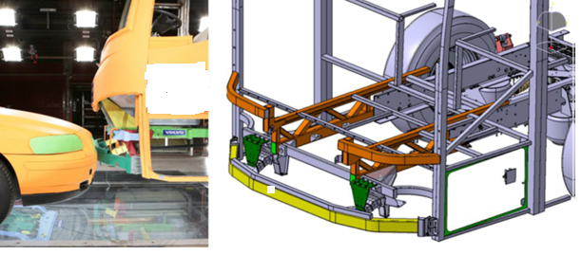

*Photo: Accident Investigation Board Norway - report*



*Photo: Accident Investigation Board Norway - report*

There has been a considerable number of accidents with buses where bus drivers have been seriously injured or killed in connection with head-on collisions in Norway.

In the period from 2011 to 2023, 11 bus drivers have died in head-on collisions.

It is not easy to find any good estimates of how large the effect of underrun protection devices on buses will be, but it is not inconceivable that it will exceed investment costs by a fair margin.

It will probably have a positive effect on all types of road users involved in this type of accidents. The driver of the bus will be less exposed, brakes and steering will not collapse in the collision, which will have a positive impact on bus passengers. For persons of the colliding party, it will probably be positive for the outcome of the accident that they do not end up under the bus.

In the Norwegian Public Roads Administration's assessment, the measure to improve frontal protection for drivers will involve small costs for society compared to the gains in terms of increased road safety

[The Accident Investigation Board Norway](https://havarikommisjonen.no/Vei/Avgitte-rapporter/2019-04-eng) has in the [report](https://havarikommisjonen.no/Vei/Avgitte-rapporter/2019-04-eng) recommended the introduction of technical requirements applying to the bus front to reduce the extent of damage and injury in connection with potential frontal impact accidents. It has also been raised by the labour unions that buses need to become more crash resistant.

On this background Norway will propose to change the scope of ECE regulation 29 and perhaps add a new section for testing the front of the buses. Alternatively make a new regulation for frontal protection for buses.