Proposal for 09 series of amendments to UN Regulation No. 16

Submitted by the expert from Finland

The text reproduced below was prepared by the expert from Finland in order to enhance the safety of the belted passenger seated behind a seat by removing the two of the derogations for two-point belts laid down in paragraphs 8.1.7. to 8.1.7.4 of the UN Regulation 16.

I. Proposal

*Paragraph 8.1.7. to 8.1.7.4.*,amend to read:

"8.1.7. Every seating position in Annex 16 marked with the symbol ●, three-point belts of a type specified in Annex 16 shall be provided unless ~~one of~~ the following condition~~s~~ is fulfilled, in which case two-point belts of a type specified in Annex 16 may be provided.

~~8.1.7.1. There is a seat or other vehicle parts conforming to paragraph 3.5. of Appendix 1 to UN Regulation No. 80 directly in front; or~~

8.1.7.~~2~~**1**. No part of the vehicle is in or, when the vehicle is in motion, capable of being in the reference zone~~; or~~**.**

~~8.1.7.3. Parts of the vehicle within the said reference zone comply with the energy absorbing requirements set out in Appendix 6 of UN Regulation No. 80.~~

8.1.7.~~4~~**2**. Paragraph~~s~~ 8.1.7.1. ~~to 8.1.7.3.~~ shall not apply to a driver’s seat."

*Insert new paragraphs 15.6. to 15.6.8.,* to read:

**"15.6. Transitional provisions applicable to 09 series of amendments**

**15.6.1. As from the official date of entry into force of the 09 series of amendments, no Contracting Party applying this Regulation shall refuse to grant or refuse to accept type approvals under this Regulation as amended by the 09 series of amendments.**

**15.6.2. As from 1 September [2025], Contracting Parties applying this Regulation shall not be obliged to accept type approvals to the preceding series of amendments, first issued after 1 September [2025].**

**15.6.3. Until 1 September [2027], Contracting Parties applying this Regulation shall accept type approvals to the preceding series of amendments, first issued before 1 September [2025].**

**15.6.4. As from 1 September [2027], Contracting Parties applying this Regulation shall not be obliged to accept type approvals issued to the preceding series of amendments to this Regulation.**

**15.6.5. Notwithstanding the transitional provisions above, Contracting Parties who start to apply this Regulation after the date of entry into force of the most recent series of amendments are not obliged to accept type approvals which were granted in accordance with any of the preceding series of amendments to this Regulation.**

**15.6.6. Notwithstanding paragraph 15.6.4, Contracting Parties applying this Regulation shall continue to accept type approvals issued according to the preceding series of amendments to this Regulation, for the vehicles/vehicle systems which are not affected by the changes introduced by the 09 series of amendments.**

**15.6.7. Contracting Parties applying this Regulation may grant type approvals according to any preceding series of amendments to this Regulation.**

**15.6.8. Contracting Parties applying this Regulation shall continue to grant extensions of existing approvals to any preceding series of amendments to this Regulation**

*Annex 2*, amend to read:

"Annex 2

…

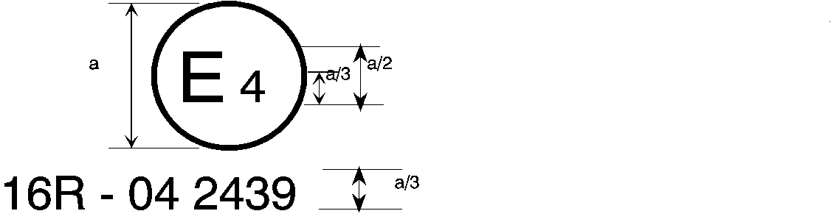

**09** 2439

The above … amended by the **09** series of amendments.

…

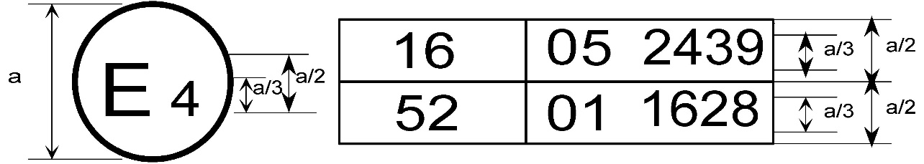

**09** 2439

The above … included the **09** series of amendments and Regulation No. 52 the 01 series of amendments.

…

2. Arrangements of the safety-belt approval marks (see paragraph 5.3.5. of this Regulation)



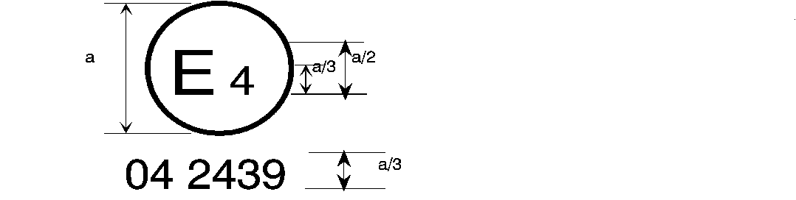

**09** 2439

a = 8 mm min.

The belt … the 06, 07**,** ~~or~~ 08 **or 09** series of amendments at the time of approval.

###### B → 4 m



**09** 2489

The belt … 06, 07**,** ~~or~~ 08 **or 09** series of amendments at the time of approval.

…

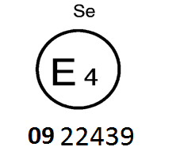

The belt bearing … the 06, 07**,** ~~or~~ 08 **or 09** series of amendments at the time of approval.

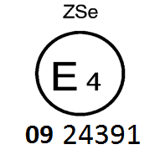

The belt … the 06, 07**,** ~~or~~ 08 **or 09** series of amendments at the time of approval.



**09** 2439

a ≥ 8 mm

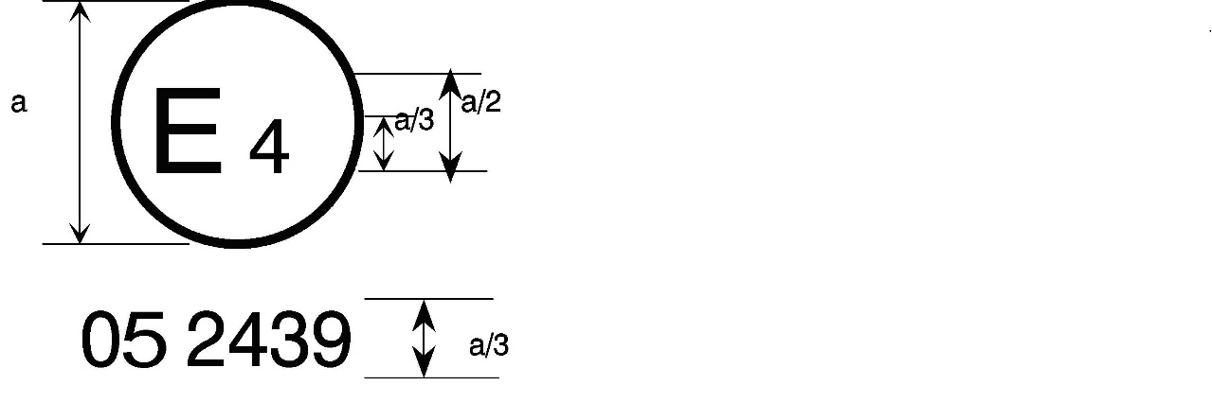

a = 8 mm min.



The belt … the 06, 07**,** ~~or~~ 08 **or 09** series of amendments at the time of approval. This belt shall not be fitted to vehicles of category M1.

Aer4m

**E4**

AIRBAG

**09**2439

The … 06, 07**,** ~~or~~ 08 **or 09** series of amendments at the time of the approval. This safety-belt has to be fitted to a vehicle equipped with an airbag in the given seating position."

II. Justification

1. As presented in documents GRSP-71-07, GRSP-70-06 and GRSP-70-07 the two-point belts offer only limited level of safety compared to three-point belts especially in case of frontal collision.

2. Based on the GRSG-109-03 about one third of the bus collisions in Europe are frontal collisions. Frontal collisions have relatively high Accident Casualty Rates (number of casualties in one accident).

3. Based on the accident data from the Karkkila accident (presented in GRSP-70-06) the level of safety offered by two-point belts is not sufficient.

4. Based on the document GRSP-70-07 (Estimate of the cost and impact of three-point seat belts in buses in Finland) equipping the buses with three-point safety belts is a cost effective way to increase safety of the passengers.

5. Three-point safety belts are widely used in passenger cars and the literature supports the usage of three-point belts also in buses.