|  |  |  |  |
| --- | --- | --- | --- |
|  | United Nations | ECE/TRANS/WP.29/GRE/2023/10 | |
| Description: _unlogo | **Economic and Social Council** | | Distr.: General  6 February 2023  Original: English |

**Economic Commission for Europe**

Inland Transport Committee

**World Forum for Harmonization of Vehicle Regulations**

**Working Party on Lighting and Light-Signalling**

**Eighty-eighth session**

Geneva, 25-28 April 2023

Item 6 (a) of the provisional agenda

**Installation UN Regulations:**

**UN Regulation No. 48 (Installation of Lighting and Light-Signalling Devices)**

Proposal for a Supplement to the 06, 07 and 08 series of amendments to UN Regulation No. 48

Submitted by the expert from the International Organization of Motor Vehicle Manufacturers[[1]](#footnote-2)\*

The text reproduced below was prepared by the experts from the International Organization of Motor Vehicle Manufacturers (OICA), with the aim to allow logos smaller than 5 cm2. It is based on ECE/TRANS/WP.29/GRE/2020/5/Rev.2 and GRE-85-26. The proposed modifications to the current text of the UN Regulation are marked in bold for new or strikethrough for deleted characters.

I. Proposal

*Paragraph 5.5.5.,* amend to read:

"5.5.5. In case of lamps incorporating a ~~manufacturer~~ logo, **the following conditions apply:**

**(a) Logos with a size not exceeding 5 cm² are permitted.**

**(b) Manufacturer logos only, with a size greater than 5 cm² but not exceeding 100 cm² are permitted in the following locations:**

**on the rear of the vehicle,** ~~only~~ two lateral logos (one on each side) or one central logo ~~can be fitted on the rear of the vehicle~~ and**/or**,

**on the front of the vehicle,** ~~only~~ two lateral logos (one on each side) or one central logo ~~can be fitted on the front of the vehicle~~.

**(c)** All **other** logos~~that are not vehicle manufacturer or body manufacturer logos~~ are prohibited."

II. Justification

1. The definition of “manufacturer logo” excludes trademarks of the lamp or vehicle manufacturers that are present on the apparent surface of lamps for decades without any complaints to traffic safety. The introduction of the requirements on logos as a Supplement to existing UN Regulations means that component manufacturers are enforced to remove the trademarks/logos from their designs as soon as amendments to their approvals become necessary, or as soon as they apply for approvals pursuant to UN Regulation No. 148 for lamps approved to the previous UN Regulations, e.g. No. 7. This introduces costs for the modification of production tools without any benefit to traffic safety.

Picture

**Examples of logos**

Image from YouTube: <https://www.youtube.com/watch?app=desktop&v=6vHo5WWqfwI&feature=youtu.be>

Video source: Audi

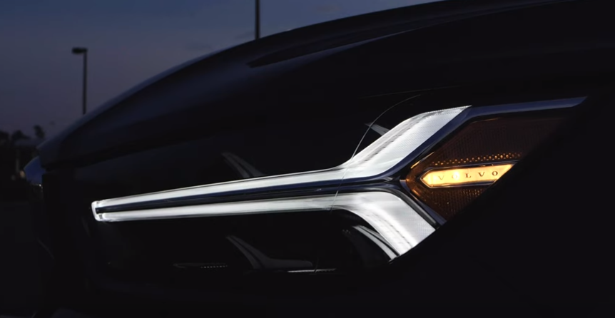

Picture source: Paul Henri-Matha/Volvo Cars

1. As the current text of the 01 series of amendments to UN Regulation No. 148 and the associated amendments to UN Regulation No. 48 only allow official logos/trademarks, such inscriptions or graphics will be forbidden in the future. This proposal intends to allow those graphics in a very limited way in addition to the official manufacturer logos.
2. The evaluation introduced in informal document GRE-85-16 implies that small structures cannot be identified by the human eye in relevant distances if their size does not exceed 100 cm² and their structures are composed of elements of less than 10 mm size. We believe that an exemption for extremely small logos and trademarks is possible because they cannot be identified as logos and therefore cannot have a negative influence on traffic safety.
3. Our approach is to exempt logos smaller than 5 cm² from the requirements. Logos smaller than this cannot act as representative signs because even within close vicinity of the vehicle they are not visible.

1. \* In accordance with the programme of work of the Inland Transport Committee for 2023 as outlined in proposed programme budget for 2023 (A/77/6 (Sect. 20), table 20.6), the World Forum will develop, harmonize and update UN Regulations in order to enhance the performance of vehicles. The present document is submitted in conformity with that mandate. [↑](#footnote-ref-2)