Proposal for amendments to document GRSG/2023/15 (Supplement 2 to the 01 Series of UN Regulation No. 160 (Event Data Recorder))
The text reproduced below was prepared by the expert from the International Organization of Motor Vehicle Manufacturers (OICA) to adapt the introduction of new verification procedures to the 01 Series of Amendments of the regulation. The modifications to the current text of the proposal by the IWG on EDR/DSSAD (see document ECE/TRANS/WP.29/GRSG/2023/15) are marked in blue bold for new and blue strikethrough for deleted characters.

I. Proposal
Insert new paragraph 6., to read:
"6. Verification Procedures
6.1. The accuracy of the measurement of longitudinal and lateral acceleration data element shall be verified using a component test fixture that subjects the EDR/airbag control module acceleration sensors to a sinusoidal acceleration motion in accordance with the following:
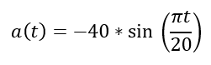 +/- 2g
6.1.1. The component test fixture shall be equipped with an acceleration sensor with a minimum range of +/- 500g and associated data acquisition system with a sampling frequency of 10kHz that is oriented to sense acceleration in the direction of the test fixture’s motion.
6.1.2. The air bag electronic control unit/EDR and applicable peripheral sensors, if needed to generate the air bag deployment signal, shall be mounted on the component test fixture as oriented in the vehicle. If the above does not generate a deployment signal, the manufacturer shall recommend the most appropriate way to generate the deployment signal.
6.1.3. The air bag deployment signal shall be recorded along with the component test fixture’s acceleration.
6.1.4. Following the activation of the component test fixture, the acceleration traces recorded by the component test fixture shall be passed through a 150 Hz two pole Butterworth filter. The equation for the 150 Hz Butterworth filter is shown below:
a_ref_150Hzfilt(n) = 0.00208057 * a_ref_raw(n)
+0.00416113 * a_ref_raw(n-1)
+0.00208057 * a_ref_raw(n-2)
+1.86689228 * a_ref_150Hzfilt(n-1)
-0.87521455 * a_ref_150Hzfilt(n-2)
The filtered component test fixture acceleration traces shall be compared to the acceleration traces recorded in the EDR unit by aligning the traces using the air bag deployment signal time.
6.1.5. The EDR recorded acceleration trace shall be fully contained in a corridor that is +/- 10 per cent of the full-scale range of the accelerometer used by the controller containing the EDR applied to the component test fixture’s filtered acceleration trace. The comparison of acceleration sensor traces shall only be made on the axis the component test was conducted.
For example, if the accelerometer in the controller containing the EDR function has a +/- 100 g range, then +/- 10 g would be applied to the component test fixture’s filtered acceleration trace. The EDR recorded acceleration trace shall be fully contained within that corridor (see the Figure).

Corridor +/- 10 Per Cent of the Full-Scale Range of the Accelerometer
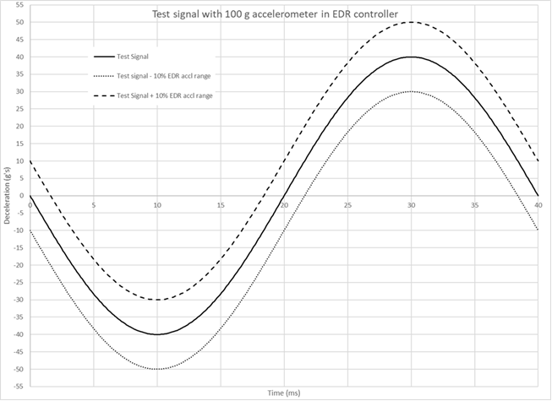
6.1.6. The EDR acceleration trace in paragraph 6.1.5. can be time shifted up to +/- 2ms based on the inverse of the 500 Hz sample rate to further align the data. The minimum step of the time shift may be the inverse of the sample rate of the EDR.
6.1.7. The acceleration data elements satisfy the tolerance condition if the EDR recorded acceleration trace is fully contained within the corridor established in paragraph 6.1.5., with or without following the above time shift in paragraph 6.1.6.
6.1.8. If the recommended waveform cannot realize algorithm wakeup due to the reason of manufacturer’s algorithm strategy, the manufacture may select a waveform, or amplify the suggested waveform. The waveform used for the EDR acceleration data accuracy shall be provided for review, if it is different than the waveform defined in the verification process."
Paragraphs 6. to 11., renumber as paragraphs 7. to 12.

Annex 4, Table 1, amend to read:
"…
Lateral acceleration  (post-crash) | If Recorded | 0–250 ms or 0 to End of Event Time plus 30 ms, whichever is shorter. | 500 | -50 to +50g | +/- 10%10 | 1 g | Planar  Rollover11
Longitudinal acceleration  (post-crash) | If Recorded | 0–250 ms or 0 to End of Event Time plus 30 ms, whichever is shorter. | 500 | -50 to +50g | +/- 10%¹⁰ | 1 g | Planar
…"
Footnotes 10 to 17 (former), renumber as Footnotes 12 to 19.

II. Justification
- There are multiple ways in which the acceleration data accuracy tolerance can be applied. This can potentially lead to different interpretations when applied by type-approval authorities. To resolve this the IWG specified that the currently specified accuracy tolerance be specified as "+/- 10 per cent of the full range of the accelerometer used in the ECU containing the EDR function".
- Since lateral acceleration in rollover events are not recorded using the same sensors as used for lateral air bag deployments, the format requirements are not appropriate and thus a footnote was added to clarify that the format for lateral acceleration in rollover events is at the option of the manufacturer.
- The verification procedures are removed from the original proposal since those requirements require a necessary lead-time for implementation and hence cannot be introduced with a supplement. A separate document proposes to include these verification procedures via a new series of amendments.

10 +/- 10 per cent of the full range of the accelerometer used in the Electronic Control Unit (ECU) containing the EDR function.
11 Format for lateral acceleration recorded in rollover is at the option of the manufacturer.

