Proposal supplementing document GRSG/2023/16
for Supplement 1 to the 05 Series of Amendments to
UN Regulation No. 46 (Devices for indirect vision)

- Proposal
Paragraph 6.1.1.2., amend to read:
"6.1.1.2. (a) Rear-view mirrors (Classes II to VII)
The edge of the reflecting surface shall be enclosed in a protective housing (holder, etc.) which, on its perimeter, shall have a value "c" greater than or equal to 2.5 mm at all points and in all directions.
In cases where When the edge of the reflecting surface is enclosed in a protective housing (holder, etc.), the radius of curvature "c" on its perimeter shall be not less than 2.5 mm at all points and in all directions.
In cases where When the edge of the reflecting surface projects beyond the protective housing independent from any adjustment position, the radius of curvature "c" on its perimeter shall be not less than 2.5 mm at all points and in all directions, and shall apply to the edge of the projecting part.
In cases where When If the reflecting surface projects beyond the protective housing in any adjustment position, the radius of curvature "c" on the edge of the projecting part shall be not less than 2.5 mm and the reflecting surface shall return into the protective housing under a force of 50 N applied to the point of greatest projection, relative to the protective housing, in a horizontal direction, approximately parallel to the longitudinal median plane of the vehicle.
(b) Rear-view mirrors (Class I)
In cases where the edge of the reflecting surface is enclosed in a protective housing (holder, etc.), the radius of curvature "c" on its perimeter shall be not less than 2.5 mm at all points and in all directions. In cases, where the edge of the reflecting surface projects beyond the protective housing, this requirement shall apply to the edge of the projecting part."
For information only (text unchanged):
"6.1.1.3. When the mirror is mounted on a plane surface, all parts, irrespective of the adjustment position of the device, including those parts remaining attached to the support after the test provided for in paragraph 6.3.2. below, which are in potential, static contact with a sphere either 165 mm in diameter in the case of a Class I mirror or 100 mm in diameter in the case of a Class II to VII mirror, shall have a radius of curvature 'c' of not less than 2.5 mm.
6.1.1.4. The requirements in paragraphs 6.1.1.2. and 6.1.1.3. above shall not apply to parts of the external surface which protrude less than 5 mm, but the outward facing angles of such parts shall be blunted, save where such parts protrude less than 1.5 mm. For determining the dimension of the projection, the following method shall apply:"
II. Justification
- The changes to document GRSG/2023/16 are indicated in red bold characters. They are mainly editorial improvements and the proposed solution to the comments expressed by France at the 124th session of GRSG (October 2022). This informal document adds also new illustrations in the justification.
- The current text of UN Regulation No. 46 on "Devices for indirect vision" allows rear-view mirrors of Class I to have a reflecting surface which projects beyond the protective housing.
- For Class II to VII mirrors, it is only possible to have a reflecting surface projecting beyond the housing in single adjustment positions. In this case, the reflecting surface must return into the protective housing if a force of 50 N is applied. This requirement cannot be met by mirrors where the reflecting surface is assembled onto the housing (frameless).
- A frameless design of the mirror could reduce the width and height of the mirror significantly (up to 30 per cent). This would then have two major benefits: a reduction of collision probability with bicyclists/pedestrians and a reduction of the aerodynamic resistance (c_{w}).
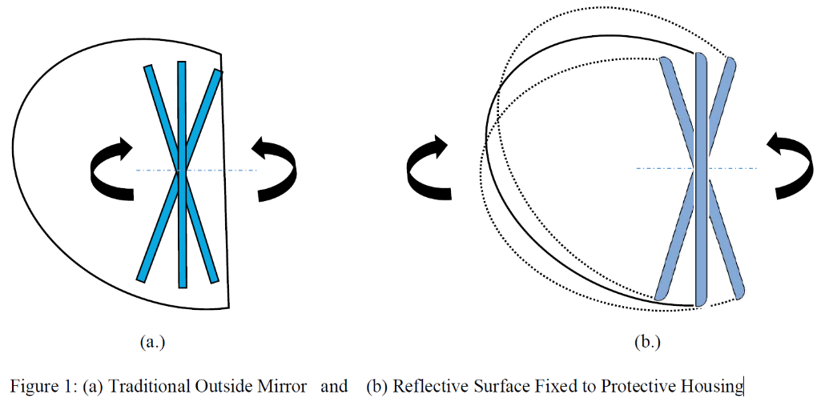
Figure 1 (a): Traditional outside mirror Figure 1 (b): Reflective surface fixed to protective housing
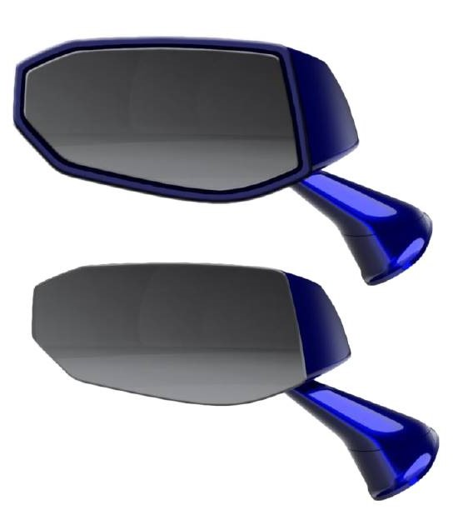
Figure 2: Traditional outside mirror

Figure 3: Reflective surface fixed to protective housing

- The other requirements on the radius of curvature (paragraphs 6.1.1.3. and 6.1.1.4.) remain unchanged. The impact test according to paragraph 6.3.2. still has to be fulfilled.

