Economic Commission for Europe
Inland Transport Committee
Working Party on the Transport of Dangerous Goods 16 March 2023
Joint Meeting of the RID Committee of Experts and the
Working Party on the Transport of Dangerous Goods
Bern, 20-24 March 2023
Item 2 of the provisional agenda:
Tanks
Requirements in RID/ADR 6.8.2.2.11 for level-gauges
Transmitted by the Government of the United Kingdom
Summary
Executive summary: Following the submission of proposals on 6.8.2.2.11 to the September 2022 session, the Working Group on Tanks was invited to consider the text that might be adopted at a future meeting. This document provides additional information and text for consideration by the Working Group on Tanks.
Action to be taken: Consideration of the information and proposals in this document by the Working Group on Tanks.
Related documents: ECE/TRANS/WP.15/AC.1/2022/29 and informal documents INF.31 and INF.32 of the autumn 2022 session,
ECE/TRANS/WP.15/AC.1/2022/3 and informal document INF.9 of the spring 2022 session,
ECE/TRANS/WP.15/AC.1/164/Add.1.
Background
1. Following an exchange of views on proposals submitted to the Autumn 2022 session in document ECE/TRANS/WP.15/AC.1/2022/29 and informal documents INF.31 and INF.32, the Joint Meeting agreed there was a need to clarify 6.8.2.2.11 in a way that makes it clear that level-gauges of the sight glass type are not permitted for Chapter 6.8 tanks.
2. However, agreement could not be reached on the form of words to be adopted and the Working Group on Tanks was therefore invited to consider this subject in detail at a future meeting, considering the views expressed by delegates and in particular the types of sight-glasses that should be permitted for service equipment.
3. This document has therefore been submitted to provide delegates with additional information about level gauges and a revised proposal that takes into account the discussions at the September 2022 session.
Consideration
4. In the opinion of delegates that took the floor at previous sessions of the Joint Meeting and the Working Group on Tanks, level-gauges of the following sight glass type should not be fitted to the shells of chapter 6.8 tanks:

5. It was thought that RID/ADR could be amended to make it clear that such sight-glasses should not be fitted. However, care should be taken to not inadvertently prohibit the fitment of sight-glasses to service equipment which would not present a similar risk to product loss if they should fail, be damaged or be sheared off. This includes the fitment of sight glasses to:
Vapour transfer valves: | Loading adaptors:
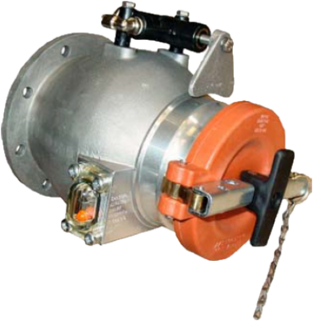 | 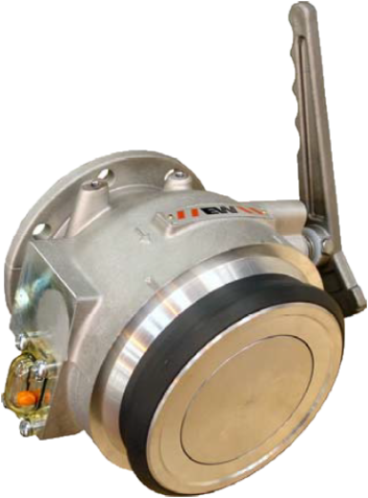

Proposals
6. Delete the current text of RID/ADR 6.8.2.2.11 and replace it by (new text in bold):
“Glass level-gauges and level-gauges made of other fragile material, which are in direct communication with the contents of the shell, shall not be used. Level-gauges shall not be fitted to shells if they incorporate transparent material which can, at any time, come into direct contact with the contents of the shell.”
7. Insert the following transitional provisions:
(RID:)
“1.6.3.xx Tank-wagons constructed before 1 July 2025 in accordance with the requirements in force up to 31 December 2024, but which however do not conform to the requirements of 6.8.2.2.11 applicable from 1 January 2025 may continue to be used.”
(ADR:)
“1.6.3.xx Fixed tanks (tank-vehicles) and demountable tanks constructed before 1 July 2025 in accordance with the requirements in force up to 31 December 2024, but which however do not conform to the requirements of 6.8.2.2.11 applicable from 1 January 2025 may continue to be used.”
(RID and ADR:)
“1.6.4.xx Tank-containers constructed before 1 July 2025 in accordance with the requirements in force up to 31 December 2024, but which however do not conform to the requirements of 6.8.2.2.11 applicable from 1 January 2025 may continue to be used.”

