|  |  |  |
| --- | --- | --- |
|  | E/ECE/324/Rev.1/Add.48/Rev.6/Amend.8−E/ECE/TRANS/505/Rev.1/Add.48/Rev.6/Amend.8 | |
|  |  | 15 September 2022 |

Agreement

Concerning the Adoption of Harmonized Technical United Nations Regulations for Wheeled Vehicles, Equipment and Parts which can be Fitted and/or be Used on Wheeled Vehicles and the Conditions for Reciprocal Recognition of Approvals Granted on the Basis of these United Nations Regulations[1]*

(Revision 3, including the amendments which entered into force on 14 September 2017)

_________

Addendum 48 – UN Regulation No. 49

Revision 6 - Amendment 8

Supplement 7 to the 06 series of amendments – Date of entry into force: 22 June 2022

Uniform provisions concerning the measures to be taken against the emission of gaseous and particulate pollutants from compression-ignition engines and positive ignition engines for use in vehicles

This document is meant purely as documentation tool. The authentic and legal binding text is: ECE/TRANS/WP.29/2021/130.

**_________**

**UNITED NATIONS**

*Annex 4*

*Paragraph 8.2.,* amend to read:

"8.2. NOx correction for humidity

As the NOx emission depends on ambient air conditions, the NOx concentration shall be corrected for humidity with the factors given in paragraph 8.2.1. or 8.2.2. The intake air humidity Ha may be derived from relative humidity measurement, dew point measurement, vapour pressure measurement or dry/wet bulb measurement using generally accepted equations.

For all humidity calculations (for example Ha, Hd) using generally accepted equations the saturation vapour pressure is required. For calculating the saturation vapour pressure which is in general a function of the temperature (at the humidity measurement point) the equation D.15 specified in Annex D to ISO Standard 8178-4:2020 should be used."

*Paragraph 8.4.2.3.*, *Equation (36)*, amend to read:

"…

The following equation shall be applied:

$$m_{gas}=u_{gas}×\sum_{i=1}^{i=n}{\left(c_{gas,i}×q_{mew,i}×\frac{1}{f}\right) } in (g/test) (36)$$

Where:

…"

*Paragraph 8.4.2.4., Equation (37)*, amend to read:

"…

The following equation shall be applied:

$m_{gas}=\sum_{i=1}^{i=n}{\left({u_{gas,i}×c}_{gas,i}×q_{mew,i}×\frac{1}{f}\right)} in \left(\frac{g}{test}\right)$ (37)

Where:

…"

*Paragraph 8.5.1.4.*, *Equation (54)*, amend to read:

"…

$Q_{SSV}=\frac{A_{0}}{60}d_{V}^{2}C_{d}p_{p}\sqrt{\left[\frac{1}{T}\left(r_{p}^{1.4286}-r_{p}^{1.7143}\right)∙\left(\frac{1}{1-r_{D}^{4}r_{p}^{1.4286}}\right)\right]}$ (54)

Where:

*A*0 is 0.005692 in SI units of 

*d*V is the diameter of the SSV throat, mm

…"

*Paragraph 8.5.2.3.1.*, *Equation (57)*, amend to read:

"…

$u_{gas}=\frac{M_{gas}}{M_{d}×\left(1-\frac{1}{D}\right)+M_{e}×\left(\frac{1}{D}\right)}×\frac{1}{1000}$ (57)

…"

*Paragraph 8.6.1.,* amend to read:

"…

Depending on the measurement system and calculation method used, the uncorrected emissions results shall be calculated with equations 36, 37, 56, 58 or 62, respectively. For calculation of the corrected emissions, *c*gas in equations 36, 37, 56, 58 or 62, respectively, shall be replaced with *c*cor of equation 66. If instantaneous concentration values *c*gas,i are used in the respective equation, the corrected value shall also be applied as instantaneous value *c*cor,i. In equation**s** 58 and 62, the correction shall be applied to both the measured and the background concentration.

…"

*Paragraph 9.2., Table 7,* amend to read:

"Table 7

**Linearity requirements of instruments and measurement systems**

|  |  |  |  |  |
| --- | --- | --- | --- | --- |
| *Measurement system* | ꭓ*min* X (*a1* - 1*)+ a0* | *Slope a1* | *Standard error SEE* | *Coefficient of*  *Determination r2* |
| Engine speed | ≤ 0.05 % max | 0.98 - 1.02 | ≤ 2 % max | ≥ 0.990 |
| Engine torque | ≤ 1 % max | 0.98 - 1.02 | ≤ 2 % max | ≥ 0.990 |
| Fuel flow | ≤ 1 % max | 0.98 - 1.02 | ≤ 2 % max | ≥ 0.990 |
| Airflow | ≤ 1 % max | 0.98 - 1.02 | ≤ 2 % max | ≥ 0.990 |
| Exhaust gas flow | ≤ 1 % max | 0.98 - 1.02 | ≤ 2 % max | ≥ 0.990 |
| Diluent flow | ≤ 1 % max | 0.98 - 1.02 | ≤ 2 % max | ≥ 0.990 |
| Diluted exhaust gas flow | ≤ 1 % max | 0.98 - 1.02 | ≤ 2 % max | ≥ 0.990 |
| Sample flow | ≤ 1 % max | 0.98 - 1.02 | ≤ 2 % max | ≥ 0.990 |
| Gas analyzers | ≤ 0.5 % max | 0.99 - 1.01 | ≤ 1 % max | ≥ 0.998 |
| Gas dividers | ≤ 0.5 % max | 0.98 - 1.02 | ≤ 2 % max | ≥ 0.990 |
| Temperatures | ≤ 1 % max | 0.99 - 1.01 | ≤ 1 % max | ≥ 0.998 |
| Pressures | ≤ 1 % max | 0.99 - 1.01 | ≤ 1 % max | ≥ 0.998 |
| PM balance | ≤ 1 % max | 0.99 - 1.01 | ≤ 1 % max | ≥ 0.998 |
| Humidity measurement device | ≤ 2 % max. | 0.98 – 1.02 | ≤ 2 % | ≥ 0.95 |

"

*Paragraph 9.3.3.1.,* amend to read:

"9.3.3.1. Pure gas

…

Hydrogen mixture (FID burner fuel)

(40 ± 1 per cent hydrogen, balance helium or alternatively nitrogen)

(Contamination ≤1 ppm C1, ≤400 ppm CO2)"

*Paragraph 9.3.6.2.,* amend to read:

"9.3.6.2. Calibration

The CLD and the HCLD shall be calibrated in the most common operating range following the manufacturer's specifications using zero and span gas (the NO content of which shall amount to about 80 per cent of the operating range and the NO2 concentration of the gas mixture to less than 5 per cent of the NO concentration). With the ozonator deactivated, the NOx analyzer shall be in the NO mode so that the span gas does not pass through the converter. The indicated concentration has to be recorded."

*Paragraph 9.3.6.8.,* amend to read:

"9.3.6.8. NOx mode

Keeping NO**x** mode with the ozonator deactivated, the flow of oxygen or synthetic air shall be shut off. The NOx reading of the analyzer shall not deviate by more than ±5 per cent from the value measured according to paragraph 9.3.6.2. (the analyzer is in the NOx mode)."

*Paragraph 9.5.4.1.*, amend to read:

"9.5.4.1. Data analysis

…

$C_{d}=\frac{Q_{ssv}}{\frac{A_{0}}{60}×d_{V}^{2}×p_{p}×\sqrt{\left[\frac{1}{T}×\left(r_{p}^{1.4286}-r_{p}^{1.7143}\right)×\left(\frac{1}{1-r_{D}^{4}×r_{p}^{1.4286}}\right)\right]}} (89)$

Where:

*Q*SSV is the *airflow* rate at standard conditions (101.3 kPa, 273 K), m3/s

*T* is the temperature at the venturi inlet, K

*d*V is the diameter of the SSV throat, mm

…

$Re=A_{1}×60×\frac{Q_{SSV}}{d_{V}×μ}$ (90)

With

 (91)

Where:

A1 is 27.43831 in SI units of $\left(\frac{kg}{m^{3}}\right)\left(\frac{min}{s}\right)\left(\frac{mm}{m}\right)$

*Q*SSV is the airflow *rate* at standard conditions (101.3 kPa, 273 K), m3/s

*d*V is the *diameter* of the SSV throat, mm

…"

*Annex 4, Appendix 2*

*Paragraph A.2.1.3.*, amend to read:

"A.2.1.3. Components of Figures 9 and 10

EP Exhaust pipe

SP1 Raw exhaust gas sampling probe (Figure 9 only)

…"

*Paragraph A.2.2.1.*, amend to read:

"…

# Figure 12

# **Scheme of partial flow dilution system (total sampling type)**

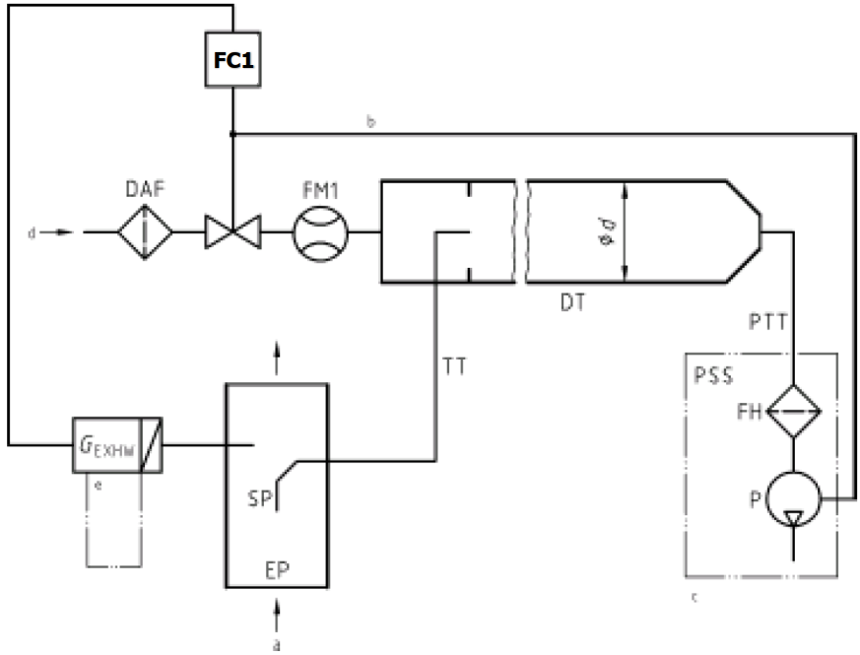

a = exhaust b = optional c = details see Figure 16

…"

*Paragraph A.2.2.5.*, amend to read:

"…

For a partial flow dilution system, a sample of the diluted exhaust gas is taken from the dilution tunnel DT through the particulate sampling probe PSP and the particulate transfer tube PTT by means of the sampling pump P, as shown in Figure 16. The sample is passed through the filter holder(s) FH that contain the particulate sampling filters. The sample flow rate is controlled by the flow controller FC2.

For of full flow dilution system, a double dilution particulate sampling system shall be used, as shown in Figure 17. A sample of the diluted exhaust gas is transferred from the dilution tunnel DT through the particulate sampling probe PSP and the particulate transfer tube PTT to the secondary dilution tunnel SDT, where it is diluted once more. The sample is then passed through the filter holder(s) FH that contain the particulate sampling filters. The diluent flow rate is usually constant whereas the sample flow rate is controlled by the flow controller FC2. If electronic flow compensation EFC (see Figure 15) is used, the total diluted exhaust gas flow is used as command signal for FC2.

…"

1. * Former titles of the Agreement:

   Agreement concerning the Adoption of Uniform Conditions of Approval and Reciprocal Recognition of Approval for Motor Vehicle Equipment and Parts, done at Geneva on 20 March 1958 (original version);

   Agreement concerning the Adoption of Uniform Technical Prescriptions for Wheeled Vehicles, Equipment and Parts which can be Fitted and/or be Used on Wheeled Vehicles and the Conditions for Reciprocal Recognition of Approvals Granted on the Basis of these Prescriptions, done at Geneva on 5 October 1995 (Revision 2).